**Project Proposal: Online Betting Platform**

**Project Relevance**

Betting has become a big part of the global entertainment and sports industry. The digital transformation of betting platforms has made them more accessible, engaging, and user-friendly. **1xBet** and **Olimpbet** have successfully developed large markets by providing online experiences and extensive betting options. However, these platforms often face criticism for lack of transparency, and insufficient tools for responsible gambling, overcomplicated interface.

In Kazakhstan, the online betting market remains underexplored despite growing internet availability and interest in sports. Developing a beginner-friendly betting website with simple interface can address these gaps while following ethical gambling practices.

**Competitor Analysis**

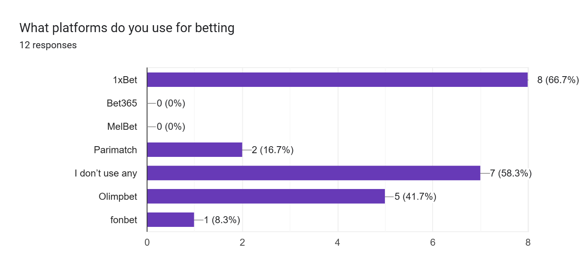

The survey provided us a list of competitors, from which the two most prevalent are **Olimpbet, 1XBET**.

**1xBet**

* **Strengths:**
  + Broad range of sports and eSports betting options.
  + User-friendly interface with live streaming features.
  + Various payment options.
* **Weaknesses:**
  + Overly complex navigation for beginners.
  + Limited tools for responsible gambling.

**Olympbet**

* **Strengths:**
  + Simpler design for users.
  + Interface works smoothly.
* **Weaknesses:**
  + Limited introduction for new users.

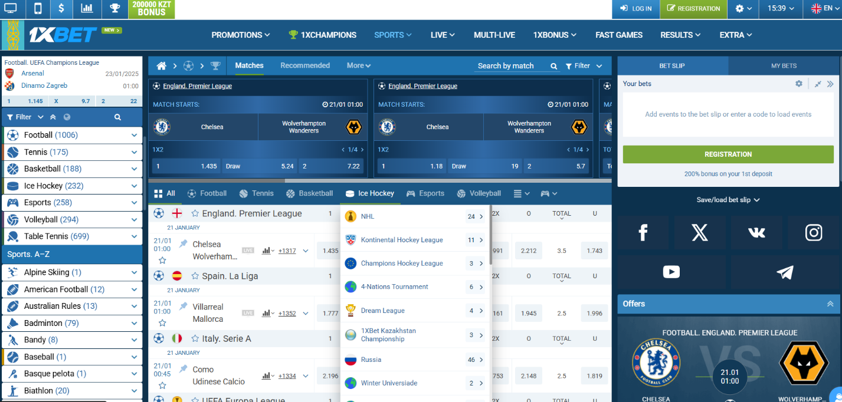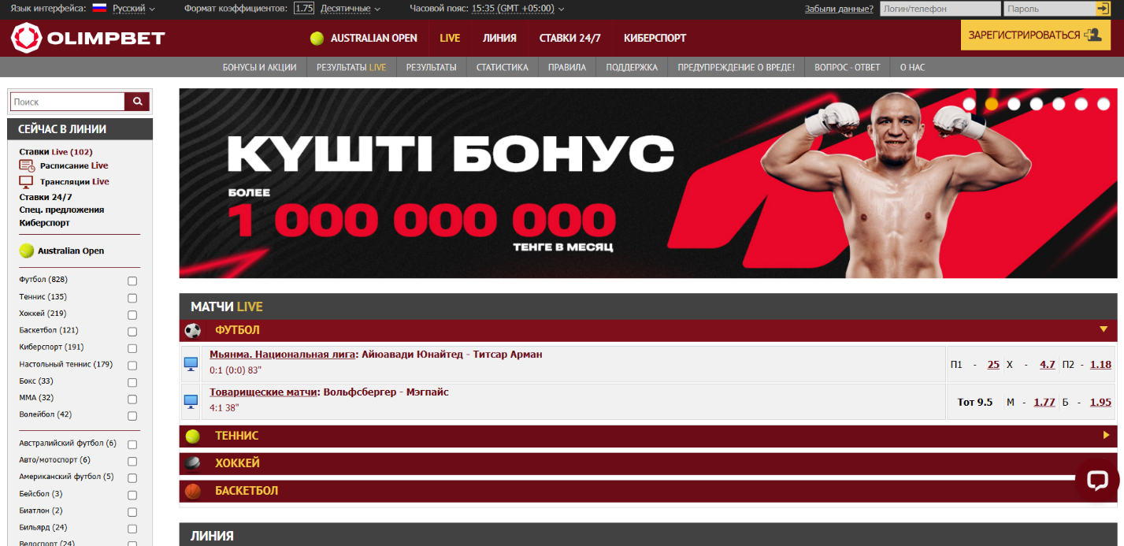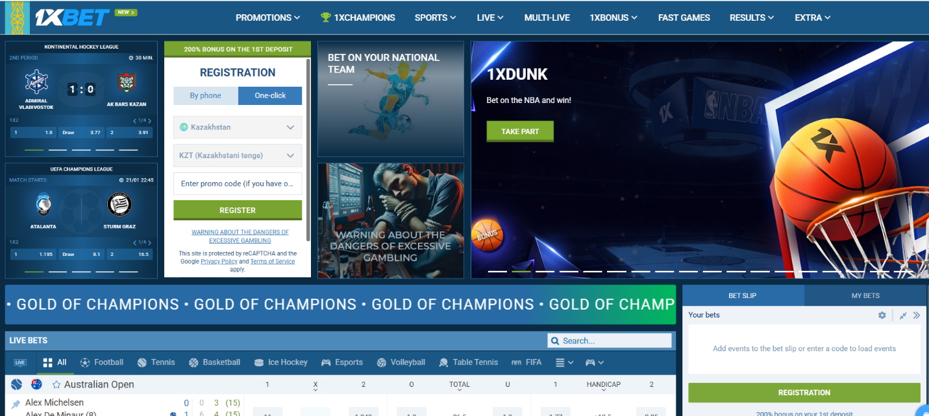

As shown on these screenshots, 1xbet has a design that may seem overwhelming to a beginner, with many details and menus. And while Olimpbet provides a simpler interface, it still may be too much for a new user.

**Differentiators for Our Platform**

Our platform will combine the strengths of these competitors while addressing their weaknesses by:

* Offering intuitive navigation for both beginners and experienced users. (Possibly providing different layouts for both types of users)
* Introducing enhanced tools for responsible gambling, such as betting limits and self-exclusion options.
* Offering extensive introduction/tutorial to further engage players.

**Project Audience**

The primary target audience includes:

1. **Casual Bettors:** Individuals who bet occasionally for entertainment.
2. **Sports Enthusiasts(Majority):** Fans looking to enhance their viewing experience by betting on their favorite teams.
3. **Experienced Bettors:** Users seeking advanced tools and analytics for informed decision-making.

Demographics:

* Age: 18-25 years.
* Interests: Sports, gaming, and digital platforms.
* 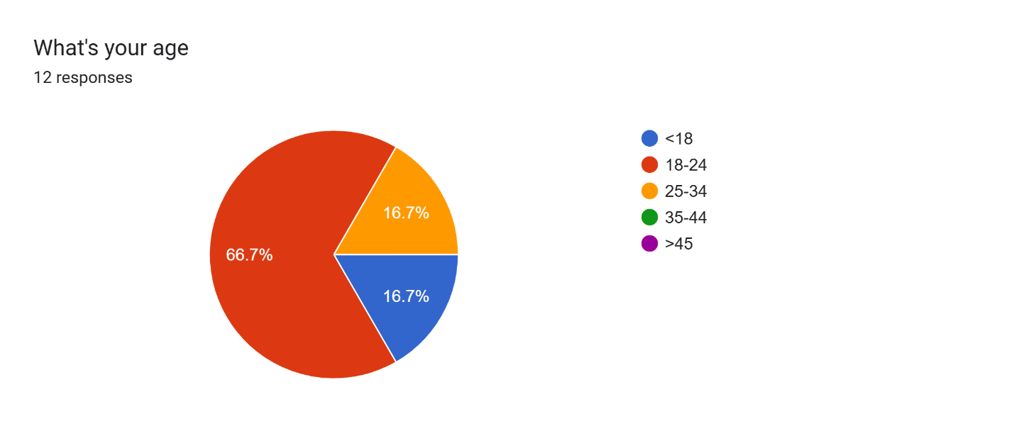

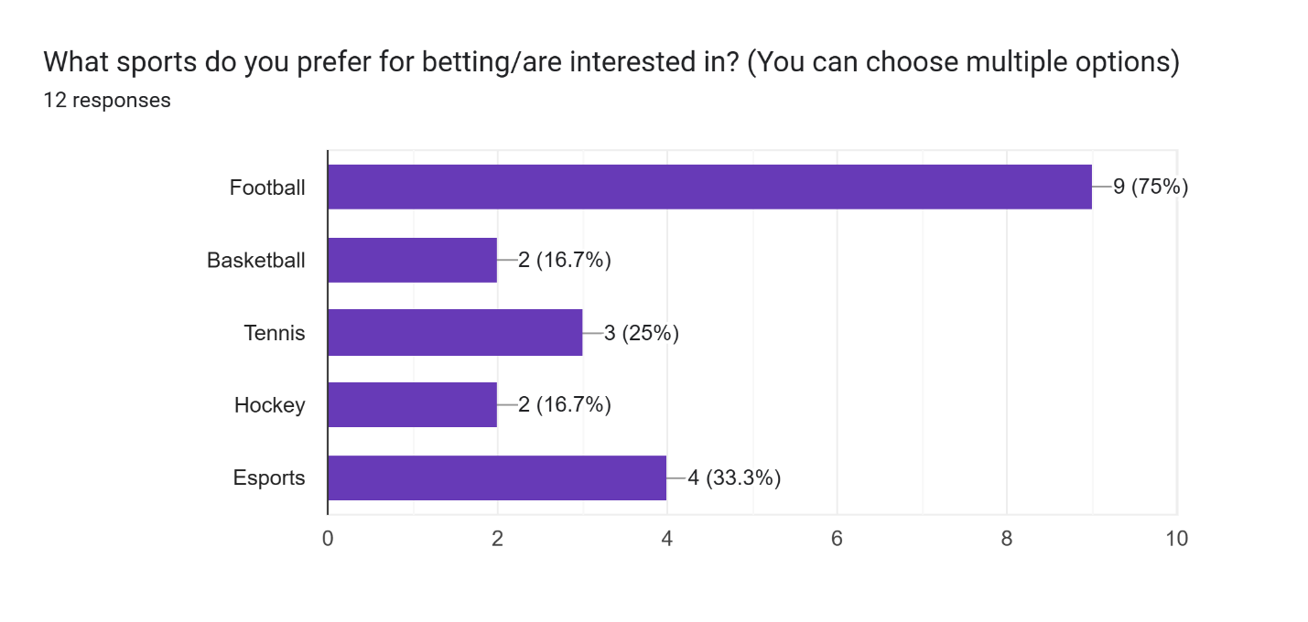

**Project Features**

**Core Features**

1. **User-Friendly Interface:**
   * Simple navigation for new users.
   * Advanced features like multi-bet options for experienced bettors.
   * 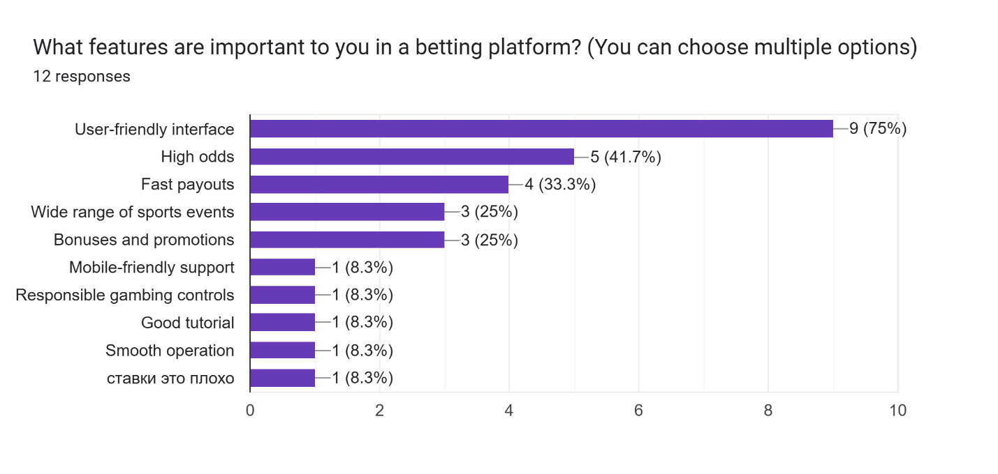
2. **Comprehensive Betting Markets:**
   * Sports: Football, basketball, cricket, and more.
   * eSports: Dota 2, CS:GO, and other popular games.
3. **Live Betting and Streaming:**
   * Real-time odds and updates.
   * Smooth operation
4. **Localized Content:**
   * Multilingual support (Kazakh, Russian, English).
   * Local payment methods and currencies.
5. **Responsible Gambling Tools:**
   * Self-exclusion features.
   * Daily, weekly, and monthly betting limits.
   * Loss limits.
6. **Gamification:**
   * Reward systems, badges, and leaderboards to increase user engagement.

**Results of Preliminary Research**

Initial surveys conducted among potential users revealed:

* **High interest in football and esports:** Most respondents take interest in either football or esports.
* **Demand for simple interface:** 75% expressed interest in a simple interface, many noted that interfaces on existing platforms are too complicated.

**References**

* Competitor websites: [1xBet](https://1xbet.com/), [Olympbet](https://olympbet.com/)
* Surveys and user feedback: <https://docs.google.com/forms/d/e/1FAIpQLSfu3mX0uO1FzI9iYavCA7Gw2epJtD-CIQzFT5Hb1FDzMUiKUQ/viewform?usp=header>, <https://bet24.kz/bookmakers/1xbet/reviews/>, <https://bet24.kz/bookmakers/olimpbet/reviews/>