A nearly 1.5 millennia long record of North Atlantic climatic forcing recorded in tree-ring growth records from the Angstel/Vecht Delta, the Netherlands (1283 BCE–156 CE)
Michiel Arts¹* and Jos Bazelmans²,³*
¹ SEDICLIM lab, Department of Geology, University of Liège, Belgium
² Cultural Heritage Agency of the Netherlands, Amersfoort, the Netherlands
³ Faculty of Archaeology, Leiden University, Leiden, the Netherlands
*These authors contributed equally to this work. Corresponding author: j.bazelmans@cultureelerfgoed.nl

Abstract
The impact of multi-annual to multidecadal climatic cycles on tree-ring growth in lowland wetlands remains understudied. Here, we analyse a nearly one-and-a-half-thousand-year tree-ring chronology (1283 BCE–156 CE) based on bog oaks from an alder carr in the Angstel/Vecht delta, the Netherlands, to assess how multi-year climatic oscillations influence tree-ring growth and the origin of the identified cycles. Wavelet, cross-wavelet, and bicoherence analyses reveal cycles of ~15.5, ~38, and ~60 years, which are significant against most of the white-noise, red-noise, and power-law backgrounds tested, and a borderline cycle of ~24 years. The ~60-year cycle is the most persistent and the ~15.5-year cycle the strongest but episodic; cycles of 8 years or shorter and of 80 years or longer cannot be separated from noise. To investigate their forcing, we compare the tree-ring record with the Uamh an Tartair stalagmite record from northwestern Scotland, a proxy for North Atlantic precipitation. Across the multidecadal band, the tree-ring record lags the stalagmite by about a quarter cycle at ~60 years and more at shorter periods, consistent with a shared North Atlantic driver and a delayed oak response. We attribute this delay to cumulative forcing through groundwater storage in the Angstel/Vecht delta, where periods of increased regional rainfall raise groundwater levels and suppress oak growth. The bicoherence results indicate that the ~15- and ~38-year cycles may arise as nonlinear combination tones of longer-period cycles, suggesting that cyclicity in tree-ring records reflects nonlinear interactions among forcing mechanisms and that lowland bog-oak records are sensitive archives of multidecadal hydroclimatic variability in the North Atlantic region.
Keywords: tree-ring growth, bog oak, alder carr, Angstel and Vecht, Netherlands, hydroclimate variability, North Atlantic Oscillation, Atlantic Multidecadal Oscillation, wavelet analysis, red noise, bicoherence

1. Introduction
Hydroclimate variability in western Europe is strongly influenced by large-scale patterns over the North Atlantic, in particular the North Atlantic Oscillation (NAO), the Atlantic Multidecadal Oscillation (AMO) and solar variability (Ait Brahim et al., 2018; Börgel et al., 2020; Dieppois et al., 2013; Pinto and Raible, 2012). These patterns affect temperature, rainfall, storm activity and groundwater recharge from seasonal to centennial timescales, and leave traces in ocean, lake and cave archives (Baldini et al., 2008; Hubeny et al., 2006; Rust et al., 2020). How they are expressed in tree-ring records from lowland wetlands, and especially before the instrumental period, remains poorly known.
Oak ring-width and stable-isotope chronologies have been used repeatedly to reconstruct European hydroclimate, with mixed results: some regions yield useful precipitation or drought skill, others little, and the climatic interpretation of subfossil bog-oak material has proved harder still (Cook et al., 1998; Kelly et al., 2002; Leuschner et al., 2002; Roig et al., 2009; Trouet et al., 2009). For NW-European bog oaks, groundwater level is generally taken as the dominant control rather than temperature or summer rainfall directly (Jansma, 2020; Sass-Klaassen and Hanraets, 2006). Two consequences follow here. First, our record has no overlap with instrumental data, so it has no calibration or verification interval, and the climatic interpretation rests on the system's physiology and on comparison with independently dated archives rather than on transfer-function skill. Second, because the growth response to waterlogging is threshold-like and cumulative, the relation between forcing and ring width is expected to be nonlinear, which is one reason we look explicitly for interactions between frequency components.
In the Angstel/Vecht region, oaks grew in alder carrs on peat where groundwater was closely coupled to precipitation and to Rhine discharge (Jansma, 2020). Individual floods and episodes of prolonged waterlogging reduce increment, produce flood rings, promote root decay and increase the risk of mortality (Coder, 1994; Copini et al., 2016; Sass-Klaassen and Hanraets, 2006). Whether the same sign holds for sustained, multidecadal changes in the water table is a separate question, and the present record addresses it by relating it to an independent archive (Section 5.2). Continued peat formation favoured preservation of the subfossil wood (Leuschner et al., 2002).
Atmospheric pressure patterns associated with the positive NAO phase are linked to major floods in northwestern Europe (Brönnimann et al., 2025). The NAO expresses the pressure difference between the Azores High and the Icelandic Low and controls the strength and direction of the westerlies and the storm track (Hurrell, 1995; Hurrell et al., 2003). Positive phases bring mild, wet and stormy conditions and elevated winter discharge in the Rhine; negative phases bring colder, drier conditions and a later runoff peak (Steirou et al., 2017). Palaeoclimatic archives identify multi-decadal to centennial intervals of persistent NAO states (Baker et al., 2015; Olsen et al., 2012), although reconstructions differ because of age-model uncertainty and limited calibration strength.
Periodicities have been sought in tree-ring series for decades, most often in living or recent material and most often with the aim of recovering a known forcing, in particular the solar cycles, from a chronology of a few centuries (Murphy et al., 1994; Šimůnek et al., 2021). The record analysed here is different. It is a body of subfossil oaks, absolutely dated, 1439 years long and ending nearly two millennia ago, with no instrumental period to calibrate against. Its evidential situation is therefore closer to a deep-time cyclostratigraphic study than to a dendroclimatological one, and we have adopted the analytical conventions of the former: an explicit stochastic background, significance assessed at more than one level, and the extraction and testing of individual components.
This study addresses two questions: first, which periodicities in the Angstel/Vecht chronology can be distinguished from a plausible stochastic background; and second, whether the surviving components are consistent with known modes of North Atlantic variability, whether they interact nonlinearly, and whether they track an independently dated North Atlantic archive.

2. Palaeogeographic setting
The Angstel/Vecht delta, between Amsterdam, Utrecht and Naarden and the former Zuiderzee/Lake Flevo, is a Holocene peat-dominated area at the northern margin of the Rhine delta (Van Asselen et al., 2017; Vos et al., 2020; Weerts et al., 2002; Figure 1). It developed on an undulating Late Weichselian coversand surface buried beneath Holocene peat, lacustrine and fluvial deposits as groundwater levels rose with post-glacial sea-level rise (Bos et al., 2009; Hijma and Cohen, 2019).
The system developed as a distributary of the Old Rhine from the 12th century BCE onwards, conveying up to about 10% of Rhine discharge to the North Sea until the early Middle Ages and forming a dynamic flood basin with interbedded fluvial, lacustrine and peat deposits (Van der Woude, 1984; Weerts et al., 2002). Progressive infilling of peat lakes was followed by levee development through repeated overbank deposition, structuring peat-facies distribution and controlling local drainage (Bos et al., 2009; Van Dinter et al., 2017). Thick peat sequences supported alder carrs with scattered oaks sensitive to groundwater fluctuations (Jansma, 2020; Sass-Klaassen and Hanraets, 2006). Elevated water levels reduced ring width by limiting root aeration; drier phases allowed wider increments. The subfossil oaks form the chronology NLBOG26 (Bazelmans et al., submitted).
INSERT FIGURE
Figure 1. Palaeogeography of the Angstel/Vecht delta for the 3850 BCE, 1500 BCE, 500 BCE and 800 CE time slices. A, Oer-IJ; B, Lake Aetsveld; C, Old Rhine; D, Lake Flevo; E, Almere. 1, beach barriers and low dunes; 2, beach plains and dune valleys; 3, tidal flats; 4, salt marshes, floodplains and stream valleys; 5, peat areas; 6, Pleistocene sand below modern sea level; 7, Pleistocene sand above modern sea level; 8, ice-pushed ridges; 9, outer and inner water. Dashed line: research area. Modified after Vos et al. (2018).

3. Materials and methods

3.1 Software and reproducibility
All analyses were carried out in R (R Core Team, 2024). Chronology construction, which precedes the work reported here and is documented in the companion study, used dplR (Bunn, 2008) to read the Heidelberg-format measurements, detrend the individual series, and compute robust mean and variance-stabilised chronologies. The analysis reported here takes those finished chronologies as input and uses no dendrochronology-specific software: the wavelet transform, its rectification by scale and the cross-wavelet transform follow WaverideR (Arts, 2023; Arts et al., 2024); band-pass filtering, interpolation and the multitaper spectrum with its red-noise and power-law backgrounds are taken from the astrochron R package (Meyers, 2014), whose bicoherence function we re-coded for this work (Section 3.4); the surrogate generators, the area-wise test and the significance machinery are implemented in base R. The whole analysis is contained in a single script, Weesp_analysis_complete.R, which runs from the chronologies to every figure, table and p-value reported here (S11).

3.2 Chronology and detrending
The analysis uses the growth-index record NLBOG26 (Bazelmans et al., submitted): 526 specimens from 31 sites, of which 500 are absolutely dated, spanning 1371 BCE–488 CE with 90,914 measured rings. The chronologies analysed here were built for the companion study and used as input for this one. The series were read with dplR (Bunn, 2008) and placed on a historical calendar without a year zero; age-related trends were removed with a cubic smoothing spline with a 50% frequency cut-off (Cook and Peters, 1981) at min(128, 0.67 × N) years; and the chronologies were formed as biweight robust means without prewhitening, so that interannual persistence, which in this system carries hydrological information, is retained. The spline reduces the amplitude of variability at its cut-off period by half, and progressively more at longer periods. Because the cut-off is 128 years for long series and shorter for short ones (median 118 years), the chronology retains variability up to roughly 64 years, progressively loses it between 64 and 128 years, and strongly suppresses periods longer than 128 years; hence, claims about centennial periods cannot be made based on this record.
Because the number of trees changes through time, and the variance of a mean chronology, and with it the wavelet power, depends on that number, we first determined which part of the chronology is sufficiently replicated to analyse. Sample depth, running interseries correlation over a 101-year window, and the expressed population signal (EPS; Wigley et al., 1984) were computed for every year (Figure 2; S1). We defined the analysis window by a stated criterion rather than by choice: the longest continuous interval with sample depth ≥ 10 and EPS ≥ 0.85, which is 1283 BCE–156 CE (1439 years). Within it, sample depth ranges from 10 to 106 (median 68), running R̄ from 0.19 to 0.50 (mean 0.36), and EPS exceeds 0.85 in 98.2% of years. Two segments at the ends of the window, 1283–1210 BCE and 39 BCE–156 CE (269 years together), have fewer than 40 series. We retained them so the record covers the full replicated interval, but we treat results based on these segments with extra care, and we checked the principal results against the core interval 1209–40 BCE, where every year has at least 40 series (S5, S7).
The variance of a mean chronology depends on replication and on interseries correlation, so changes in replication alone can create or remove apparent cycles. To test whether this affects our results, we built two additional chronologies for the same trees and years: a variance-stabilised chronology (Frank et al., 2007), which corrects the variance of each year for its sample depth and the 101-year running R̄, and a constant-replication chronology over 1209–40 BCE, where every year has at least 40 series. For the latter, we drew exactly 40 series at random per year, 1000 times, and retained the median. If the cycles were an artefact of changing replication, they would weaken or disappear in these two chronologies. We repeated the spectral analysis on all three (Section 4.1; S5). The three chronologies give practically identical spectra; the constant-replication chronology reproduces the original almost exactly, and sample depth and running variance are not correlated (S1, S5). Based on these tests, we conclude that the spectral structure of the Angstel/Vecht chronology does not depend on replication, and that the chronology is sufficiently replicated and stable to support the spectral analysis.
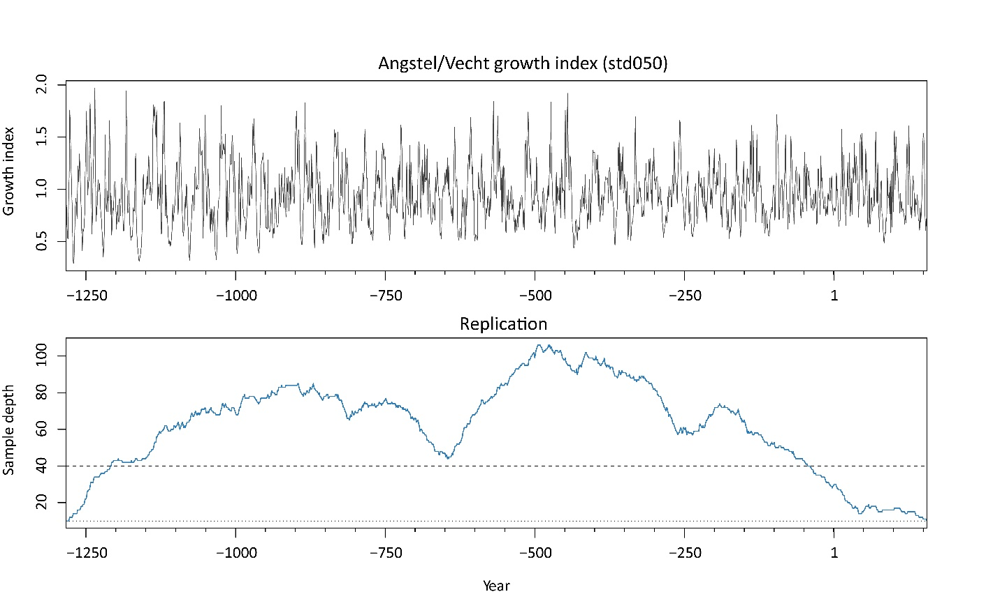
Figure 2. Upper panel, the Angstel/Vecht growth index over the analysis window. Lower panel, sample depth; dotted line n = 10, dashed line n = 40.

3.3 Spectral analysis and significance
We examined periodicity with the continuous wavelet transform (CWT) as implemented in the WaverideR package (Arts, 2023; Arts et al., 2024), which rectifies wavelet power by scale following Liu et al. (2007), and cross-checked the result with the multitaper method (MTM; Thomson, 1982) as implemented in astrochron (Meyers, 2014), assessed against a robust red-noise background (Mann and Lees, 1996) and against a fitted power law.
For the CWT, we used a Morlet parameter ω₀ of 10, which is high enough to separate the candidate components in the decadal to multidecadal range, where the expected periods are close together in log space, while retaining enough time resolution to show whether a component is sustained or episodic. The scale increment was set to dj = 1/100 for the figures, so that narrow peaks are not missed by undersampling. We examined periods between 2 and 256 years.
The chronology is strongly persistent (AR(1) φ = 0.662; S2), so a red background is unavoidable. Rather than adopt one, we evaluated significance against four: white noise; AR(1) with φ estimated from the observed chronology; AR(1) with φ = 0.510 estimated after the candidate cycle bands were notched out of the spectrum, using a rectangular stop band of ±10% around each candidate period, which is the window used by the maximum-in-band test; this removes the circularity of fitting the background to a series that still contains the signal under test, and the sensitivity of φ to that width is given in S10; and a power law with β = 1.151 fitted outside those bands (estimated on the multitaper spectrum, not on the scale-rectified wavelet spectrum). Neither of the two AR(1) variants is “correct” (the first absorbs part of the signal into the null, the second assumes the candidate bands are signal), and reporting both bounds the answer. Significance is reported at three levels: pointwise; maximum-in-band; and area-wise (Maraun and Kurths, 2004; Maraun et al., 2007). Full specification, surrogate counts and the complete result tables are given in S2–S4. We fixed two criteria before presenting the results. A component is retained as a spectral feature if the maximum power within a ±10% period window exceeds the 95th percentile of at least three of the four backgrounds. We describe it as persistent only if it also passes the area-wise test at the 5% level under a red background.

3.4 Cycle extraction, nonlinear interaction and cross-record comparison
We extracted the main cycles from the growth index with a Taner bandpass filter (Taner, 2000), as implemented in the astrochron R package (Meyers, 2014), and used the CWT to follow how much of the total wavelet power each cycle carries through time. Because this share changes through the record, we also determined when the balance between the multidecadal (48–80 years) and decadal (14–17 years) cycles changes most, and whether a change of that size can arise from red noise alone (S9).
To test whether some cycles are generated within the record rather than imposed from outside, we used bicoherence. Bicoherence measures whether two cycles are phase-coupled to a third cycle at the sum of their frequencies. Such coupling arises when a proxy responds nonlinearly to its forcing, and the third cycle is then a combination tone rather than an independent signal (Hagelberg et al., 1991; Choudhury et al., 2008; Schultz et al., 2015). We used the magnitude-squared bicoherence of Kim and Powers (1979) with Welch overlapped segment averaging (WOSA; Welch, 1967). The bicoherence function is based on the one in the astrochron R package (Meyers, 2014), but re-coded for this work; the code is given in S11 and the settings in the caption of Figure 5.
To assess whether the cycles reflect North Atlantic climate, we compared the Angstel/Vecht growth index with the Uamh an Tartair stalagmite growth-rate record from northwest Scotland (Proctor et al., 2000, 2002; Baker et al., 2015), an independently dated North Atlantic archive introduced in Section 4.6. We applied the cross-wavelet transform as implemented in WaverideR (Arts, 2023), with phase arrows placed on local maxima of cross-power (Figure 7). Because cross-power is high wherever both records have power, whether or not they are related, we also compared the records directly: we band-pass filtered both, correlated them at zero lag and at a range of lags, and followed the correlation through time in a 201-year running window. Significance was assessed against phase-randomised surrogates of the stalagmite record, which preserve its spectrum (S7). As an accessory analysis, we applied the same procedure to the Sawtooth Lake AMV index (Lapointe et al., 2020; S8).

4. Results

4.1 Robustness of the chronology
Observed cycles in the chronology are not an artefact of its construction. Over 1209–40 BCE, where every year has at least 40 series, the original chronology, the variance-stabilised chronology and the chronology with exactly 40 series per year give practically the same spectrum, with the same cycles at the same periods and the same significance (S5). Periods with more or fewer trees do not show more or less variance (S1). The choice of detrending method does not change the result either: all five methods tested give the same cycles between 8 and 64 years. Methods that keep more long-term variation show more power above 64 years, but that power does not stand out from red noise (S6).

4.2 Spectral structure and which components are supported
The CWT average spectral power (Figure 3) contains local maxima near 2.2, 3.7, 6.3, 8.0, 11.7, 15.5, 23.4, 38.1 and 59.7 years, with subsidiary structure near 78.8, 107.6 and 181 years. Power peaks near 16 years and declines at longer periods. The multitaper spectrum places the corresponding maxima at 3.5, 5.8, 8.1, 12.0, 15.9, 24.1, 41.8 and 55.4 years; differences of a few per cent between the two estimators reflect their resolution and smoothing and should not be read as distinct periodicities. For each of these peaks, Table 1 gives the probability that a peak of the observed height arises from each of the four background models.
Table 1. Probability that the maximum CWT average spectral power within a ±10% period window is exceeded by the corresponding maximum under each background model (10,000 surrogates each; std050, 1283 BCE–156 CE). The multitaper equivalent, the octave-band maxima and the same test under ω₀ = 6 are given in S2.
Component (observed peak) | White | AR(1) φ = 0.662 | AR(1) φ = 0.510 | Power law β = 1.15 | Backgrounds passed
~2.2 yr | 1.00 | 0.75 | 1.00 | <0.001 | 1 of 4
~3.7 yr | 1.00 | 0.47 | 1.00 | <0.001 | 1 of 4
~6.3 yr | 1.00 | 0.48 | 0.99 | <0.001 | 1 of 4
~8.0 yr | 0.072 | 0.23 | 0.78 | <0.001 | 1 of 4
~11.7 yr | <0.001 | 0.48 | 0.51 | <0.001 | 2 of 4
~15.5 yr | <0.001 | 0.034 | 0.009 | <0.001 | 4 of 4
~23.4 yr | <0.001 | 0.37 | 0.058 | <0.001 | 2 of 4
~38.1 yr | <0.001 | 0.20 | 0.012 | <0.001 | 3 of 4
~59.7 yr | <0.001 | 0.11 | 0.005 | 0.002 | 3 of 4
~78.8 yr | 0.002 | 0.83 | 0.48 | 0.94 | 1 of 4
~107.6 yr | 0.029 | 0.91 | 0.69 | 0.99 | 1 of 4
~181.0 yr | 0.57 | 0.99 | 0.95 | 1.00 | 0 of 4

The ~15.5-year component is significant under all four backgrounds and in the multitaper spectrum as well (S2). The ~38.1- and ~59.7-year components are significant under three of the four, but not under the conventional AR(1) background, so their significance depends on how the background is estimated: they are clearly significant when the AR(1) coefficient is estimated after the candidate cycles are removed (φ = 0.510), and not when it is estimated from the full series (φ = 0.662), and this difference of 0.15 in φ decides the outcome (Table 1). The ~23.4-year component is borderline: it is significant against white noise and the power law, narrowly misses significance under the signal-corrected AR(1) background and is not significant under the conventional one. It therefore falls just short of the criterion set in Section 3.3, and we retain it as a borderline component. The ~11.7-year component is marginal. Components at and above ~79 years cannot be distinguished from red noise and lie in the part of the spectrum already reduced by the detrending (Section 3.2), while components below 8 years are supported only against a power-law background, and the 2–4-year band carries less power than white noise, which excludes it as a feature of the record. The multitaper spectrum gives the same result: assessed against a robust red-noise background (Mann and Lees, 1996) and against a fitted power law, the components at 15.4, 24, 38 and 60 years are significant and those at 80 and 110 years are not (Table S5). Based on two independent methods, we therefore conclude that the decadal and multidecadal cycles are present in the record, while the centennial ones are not. Figure 4 shows each component and its share of total wavelet power over time.
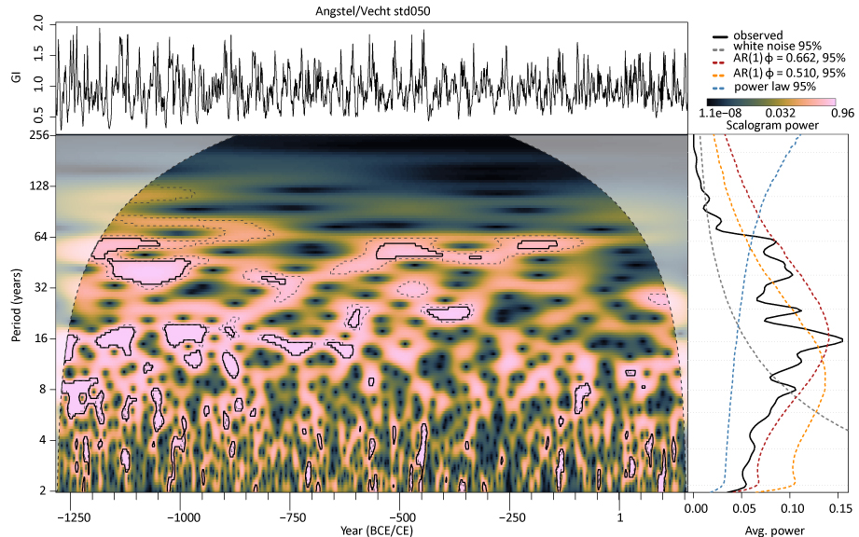
Figure 3. Wavelet analysis of the Angstel/Vecht growth index. Upper left, the growth index. Lower left, the CWT scalogram, with 95% contours under the AR(1) background fitted to the observed series (solid) and under the signal-corrected AR(1) background (dashed); the shaded area is the cone of influence, which is excluded from every statistic. Right, the CWT average spectral power (solid) with the 95th percentile of each of the four backgrounds (dashed). Power is normalised by the series variance.
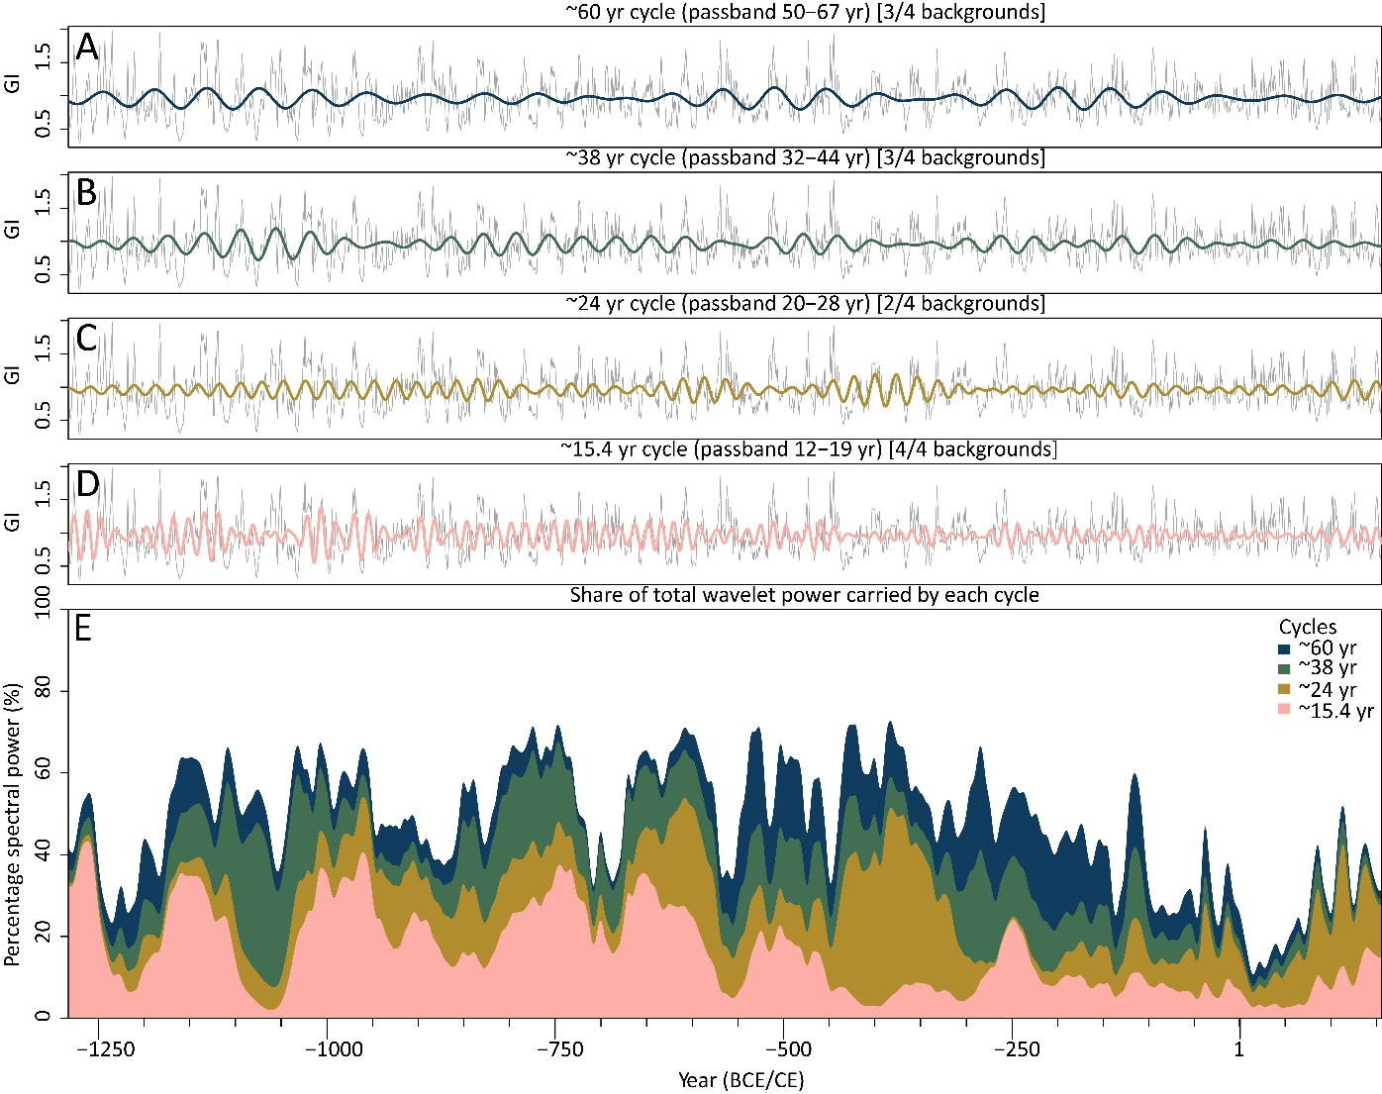
Figure 4. The cycles supported by at least three of the four background models and the borderline ~24-year cycle, extracted from the growth index (grey) by Taner bandpass filtering: A, ~60 years; B, ~38 years; C, ~24 years (borderline); D, ~15.4 years. The passband and the number of backgrounds under which each cycle is significant are given in the panel titles. E, share of total wavelet power carried by each cycle through time; years near the ends of the record, where most of the wavelet power lies inside the cone of influence, are not shown.

4.3 Persistence
A cycle that is present throughout the record is stronger evidence than one that appears only now and then, and red noise readily produces short bursts of high power. We therefore asked, for each period band, how long its power stays continuously above the 95% level of the background, and compared this with the longest stretches that red noise produces. Only the 32–64-year band lasts longer than red noise allows: its power stays elevated for 173 years without interruption, whereas the background produces at most 148 years (211 against 154 years under the signal-corrected background). The 16–32-year band is borderline. The ~16-year cycle, although the strongest in the spectrum, is short-lived: its longest uninterrupted stretch is 29 years, well within the 57 years that red noise routinely produces. Based on this we state that the record contains one sustained multidecadal band and one strong but episodic decadal cycle. The share of wavelet power carried by each cycle shows the same behaviour (Figure 4E). It undulates through the record rather than staying constant, which indicates that the cycles are amplitude-modulated and partly transient. The ~16-year cycle carries a large share of the power in some intervals, such as 1150–950 and 800–600 BCE, and almost none in others, such as 500–300 BCE, while the multidecadal cycles are present throughout but vary in strength, the ~60-year cycle being strongest between about 550 and 100 BCE. Such modulation is expected if part of the decadal structure arises from interaction between longer cycles (Section 4.5). A limitation of this result is that it depends on the test used: a second test, based on the total size of significant patches in the scalogram rather than on their duration, does not find any band significant. We therefore treat the persistence of the multidecadal band as supported but not established, and no conclusion in Section 5 rests on it alone. Full results are given in S3, and a run on the AR(1)-prewhitened series in S4.

4.4 A change in spectral organisation near 572 BCE
Figures 3 and 4E show that the balance between the multidecadal and decadal cycles changes through the record: before about 570 BCE the decadal cycles carry a large share of the wavelet power, and afterwards the multidecadal cycles dominate. The largest change in this balance occurs at 572 BCE. The same analysis on the variance-stabilised chronology and with four other detrending methods places it at 576–577 BCE, so the date does not depend on how we built the chronology. Red noise can produce a change of this size by chance, but at a random position in the record, so the reproducible date carries more weight than the size of the change (S9). We suggest that this change records the response of the Angstel/Vecht oaks to the end of the 2.8 ka event, the interval of wetter and cooler conditions in northwest Europe, between about 850 and 600 BCE, associated with the Homeric grand solar minimum (van Geel et al., 2014; Martin-Puertas et al., 2012; Harding et al., 2023). At the principal site, pollen records a shift to more rain-fed, acidic peat conditions around 650 BCE (Bazelmans et al., submitted), suggesting a change in carr hydrology at about the same time. A response of the carr to its own successional development cannot be excluded on the basis of this record alone.

4.5 Nonlinear interactions
The bicoherence results (Figure 5) indicate significant quadratic phase coupling between several components. Coupling of this kind is expected wherever a proxy responds nonlinearly to its forcing, and has been used to identify it in palaeoclimatic series (Hagelberg et al., 1991; Schultz et al., 2015). Two interactions are well enough resolved to infer: the 37.5-year cycle, the combination tone of the 1/60 + 1/100 yr⁻¹ cycles, and the 15.0-year cycle, the combination tone of 1/24 + 1/40 yr⁻¹. Synthesising each daughter by multiplying its band-passed parents, filtering the product at the sum frequency, and comparing it with the component extracted directly from the record (Figure 6) gives a moderate positive correlation for the 37.5-year component and a weak one for the 15.0-year component. The match is intermittent rather than continuous, holding over some multi-century intervals and failing in others. Three limitations bear on this result. First, the match is weak for the 15.0-year cycle, so for that component a nonlinear origin is possible but not demonstrated. Second, the ~100-year parent (107.6 years in Table 1) is not itself a significant feature of the spectrum, so the interaction generating the 37.5-year component should be read as involving low-frequency variability in the 64–128-year range rather than a demonstrated centennial cycle. Third, bicoherence is sensitive to non-stationarity and smoothing bandwidth, and it establishes phase coupling rather than causal direction. Within these limits, the analysis supports an internal origin for part of the decadal structure, arising from interaction between longer-period components rather than from an external oscillation of that period. On this reading, the episodic character of the ~16-year component is expected rather than anomalous.
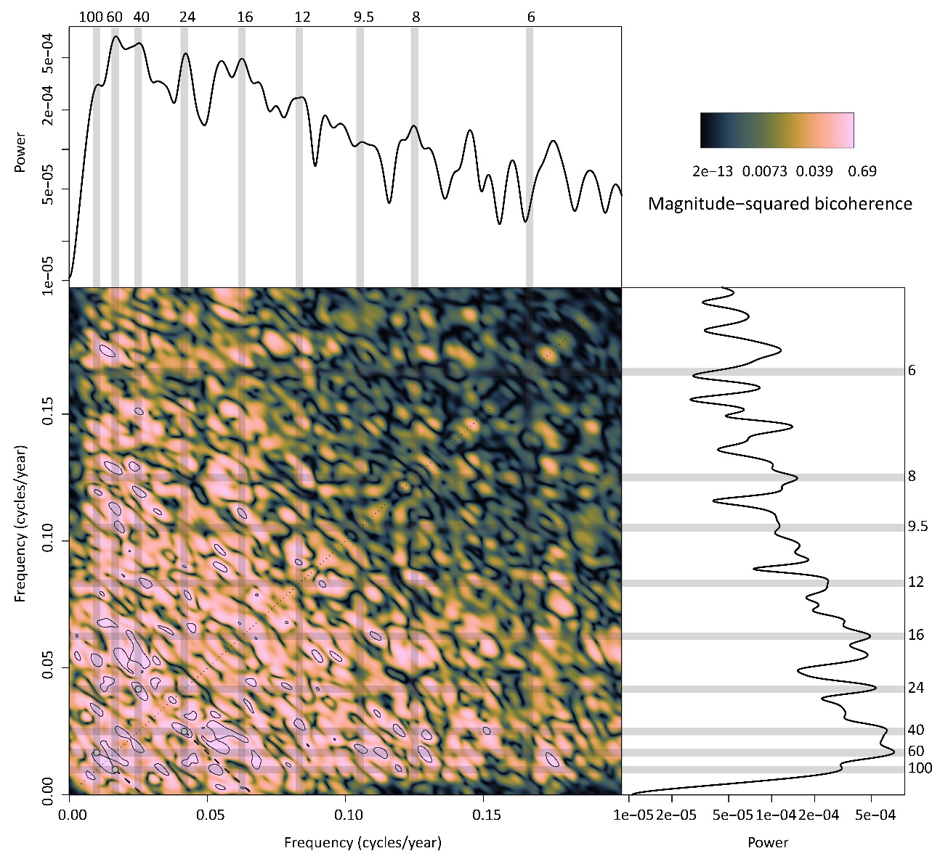
Figure 5. Magnitude-squared bicoherence of the growth index, estimated from 8 WOSA segments with 50% overlap and a conditioning factor set at the 75th percentile of the denominator; the contour is the 90% confidence level. Grey bands mark the frequencies of the components discussed in the text; dashed lines mark the two sum-frequency interactions presented in Figure 6.
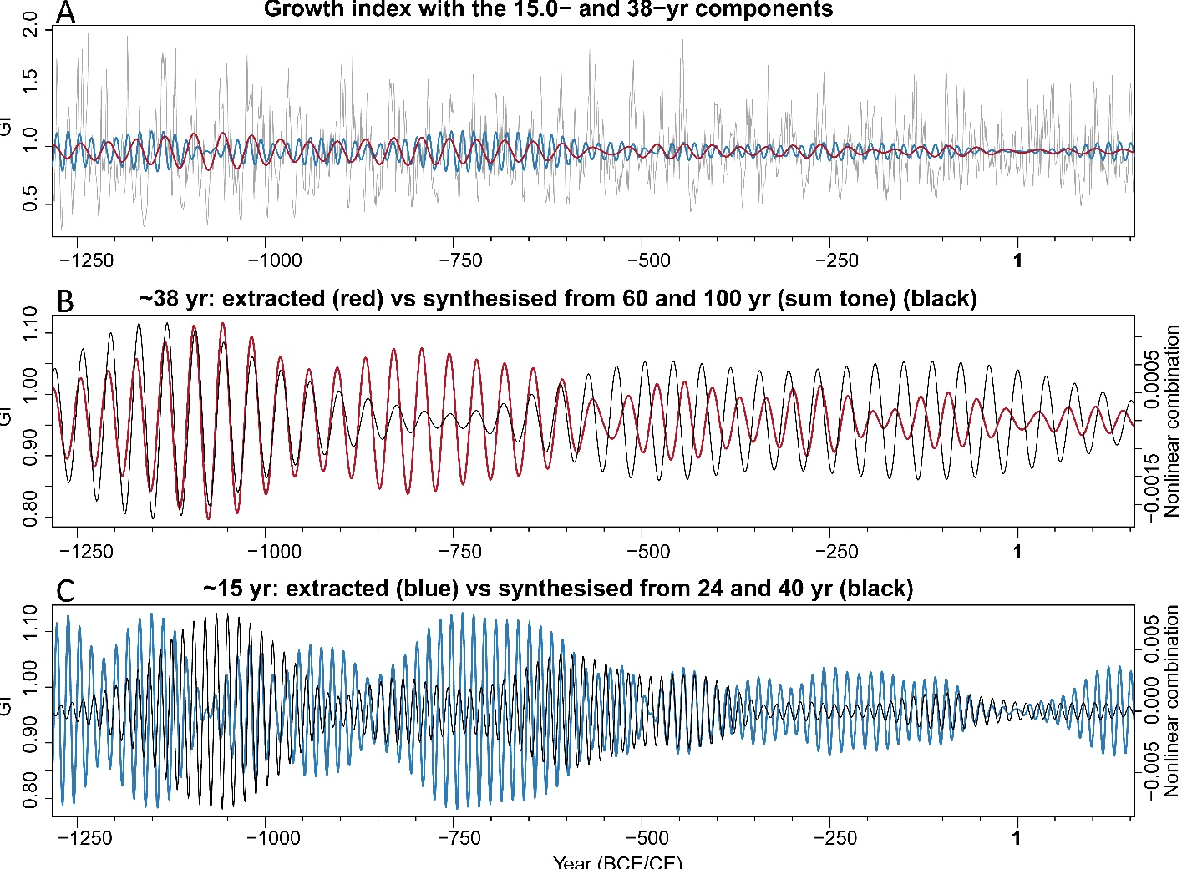
Figure 6. A, growth index with the 15.0- and 37.5-year components extracted directly from the record. B, the 37.5-year component extracted directly (red) and synthesised as the sum-frequency combination tone of the 60- and 100-year components (black). C, the same for the 15.0-year component and the 24- and 40-year parents.

4.6 Cross-wavelet comparison with the Uamh an Tartair stalagmite record
To better understand the climatic origin of the cycles in the Angstel/Vecht record, we compared it with the Uamh an Tartair stalagmite growth-rate record from northwest Scotland. Growth of these stalagmites is controlled by the water table in the overlying blanket peat and follows North Atlantic weather and precipitation; the composite record correlates negatively with the winter North Atlantic Oscillation (Proctor et al., 2000; Baker et al., 2011, 2015). The comparison covers 889 BCE–156 CE, the interval shared with the second archive in S8; the full overlap from 991 BCE gives the same result (S7). The cross-wavelet transform shows the highest shared power between about 30 and 64 years, and a secondary area of high power between about 8 and 30 years, where power and phase are more variable (Figure 7). In the 30–64-year band, the stalagmite record leads the oak record throughout. Near 60 years, where shared power is highest, the phase arrows point upward, a lead of about a quarter cycle; towards 30–40 years they rotate to the left and the lead approaches half a cycle. A phase that rotates with period in this way indicates a roughly constant delay in years rather than a constant fraction of the cycle, and a single delay of about 16 years describes the phase across the band better than any constant phase (S7). The oaks therefore lag the stalagmite record by roughly 16 to 19 years. The band-passed records confirm this relation (Figure S3). Shifted by this delay, the two records are positively correlated, and the relation holds through most of the record, strongly before about 700 BCE and after about 300 BCE and weakly in between. Without the shift, they appear negatively correlated, because a delay of 16 to 19 years is close to half a cycle at periods near 38 years. At periods shorter than 32 years, the records are not correlated. Against phase-randomised surrogates, the relation is at the margin of significance (S7). A limitation of Figure 7 is that cross-power is rectified by scale, which lowers the power at long periods and reduces the number of arrows drawn there; it does not affect the phase (S7).
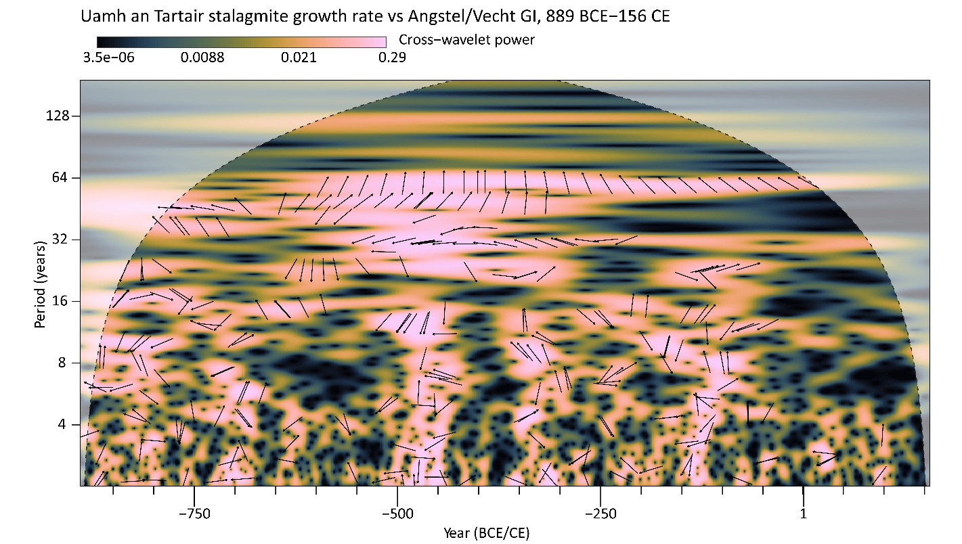
Figure 7. Cross-wavelet transform of the Uamh an Tartair stalagmite growth rate, northwest Scotland, and the Angstel/Vecht growth index, 889 BCE–156 CE. Phase arrows are placed on ridges of cross-power: an arrow pointing right means the records are in phase, left antiphase, and up that the stalagmite record leads by a quarter cycle. The arrows rotate from pointing left near 32–40 years to pointing upward near 60 years, the pattern produced by the stalagmite record leading by a roughly constant delay. The dashed curve is the cone of influence. The band-passed records and their running correlation are shown in Figure S3, and the same comparison with the Sawtooth Lake AMV index in Figure S4.

5. Discussion

5.1 What the record shows and how far it can be interpreted
The Angstel/Vecht record supports two statements about its own spectral structure, independently of any comparison. The first is that a band of multidecadal power, centred near 60 years with a secondary component near 38 years, is present through most of the chronology, although its strength varies, and is the only feature whose continuous expression a red background fitted to the record cannot reproduce. The second is that a component near 15.5 years carries the highest CWT average spectral power of any single peak, is significant under every background we tested, and yet is episodic. Both statements survive the controls that bear on them. The spectral structure is not a replication artefact, because a constant-replication chronology reproduces it and sample depth and running variance are not correlated (Section 4.1). It is not an artefact of detrending, because the position of the components is stable across five detrending strategies. Given these constraints, we interpret the multidecadal band and the ~15.5-year component as properties of the growth record rather than of its construction.
Taken with the bicoherence result, these two features describe a spectral architecture that is not a simple sum of external cycles. The strongest peak in the average spectral power, at ~15.5 years, is episodic and is placed by bicoherence at the sum frequency of longer-period components, although the synthesised tone reproduces it only weakly; the band that is robustly persistent, at 32–64 years, is the one whose period range matches slow oceanic variability. This is the pattern expected if slow boundary conditions modulate faster variability nonlinearly, and it is consistent with the threshold-like, cumulative growth response to waterlogging set out in Section 5.2. It also indicates that a peak in a tree-ring spectrum need not correspond to an external oscillation of the same period, which affects how we interpret spectral components.
Three limits set how far the record can be interpreted. The first is the frequency ceiling. Detrending is a high-pass filter applied before any spectral analysis, with a known frequency response that biases the ratio of low- to high-frequency power (Franke et al., 2013; Klesse, 2021); here it halves the amplitude of variability at a 128-year period, so the chronology contains no discernible centennial variability. At the other end, the 2- to 4-year band has less power than white noise, so it is not a feature of this record. The growth index is therefore informative over roughly one to six decades, and not outside that range.
The second limit is the background. The chronology is strongly autocorrelated, and whether a peak is significant depends on assumptions about the noise. A difference of 0.15 in the AR(1) coefficient, arising only from whether it is estimated before or after removing the candidate bands, moves the multidecadal components from clearly significant to not significant. Under the conventional AR(1) background, only the ~15.5-year component is significant; under the background estimated without the candidate bands, the ~38- and ~60-year components are significant as well, and the ~24-year component narrowly misses significance. The conventional background penalises multidecadal variance heavily even in records built to carry it: for example, the titanium-based Atlantic Multidecadal Variability index of South Sawtooth Lake, Ellesmere Island (Lapointe et al., 2020), a published reconstruction of Atlantic multidecadal variability, fails the same test against an AR(1) background fitted to itself (S8). The choice of spectral background is therefore itself a choice made by the analyst rather than a property of the data (Vaughan et al., 2011; Meyers, 2012). This is not a peculiarity of our record: the noise of a tree-ring chronology is itself red, arising from ontogeny and biological memory rather than from a climatic process (McPartland et al., 2024, 2025), so the white and AR(1) backgrounds conventionally used are not self-evidently the right ones. We therefore report the result under each background rather than against a single threshold (S2, S10).
The third limit is that trees do not respond to their environment in proportion to it. Oak growth increases with better conditions only up to a point, and beyond a threshold, such as a water table that is too high or too low, it declines. Because of this nonlinear response, two climatic cycles acting on the same trees can combine into new cycles in the growth record, which is why we used bicoherence rather than treating the record as a simple sum of external cycles. It also means that a strong cycle in the growth index does not necessarily reflect a strong cycle in the climate that drives it, so the size of a cycle in the record cannot be translated directly into the size of its cause.

5.2 A delayed response of the oaks to North Atlantic hydroclimate
The Uamh an Tartair stalagmites grow faster when the overlying blanket peat dries out, because a drier peat produces more soil CO₂, which makes the drip water more aggressive and increases calcite precipitation. High growth rates therefore mark dry conditions, and the record correlates negatively with the winter NAO, with a positive NAO indicating the wet phase in northwest Scotland (Proctor et al., 2000; Baker et al., 2011, 2015).
Our working hypothesis is that waterlogging limited oak growth in the delta: a high water table reduces root aeration and ring width, and drier phases allow wider rings (Sass-Klaassen and Hanraets, 2006). Floods and prolonged inundation act in the same direction from season to season (Copini et al., 2016; Jansma, 2020), but do not produce a spectral peak. Unlike the shallow blanket peat above the cave, the water table in the delta is coupled to regional groundwater and Rhine discharge and responds to precipitation over years to decades. The hypothesis therefore predicts that oak growth peaks some time after the driest intervals recorded by the stalagmite. Based on Section 4.6, we state that this is what we observe: across the multidecadal band, oak growth follows the stalagmite record with a delay of roughly 16 to 19 years, whereas a water table that favoured growth when high would produce the opposite phase. We therefore interpret the multidecadal variability in the growth index as a delayed response to North Atlantic hydroclimate, mediated by the slow response of the groundwater table in the peatland. A limitation of this interpretation is that a constant dating offset of 16 to 19 years between the dendrochronologically dated chronology and the lamina-counted stalagmite composite (Baker et al., 2015) would produce the same signature, and the comparison cannot exclude it. In addition, the relation is at the margin of significance and weak between about 700 and 300 BCE; the water balance of the delta depends on Rhine discharge from central Europe and the Alps, which need not follow northwest Scotland (Steirou et al., 2017); and because positive NAO phases are mild as well as wet, a temperature control cannot be excluded.

5.3 Linking cycles to climatic oscillations
A cycle with the same period as a known climate pattern is not necessarily caused by it. Unrelated processes can produce similar periods, and in a wetland the local hydrology, peat growth and forest dynamics have rhythms of their own. We therefore discuss the cycles in order of how well they are supported, using the Uamh an Tartair stalagmite record as the only independent check available.
The multidecadal band, with its main cycle near 60 years and a secondary cycle near 38 years, is the best candidate for a climatic origin, for three reasons. Its period range matches the 50–70-year band commonly reported for the Atlantic Multidecadal Oscillation (AMO; Delworth and Mann, 2000; Knudsen et al., 2011; Schlesinger and Ramankutty, 1994). It is also the band whose sustained presence red noise reproduces least easily (Section 4.3). Finally, it follows the Uamh an Tartair stalagmite record with a consistent delay of roughly 16 to 19 years (Section 4.6), and a published AMV index shows a positive relation with it at about 35 to 52 years (S8). Based on these observations, we state that the band is consistent with multidecadal North Atlantic variability of AMO type, possibly modulated by solar forcing. This link, however, is not demonstrated. The origin of the AMO itself is debated, as an internal oscillation of the ocean or a response to external forcing such as clustered volcanic eruptions (Mann et al., 2021; Michel et al., 2022), and the peatland and its groundwater system may generate multidecadal variability of their own. A single site cannot separate these possibilities.
For the decadal cycles, the case is weaker. The ~15.5-year cycle is the most robust peak in the spectrum, but it is episodic, and the bicoherence places it at the sum frequency of the ~24- and ~40-year cycles. Because the synthesised combination tone matches the observed cycle only weakly, a nonlinear origin is possible but not demonstrated. The ~24-year cycle is borderline, significant under two of the four backgrounds and narrowly missing a third, and the ~11.7-year cycle is marginal. Their periods lie close to the Hale and Schwabe solar cycles, but the correspondence is not exact, and their support is too weak to attribute them. Cycles shorter than 8 years are not supported, and the 2–4-year band carries less power than white noise, so we cannot attribute these cycles to a specific process. Cycles of about 80 years and longer cannot be separated from red noise, are reduced by detrending, and are, as such, not interpreted.
Taken together, the Angstel/Vecht record shows that lowland bog oaks register North Atlantic hydroclimate on multidecadal timescales, but with a delay of roughly two decades and filtered through the slow response of the peatland water table. This has two consequences for similar archives. First, a direct, in-phase comparison with climate records will underestimate the link, because the relation only becomes clear once the delay is considered. Second, the cycles in such a record are shaped by the response of the trees and their environment, so their periods and amplitudes cannot be read directly as those of the climate that drives them.

6. Conclusions
The Angstel/Vecht bog-oak chronology is a well-replicated, annually resolved record of lowland hydroclimate for 1283 BCE–156 CE. Its cycles are not an artefact of how the chronology was built: a chronology with exactly 40 trees in every year, and a variance-stabilised chronology, give practically the same spectrum.
The record contains cycles of ~15.5, ~38 and ~60 years, which are significant against most of the background models tested, and a borderline ~24-year cycle. The ~60-year cycle is the most persistent, while the ~15.5-year cycle is the strongest but episodic, and the strength of all four cycles varies through time. Cycles of 8 years or shorter and of 80 years or longer cannot be separated from noise and are not interpreted. Bicoherence indicates that the ~15- and ~38-year cycles may be combination tones of longer cycles, which suggests that part of the cyclicity is generated by the nonlinear response of the trees rather than imposed directly by climate. Near 572 BCE the balance between the multidecadal and decadal cycles changes, at a date that is reproducible across chronologies and detrending methods, and which we tentatively link to the end of the 2.8 ka event.
Compared with the Uamh an Tartair stalagmite record from northwest Scotland, oak growth lags the stalagmite throughout the multidecadal band by roughly 16 to 19 years, about a quarter cycle near 60 years. This agrees with our working hypothesis that waterlogging limited oak growth in the delta: rainfall slowly raised the groundwater table, so oak growth peaked about two decades after the driest intervals recorded in Scotland. A dating offset between the two archives would produce the same pattern and cannot yet be excluded. The Angstel/Vecht chronology therefore shows that absolutely dated subfossil bog oaks from lowland wetlands, spanning more than a millennium, can serve as archives of past North Atlantic hydroclimate, provided that the trees' delayed, nonlinear response and their peatland setting are considered when interpreting their cycles.

Data availability
The three chronologies analysed here, and the diagnostic series (sample depth, running R̄, running variance, EPS) are provided as supplementary data, together with all analysis code. The underlying ring-width measurements are described in Bazelmans et al. (XXX). The two comparison records are publicly archived and were used as published, with no recalibration: the Uamh an Tartair composite growth-rate record of Baker et al. (2015) at (https://www.ncei.noaa.gov/pub/data/paleo/speleothem/europe/scotland/tartair2015sucomp.txt), and the South Sawtooth Lake annual titanium and AMVI reconstruction of Lapointe et al. (2020) at DOI 10.25921/emsg-na26.

Supplementary material
S1 Chronology quality, replication and the constant-replication experiment. S2 Background models and the full significance tables. S3 Area-wise (persistence) test. S4 Prewhitening sensitivity. S5 Robustness across the three chronologies. S6 Detrending sensitivity. S7 Comparison with the Uamh an Tartair record: cross-wavelet conventions, phase by period, band-pass correlation and significance. S8 The Sawtooth Lake AMV index: its own band significance and the like-for-like comparison. S9 The transition near 572 BCE and its test against red noise. S10 Spectral background models and the criteria for accepting a cycle. S11 Code and data, including the R script, are at https://github.com/stratigraphy/Weesp-dendro-cycles.

References
Ait Brahim Y, Wassenburg JA, Cruz FW, Sifeddine A, Scholz D, Bouchaou L et al. (2018) Multi-decadal to centennial hydro-climate variability and linkage to solar forcing in the Western Mediterranean during the last 1000 years. Scientific Reports 8(1): 17446. https://doi.org/10.1038/s41598-018-35498-x
Arts M (2023) WaverideR: Extracting Signals from Wavelet Spectra. R package. https://doi.org/10.32614/CRAN.package.WaverideR
Arts M, Corradini C, Pondrelli M, Pas D and Da Silva A-C (2024) Age and orbital forcing in the upper Silurian Cellon section (Carnic Alps, Austria) uncovered using the WaverideR R package. Frontiers in Earth Science 12: 1357751. https://doi.org/10.3389/feart.2024.1357751
Baker A, Hellstrom JC, Kelly BFJ, Mariethoz G and Trouet V (2015) A composite annual-resolution stalagmite record of North Atlantic climate over the last three millennia. Scientific Reports 5(1): 10307. https://doi.org/10.1038/srep10307
Baker A, Wilson R, Fairchild IJ, Franke J, Spötl C, Mattey D et al. (2011) High resolution δ18O and δ13C records from an annually laminated Scottish stalagmite and relationship with last millennium climate. Global and Planetary Change 79(3-4): 303–311. https://doi.org/10.1016/j.gloplacha.2010.12.007
Baldini LM, McDermott F, Foley AM and Baldini JUL (2008) Spatial variability in the European winter precipitation δ18O‐NAO relationship: Implications for reconstructing NAO‐mode climate variability in the Holocene. Geophysical Research Letters 35(4): 2007GL032027. https://doi.org/10.1029/2007gl032027
Bazelmans J et al. (submitted) [Angstel/Vecht chronology NLBOG26: full reference to be completed by the authors].
Börgel F, Frauen C, Neumann T and Meier HEM (2020) The Atlantic Multidecadal Oscillation controls the impact of the North Atlantic Oscillation on North European climate. Environmental Research Letters 15(10): 104025. https://doi.org/10.1088/1748-9326/aba925
Bos IJ, Feiken H, Bunnik F and Schokker J (2009) Influence of organics and clastic lake fills on distributary channel processes in the distal Rhine–Meuse delta (The Netherlands). Palaeogeography, Palaeoclimatology, Palaeoecology 284(3-4): 355–374. https://doi.org/10.1016/j.palaeo.2009.10.017
Brönnimann S, Franke J, Valler V, Hand R, Samakinwa E, Lundstad E et al. (2025) Past hydroclimate extremes in Europe driven by Atlantic jet stream and recurrent weather patterns. Nature Geoscience 18(3): 246–253. https://doi.org/10.1038/s41561-025-01654-y
Bunn AG (2008) A dendrochronology program library in R (dplR). Dendrochronologia 26(2): 115–124. https://doi.org/10.1016/j.dendro.2008.01.002
Choudhury MAAS, Shah SL and Thornhill NF (2008) Bispectrum and bicoherence. In: Diagnosis of Process Nonlinearities and Valve Stiction: Data Driven Approaches. Advances in Industrial Control. Berlin: Springer, pp. 29–41. https://doi.org/10.1007/978-3-540-79224-6_3
Coder KD (1994) Flood Damage to Trees. Forest Resources Publication FOR94-61. Athens, GA: University of Georgia Cooperative Extension Service.
Cook ER and Peters K (1981) The smoothing spline: A new approach to standardizing forest interior tree-ring width series for dendroclimatic studies. Tree-Ring Bulletin 41: 45–53. http://hdl.handle.net/10150/261038
Cook ER, D'Arrigo RD and Briffa KR (1998) A reconstruction of the North Atlantic Oscillation using tree-ring chronologies from North America and Europe. The Holocene 8(1): 9–17. https://doi.org/10.1191/095968398677793725
Copini P, den Ouden J, Robert EMR, Tardif JC, Loesberg WA, Goudzwaard L et al. (2016) Flood-Ring Formation and Root Development in Response to Experimental Flooding of Young Quercus robur Trees. Frontiers in Plant Science 7: 775. https://doi.org/10.3389/fpls.2016.00775
Delworth TL and Mann ME (2000) Observed and simulated multidecadal variability in the Northern Hemisphere. Climate Dynamics 16(9): 661–676. https://doi.org/10.1007/s003820000075
Dieppois B, Durand A, Fournier M and Massei N (2013) Links between multidecadal and interdecadal climatic oscillations in the North Atlantic and regional climate variability of northern France and England since the 17th century. Journal of Geophysical Research: Atmospheres 118(10): 4359–4372. https://doi.org/10.1002/jgrd.50392
Frank D, Esper J and Cook ER (2007) Adjustment for proxy number and coherence in a large‐scale temperature reconstruction. Geophysical Research Letters 34(16): L16709. https://doi.org/10.1029/2007gl030571
Franke J, Frank D, Raible CC, Esper J and Brönnimann S (2013) Spectral biases in tree-ring climate proxies. Nature Climate Change 3(4): 360–364. https://doi.org/10.1038/nclimate1816
Hagelberg T, Pisias N and Elgar S (1991) Linear and nonlinear couplings between orbital forcing and the marine δ18O record during the Late Neocene. Paleoceanography 6(6): 729–746. https://doi.org/10.1029/91pa02281
Harding P, Martin-Puertas C, Sjolte J, Walsh AA, Tjallingii R, Langdon C et al. (2023) Wind regime changes in the Euro-Atlantic region driven by Late-Holocene Grand Solar Minima. Climate Dynamics 60(7-8): 1947–1961. https://doi.org/10.1007/s00382-022-06388-w
Hijma MP and Cohen KM (2019) Holocene sea-level database for the Rhine-Meuse Delta, The Netherlands: Implications for the pre-8.2 ka sea-level jump. Quaternary Science Reviews 214: 68–86. https://doi.org/10.1016/j.quascirev.2019.05.001
Hubeny JB, King JW and Santos A (2006) Subdecadal to multidecadal cycles of Late Holocene North Atlantic climate variability preserved by estuarine fossil pigments. Geology 34(7): 569–572. https://doi.org/10.1130/g22671a.1
Hurrell JW (1995) Decadal Trends in the North Atlantic Oscillation: Regional Temperatures and Precipitation. Science 269(5224): 676–679. https://doi.org/10.1126/science.269.5224.676
Hurrell JW, Kushnir Y, Ottersen G and Visbeck M (2003) An overview of the North Atlantic Oscillation. In: Hurrell JW, Kushnir Y, Ottersen G and Visbeck M (eds) The North Atlantic Oscillation: Climatic Significance and Environmental Impact. Geophysical Monograph 134. Washington, DC: American Geophysical Union, pp. 1–35. https://doi.org/10.1029/134GM01
Jansma E (2020) Hydrological disasters in the NW-European Lowlands during the first millennium AD: a dendrochronological reconstruction. Netherlands Journal of Geosciences 99: e11. https://doi.org/10.1017/njg.2020.10
Kelly PM, Leuschner HH, Briffa KR and Harris IC (2002) The climatic interpretation of pan-European signature years in oak ring-width series. The Holocene 12(6): 689–694. https://doi.org/10.1191/0959683602hl582rp
Kim YC and Powers EJ (1979) Digital bispectral analysis and its applications to nonlinear wave interactions. IEEE Transactions on Plasma Science 7(2): 120–131. https://doi.org/10.1109/TPS.1979.4317207
Klesse S (2021) Critical note on the application of the “two-third” spline. Dendrochronologia 65: 125786. https://doi.org/10.1016/j.dendro.2020.125786
Knudsen MF, Seidenkrantz M-S, Jacobsen BH and Kuijpers A (2011) Tracking the Atlantic Multidecadal Oscillation through the last 8,000 years. Nature Communications 2(1): 178. https://doi.org/10.1038/ncomms1186
Lapointe F, Bradley RS, Francus P, Balascio NL, Abbott MB, Stoner JS et al. (2020) Annually resolved Atlantic sea surface temperature variability over the past 2,900 y. Proceedings of the National Academy of Sciences 117(44): 27171–27178. https://doi.org/10.1073/pnas.2014166117
Leuschner HH, Sass-Klaassen U, Jansma E, Baillie MGL and Spurk M (2002) Subfossil European bog oaks: population dynamics and long-term growth depressions as indicators of changes in the Holocene hydro-regime and climate. The Holocene 12(6): 695–706. https://doi.org/10.1191/0959683602hl584rp
Liu Y, Liang XS and Weisberg RH (2007) Rectification of the Bias in the Wavelet Power Spectrum. Journal of Atmospheric and Oceanic Technology 24(12): 2093–2102. https://doi.org/10.1175/2007jtecho511.1
Mann ME and Lees JM (1996) Robust estimation of background noise and signal detection in climatic time series. Climatic Change 33(3): 409–445. https://doi.org/10.1007/bf00142586
Mann ME, Steinman BA, Brouillette DJ and Miller SK (2021) Multidecadal climate oscillations during the past millennium driven by volcanic forcing. Science 371(6533): 1014–1019. https://doi.org/10.1126/science.abc5810
Maraun D and Kurths J (2004) Cross wavelet analysis: significance testing and pitfalls. Nonlinear Processes in Geophysics 11(4): 505–514. https://doi.org/10.5194/npg-11-505-2004
Maraun D, Kurths J and Holschneider M (2007) Nonstationary Gaussian processes in wavelet domain: Synthesis, estimation, and significance testing. Physical Review E 75(1): 016707. https://doi.org/10.1103/PhysRevE.75.016707
Martin-Puertas C, Matthes K, Brauer A, Muscheler R, Hansen F, Petrick C et al. (2012) Regional atmospheric circulation shifts induced by a grand solar minimum. Nature Geoscience 5(6): 397–401. https://doi.org/10.1038/ngeo1460
McPartland MY, Dolman AM and Laepple T (2024) Separating Common Signal From Proxy Noise in Tree Rings. Geophysical Research Letters 51(13): e2024GL109282. https://doi.org/10.1029/2024gl109282
McPartland MY, Münch T, Dolman AM, Hébert R and Laepple T (2025) The colors of proxy noise. Climate of the Past 21(11): 1917–1931. https://doi.org/10.5194/cp-21-1917-2025
Meyers SR (2012) Seeing red in cyclic stratigraphy: Spectral noise estimation for astrochronology. Paleoceanography 27(3): PA3228. https://doi.org/10.1029/2012pa002307
Meyers SR (2014) astrochron: An R Package for Astrochronology. R package. https://doi.org/10.32614/CRAN.package.astrochron
Michel SLL, Swingedouw D, Ortega P, Gastineau G, Mignot J, McCarthy G et al. (2022) Early warning signal for a tipping point suggested by a millennial Atlantic Multidecadal Variability reconstruction. Nature Communications 13(1): 5176. https://doi.org/10.1038/s41467-022-32704-3
Murphy JO, Sampson H, Veblen TT and Villalba R (1994) Regression Model for the 22-year Hale Solar Cycle Derived from High Altitude Tree-ring Data. Publications of the Astronomical Society of Australia 11(2): 157–163. https://doi.org/10.1017/s1323358000019822
Olsen J, Anderson NJ and Knudsen MF (2012) Variability of the North Atlantic Oscillation over the past 5,200 years. Nature Geoscience 5(11): 808–812. https://doi.org/10.1038/ngeo1589
Pinto JG and Raible CC (2012) Past and recent changes in the North Atlantic oscillation. WIREs Climate Change 3(1): 79–90. https://doi.org/10.1002/wcc.150
Proctor CJ, Baker A and Barnes WL (2002) A three thousand year record of North Atlantic climate. Climate Dynamics 19(5–6): 449–454. https://doi.org/10.1007/s00382-002-0236-x
Proctor CJ, Baker A, Barnes WL and Gilmour MA (2000) A thousand year speleothem proxy record of North Atlantic climate from Scotland. Climate Dynamics 16(10-11): 815–820. https://doi.org/10.1007/s003820000077
R Core Team (2024) R: A Language and Environment for Statistical Computing. Vienna: R Foundation for Statistical Computing. https://www.R-project.org/
Roig FA, Barriopedro D, García Herrera R, Patón Domínguez D and Monge S (2009) North Atlantic Oscillation signatures in western Iberian tree-rings. Geografiska Annaler: Series A, Physical Geography 91(2): 141–157. https://doi.org/10.1111/j.1468-0459.2009.00360.x
Rust W, Cuthbert M, Bloomfield J, Corstanje R, Howden N and Holman I (2020) Exploring the role of hydrological pathways in modulating North Atlantic Oscillation (NAO) teleconnection periodicities from UK rainfall to streamflow. Hydrology and Earth System Sciences Discussions. https://doi.org/10.5194/hess-2020-312
Sass-Klaassen U and Hanraets E (2006) Woodlands of the past – The excavation of wetland woods at Zwolle-Stadshagen (the Netherlands): Growth pattern and population dynamics of oak and ash. Netherlands Journal of Geosciences - Geologie en Mijnbouw 85(1): 61–71. https://doi.org/10.1017/s0016774600021429
Schlesinger ME and Ramankutty N (1994) An oscillation in the global climate system of period 65–70 years. Nature 367(6465): 723–726. https://doi.org/10.1038/367723a0
Schultz JA, Beck C, Menz G, Neuwirth B, Ohlwein C and Philipp A (2015) Sensitivity of proxies on non-linear interactions in the climate system. Scientific Reports 5(1): 18560. https://doi.org/10.1038/srep18560
Šimůnek V, Hájek V, Prokůpková A and Gallo J (2021) Finding an imprint of solar and climatic cycles in tree rings of European beech (Fagus sylvatica L.). Journal of Forest Science 67(9): 409–419. https://doi.org/10.17221/94/2020-JFS
Steirou E, Gerlitz L, Apel H and Merz B (2017) Links between large-scale circulation patterns and streamflow in Central Europe: A review. Journal of Hydrology 549: 484–500. https://doi.org/10.1016/j.jhydrol.2017.04.003
Taner MT (2000) Attributes revisited. Technical Publication. Houston, TX: Rock Solid Images.
Thomson DJ (1982) Spectrum estimation and harmonic analysis. Proceedings of the IEEE 70(9): 1055–1096. https://doi.org/10.1109/proc.1982.12433
Trouet V, Esper J, Graham NE, Baker A, Scourse JD and Frank DC (2009) Persistent Positive North Atlantic Oscillation Mode Dominated the Medieval Climate Anomaly. Science 324(5923): 78–80. https://doi.org/10.1126/science.1166349
Van Asselen S, Cohen KM and Stouthamer E (2017) The impact of avulsion on groundwater level and peat formation in delta floodbasins during the middle-Holocene transgression in the Rhine-Meuse delta, The Netherlands. The Holocene 27(11): 1694–1706. https://doi.org/10.1177/0959683617702224
Van der Woude JD (1984) The fluviolagoonal palaeoenvironment in the Rhine/Meuse deltaic plain. Sedimentology 31(3): 395–400. https://doi.org/10.1111/j.1365-3091.1984.tb00867.x
Van Dinter M, Cohen KM, Hoek WZ, Stouthamer E, Jansma E and Middelkoop H (2017) Late Holocene lowland fluvial archives and geoarchaeology: Utrecht's case study of Rhine river abandonment under Roman and Medieval settlement. Quaternary Science Reviews 166: 227–265. https://doi.org/10.1016/j.quascirev.2016.12.003
van Geel B, Heijnis H, Charman DJ, Thompson G and Engels S (2014) Bog burst in the eastern Netherlands triggered by the 2.8 kyr BP climate event. The Holocene 24(11): 1465–1477. https://doi.org/10.1177/0959683614544066
Vaughan S, Bailey RJ and Smith DG (2011) Detecting cycles in stratigraphic data: Spectral analysis in the presence of red noise. Paleoceanography 26(4): PA4211. https://doi.org/10.1029/2011pa002195
Vos P, van der Meulen M, Weerts H and Bazelmans J (2018) Atlas van Nederland in het Holoceen: Landschap en bewoning vanaf de laatste ijstijd tot nu. Amsterdam: Prometheus.
Vos P, van der Meulen M, Weerts H and Bazelmans J (2020) Atlas of the Holocene Netherlands: Landscape and Habitation since the Last Ice Age. Amsterdam: Amsterdam University Press. https://doi.org/10.5117/9789463724432
Weerts H, Cleveringa P and Gouw M (2002) De Vecht/Angstel, een riviersysteem in het veen. Grondboor & Hamer 56(3/4): 66–71.
Welch PD (1967) The use of fast Fourier transform for the estimation of power spectra: A method based on time averaging over short, modified periodograms. IEEE Transactions on Audio and Electroacoustics 15(2): 70–73. https://doi.org/10.1109/tau.1967.1161901
Wigley TML, Briffa KR and Jones PD (1984) On the Average Value of Correlated Time Series, with Applications in Dendroclimatology and Hydrometeorology. Journal of Climate and Applied Meteorology 23(2): 201–213. https://doi.org/10.1175/1520-0450(1984)023<0201:otavoc>2.0.co;2

