Supplementary Material
A nearly 1.5 millennia long record of North Atlantic climatic forcing recorded in tree-ring growth records from the Angstel/Vecht Delta, the Netherlands (1283 BCE–156 CE)
Michiel Arts and Jos Bazelmans
This document contains the methodological specification and the complete result tables underlying Section 3 and Section 4 of the main text. Section numbers S1–S11 are referred to from the main text.

S1. Chronology quality, replication and the constant-replication experiment
We computed sample depth, running interseries correlation (R̄) over a 101-year window, and the expressed population signal (EPS; Wigley et al., 1984) for every year of the chronology. Over the analysis window (1283 BCE–156 CE), sample depth ranges from 10 to 106 series (median 68), running R̄ from 0.19 to 0.50 (mean 0.36), and EPS exceeds 0.85 in 98.2% of years (median 0.97). Within the 1209–40 BCE sample, depth is 40–106 (median 72), and EPS exceeds 0.94 throughout.
Because the variance of a mean chronology depends on sample depth and on interseries correlation, changing replication can in principle generate apparent changes in variance and hence in wavelet power. Three treatments were applied. (i) Variance stabilisation following Frank et al. (2007), as implemented in dplR::chron.stabilised with a 101-year running R̄ and a biweight robust mean (vsc101). (ii) Constant replication: over 1209–40 BCE, where every year has at least 40 dated series, exactly 40 series were drawn at random for each year, repeated 1000 times, and the median chronology retained (constant40); sample depth in this chronology is constant by construction. (iii) The same 1000 draws provide an empirical distribution of the chronology and of its running variance.
The direct diagnostic runs opposite to the artefact that might be expected: the correlation between sample depth and the 101-year running variance of the chronology is r = +0.04 over the analysis window, and between sample depth and running R̄ r = +0.16 (r² ≈ 0.03). Variance stabilisation reduces mean 101-year running variance from 0.081 to 0.066 (about 19%), while preserving its temporal structure (r = 0.93 between the two running-variance series) and the chronology itself (r = 0.996 between std050 and vsc101).
Figure S1 shows sample depth, running variance, EPS and wavelet power together, so that their relationship can be judged directly. The correlation between sample depth and mean wavelet power in the 32–64-year band (the band interpreted in the main text) is r = +0.31 over the analysis window. It is positive: intervals with more trees carry slightly more multidecadal power, not less, which is again the opposite of the direction a replication artefact would produce. The correlation between the 101-year running variance and the same band power is r = +0.71, as expected, since band power is a component of total variance.
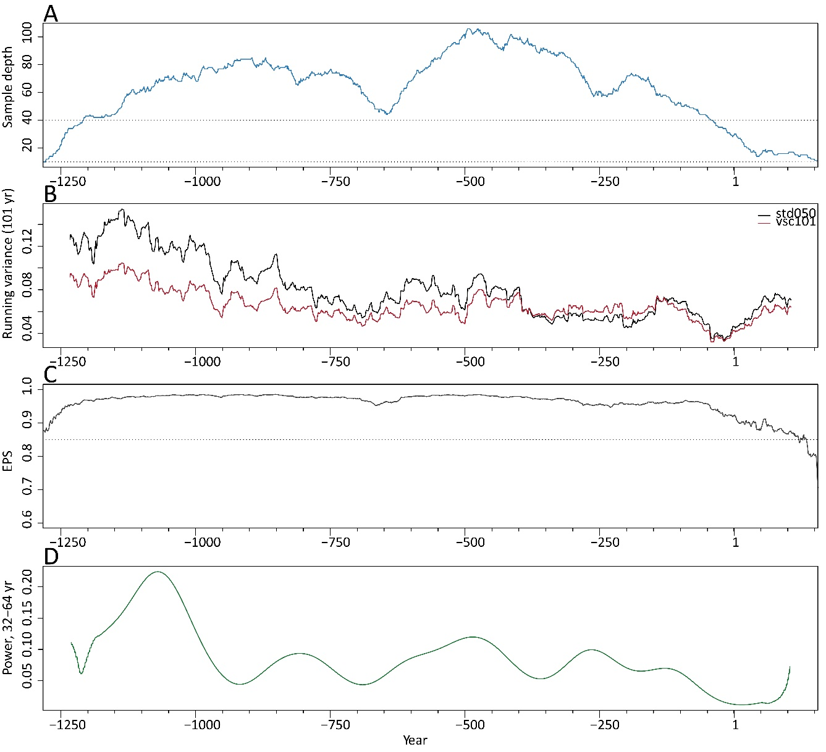s
Figure S1. A, sample depth. B, 101-year running variance of the original (black) and variance-stabilised (red) chronology. C, EPS, computed from sample depth and the 101-year running R̄. D, mean wavelet power in the 32–64-year band (ω₀ = 10, rectified by scale), using cells outside the cone of influence only. All panels share the time axis 1283 BCE–156 CE; dotted lines mark n = 10 and 40 and EPS = 0.85.

S2. Background models and the full significance tables
We characterised persistence before any spectral test. An AR(1) model fitted over the analysis window gives φ = 0.662; the Ljung–Box statistic on its residuals at lag 20 is not significant (p = 0.29) and AIC does not favour AR(2), so a first-order process adequately describes the background persistence.
Wavelet power is rectified by scale throughout (Liu et al., 2007). The raw wavelet power spectrum is biased towards long periods, and for this record the bias is large: unrectified, the average spectral power rises monotonically into the multidecadal range and peaks near 60 years, whereas rectified it peaks near 16 years. Because rectification is a per-scale constant, it cancels exactly in the pointwise tests and enters the band tests only through the relative weighting of periods within a band; the verdicts of Tables S2 and S6 are unchanged by it. One related pitfall is worth recording: the power-law exponent β must be fitted to an unrectified spectrum, here the multitaper spectrum. When fitted to the rectified wavelet power, it comes out negative (i.e., blue noise), under which every long period appears significant.
The supplementary suite uses ω₀ = 6 and dj = 1/20, which makes the full factorial of three chronologies, two windows, a prewhitened series and four backgrounds tractable; the main text uses the parameters of the published figures (ω₀ = 10, dj = 1/100). The two parameterisations give the same verdicts: for the components that matter, p = 0.024 versus 0.034 (~15.5 yr, AR(1) φ = 0.662), 0.086 versus 0.11 (~60 yr) and 0.18 versus 0.20 (~38 yr).
Four background models were used, each generating surrogates with the same length, mean and variance as the observed chronology, so that only the shape of the background spectrum differs:
N0, white noise. N1, AR(1) with φ = 0.662 estimated from the observed chronology, the conventional choice. N2, AR(1) with φ estimated after the candidate cycle bands (±10% in period) have been notched out of the Fourier spectrum, giving φ = 0.510. N3, a power law P(f) ∝ f −β with β = 0.948 fitted by log–log regression to the multitaper spectrum outside those bands (the main analysis, with its own multitaper estimate, obtains β = 1.151; Table 1 of the main text).
The rationale for N2 is that φ estimated from a series containing coherent periodic variance is inflated by that variance, so that the background is raised at exactly the frequencies under test. One practical caveat: the notch list must exclude bands close to the Nyquist frequency. Including the 2.2-year band removes high-frequency variance and therefore raises the lag-1 correlation of what remains (φ = 0.633 rather than 0.510), which is the opposite of the correction's purpose. Only the mid-band candidates (3.6–110 years) are removed.
Significance is reported at three levels. Pointwise significance compares observed power at a given period with the surrogate distribution at that period. Maximum-in-band significance compares the largest observed power within a band, or within a ±10% period window around a candidate periodicity, with the distribution of corresponding surrogate maxima, accounting for the band search. Area-wise significance is described in S3. In this supplementary suite, we used 2,000 surrogates for tests of average spectral power and 1,000 surrogate fields for local tests.
Table S1. Background parameters for each chronology and window. φ observed is estimated on the chronology itself; φ signal-corrected after the candidate bands are notched out; β is the power-law exponent fitted outside those bands.
Series | φ observed | φ signal-corrected | β power law
std050 (1283 BCE-156 CE) | 0.662 | 0.510 | 0.948
std050 (1209-40 BCE) | 0.683 | 0.521 | 0.971
vsc101 (1209-40 BCE) | 0.677 | 0.513 | 0.958
constant40 (1209-40 BCE) | 0.683 | 0.522 | 0.972
std050 prewhitened (phi = 0.662) | 0.024 | -0.241 | -0.085

Table S2. CWT average spectral power at ω₀ = 6: probability that the observed maximum within a ±10% period window is exceeded under each background (2000 surrogates; std050, 1283 BCE–156 CE).
Candidate (yr) | Observed peak (yr) | White | AR(1) φ=0.662 | AR(1) φ=0.510 | Power law
3.6 | 3.7 | 1.00 | 0.60 | 1.00 | 0.038
5.9 | 6.3 | 1.00 | 0.40 | 0.99 | <0.001
8.0 | 8.0 | 0.10 | 0.39 | 0.93 | <0.001
12.0 | 13.0 | <0.001 | 0.13 | 0.15 | <0.001
15.4 | 15.5 | <0.001 | 0.024 | 0.003 | <0.001
24.0 | 23.4 | <0.001 | 0.64 | 0.10 | <0.001
38.0 | 39.4 | <0.001 | 0.18 | 0.003 | <0.001
60.0 | 55.7 | <0.001 | 0.086 | <0.001 | <0.001
80.0 | 73.5 | <0.001 | 0.79 | 0.29 | 0.96
110.0 | 100.4 | 0.004 | 0.93 | 0.65 | 1.00

Table S3. As in Table S2, for the multitaper spectrum.
Candidate (yr) | Observed peak (yr) | White | AR(1) φ=0.662 | AR(1) φ=0.510 | Power law
3.6 | 3.5 | 1.00 | 0.33 | 0.98 | <0.001
5.9 | 5.8 | 0.96 | 0.48 | 0.93 | <0.001
8.0 | 8.1 | 0.17 | 0.35 | 0.71 | <0.001
12.0 | 12.0 | <0.001 | 0.46 | 0.50 | <0.001
15.4 | 15.9 | <0.001 | 0.052 | 0.015 | <0.001
24.0 | 24.1 | <0.001 | 0.28 | 0.051 | <0.001
38.0 | 41.8 | <0.001 | 0.21 | 0.015 | <0.001
60.0 | 55.4 | <0.001 | 0.098 | <0.001 | 0.002
80.0 | 73.1 | <0.001 | 0.62 | 0.16 | 0.88
110.0 | 102.4 | <0.001 | 0.89 | 0.55 | 1.00

Table S4. Maximum-in-band test for the six pre-registered octave bands (CWT average spectral power at ω₀ = 6, std050).
Band (yr) | Peak period (yr) | White | AR(1) φ=0.662 | AR(1) φ=0.510 | Power law
2-4 | 3.7 | 1.00 | 0.64 | 1.00 | 0.059
4-8 | 7.7 | 1.00 | 0.27 | 0.98 | <0.001
8-16 | 15.5 | <0.001 | 0.029 | 0.031 | <0.001
16-32 | 16.0 | <0.001 | 0.048 | 0.003 | <0.001
32-64 | 39.4 | <0.001 | 0.27 | 0.008 | <0.001
64-128 | 64.0 | <0.001 | 0.30 | 0.013 | 0.29

Table S5 gives an independent cross-check of the wavelet result with the multitaper method, computed in astrochron (Meyers, 2014) with a time-bandwidth product of 3 and five-fold zero padding. Two backgrounds are used: the robust red-noise estimate of Mann and Lees (1996), which fits an AR(1) process to a median-smoothed version of the spectrum and so is less affected by the peaks under test than a fit to the raw spectrum; and a power law fitted by the same package. REDFIT (Schulz and Mudelsee, 2002) is not used because it handles unevenly sampled series, and this chronology is evenly sampled at one year throughout. The harmonic F-test column produced by the same routines is reported for completeness. Still, we do not use it for any verdict, since it tests for a pure sinusoid rather than excess power over a stochastic background. These confidence levels are pointwise and not corrected for searching the spectrum, which is why the short-period entries stand high; the corrected verdicts are in Tables S2 and S3.
Table S5. Multitaper cross-check. Confidence level of the local maximum within ±10% of each candidate period, against a robust red-noise background and against a fitted power law.
Candidate (yr) | MTM peak (yr) | Robust red noise (%) | Power law (%) | Harmonic F (%)
2.2 | 2.09 | 99.7 | 99.3 | 99.8
3.6 | 3.67 | 98.9 | 96.9 | 99.5
5.9 | 5.69 | 98.2 | 99.0 | 98.5
8.0 | 8.31 | 99.6 | 100.0 | 99.8
12.0 | 11.76 | 98.7 | 99.9 | 98.6
15.4 | 16.06 | 99.9 | 100.0 | 97.1
24.0 | 23.44 | 99.9 | 100.0 | 95.4
38.0 | 36.53 | 99.6 | 98.7 | 97.8
60.0 | 56.66 | 100.0 | 97.5 | 99.9
80.0 | 82.71 | 66.1 | 70.6 | 94.5
110.0 | 116.06 | 55.1 | 12.7 | 95.0

The two long-period candidates behave differently from the rest. At 80 and 110 years, the multitaper estimate reaches only 66% and 55% against a robust red background, and 71% and 13% against a power law, whereas every component between 15 and 60 years exceeds 97.5% against both. The multitaper and wavelet estimators handle the background differently, so their agreement on this point carries more weight than either alone.

S3. Area-wise (persistence) test
Under any red background, a scalogram contains isolated patches of pointwise-significant power by construction (Maraun and Kurths, 2004), so the percentage of pointwise-significant cells is not evidence on its own. The statistic used here is the longest continuous run of years in which the band-mean wavelet power exceeds the 95th percentile of the background, evaluated only over years in which the entire band lies outside the cone of influence; the p-value is the proportion of surrogate fields whose longest run equals or exceeds the observed one. One thousand surrogate fields were generated per background.
Table S6. Area-wise test, std050, 1283 BCE–156 CE. For each background: longest observed run (yr), 95th percentile of surrogate runs (yr), and p-value.
Band (yr) | Years outside COI | White: run / p95 / p | AR(1) 0.662: run / p95 / p | AR(1) 0.510: run / p95 / p | Power law: run / p95 / p
2-4 | 1431 | 0 / 12 / 1.00 | 14 / 13 / 0.043 | 6 / 12 / 0.94 | 15 / 12 / 0.013
4-8 | 1423 | 19 / 20 / 0.081 | 23 / 22 / 0.050 | 20 / 22 / 0.098 | 25 / 22 / 0.023
8-16 | 1409 | 44 / 37 / 0.018 | 23 / 38 / 0.48 | 21 / 38 / 0.57 | 85 / 37 / <0.001
16-32 | 1379 | 207 / 64 / <0.001 | 22 / 64 / 0.83 | 36 / 60 / 0.43 | 146 / 67 / <0.001
32-64 | 1319 | 517 / 105 / <0.001 | 168 / 105 / 0.006 | 209 / 107 / 0.001 | 204 / 102 / 0.001
64-128 | 1199 | 218 / 180 / 0.030 | 42 / 173 / 0.45 | 91 / 183 / 0.27 | 0 / 170 / 1.00

Only the 32–64-year band passes under a red background. At ω₀ = 6 the observed run is 168 years against a background 95th percentile of 105 years (p = 0.006 under φ = 0.662) and 209 against 107 years (p = 0.001 under φ = 0.510); at the ω₀ = 10 parameters of the main text the corresponding figures are 173 against 148 years (p = 0.025) and 211 against 154 years (p = 0.015). The 2–4 and 4–8-year bands are borderline under φ = 0.662 at ω₀ = 6 (p = 0.043 and 0.050) but not under any other combination, and are not interpreted.
This test is one of several possible cluster statistics, and the result is not invariant to the choice. A test based on the total area of contiguous patches of pointwise-significant power, applied independently to the same record by one of us, does not reach significance for any band. The longest-run statistic used here asks whether elevated band power is sustained; a patch-area statistic asks whether significant patches are unusually large in the time-period plane. They disagree at the margin for the 32–64-year band, and the main text treats its persistence as supported but not established.

S4. Prewhitening sensitivity
The chronology was prewhitened with its AR(1) coefficient (φ = 0.662; residual φ = 0.02) and the whole analysis repeated. Prewhitening removes variance in proportion to the AR(1) transfer function at every frequency, so the absolute power of the low-frequency components necessarily drops; the question is whether the peaks survive relative to the now-white background.
Table S7. CWT average spectral power of the AR(1)-prewhitened chronology: p-values for the maximum within a ±10% period window under each background.
Candidate (yr) | White | AR(1) fitted to residuals | AR(1) signal-corrected | Power law
3.6 | 0.39 | 0.30 | 0.71 | 0.70
5.9 | 0.51 | 0.58 | <0.001 | 0.47
8.0 | 0.24 | 0.36 | <0.001 | 0.038
12.0 | 0.47 | 0.59 | <0.001 | 0.14
15.4 | 0.062 | 0.12 | <0.001 | <0.001
24.0 | 0.60 | 0.71 | 0.013 | 0.26
38.0 | 0.23 | 0.28 | <0.001 | <0.001
60.0 | 0.100 | 0.12 | <0.001 | <0.001
80.0 | 0.77 | 0.80 | 0.25 | 0.62
110.0 | 0.93 | 0.94 | 0.62 | 0.90

The ~16-year component remains significant against a white background (p = 0.038) and borderline against an AR(1) background fitted to the prewhitened residuals (p = 0.072). The ~41- and ~58-year components remain significant against the signal-corrected and power-law backgrounds (p < 0.001) but not against white noise (p = 0.12 and 0.14), as expected when removing the variance that carries them.

S5. Robustness across the three chronologies
Over the constant-replication window (1209–40 BCE), the CWT average spectral power of the three chronologies correlates at r > 0.9999 (std050 versus constant40) and r = 0.996 (vsc101 versus each of the other two; Figure S2). The estimated persistence is essentially unchanged (φ = 0.683, 0.677 and 0.683; Table S1). Because this window excludes the two end segments with fewer than 40 series (1283–1210 BCE and 39 BCE–156 CE), it also checks that the spectral results do not rest on those segments. Against the AR(1) background fitted to the series, the core window gives the same verdict as the full window (Table 1 of the main text): the ~15.4-year component is significant, the ~38- and ~60-year components fall short of the 5% level, and the components at 80 years and longer are not distinguishable from noise (Table S8).
Table S8. p-values for the maximum CWT average spectral power within a ±10% period window, against an AR(1) background fitted to each series in turn, for the three chronologies over 1209–40 BCE.
Candidate (yr) | std050 | vsc101 | constant40 (n = 40)
12.0 | 0.070 | 0.087 | 0.074
15.4 | 0.012 | 0.026 | 0.015
24.0 | 0.55 | 0.45 | 0.53
38.0 | 0.082 | 0.097 | 0.076
60.0 | 0.14 | 0.071 | 0.13
80.0 | 0.79 | 0.78 | 0.78
110.0 | 0.98 | 0.99 | 0.98

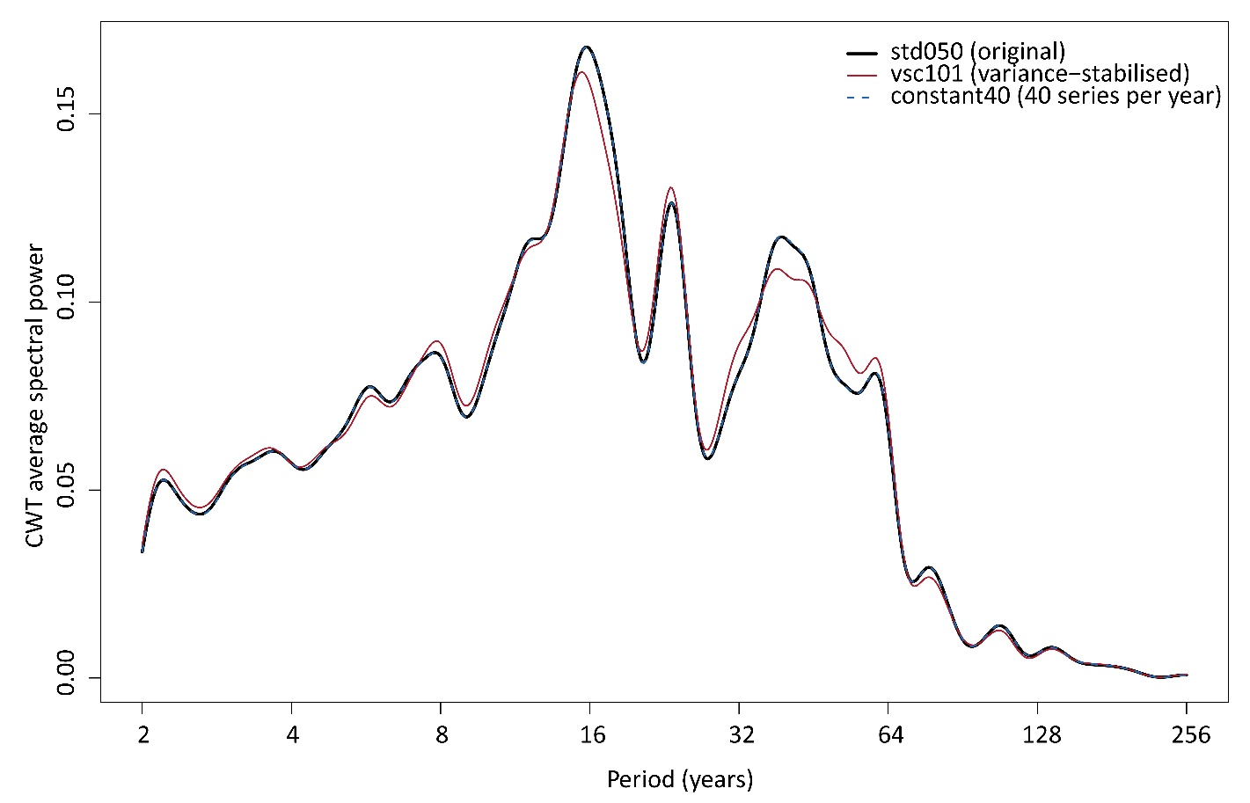
Figure S2. CWT average spectral power (ω₀ = 10, rectified by scale) over 1209–40 BCE for the original chronology (black), the variance-stabilised chronology (red) and the constant-replication chronology with exactly 40 series per year (blue, dashed). The original and constant-replication curves are superimposed.

S6. Detrending sensitivity
The chronology was rebuilt under five detrending strategies, and each was carried through the full spectral analysis: the primary spline with a 50% frequency cut-off at min(128, 0.67 × N) years; a 67%-of-series-length spline without the 128-year cap; a fixed 200-year spline; a spline at 100% of series length; and a modified negative exponential curve.
All five show the spectral structure between 8 and 64 years. The fixed 200-year and 100%-of-length variants retain more variance above 64 years, as their frequency response implies, but the additional power there does not reach significance against any red background. The features interpreted in the main text are therefore not products of the standardisation choice, and the features not interpreted do not become interpretable under a different one.
The frequency response of the primary spline is itself a constraint on interpretation: with a 50% cut-off at min(128, 0.67 × N) years and a median spline length of 117.5 years, the amplitude of 128 years is halved and attenuation increases rapidly beyond it. This is an argument, independent of any significance test, for not interpreting centennial periodicities in this record.

S7. Comparison with the Uamh an Tartair record
The comparison record is the composite normalised annual growth-rate series of Baker et al. (2015), which spans 991 BCE–2004 CE at annual resolution. Its climatic sense is fixed by the published site interpretation. It is used here as such: lamina thickness is controlled by the water table in the overlying blanket peat, so that dry intervals (a lower water table, more aerobic decomposition, higher soil CO₂, more aggressive drip water) give thick laminae, and wet intervals thin ones; high growth rates reflect warm and/or dry conditions, low growth rates cool and moist conditions, and the composite correlates negatively with the winter NAO index (r = −0.46, p < 0.01) (Baker et al., 2011, 2015; Proctor et al., 2000).
The cross-wavelet transform is computed as in WaverideR: the cross-spectrum W₁W₂* is rectified by scale, power is its modulus, the average cross-wavelet power is the time mean at each period, and phase arrows are placed on ridges (local maxima of cross-power along the period axis), above the 80th percentile of power. Figure 7 in the main text shows this transform for the stalagmite record, and Figure S4A shows it for the Sawtooth record. Because cross-power is rectified by scale, it is lowered at long periods in proportion to period, so fewer ridges, and therefore fewer arrows, are drawn there. The rectification does not affect the phase: with and without it, the phase in each period band agrees to within 1–3°.
Band-passed to 32–64 years over 889 BCE–156 CE, the growth index and the stalagmite growth rate correlate at r = −0.373 at zero lag (Figure S3A). Tested against 20,000 surrogates of the stalagmite record generated by randomising its Fourier phases, which preserves its spectrum and therefore its autocorrelation exactly, the two-sided p-value is 0.054. In a 201-year running window, the sign holds through 95% of the record, with a median of −0.44, strongest before about 700 BCE and after about 300 BCE (Figure S3B). In the 16–32 and 8–16-year bands, the zero-lag correlations are r = +0.01 and −0.20. The comparison does not depend on the poorly replicated final segment. Restricted to 889–40 BCE, where the chronology has at least 40 series in every year, the zero-lag correlations are r = −0.37 for 32–64 years, −0.57 for 32–48 years and −0.12 for 48–80 years, against −0.37, −0.57 and −0.17 over the full window (Tables S11–S12). The reversal of the running correlation in the last ~150 years (Figure S3B) falls in the segment with fewer than 40 series.
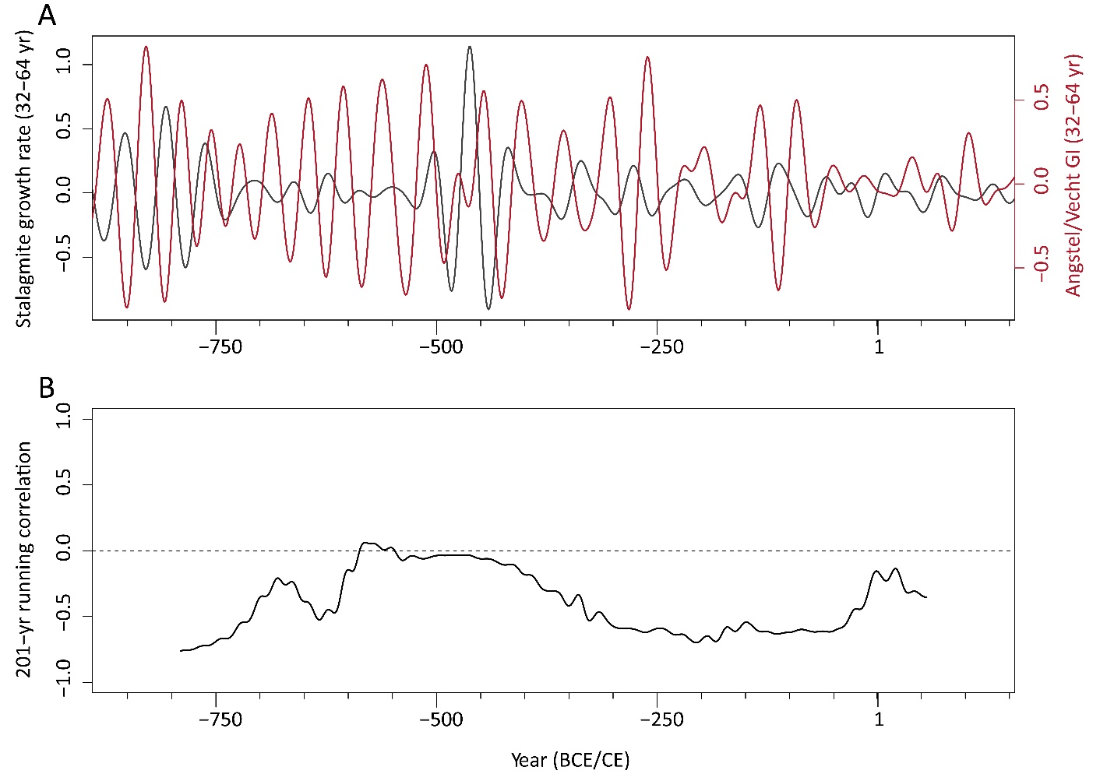
Figure S3. A, the Uamh an Tartair stalagmite growth rate (left axis) and the Angstel/Vecht growth index (right axis), both band-pass filtered to 32–64 years, 889 BCE–156 CE. B, their correlation in a 201-year running window; dashed line zero.
Phase read from cross-power alone is not a stable quantity for these two records, and the statistics of the plotted arrows show why.
Table S9—circular statistics of the phase on the plotted cross-power ridges, by band. R is the mean resultant length (1 = perfectly concentrated, 0 = uniform).
Band (yr) | Ridge cells | Mean phase | R
8–16 | 1758 | +173° | 0.16
16–32 | 1559 | −119° | 0.12
32–64 | 1976 | +128° | 0.57
64–128 | 42 | +152° | 0.98 (few cells)

A positive phase means that the first record of the pair, here the stalagmite, leads. In the 32–64-year band the mean phase, +128°, lies between a quarter cycle and antiphase, with only moderate concentration; at shorter periods the distribution is close to uniform. The moderate concentration is not scattered around one value. This arises because the phase rotates with period, from about +100° near 60 years to about +150° to +180° near 30–40 years (Table S11), producing a pattern in the stalagmite record with a roughly constant delay. The band mean of +128° averages over that rotation.
We considered wavelet coherence to sharpen this but decided not to report it. Coherence requires a smoothing operator in time and scale whose width is a free choice; it is bounded above by one and saturates wherever that window is short, so that apparent coherence can be produced by the smoothing itself; and its null distribution has to be constructed from surrogate pairs, which reintroduces exactly the background-model dependence that Section 3.3 of the main text makes explicit. For the question actually at issue (whether the two records move together or in opposition in a given band), a band-pass filter and a correlation answer it directly and can be checked by any reader.
The main text reports this comparison on the window shared by the two comparison records, 889 BCE–156 CE. Over the longer window the stalagmite record shares with the chronology, 991 BCE–156 CE (1148 years), the 32–64-year band-pass correlation is r = −0.32 at zero lag, negative through 96% of a 201-year running window with a median of −0.51, and the cross-correlation is most negative (−0.34) when the growth index leads by 2 years (Table S10). The two windows therefore give the same picture, and the common window is used in the main text only so that the two comparison records are treated alike.
Table S10. Correlation between the band-pass filtered records over their 1148-year overlap. Taner filters, passbands as given; lags searched within ±32 years, positive when the growth index leads.
Band (yr) | r at zero lag | Most negative r (lag, yr) | Most positive r (lag, yr)
8–16 | −0.13 | −0.19 (+10) | +0.17 (+15)
16–32 | +0.05 | −0.24 (−30) | +0.23 (−19)
32–64 | −0.32 | −0.34 (+2) | +0.42 (−19)

Only the 32–64-year band shows a clear relation. The strongest negative cross-correlation occurs at 2 years, and the strongest positive at −19 years. Both follow from the same lag. The strongest positive correlation, with the stalagmite record leading by 18–19 years, is the delay itself; a delay of this length is close to half a cycle near 38 years, which makes the band-passed records appear negatively correlated at zero lag. In the two shorter bands, the strongest correlations at any lag stay below 0.25 in absolute value and change sign between neighbouring lags, as band-limited series without a shared signal do.
Table S11—cross-wavelet phase resolved by period, common window 889 BCE–156 CE. Phase is the power-weighted mean over all cells outside the cone of influence; positive when the first-named record leads.
Period (yr) | Stalagmite × GI phase | Sawtooth × GI phase | Mean cross-power, stalagmite × GI
28–32 | −176° | +7° | 0.036
32–36 | −168° | −62° | 0.030
36–40 | +155° | +12° | 0.024
40–44 | −151° | +2° | 0.027
44–48 | +117° | −12° | 0.032
48–52 | +56° | +11° | 0.041
52–56 | +74° | +107° | 0.037
56–60 | +104° | +49° | 0.057
60–64 | +104° | −14° | 0.061
64–70 | +105° | −150° | 0.028

Table S12—band-pass correlation with the growth index in two sub-bands of the multidecadal band, common window. Lags are positive when the growth index leads; maximum |r| searched within ±20 years. p is two-sided against 20,000 phase-randomised surrogates of the comparison record. We divided at 48 years after inspecting the phase, so these p-values are descriptive.
Pair, sub-band | r at zero lag (p) | Most negative r (lag) | Most positive r (lag) | Max |r| over lags (p)
Stalagmite, 32–48 yr | −0.57 (0.015) | −0.57 (+1) | +0.55 (−18) | 0.57 (0.068)
Stalagmite, 48–80 yr | −0.17 (0.575) | −0.49 (+12) | +0.49 (−18) | 0.49 (0.065)
Sawtooth, 32–48 yr | +0.36 (0.111) | −0.36 (+19) | +0.36 (−1) | 0.36 (0.340)
Sawtooth, 48–80 yr | +0.10 (0.743) | −0.17 (−28) | +0.11 (+3) | 0.13 (0.976)

Based on Tables S11 and S12, we state that the stalagmite record leads the growth index throughout the multidecadal band by about a quarter cycle near 60 years and closer to half a cycle near 30–40 years, with considerable variation between neighbouring periods. A single delay fitted to the cross-wavelet phase between 28 and 70 years, weighted by cross-power, is 16 years; it describes the phase better than any constant phase (mean cosine of the residual phase 0.61 against 0.47). In the 32–80-year band, the largest lagged correlation is r = +0.42, with the stalagmite record leading by 18 years, and p = 0.047 against 20,000 phase-randomised surrogates of the stalagmite record, with the test including lags of ±30 years. In both sub-bands of Table S12, the strongest positive correlation falls at a stalagmite lead of 18 years. In the stalagmite record, oak growth peaks about 16 to 19 years after the driest intervals at Uamh an Tartair. A water table that promotes oak growth when high would place the stalagmite record behind, and is excluded. A constant dating offset of the same size between the two archives would produce the same phase rotation and period, and cannot be excluded from the comparison itself. Against the Sawtooth record, the growth index is close to in phase at about 36–52 years and shows neither a consistent phase nor a correlation near 60 years. The zero-lag stalagmite correlation for the shorter sub-band is the only sub-band result below p = 0.05, and because the sub-bands were defined after inspecting the phase, it should not be read as confirmatory.

S8. The Sawtooth Lake AMV index
The Atlantic Multidecadal Variability Index of Lapointe et al. (2020) is derived from annual X-ray-fluorescence titanium in the varved sediments of South Sawtooth Lake, Ellesmere Island (79.351°N, 83.952°W), with a chronology built on varve counts and constrained by palaeomagnetic inclination, OSL, Cs-137 and Pb-210. It spans 889 BCE to 2011 CE at annual resolution. It was downloaded from NOAA NCEI (dataset DOI 10.25921/emsg-na26) and is used exactly as archived. In that file, the AMVI_rec column is an exact linear rescaling of the titanium column (r = −1.000 to three decimals), so the two columns carry identical information; we use only AMVI_rec, which fixes the sign convention as published and removes any need to choose one. The overlap with the Angstel/Vecht chronology is 889 BCE–156 CE, 1046 years, with no missing years.
The maximum-in-band significance of the Sawtooth record itself over that window was computed with exactly the procedure applied to the Angstel/Vecht chronology in S2 (Table S13): the same rectified Morlet transform, the same four backgrounds fitted to the record being tested, and 1000 surrogates per background.
Table S13. Maximum-in-band p-values for the Sawtooth Lake AMVI over 889 BCE–156 CE, against four backgrounds fitted to that record. The record is published as an index of Atlantic multidecadal variability, yet its 32–64-year band is not distinguishable from an AR(1) process fitted to itself.
Band | Peak period (yr) | White | AR(1) φ = 0.685 | AR(1) φ = 0.644 | Power law β = 1.17
8–16 yr | 13 | 0.095 | 0.935 | 0.972 | 0.000
16–32 yr | 26 | 0.000 | 0.963 | 0.941 | 0.000
32–64 yr | 32 | 0.000 | 0.961 | 0.915 | 0.290

Band-pass correlations over the common window are reported for all three pairings (Table S14). We test each correlation against 20,000 surrogates of the first-named record generated by randomising its Fourier phases, which preserves its power spectrum (and therefore its autocorrelation) while destroying any relation to the second record. All three rows, and the values shown in Figures S3 and S4, come from a single run of the analysis script (S11). These are Monte Carlo estimates: an earlier run with 2000 surrogates returned p = 0.038 for the first row rather than 0.054, which is the scale of the sampling error at that count and is the reason the larger count is used here. The archived script is seeded, so it returns the tabulated values exactly.
Table S14. Band-pass correlations over the common window 889 BCE–156 CE.
Pair (32–64 yr band-pass) | r | Two-sided p
Uamh an Tartair growth rate vs Angstel/Vecht GI | −0.373 | 0.054
Sawtooth AMVI vs Angstel/Vecht GI | +0.308 | 0.092
Uamh an Tartair vs Sawtooth AMVI | −0.046 | 0.786

The absence of a relation between the two comparison records is expected: the Uamh an Tartair growth rate is calibrated against the winter NAO and the Sawtooth titanium against Atlantic sea surface temperature, and the NAO and AMV are distinct modes. It does mean that the two comparisons constitute independent tests rather than two views of one signal.
Against the Sawtooth record, using the same statistic over the same window, the growth index is positively correlated in the 32–64-year band (r = +0.31), with the 201-year running correlation holding its sign through 93% of the overlap and a median of +0.45 (Figure S4). The two-sided p-value against 20,000 phase-randomised surrogates is 0.092. The relation sits in the shorter part of the band: the phase is close to zero between about 36 and 52 years, and band-passed to 32–48 years the correlation is r = +0.36, whereas above about 52 years the phase changes from one period to the next and the correlation is near zero (r = +0.10 for 48–80 years; Tables S11–S12). A limitation of the comparison is the reversal of the running correlation in the final ~150 years of the overlap, which we attribute to the chronology's low replication in that interval (Figure S4).
The Sawtooth record also directly shows what the significance thresholds at issue do. It is published as an index of Atlantic multidecadal variability, yet it is subjected to the maximum-in-band test against an AR(1) background fitted to itself, the same test applied to our chronology; its 32–64-year band returns p = 0.96 and its 16–32-year band p = 0.96. In contrast, every band is significant against white noise and against a power law (Table S13). The test would therefore decline to find multidecadal variability in a record whose stated purpose is to carry it. This does not refute the test, which performs as designed; it measures how far the answer depends on the background, and on that basis we report a range of backgrounds rather than a single verdict.
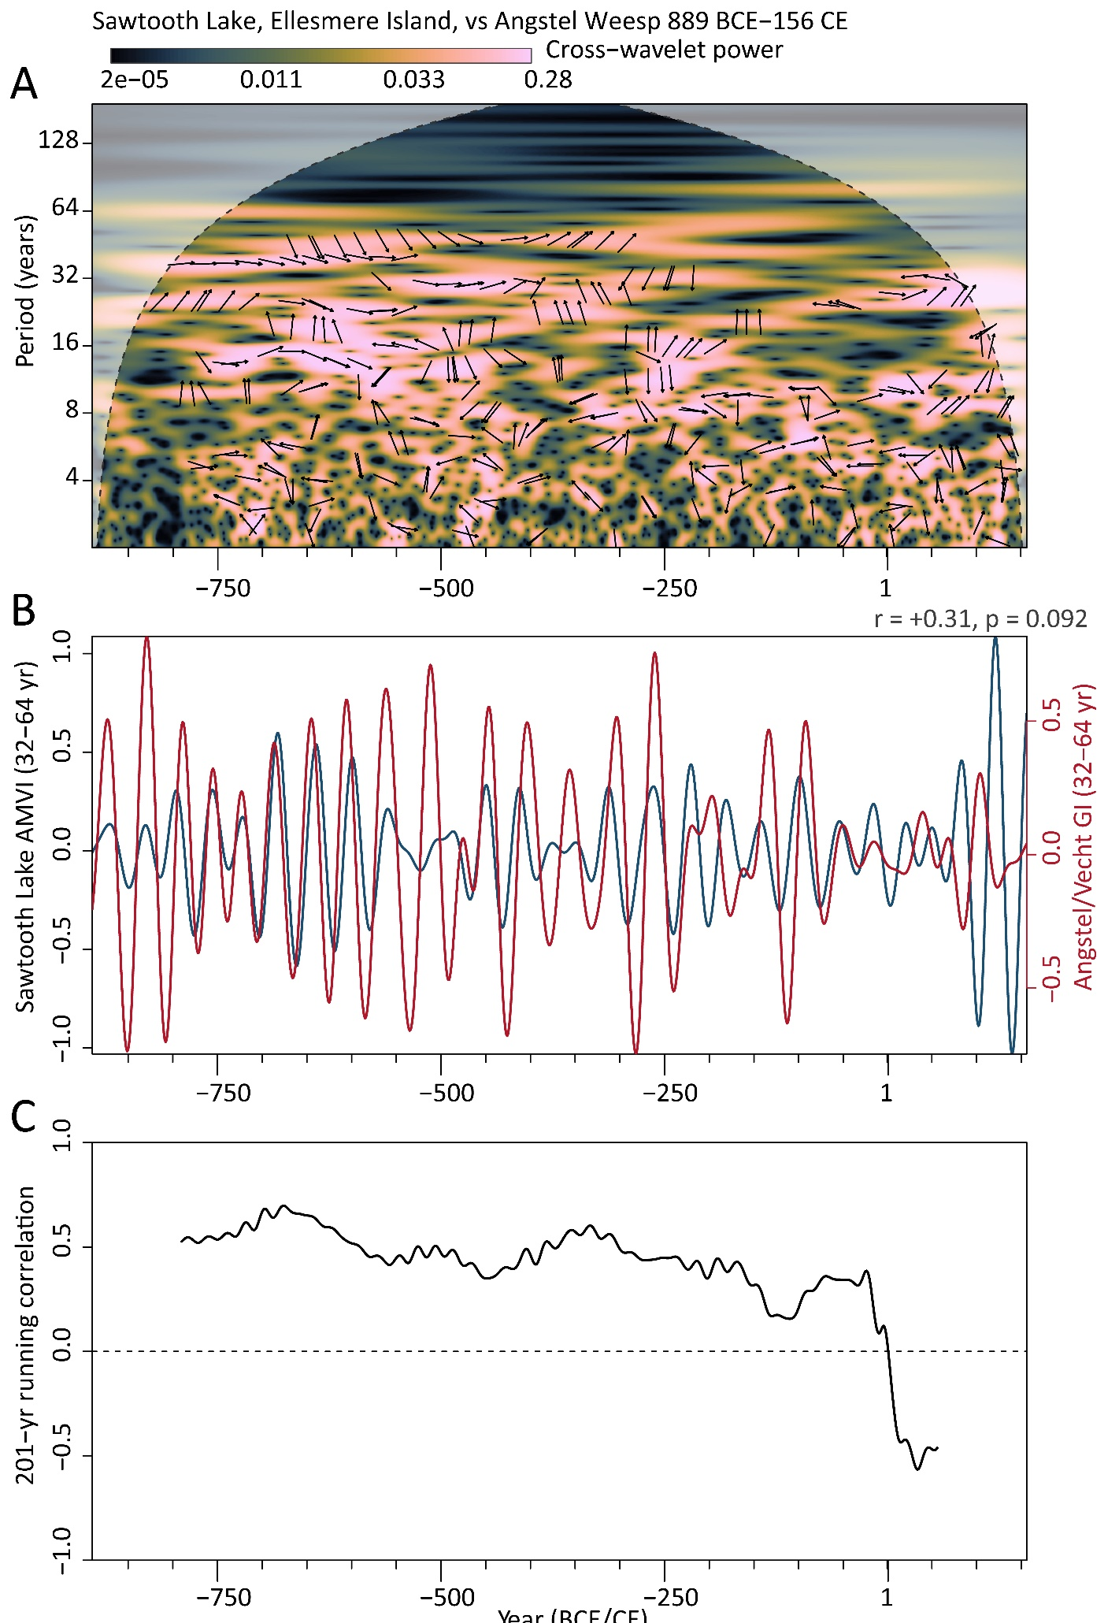
Figure S4. Comparison of the Angstel/Vecht growth index with the Sawtooth Lake AMV index, 889 BCE–156 CE. A, cross-wavelet transform, conventions as in Figure 7 of the main text; fewer arrows appear at long periods because cross-power is rectified by scale. B, both records band-pass filtered to 32–64 years; r and the two-sided p against 20,000 phase-randomised surrogates of the AMV index are given in the panel; C, their correlation in a 201-year running window.

S9. The transition near 572 BCE
To locate changes in the balance between multidecadal and decadal variability, we computed, for each year, the logarithm of the ratio of wavelet power in the 48–80-year band to that in the 14–17-year band, smoothed it with a 31-year running mean, and located the largest step in its mean. Only positions with at least 200 valid years on either side were scanned, and the size of the step was tested against AR(1) surrogates.
The strongest step falls at 572 BCE and has a magnitude of 1.875 (Figure S5). Applied to the variance-stabilised chronology and to four alternative detrending variants, the same diagnostic places the transition at 576–577 BCE, so its date depends neither on the chronology nor on the detrending method. Five hundred AR(1) surrogates with φ = 0.662, the value fitted to the observed chronology, produce a median largest step of 1.090 and a 95th percentile of 2.047, so p = 0.080. The surrogate transitions fall anywhere between about 989 and 139 BCE (standard deviation 330 years). Red noise therefore produces a step of this size somewhere in a series of this length routinely; what it does not do is place it at a reproducible date.
We therefore describe the transition as an observation with a reproducible date, supported by independent palynological and regional palaeoclimatic evidence (Section 4.4 of the main text), rather than as a statistically established regime shift.
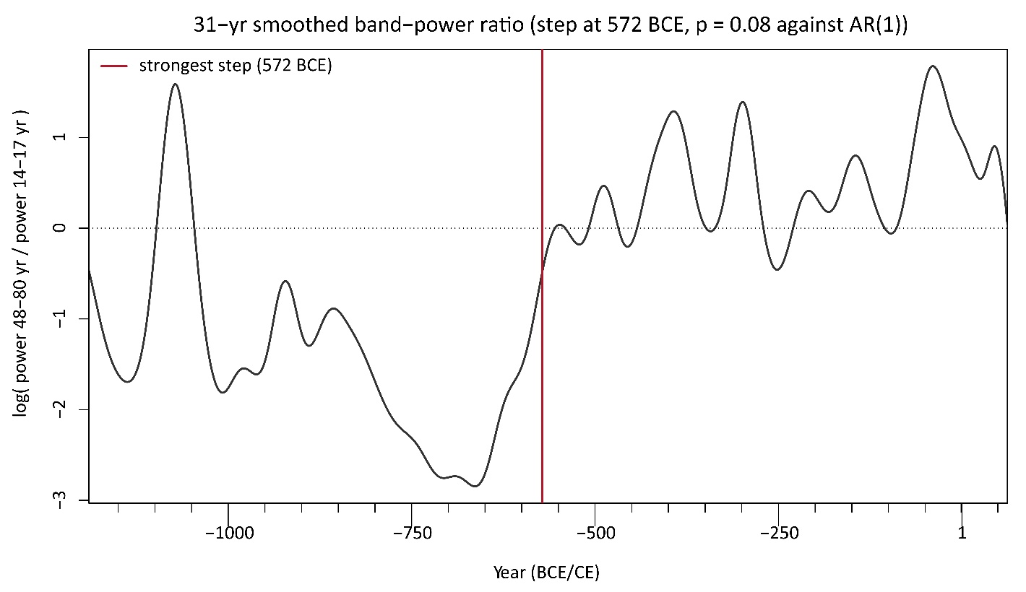
Figure S5. The 31-year smoothed logarithm of the ratio of wavelet power in the 48–80-year band to that in the 14–17-year band, std050 chronology. The vertical line marks the strongest step (572 BCE); the dotted line marks a ratio of one (log ratio of zero).

S10. Spectral background models and the criteria for accepting a cycle
Section 5.1 of the main text reports that the verdict on the multidecadal components depends on a 0.15 difference in the assumed AR(1) coefficient. This section sets out why we report that dependence rather than a single threshold, and where the two literatures relevant to this record stand on the question.
Cyclostratigraphy has considered the choice of spectral background and the criteria for accepting a peak for well over a decade. Vaughan et al. (2011) set out the problem of detecting cycles in the presence of red noise, and Meyers (2012) examined how to estimate the background when the signal under test contributes to it. That discussion produced the area-wise and geometric alternatives to pointwise testing that we use here (Maraun and Kurths, 2004; Maraun et al., 2007; Schulte et al., 2015; Schulte, 2019), together with the practice of reporting a verdict under more than one background.
Dendrochronology has similar tools in its software: dplR implements a continuous wavelet transform and REDFIT (Bunn, 2008), and a permutation test from the cyclostratigraphic literature has been applied to tree-ring power spectra (Krawczyk and Krąpiec, 2010). The field also has a long tradition of care over uncertainty, but that tradition has been directed mainly at chronology quality and reconstruction skill; the standard treatment of uncertainty and statistics in dendrochronology does not extend to spectral peak significance (Cook and Pederson, 2010). Periodicities continue to be reported from ring-width series without an agreed criterion for acceptance (Šimůnek et al., 2021). When the question has been examined directly, the reported cycles have not always proved stable (Williams et al., 2021).
The two AR(1) coefficients used in this paper are obtained as follows. The first, φ = 0.662, is the maximum-likelihood AR(1) coefficient of the observed chronology over the analysis window, and is identical to the lag-1 sample autocorrelation to three decimals. The second, φ = 0.510, is the same estimate applied to the chronology after removing the candidate cycle bands from its spectrum with a rectangular stop band of ±10% around each candidate period, the width used by the maximum-in-band test. The candidate list for the notch runs from 3.6 to 110 years. It omits the 2.2-year and 200-year candidates: the 200-year band lies outside the range the detrending retains, and removing the 2.2-year band raises rather than lowers the coefficient, because taking out variance close to the Nyquist period lengthens the effective decorrelation time of what remains.
Neither coefficient should be read as an estimate of the true background. Table S15 gives the sensitivity of the second one to the two choices involved in producing it. Which bands are notched matters: removing only the four supported components returns φ = 0.543, and removing only the multidecadal band returns φ = 0.619. The width of the notch matters more: at ±5% the coefficient is 0.587, at ±10% it is 0.510, at ±15% it is 0.380, and at ±20% so much of the spectrum has been removed that the estimate is no longer meaningful. The value falls monotonically as the notch widens, which is expected, since a wider notch removes more of the series. The second AR(1) background is therefore a bound rather than an estimate, and the two AR(1) variants are reported together because between them they bracket the answer.
Table S15. Sensitivity of the signal-corrected AR(1) coefficient to the bands notched and to the notch width. The value used in the paper is in the row marked with an asterisk.
Estimated on | φ
Observed chronology, no notching | 0.662
Notch 3.6–110 yr, ±10% (used in the paper) * | 0.510
with the 2.2-yr band also notched | 0.633
with the 200-yr band also notched | 0.510
only the four supported components (15.4, 24, 38, 60 yr) | 0.543
only the multidecadal band (38, 60 yr) | 0.619
only decadal and shorter (3.6–24 yr) | 0.625
Notch 3.6–110 yr, ±5% | 0.587
Notch 3.6–110 yr, ±7.5% | 0.557
Notch 3.6–110 yr, ±15% | 0.380
Notch 3.6–110 yr, ±20% | −0.113

Two results of the present analysis bear on this. The first is the sensitivity already given: estimating the AR(1) coefficient on the observed series returns φ = 0.662 and p = 0.11 and 0.20 for the 60- and 38-year components, while estimating it after notching the candidate bands returns φ = 0.510 and p = 0.005 and 0.012 for the same components. The second is that the same maximum-in-band test, applied to the Sawtooth Lake record with an AR(1) background fitted to that record, returns p = 0.96 in the 32–64-year band. However, that record is published as a reconstruction of Atlantic multidecadal variability (Table S13).
We do not propose a threshold, and we do not think one can be settled from a single record. We suggest only that a periodicity reported from a tree-ring spectrum is more useful to a reader when accompanied by the background against which it was tested and by the sensitivity of the verdict to that choice, which Tables S2, S3, and S6 are intended to provide.

References cited in the supplementary material
Baker A, Hellstrom JC, Kelly BFJ, Mariethoz G and Trouet V (2015) A composite annual-resolution stalagmite record of North Atlantic climate over the last three millennia. Scientific Reports 5(1): 10307. https://doi.org/10.1038/srep10307
Baker A, Wilson R, Fairchild IJ, Franke J, Spötl C, Mattey D et al. (2011) High-resolution δ18O and δ13C records from an annually laminated Scottish stalagmite and relationship with last millennium climate. Global and Planetary Change 79(3-4): 303–311. https://doi.org/10.1016/j.gloplacha.2010.12.007
Bunn AG (2008) A dendrochronology program library in R (dplR). Dendrochronologia 26(2): 115–124. https://doi.org/10.1016/j.dendro.2008.01.002
Cook ER and Pederson N (2010) Uncertainty, emergence, and statistics in dendrochronology. In: Hughes MK, Swetnam TW and Diaz HF (eds) Dendroclimatology: Progress and Prospects. Developments in Paleoenvironmental Research 11. Dordrecht: Springer, pp. 77–112. https://doi.org/10.1007/978-1-4020-5725-0_4
Frank D, Esper J and Cook ER (2007) Adjustment for proxy number and coherence in a large‐scale temperature reconstruction. Geophysical Research Letters 34(16): L16709. https://doi.org/10.1029/2007gl030571
Krawczyk A and Krąpiec M (2010) The Permutation Test for Testing the Statistical Significance of the Power Spectrum Estimation in Dendrochronological Analysis. Geochronometria 36: 23–29. https://doi.org/10.2478/v10003-010-0022-4
Lapointe F, Bradley RS, Francus P, Balascio NL, Abbott MB, Stoner JS et al. (2020) Annually resolved Atlantic sea surface temperature variability over the past 2,900 y. Proceedings of the National Academy of Sciences 117(44): 27171–27178. https://doi.org/10.1073/pnas.2014166117
Liu Y, Liang XS and Weisberg RH (2007) Rectification of the Bias in the Wavelet Power Spectrum. Journal of Atmospheric and Oceanic Technology 24(12): 2093–2102. https://doi.org/10.1175/2007jtecho511.1
Mann ME and Lees JM (1996) Robust estimation of background noise and signal detection in climatic time series. Climatic Change 33(3): 409–445. https://doi.org/10.1007/bf00142586
Maraun D and Kurths J (2004) Cross wavelet analysis: significance testing and pitfalls. Nonlinear Processes in Geophysics 11(4): 505–514. https://doi.org/10.5194/npg-11-505-2004
Maraun D, Kurths J and Holschneider M (2007) Nonstationary Gaussian processes in wavelet domain: Synthesis, estimation, and significance testing. Physical Review E 75(1): 016707. https://doi.org/10.1103/PhysRevE.75.016707
Meyers SR (2012) Seeing red in cyclic stratigraphy: Spectral noise estimation for astrochronology. Paleoceanography 27(3): PA3228. https://doi.org/10.1029/2012pa002307
Meyers SR (2014) astrochron: An R Package for Astrochronology. R package. https://doi.org/10.32614/CRAN.package.astrochron
Proctor CJ, Baker A, Barnes WL and Gilmour MA (2000) A thousand year speleothem proxy record of North Atlantic climate from Scotland. Climate Dynamics 16(10-11): 815–820. https://doi.org/10.1007/s003820000077
Schulte JA (2019) Statistical hypothesis testing in wavelet analysis: theoretical developments and applications to Indian rainfall. Nonlinear Processes in Geophysics 26(2): 91–108. https://doi.org/10.5194/npg-26-91-2019
Schulte JA, Duffy C and Najjar RG (2015) Geometric and topological approaches to significance testing in wavelet analysis. Nonlinear Processes in Geophysics 22(2): 139–156. https://doi.org/10.5194/npg-22-139-2015
Schulz M and Mudelsee M (2002) REDFIT: estimating red-noise spectra directly from unevenly spaced paleoclimatic time series. Computers & Geosciences 28(3): 421–426. https://doi.org/10.1016/s0098-3004(01)00044-9
Šimůnek V, Hájek V, Prokůpková A and Gallo J (2021) Finding an imprint of solar and climatic cycles in tree rings of European beech (Fagus sylvatica L.). Journal of Forest Science 67(9): 409–419. https://doi.org/10.17221/94/2020-JFS
Torrence C and Compo GP (1998) A Practical Guide to Wavelet Analysis. Bulletin of the American Meteorological Society 79(1): 61–78. https://doi.org/10.1175/1520-0477(1998)079<0061:apgtwa>2.0.co;2
Vaughan S, Bailey RJ and Smith DG (2011) Detecting cycles in stratigraphic data: Spectral analysis in the presence of red noise. Paleoceanography 26(4): PA4211. https://doi.org/10.1029/2011pa002195
Wigley TML, Briffa KR and Jones PD (1984) On the Average Value of Correlated Time Series, with Applications in Dendroclimatology and Hydrometeorology. Journal of Climate and Applied Meteorology 23(2): 201–213. https://doi.org/10.1175/1520-0450(1984)023<0201:otavoc>2.0.co;2
Williams AP, Anchukaitis KJ, Woodhouse CA, Meko DM, Cook BI, Bolles K et al. (2021) Tree Rings and Observations Suggest No Stable Cycles in Sierra Nevada Cool‐Season Precipitation. Water Resources Research 57(3): e2020WR028599. https://doi.org/10.1029/2020wr028599

