Ben Poole | benpoole@outlook.com | (402) 875-3498 | Omaha, NE | benpoole.me
Digital Product Strategy | Marketing Analytics | FinTech Platform Leader | AI-Enabled Discovery
EXECUTIVE SUMMARY
Product leader with 25+ years spanning financial services, enterprise SaaS, and digital platform strategy. Built wealth management technology from startup to $40B AUA at Orion Advisor Services, then scaled enterprise product adoption and change management at PayPal (30,000+ employees) and Autodesk. Combines deep financial services domain expertise with hands-on AI/ML product delivery, data platform strategy, and Prosci-certified change management. FINRA Series 6 licensed. Passionate about building digital experiences that earn advisor trust and drive measurable business outcomes.
KEY CAPABILITIES
- Digital product vision, strategy & multi-platform roadmaps  - AI-assisted discovery, rapid experimentation & prototyping  - Advisor-facing platform design & onboarding optimization  - Cross-functional leadership across Design, Engineering & Business | - Wealth management platforms & FINRA Series 6 licensed  - Data-driven product decisions (Snowflake, Looker, Power BI)  - Prosci ADKAR change management & enterprise adoption  - Vendor strategy, contract negotiation & partner ecosystems
PROFESSIONAL EXPERIENCE
Senior Manager, Data Products — Construction Cloud
Autodesk, Inc. Aug 2022 – Present
- Built analytics platform framework including workflows library, metrics library, AI Data Agent POC, and experimentation framework enabling Product teams to self-serve insights at scale
- Led cross-functional team of Data Product Managers partnering with Engineering, Data Science, and Analytics to drive adoption of advanced tools and AI models
- Scoped and launched ML-powered data product generating $2.7M in attributed pipeline through product marketing and sales enablement
- Led BI Engineering program (Power BI, Google Looker, Snowflake), reducing average load time from 29 to 7 seconds
- Launched Construction Data Products Catalog, a platform delivering SaaS metrics and customer insights to GTM, Sales, and CS teams across Autodesk Construction Cloud
- Drove in-app messaging strategy and customer data platform focused on onboarding, adoption measurement, and personalized user experiences
- Managed vendor relationships and contracts for third-party construction data enrichment services; facilitated Design Thinking workshops with customers and partners on AI, automation, and sustainability
Senior Manager, Organizational Change Management & UX Research
PayPal, Inc. Apr 2018 – Aug 2022
- Led enterprise-wide digital transformation supporting 30,000+ employees through collaboration platform rollout — applying ADKAR framework to achieve NPS increase from 35 to 85
- Drove 1,500% increase in platform adoption by redesigning enterprise deployment strategy through change champions network and peer-to-peer learning
- Partnered with Product and Technology leadership to design program governance, stakeholder engagement, and resistance management strategies for major platform initiatives
- Established scalable operating model for Change Management and UX Research with repeatable processes and governance across business units
- Led cross-functional UX Research team deploying human-centered methods to inform technology solution design and strategic product decisions
- Influenced M&A integration and project go/no-go decisions through risk analysis, use-case validation, and executive-level recommendations
Promoted from UX Research Team Lead
Product Manager, Cloud Collaboration & Unified Communications
HDR, Inc. Feb 2010 – Apr 2018
- Expanded scope from Product Owner to Chief-of-Staff function, becoming trusted partner to technology leadership on strategic planning, cross-functional coordination, and enterprise platform ownership
- Led multi-year cloud platform strategy including hybrid architecture design and technology service catalog for 10,000+ employee AEC firm
- Built enterprise change champion network to accelerate strategic technology adoption across design and construction workflows
- Negotiated and managed vendor contracts (Microsoft, Oracle, Cisco), saving $1.4M in vendor costs while increasing value of technology investments
Promoted from Senior Web Application Developer
Web Solutions & Product Marketing Lead → Senior Web Application Developer
Orion Advisor Services (formerly CLS Investments) 1997 – 2010
- Founding team member of FinTech startup; scaled platform from inception to $40B in AUA — leading web application development and marketing divisions
- Led product marketing, UX strategy, and developer experience through high-growth phase, establishing design patterns and development best practices for wealth management platform
- Supported sales and partnership growth through technical consulting, conference speaking, executive presentations, and partner integration programs
- Created cross-functional alignment across Sales, Operations, Engineering, and Product — bridging business objectives with technical delivery
- Earned FINRA Series 6 Securities license to deepen domain expertise in wealth management and investment products
BUSINESS IMPACT METRICS
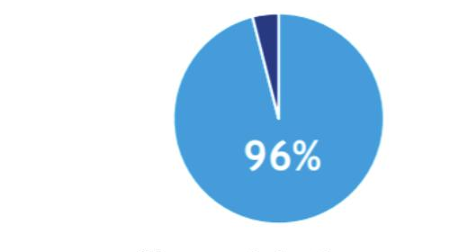 | 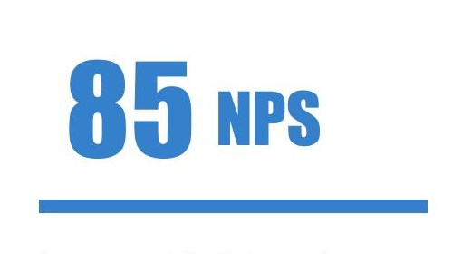 | 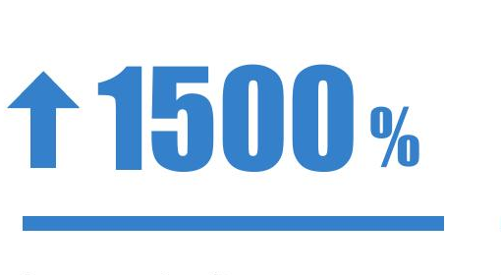 | 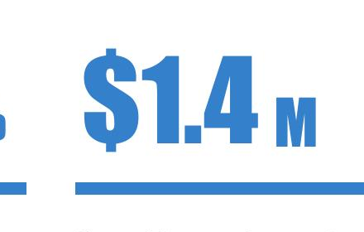 | 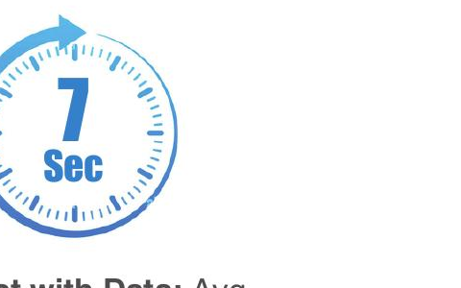
User satisfaction insight — key metric for global change management | Collaboration platform NPS increased by 50 points among 30,000 employees | Software adoption increased through change champions network | Saved in vendor contract costs while increasing value of spend | Avg. load time for data product customers — down from 29 seconds
EDUCATION
Masters of Business Analytics (Pursuing) — Bellevue University (Expected May 2027)
Bachelor of Journalism, Advertising & Mass Communications — University of Nebraska–Lincoln
Minors: Economics, English
CERTIFICATIONS & CREDENTIALS
- Prosci ADKAR Change Practitioner
- Microsoft Azure Fundamentals
- LUMA Design Thinking Practitioner
- FINRA Series 6 — Registered Financial Products Representative (inactive)
COMMUNITY & LEADERSHIP
- Omaha Chamber of Commerce Business Engagement Council Member
- University of Nebraska–Omaha STEM Education Program Business Advisor
- Omaha Community Foundation — Omaha Venture Group Senior Member and Group Leader
- Graduate — AIM Institute Advanced IT Leadership Academy
- HDR Associate Professional Designation for Leadership; Pathfinder Award for Innovation and Teamwork

