1. Personal data
Name: Ogar Maksim  Citizenship: Russian Federation  Address: Moscow  Date of Birth: 1984.12.10  E-mail: mogar@inbox.ru  Phone: +7 (916) 127-59-57 | 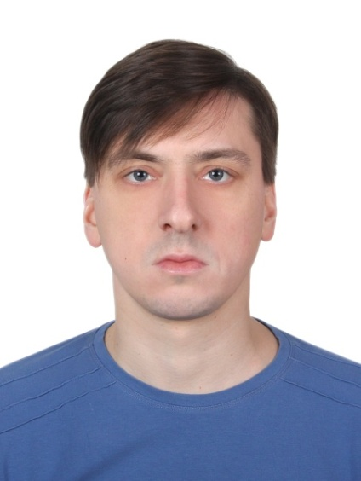

2. Position
Middle C++ developer/ Qt-developer

3. Wage
150 000 RUR

4. Skills
4.1 C/C++:
Environment: C++ Builder, QTCreator, C++17 STL, Qt-libraries.
Linkers: Qmake, Cmake.
Currently using:
Windows - QTCreator /CMake /MinGW
Linux (Ubuntu, AstraLinux) - QTCreator /CMake /GCC
Android - QTCreator /QMake /Clang
GUI-development:
- in Borland C++ Builder
- in QTCreator - QtWidgets (using QTDesigner, or without it)

STL-skills:
object-oriented programming, standard containers and algorithms, I/O streams, multithreading, smart-pointers and RAII, forward reference, lambda-expressions.

Additional QT-library skills:
- QVariant, QEvent, QIODevice (QFile, QDir, QBuffer, QTextStream, QDataStream), QDateTime, QTimer, QProcess, QThread, QTcpSocket, QUdpSocket, QTcpServer, QtSQL-module, view-model technology

4.2 Network development
Development client/server-applications using TCP/IP and fast UDP

4.3 Database development:
MySQL, PostgreSQL

4.4 Version control system:
GIT, Perforce

4.5 3D graphics (OpenGL + GLUT/FreeGLUT):
Geometric Primitives and Buffers, Color, Materials, and Lighting, Texture Mapping, Curves and Surfaces, Pipeline (Faster Geometry Throughput), Interactive Graphics, Occlusion Queries, Depth Textures and Shadows, vertex and fragment shaders

4.6 Other skills:
- assembly language (TurboAssembler 5.0, TurboDebugger 5.0, W32Dasm);
- Python3 (PyCharm, QTDesigner)

5. Experience
5.1 2005 – 2020: State enterprise "Almaz" as an engineer/team lead.
Job descriptions:
- leadership of the scientific group on software modeling (in C++);
- leadership of the scientific group on the hardware for the operation of laser installations;
- MySQL application development

5.2 2020.04. - 2021.04: Freelance
Major projects:
- application for calculating a loan for Android;
- MySQL client application;
- file splitter/merger;
- a music player with a connected media library;
- TCP/IP client/server;
- application "Heart" on OpenGL

5.3 2021.04 -2021.10: State enterprise "Almaz-Antey" as an engineer-programmer
Job descriptions:
- development of a frontend application for working with the server;
- development of High Level Architecture applications (parsing FOM/SOM files, etc.);
- development of a client GUI application (using QtDesigner);
- PostgreeSQL application development

5.4 2021.11. - 2022.03: Freelance

5.5 From 04.2022 - FSUE "NPP "Gamma", programmer at the center for advanced research and development
Job descriptions:
- optimization of existing C++ code (implementation of asynchronous execution of resource-intensive functions);
- transfer of existing projects from qmake-implementation to cmake.

6. Education
2007: Moscow University of Radio Engineering, Electronics and Automatics Faculty of Electronics, specialty "Optical devices and systems"

7. Additional information
- mathematical mindset (mathematics and physics);
- enjoy creative work;
- willingness to learn new programming languages;
- conscientious attitude to the fulfillment of assigned tasks;
- basic knowledge of English and French

