Software Design Document
(SDD)

for

Windows EDA Environment Manager
P3B – Installation & Remediation

at The Department of Electrical and Computer Engineering,
The University of the West Indies
St Augustine Campus
Trinidad

Version 1.0 (Draft)

Prepared by:
Michael Straughn (816040443), P3B
ECNG2007 Project 3 Group – Department of Electrical and Computer Engineering, UWI
11/11/2026

Based on the ISO/IEC/IEEE Std 29148:2018

Table of Contents
1 Introduction 3
1.1 Purpose 3
1.2 Scope 3
1.3 Overview 4
1.4 Reference Material 4
1.5 Definitions and Acronyms 4
2 System Overview 5
3 System Architecture 6
3.1 Architectural Design 6
3.2 Decomposition Description 8
3.3 Design Rationale 9
4 Data Design 10
4.1 Data Description 10
4.2 Data Dictionary 11
5 Component Design 12
6 Human Interface Design 13
6.1 Overview of User Interface 13
6.2 Screen Images 14
6.3 Screen Objects and Actions 17
7 Requirements Matrix 17
8 Appendices 18

Introduction

Purpose
This software design document describes the architecture and detailed design of P3B – Installation & Remediation, the part of the Windows EDA Environment Manager that fixes problems found by P3A's environment audit. It explains how P3B is divided into subsystems, how those subsystems work with P3A, how data is stored, how each main component behaves, and how the user interface supports safe, explicit and reversible changes.
It is written for the P3B and P3A subteams who build and maintain the software, the QA Officer who reviews it, and the course staff who assess the design against the Project 3 SRS and the project brief.

Scope
Students in the course need the same approved EDA tools – Visual Studio Code with an approved VHDL extension, GHDL, Surfer and, installed separately, AMD Vivado – at approved versions on their own Windows computers. P3A audits a computer against the shared manifest and reports which tools are missing or at an unapproved version. P3B takes those findings and, where the manifest allows, fixes them.
Goals and objectives. P3B must:
• show, before anything changes, exactly what will change, the target version and how the change can be reversed, and act only after the user approves (3B-UR-001, 3B-DC-003);
• install only course-approved open-source tools at an approved version, per user, from approved sources such as WinGet (3B-DC-001, 3B-DC-002, 3B-DC-005);
• never install, activate or license Vivado (3B-DC-004), and say plainly when no automatic fix exists (3B-UR-003);
• verify every change with smoke tests and report the result separately from the remediation outcome (P3-StR2.2, 3B-UR-002);
• record every change so it can be reversed, and run one change at a time (P3B-DR-01, P3B-DR-02, P3B-PR-01);
• hand the decision on readiness back to P3A by re-running P3A's audit after each fix (P3-StR4.1, FR-004).
Benefits. Students reach a working, consistent toolchain with fewer manual steps; staff can trust that nothing unapproved was installed; and every change is visible and reversible.
Out of scope: P3A's detection logic (P3B calls it but does not change it), installing or licensing Vivado, machine-wide changes, Project 4, and general package management.

Overview
Section 2 gives the system's context and functions. Section 3 presents the architecture, the decomposition into subsystems and classes with their interfaces and a sequence diagram, and the reasons for the main design decisions. Section 4 describes the data design and a data dictionary. Section 5 gives pseudocode for the main components. Section 6 covers the user interface with real screen images. Section 7 traces each requirement to the design, and the appendices list the proposed changes to P3A's code, build instructions and the AI-use statement.

Reference Material
Table 1: Reference material
Reference | Description
Project Portfolio Briefs (Release 3) | Abdool, A. ECNG2007 Project Portfolio Briefs, Software Development Lifecycle Project 2026/27 – P3A/P3B stakeholder requirements P3-StR2.1–4.1 and acceptance criteria.
Project 3 SRS v1.0 (Draft) | Software Requirements Specification for the Windows EDA Environment Manager, 19/09/2026 – requirements P3B-PR, 3B-UR, 3B-IR, P3B-DR, 3B-DC and FR-004.
ISO/IEC/IEEE 29148:2018 and IEEE 1016-2009 | Requirements engineering; software design descriptions (structure of this document).
P3B Test Plan v1.1 | docs/P3B-Test-Plan.docx – test cases and results (413 automated tests).
P3B Verification Report | docs/VERIFICATION-REPORT.md – requirement-by-requirement evidence, 11/11/2026.
Integration seams; Blockers; P3A changes | docs/INTEGRATION-SEAMS.md, docs/BLOCKERS.md, docs/P3A-CHANGES.md.
Provisional proposals | docs/proposals/local-eda-tool-manifest.PROVISIONAL.md, audit-remediation-contract.PROVISIONAL.md.
P3A repository | github.com/straughnmichael22-arch/ECNG_2007_Project (branch 3Av2; proposed branch p3b-integration/audit-library).
AI assistance | Anthropic. 2026. Claude (Claude Code) [Large language model] – used to assist with implementing, testing and documenting P3B, in line with the course AI policy.

Definitions and Acronyms
Table 2: Definitions and acronyms
Term | Meaning
Audit issue | One non-ready finding from P3A: tool, state (missing, unapprovedVersion, misconfigured), detected version, reason.
Manifest | eda-tool-manifest.json, P3A's file of approved tools, version ranges and manual steps (format 1.0). P3B also reads a provisional format that can express automatic installs.
Preview | ActionPreview: the exact tool, target version, changes and reversal method shown before approval.
Journal | reversal-journal.json: the persistent record of changes and how to reverse them.
Smoke test | A quick post-fix check declared in the manifest (installed version, command on PATH, file exists, version command, user variable).
Re-audit | Running P3A's audit again after a fix; P3A alone decides Ready / Not Ready.
Manual steps | Remediation steps taken word for word from the manifest that the user performs; P3B never performs them.
Test double (fake) | A stand-in for an installer, process, P3A audit or approval used in automated tests so nothing on the computer changes.
DFD, OO, PDL | Data flow diagram; object-oriented; procedural description language (pseudocode).
HKCU | The current user's part of the Windows registry, where user environment variables live.
UI, VM | User interface; the staff-supplied resettable Windows virtual machine for real install tests.
WinGet | Windows Package Manager, used for per-user installs from the winget source.

System Overview
The Windows EDA Environment Manager has two halves that share one manifest. P3A (Environment Audit & Readiness) detects which approved tools are installed and at which versions, and decides whether the computer is Ready. P3B (Installation & Remediation), described here, turns P3A's findings into safe fixes. Figure 1 shows P3B in its context.
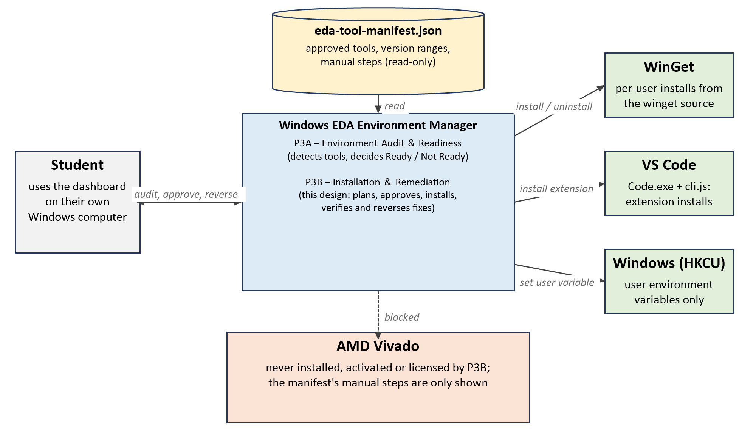
Figure 1: System context – the student, the manifest, P3A and the external software P3B may change
Functions. P3B is a Windows desktop application (C#, .NET 10, WinForms). On start-up it opens P3A's manifest and runs P3A's own audit in-process. For each problem P3A reports it decides, from the manifest alone, whether there is a supported automatic fix, manual steps, or no fix. A supported fix is shown as a preview; after the student approves that exact preview, P3B installs the approved version for the current user only, verifies it, records how to reverse it, runs the manifest's smoke tests and then re-runs P3A's audit. The dashboard shows P3B's own outcome and P3A's verdict side by side but separately.
Realistic outcomes with P3A's current manifest. The manifest gives approved version ranges and manual steps but no install sources, so P3B shows manual steps for Surfer and Vivado (Vivado is never installed), no automatic fix for VS Code, GHDL and the VHDL extensions, and nothing for components that pass. The automatic paths – WinGet packages and VS Code extensions – are fully built and tested against a provisional manifest format and become active as soon as the manifest supplies a package ID or extension ID with an exact approved version.
Constraints. Windows 10/11; user-level changes only (no administrator rights, no machine scope); no command shell for any process P3B starts; the manifest is read-only; one change at a time; nothing is installed during testing (all automated tests use test doubles); real installs only in the staff's resettable VM.

System Architecture

Architectural Design
P3B uses a layered architecture with a strict rule: every decision is made in a core that cannot change the computer, and every effect on the computer sits behind an interface in a separate Windows layer. This is enforced by automated SafetyTests that fail the build if the core references process, registry or network APIs. Figure 2 shows the subsystems, data stores and dependencies.
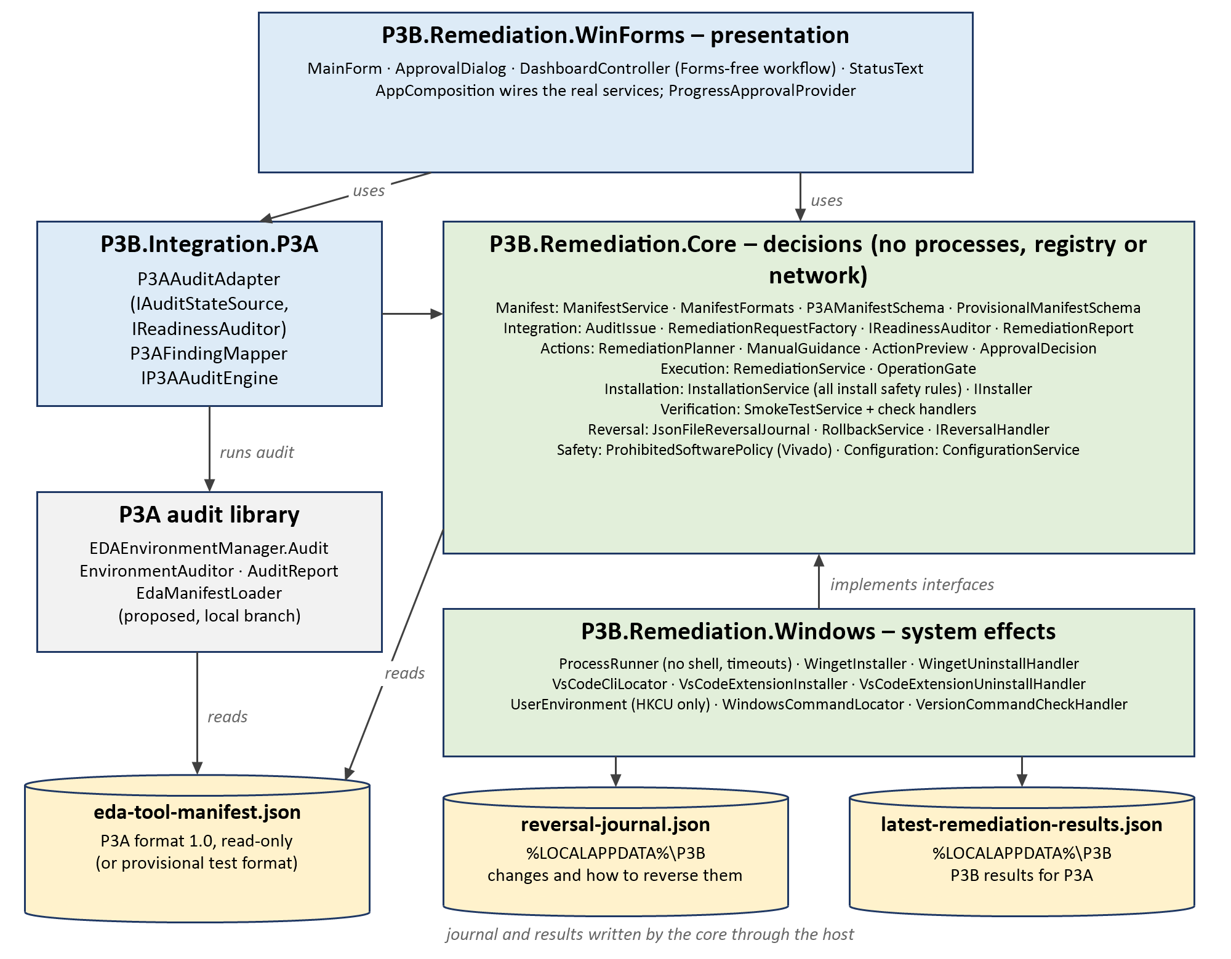
Figure 2: Architecture – subsystems, data repositories and their connections
Table 3: Subsystems and responsibilities
Subsystem | Responsibility
P3B.Remediation.WinForms | Presentation: the dashboard (MainForm), approval dialog, labels (StatusText). DashboardController holds the workflow without Forms code so it can be tested; long work runs off the UI thread.
P3B.Integration.P3A | Runs P3A's EnvironmentAuditor against the open manifest and converts P3A's AuditReport into P3B audit issues and P3A's Ready / Not Ready verdict.
P3B.Remediation.Core | All decisions: reading and validating the manifest, validating audit data, planning, approval, installation safety rules, smoke tests, reversal journal and rollback, and the Vivado block. No processes, registry or network.
P3B.Remediation.Windows | All effects: shell-free ProcessRunner with timeouts, WinGet installer and uninstaller, VS Code extension installer and uninstaller, HKCU-only user environment, command locator.
EDAEnvironmentManager.Audit (P3A) | P3A's detection code extracted into a library without changing what it detects; proposed to the P3A team on a local branch.

Collaboration. The dashboard asks the P3A adapter for findings, then hands one finding at a time to RemediationService (core). RemediationService loads the manifest, plans with RemediationPlanner, asks an executor (InstallationService) for a preview, obtains the user's approval through IApprovalProvider, and executes. InstallationService applies every install rule and calls an IInstaller from the Windows layer. Results are journalled, smoke-tested and returned; the dashboard then asks the adapter to re-audit. RollbackService uses the same OperationGate so that a reversal and a fix can never run together.

Decomposition Description
An object-oriented decomposition is used. Table 4 lists the interfaces that separate the subsystems; each has a production implementation and one or more test doubles.
Table 4: Key interfaces (seams)
Interface | Purpose | Production implementation
IManifestSource | Load the manifest, every time, read-only. | ManifestService (via SwitchableManifestSource)
IAuditStateSource | Supply P3A's non-ready findings. | P3AAuditAdapter
IReadinessAuditor | Run P3A's audit; return P3A's verdict. | P3AAuditAdapter
IRemediationService | Remediate one request end to end. | RemediationService
IRemediationExecutor | Preview and execute one action. | InstallationService
IInstaller | Availability, installed state, exact-version install, uninstall reversal. | WingetInstaller, VsCodeExtensionInstaller
IApprovalProvider | Ask the user to approve one preview. | WinFormsApprovalProvider (ApprovalDialog)
ISmokeTestRunner / ISmokeCheckHandler | Run the manifest's checks. | SmokeTestService + five handlers
IReversalJournal / IReversalHandler | Persist and perform reversals. | JsonFileReversalJournal; WinGet, VS Code and user-environment handlers
IProcessRunner | Run a process without a shell, with timeout. | ProcessRunner
ICommandLocator, IUserEnvironment | Find commands on PATH; read/write user variables. | WindowsCommandLocator; UserEnvironment (HKCU)

Figure 3 shows the dynamic behaviour for one supported fix, from P3A's audit through approval, installation, verification, journalling and P3A's re-audit.
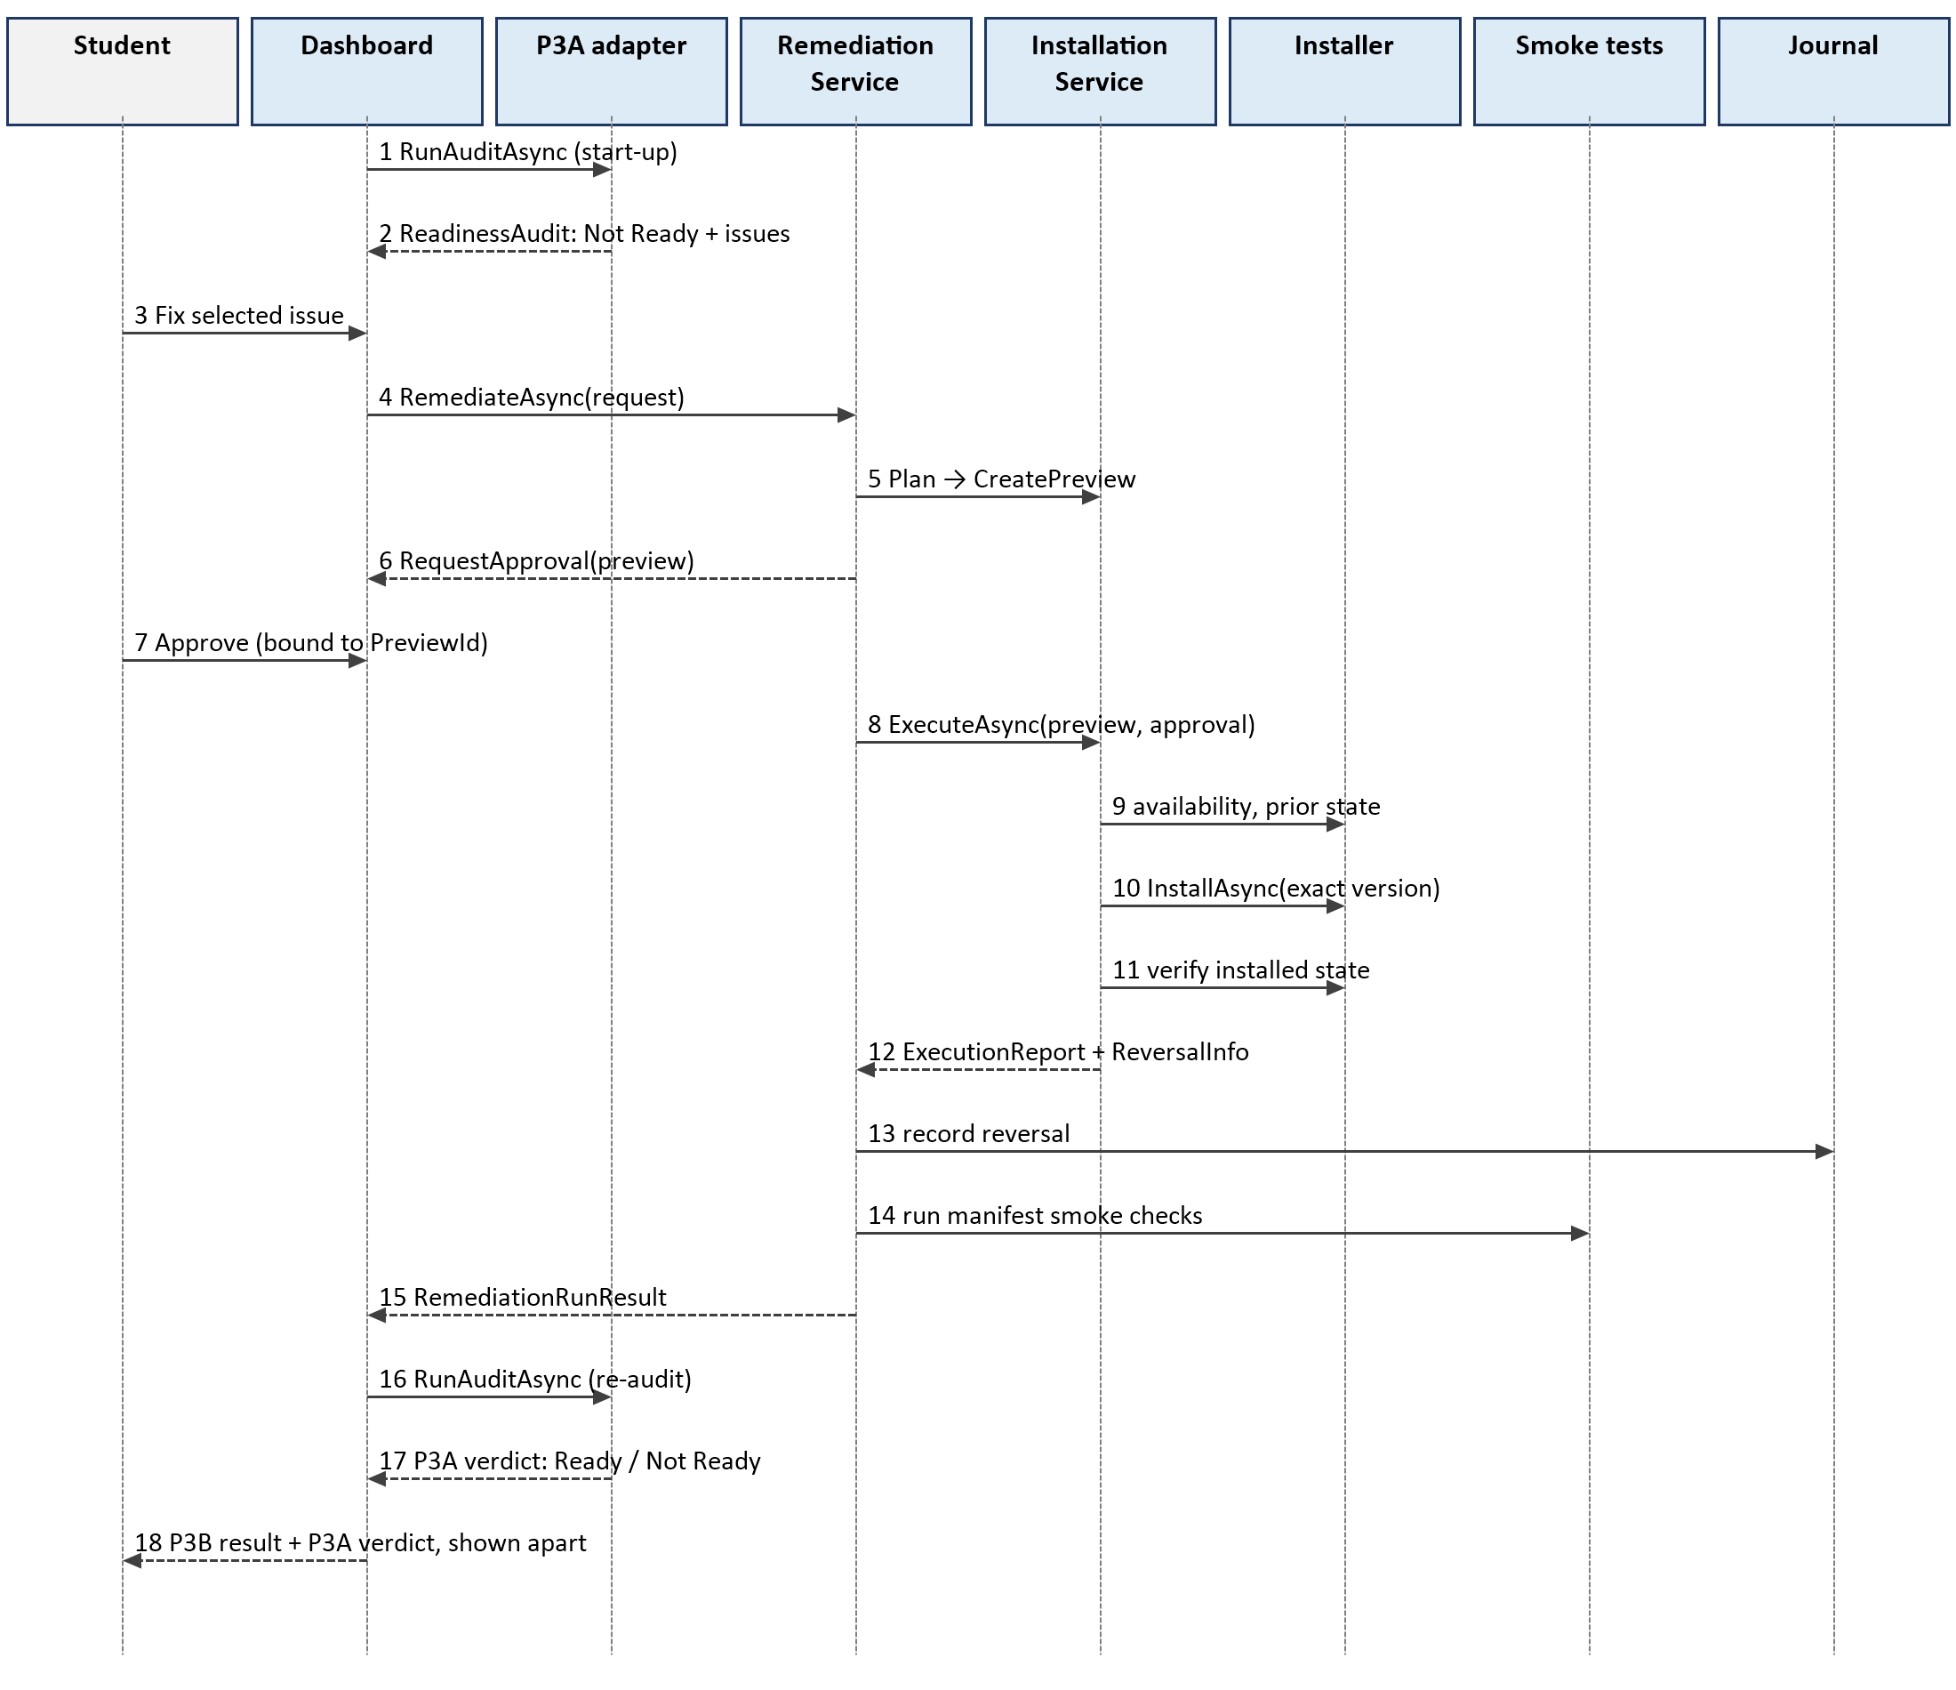
Figure 3: Sequence diagram – audit → approve → fix → verify → re-audit
Remediation states. Each issue moves through Not started → In Progress → one of Successful, Failed, Cancelled, Not approved, Not supported or Could not run. Issues with no automatic fix stay in "No automatic fix" or "Waiting for you" (manual steps). A journal entry moves from Pending to Reversed or Discarded (discarding needs an explicit warning).

Design Rationale
Table 5: Design decisions and alternatives considered
Decision | Reason | Alternatives rejected
Decision core with no side effects | Every safety rule can be unit-tested; tests cannot change the computer (enforced by SafetyTests). | Installer logic in the UI or mixed with process code: untestable without real installs.
Approval bound to a PreviewId | The user approves exactly what was shown; a different action cannot run on that approval. | A generic "OK to proceed" flag.
Success only after verification | An installer's exit code is not trusted; the installed version is read back. | Trusting exit code 0.
Per-user scope, exact pinned versions, no --force | Meets 3B-DC-001/005 without administrator rights; never adopts a newer version. | Machine-wide installs; "latest" versions.
In-process P3A audit through a shared library | P3A and P3B run identical checks; the re-audit needs no file exchange. | Two programs exchanging JSON files (kept only as a fallback); copying P3A's code into P3B.
Read P3A's manifest format directly | One manifest for both halves (P3-StR3.1). | A separate P3B manifest.
VS Code CLI via Code.exe, code.cmd only read | Batch files always run through cmd.exe, which re-interprets characters; reading code.cmd and starting Code.exe avoids any shell. | Running code.cmd with an argument allow-list; not automating extensions.
Official archives not built | No manifest provides a SHA-256 checksum, and archives must not be installed unverified. | Downloading and extracting without integrity checks.
One operation at a time (OperationGate) | Simple, safe concurrency for P3B-PR-01; a second request is refused as Busy. | Queueing requests.
Vivado blocked by a fixed rule | A safety rule that only ever blocks; independent of manifest content. | Relying on the manifest to omit Vivado.

Data Design

Data Description
P3B has no database. Its information domain is transformed as follows: P3A's audit results (AuditReport) become AuditIssue records; each valid issue becomes a RemediationRequest; the planner combines it with a ManifestTool to make a RemediationAction; the executor turns that into an ActionPreview; after approval, execution produces a RemediationResult with ReversalInfo, which is journalled; smoke tests produce a SmokeTestResult; and a RemediationReport is written for P3A. All model types are immutable C# records, so a manifest or result cannot be changed after it is read.
Table 6: Persistent data stores
Store | Access | Contents
eda-tool-manifest.json (P3A) | Read-only, every load; shared read lock | Format 1.0: tools (name, type, min/max approved version, remediation downloadUrl and instructions), extensions (name, type, approvedExtensions). The provisional format adds exact approvedVersions, remediation method/source and smokeTests.
%LOCALAPPDATA%\P3B\reversal-journal.json | Read/write by P3B; atomic replace | Pending and closed ReversalJournalEntry records, each with a typed ReversalOperation (wingetUninstall, vscodeExtensionUninstall, restoreUserEnvironmentVariable).
%LOCALAPPDATA%\P3B\latest-remediation-results.json | Written after every run | formatVersion, generatedAt, readiness statement and the latest RemediationReport per issue.
Audit results file (optional) | Read-only | { "issues": [AuditIssue] } – provisional fallback hand-off and test input.

Data Dictionary
Table 7: Data dictionary (alphabetical)
Entity | Type | Attributes and description
ActionPreview | record | PreviewId, Action, Tool, TargetVersion, ProposedChanges[], ReversalMethod, ExpectedReversal (Reversible / PartiallyReversible / NotReversible). What the user approves.
ApprovalDecision | record | PreviewId, IsApproved, Reason?; Approves(preview) is true only for the same PreviewId.
ApprovedVersionRange | record | Minimum?, Maximum? exactly as in the manifest; Describe() gives "2019.2 to 2026.1.1".
AuditFinding (P3A) | enum | None, NotInstalled, VersionUnknown, VersionUnparseable, VersionBelowMinimum, VersionAboveMaximum, InvalidMinimumVersion, InvalidMaximumVersion, EditorNotDetected, ExtensionNotInstalled, CheckDisabled.
AuditIssue | record | IssueId ("{type}/{finding}"), ToolId (manifest type), State (missing / unapprovedVersion / misconfigured, or P3A's code when unmapped), DetectedVersion?, Detail?. All optional so incomplete data is reported, not rejected.
AuditReport (P3A) | class | ManifestVersion, AuditedAt, Components[], OverallReady, OverallStatus ("Ready" / "Not Ready").
ComponentAuditResult (P3A) | class | Kind, Name, Type, DisplayName, InstallationStatus, ReadinessStatus, Version, InstalledPath?, Reason, Finding, CountsAsReady.
InstallTarget | record | Tool, ToolName, Source (package or extension ID), Version (exact approved version).
InstalledState | record | Kind (NotInstalled / TargetVersionInstalled / OtherVersionInstalled / Unknown), DetectedVersion?, Evidence.
IssueItem | class (UI) | Issue, Creation, Key, ToolName, ApprovedText, Support (Supported / ManualSteps / NotSupported / InvalidAuditData / ManifestNeeded), SupportReason, Guidance?, Status, LastRun?.
LocalEdaToolManifest | record | ManifestVersion, Tools[]; FindTool(id). Read-only.
ManifestLoadResult | record | Status (Loaded, NotConfigured, Missing, Unreadable, Malformed, UnsupportedVersion, Invalid), Description, Manifest?, Errors[] (JSON path + message).
ManifestTool | record | Id, DisplayName, ApprovedVersions[], ApprovedRange?, Remediation (Method: WinGet / VsCodeExtension / OfficialArchive / LinkToInstaller / None; Source), Instructions[], Kind (Tool / Extension), ApprovedExtensions[], SmokeChecks[].
ManualGuidance | record | DownloadUrl? (http/https only), Steps[] – from the manifest, shown, never performed.
ReadinessAudit | record | Verdict (Ready / NotReady / CouldNotRun), Summary, AuditedAt, Issues[], Components[] – P3A's result as received.
RemediationAction | record | ActionId, Request, Tool, Issue, TargetVersion (manifest's first approved version), Method, Source.
RemediationPlan | record | Action? or UnsupportedReason + Guidance?.
RemediationReport | record | ToolId, IssueId, Outcome, Message, TargetVersion, ObservedChanges[], Reversibility, ReversalJournalEntryId, Verification, ReauditRequired, Readiness (always defers to P3A).
RemediationRequest | record | RequestId, Tool, Issue, State, DetectedVersion?.
RemediationResult | record | Outcome (Succeeded, Failed, Cancelled, Rejected, Unsupported, InvalidConfiguration, Busy), Message, Action?, PriorState?, ObservedChanges[], Reversal?, ReversalJournalEntryId?.
ReversalJournalEntry | record | EntryId, RecordedAt, PreviewId, ToolId, IssueId, Kind (Automatic / ManualOnly / NothingToReverse), Method, PriorState?, ChangesToReverse[], Operation?, Status (Pending / Reversed / Discarded), ClosedAt?.
SmokeTestResult | record | PreviewId, Tool, TargetVersion, Outcome (Passed / Failed / TimedOut / Unsupported / Cancelled), Message, Checks[], ReadinessNote, CompletedAt.

Component Design
This section summarises the main member functions in pseudocode. Names match the source code in src/.

ManifestFormats.Parse – choose and validate the manifest format
parse JSON; if invalid → Malformed
version ← manifestVersion (case-insensitive, as P3A reads it)
if version = "1.0" → P3AManifestSchema.Validate
else → ProvisionalManifestSchema.Validate (any unknown version → UnsupportedVersion)
P3AManifestSchema.Validate:
for each tool: require name, type; versions must parse as System.Version; min ≤ max
downloadUrl must be http(s); instructions non-empty strings
remediation ← LinkToInstaller(downloadUrl) or None
for each extension: require name, type; approvedExtensions (fallback extensionId)
types unique; at least one component; else Invalid with JSON paths

P3AFindingMapper.ToAuditIssue – convert one P3A result
if component.CountsAsReady → no issue
type ← component.Type (null if blank)
state ← NotInstalled | ExtensionNotInstalled | EditorNotDetected → "missing"
VersionBelowMinimum | VersionAboveMaximum → "unapprovedVersion"
otherwise → P3A's finding code (reported later as incomplete audit data)
detectedVersion ← component.Version unless "Not Available" / "Not Checked" / blank
return AuditIssue(issueId = type + "/" + finding, toolId = type, state, detectedVersion,
detail = reason + " Found at: " + path)

RemediationPlanner.Plan – decide what P3B may do
tool ← manifest.FindTool(request.Tool); if none → Unsupported("not in manifest")
guidance ← ManualGuidance.From(tool) // URL + steps, or null
if ProhibitedSoftwarePolicy.IsProhibited(tool) → Unsupported(Vivado message, guidance)
if tool is an extension group without method vscodeExtension → Unsupported(list approved IDs)
if method = None → Unsupported("no automatic remediation", guidance)
if method = LinkToInstaller → Unsupported("install it yourself from <url>", guidance)
if request.State = Misconfigured → Unsupported (P3A reports no user-level misconfiguration)
return Supported(RemediationAction(request, tool)) // target = first approved version

RemediationService.RemediateAsync – one fix, end to end
if not gate.TryEnter → Busy
manifest ← source.Load(); if not usable → InvalidConfiguration (before any preview)
plan ← Planner.Plan; if unsupported → Unsupported
executor ← first executor that CanHandle(action); none → Unsupported
preview ← executor.CreatePreview(action)
decision ← approvals.RequestApprovalAsync(preview)
if not decision.Approves(preview) → Rejected (nothing changed)
report ← executor.ExecuteAsync(preview, decision)
journal.Record(report.Reversal) // a failed save is reported as a warning
if report succeeded → smokeTest ← smokeTests.RunAsync(preview)
release gate; return RemediationRunResult(remediation, smokeTest)

InstallationService.ExecuteAsync – installation safety rules
require approval of this exact preview; refuse Vivado again
require target.Version ∈ tool.ApprovedVersions
installer.CheckAvailability; if not available → Failure, nothing changed
prior ← installer.GetInstalledState
Unknown → Failure (never guess); TargetVersion → Success, nothing to reverse
attempt ← installer.InstallAsync(exact version) // cancellation stops the installer
post ← installer.GetInstalledState // always checked, even after cancel
success only if attempt Completed AND post = TargetVersionInstalled
reversal ← Automatic(uninstall) if prior NotInstalled → target installed
ManualOnly if another version was replaced or the result is unclear

VsCodeCliLocator.Locate and VsCodeExtensionInstaller
script ← commandLocator.Locate("code.cmd"); read it as text (never run)
require "set ELECTRON_RUN_AS_NODE=1" and the line "%~dp0<exe>" "%~dp0<…\cli.js>" %*
exe, cli ← full paths; both must exist inside the VS Code folder; else refuse
run: Code.exe [cli.js, args…] with ELECTRON_RUN_AS_NODE=1 for this process only
state: --list-extensions --show-versions → find "<id>@<version>"
install: --install-extension <id>@<version> (id and version allow-listed; no --force)
reverse: --uninstall-extension <id>, only if the recorded version is still installed

SmokeTestService.RunAsync
for each check declared for the tool, in order:
handler ← first handler that CanHandle(check); none → Unsupported
run with a per-check timeout → Passed / Failed / TimedOut (each with an explanation)
overall ← Failed > TimedOut > Unsupported > Passed; never claims the computer is Ready

RollbackService.ReverseAsync
require user confirmation and gate.TryEnter (shared with remediation)
entry ← journal pending entry; ManualOnly / NothingToReverse → explain, do nothing
handler ← handler for entry.Operation
attempt ← handler.ReverseAsync // checks current state first: Conflict if changed since
Reversed → journal.MarkReversedAsync; Cancelled or Failed → keep the record (never "reversed")

DashboardController – audit → fix → re-audit
on start: open P3A manifest; RunP3AAuditAsync → issues + P3A verdict
RemediateAsync(item): run fix off the UI thread; save results for P3A
if outcome ∈ {Succeeded, Failed, Cancelled} and P3A audit available:
re-run P3A audit; replace issues (keep P3B's result for issues P3A still reports)
clear "re-audit needed" only if P3A gave a verdict
banner: Ready / Not Ready only from P3A's verdict; P3B results shown on P3B tabs

Human Interface Design

Overview of User Interface
The student works in a single window (Figure 4). From top to bottom it shows: a banner with the next step; the P3A box, which shows P3A's overall Ready / Not Ready and when it was produced, with Run P3A audit; the open manifest and the source of the issues; the issues list, where each problem is marked Supported, Manual steps, Not supported, Incomplete audit data or Manifest needed; the action row; and tabs for the selected issue's details, P3B remediation result, P3B smoke tests, Reversal records and P3A audit (all components).
A supported fix opens the approval dialog (Figure 7), which lists the tool, target version, every proposed change and how it can be reversed. "Do not change anything" has the focus, so pressing Enter by accident never approves. Changes that are only partly reversible also need an "I understand" tick. While work runs, a progress bar and message are shown and the window stays responsive; only one operation can run at a time.

Screen Images
Figures 4–6 were captured from P3B running against P3A's real manifest and P3A's real audit of the development machine; Figures 7–8 use P3B's TEST fixtures (fake package IDs), and the change was declined, so nothing was installed.
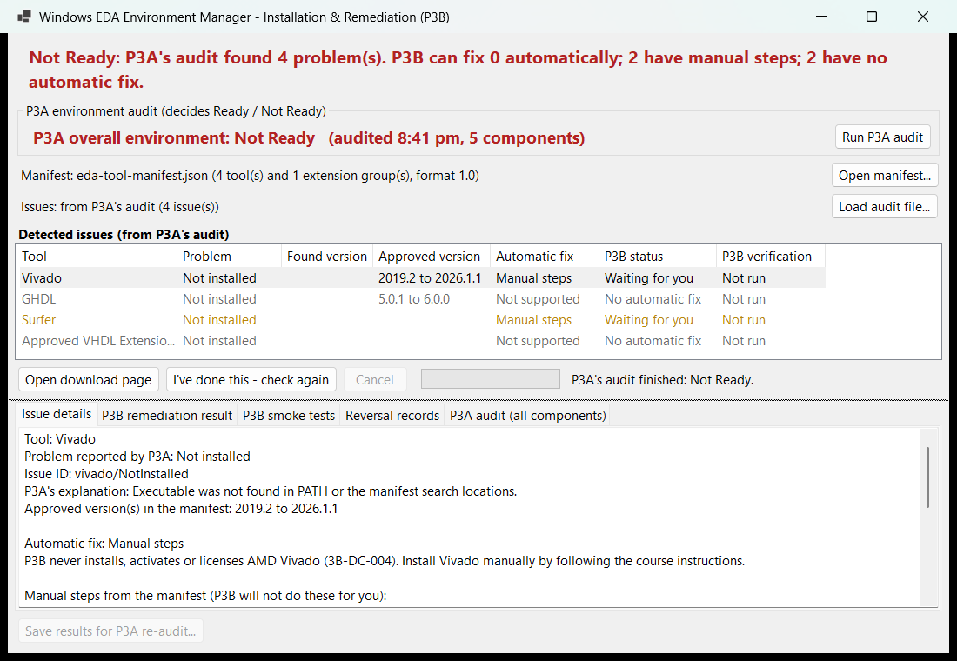
Figure 4: Dashboard after P3A's audit – P3A's verdict in its own box; Vivado selected (manual steps, never installed)
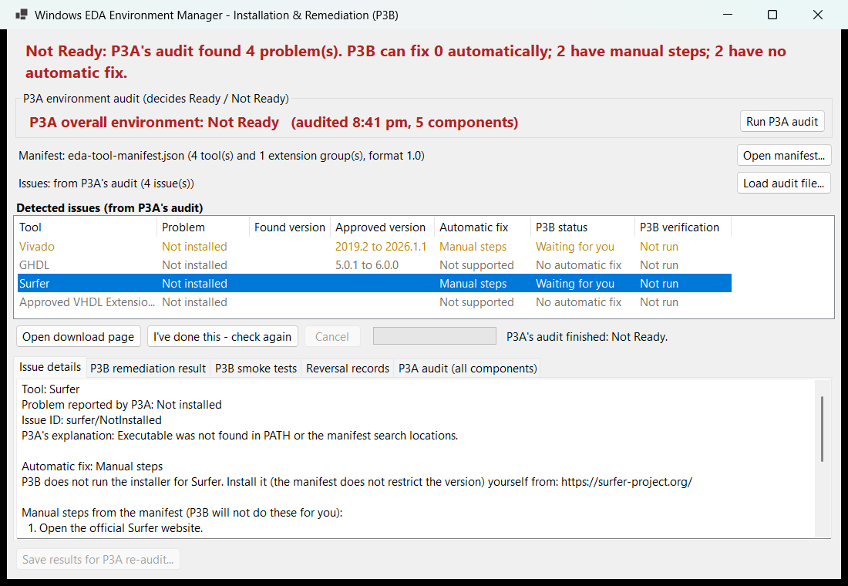
Figure 5: Manual steps for Surfer, with Open download page and I've done this – check again
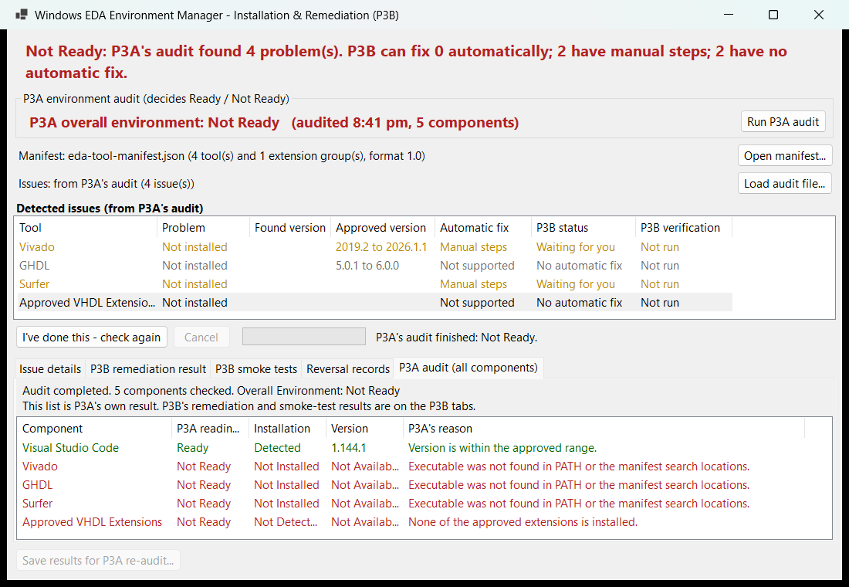
Figure 6: P3A audit tab – every component as P3A reported it
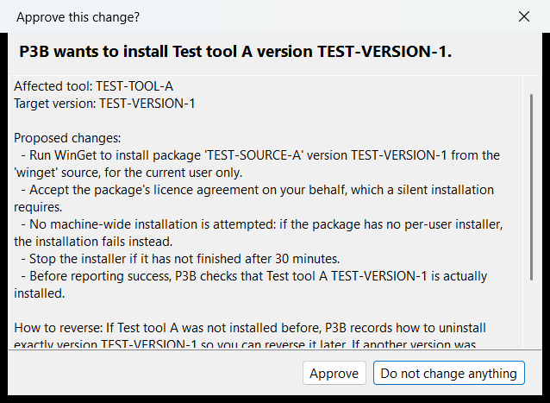
Figure 7: Approval dialog for a supported fix (TEST fixture)
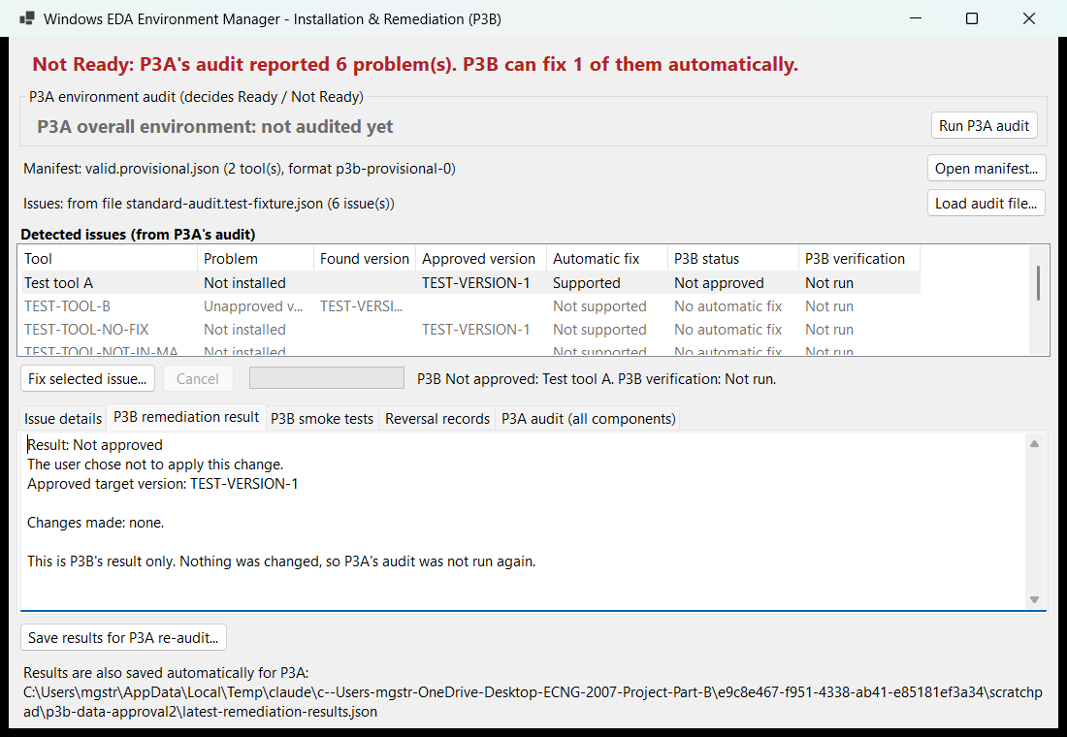
Figure 8: After declining – P3B's result shows that nothing changed and P3A was not re-run

Screen Objects and Actions
Table 8: Screen objects and actions
Object | Action / behaviour
Banner | States the next step; Ready / Not Ready only when repeating P3A's verdict; "Re-audit needed" after a change P3A has not checked; "In Progress" while busy.
P3A box + Run P3A audit | Shows P3A's verdict, time and component count; runs P3A's audit (read-only) off the UI thread.
Open manifest… / Load audit file… | Choose another manifest, or load an audit file instead of running P3A (fallback).
Issues list | One row per P3A issue: tool, problem, found version, approved version or range, automatic fix, P3B status, P3B verification; tooltip gives the reason.
Fix selected issue… | Only for Supported issues; opens the approval dialog. Hidden for issues without an automatic fix.
Open download page | Only when the manifest gives an http(s) page; opens it in the browser. P3B downloads nothing.
I've done this – check again | For manual-steps and unsupported issues; re-runs P3A's audit.
Cancel | Stops a running installer; partial changes are listed and journalled. Disabled during P3A's audit, which changes nothing.
Approval dialog: Approve / Do not change anything | Approve runs exactly the previewed change; the other button (default) changes nothing.
Reverse this change… / Discard record… | Reversal Records tab; both ask for confirmation; a cancelled reversal is never shown as reversed.
Save results for P3A re-audit… | Saves P3B's results to a chosen file (they are also saved automatically).

Requirements Matrix
Each requirement, the design elements that satisfy it, where it is described here, and the test cases in the P3B Test Plan v1.1 that verify it.
Table 9: Requirements traceability
Requirement | Design elements | Section | Test cases
P3B-PR-01 | OperationGate shared by RemediationService and RollbackService; dashboard refuses work while busy | 3.1, 5 | TC-CON, TC-RAU-03
P3B-PR-02/03 | Work off the UI thread; immediate busy state; results processed straight after completion | 3.1, 6.1 | TC-PRF
3B-UR-001 | ActionPreview, InstallationService.CreatePreview, ApprovalDialog | 5, 6 | TC-APR
3B-UR-002 | Separate RemediationResult / SmokeTestResult; P3B tabs vs P3A box | 4, 6 | TC-SMK, TC-RAU-01/02
3B-UR-003 | RemediationPlanner, ManualGuidance, "Not supported" / "Manual steps" labels | 5, 6 | TC-PLN, TC-RAU-04
3B-UR-004 | Plain labels, single window, explicit approval | 6 | TC-USE
3B-IR-001 | ManifestService, ManifestFormats, P3AManifestSchema | 4, 5 | TC-MAN, TC-P3A-01
3B-IR-002 | P3AAuditAdapter, P3AFindingMapper, RemediationRequestFactory, RemediationReport | 3, 5 | TC-AUD, TC-P3A-02/03
3B-IR-003 | Manifest loaded before any preview; load statuses | 5 | TC-MAN
3B-IR-004 | WingetInstaller, VsCodeExtensionInstaller; archives not built (no checksum) | 3.3, 5 | TC-INS, TC-EXT, TC-ACC
3B-IR-005 | Interfaces with test doubles for every effect, including P3A | 3.2 | TC-RPT-04, TC-P3A-04
P3B-DR-01 | RemediationAction/Result, ReversalJournalEntry, RemediationReport | 4 | TC-RPT
P3B-DR-02 | Immutable manifest model, read-only file access; journal kept until reversed/discarded | 4 | TC-MAN-09, TC-REV
3B-DC-001/002 | Per-user installs, sources only from the manifest, winget source only | 3.3 | TC-PRC, TC-EXT
3B-DC-003 | Preview + approval, journal, RollbackService, uninstall handlers | 3.3, 5 | TC-REV, TC-EXT-02
3B-DC-004 | ProhibitedSoftwarePolicy in planner and InstallationService | 3.3, 5 | TC-SAF
3B-DC-005 | Exact approved version, pinned commands, version allow-lists | 5 | TC-SAF, TC-EXT-03
3B-DC-006/007 | Real installs only in the VM; core and tests independent of P3A/P4 | 2, 3.1 | TC-ACC; all automated tests
P3-StR3.1/AC3.1 | P3B reads P3A's manifest with its own validating reader | 4.1 | TC-P3A-01
P3-StR4.1/AC4.1, FR-004 | IReadinessAuditor; automatic P3A re-audit; verdict only from P3A | 3.2, 5 | TC-RAU, TC-ACC-05

Appendices
Appendix A – Proposed changes to P3A's code. P3A's detection code was moved, unchanged, from AuditWindow into a class library EDAEnvironmentManager.Audit (EnvironmentAuditor, AuditReport, AuditFinding, EdaManifestLoader); AuditWindow now draws the same cards from the report; the duplicate project file was removed and a solution file and .gitignore added. This is one commit on the local branch p3b-integration/audit-library, not pushed; details in docs/P3A-CHANGES.md.
Appendix B – Building and running. Clone the group repository next to the P3B folder (..\ECNG_2007_Project, branch p3b-integration/audit-library), then run dotnet build P3B.slnx (0 warnings) and dotnet test P3B.slnx (413 tests, nothing installed). Start the dashboard with dotnet run --project src\P3B.Remediation.WinForms; it opens P3A's manifest and runs P3A's audit.
Appendix C – Open items. Install sources (package IDs, extension versions, archive URLs with SHA-256) in the manifest; the resettable VM for real installs; P3A's acceptance of the audit library; the reference machine for PR-02/03; the usability study for 3B-UR-004. See docs/BLOCKERS.md.
Appendix D – Use of AI. Claude (Claude Code, Anthropic) assisted with implementing, testing and documenting P3B. All design decisions were reviewed by the author, and every behaviour described here is backed by automated tests or recorded evidence.

