Supplemental Material for Brown et al.

## Photos of mother caring for deceased offspring

In this observation

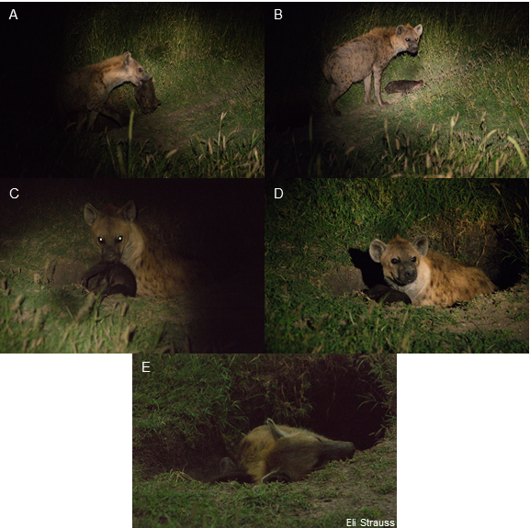

## Model detail and diagnostic for moratlity ~ age at death

Here we used a multinomial model of mortality source as a function of age at death to understand the contribution of different mortality sources to overall mortality. This model was initialized with weak, uninformative priors, and three chains were run for 15000 iterations each (7500 warmup).

#### Model summary and diagnostic

# Priors  
prior_summary(fit)

## prior class coef group resp dpar nlpar bound  
## normal(0,3) b muhuman   
## normal(0,3) b age_at_death muhuman   
## normal(0,3) b mulion   
## normal(0,3) b age_at_death mulion   
## normal(0,3) b muother   
## normal(0,3) b age_at_death muother   
## normal(0,3) b musiblicide   
## normal(0,3) b age_at_death musiblicide   
## normal(0,3) b mustarvation   
## normal(0,3) b age_at_death mustarvation   
## normal(0,3) Intercept muhuman   
## normal(0,3) Intercept mulion   
## normal(0,3) Intercept muother   
## normal(0,3) Intercept musiblicide   
## normal(0,3) Intercept mustarvation   
## source  
## default  
## (vectorized)  
## default  
## (vectorized)  
## default  
## (vectorized)  
## default  
## (vectorized)  
## default  
## (vectorized)  
## default  
## default  
## default  
## default  
## default

summary(fit)

## Family: multinomial   
## Links: mustarvation = logit; mulion = logit; musiblicide = logit; muhuman = logit; muother = logit   
## Formula: y | trials(1) ~ 1 + age_at_death   
## Data: known.mortality.mom.alive (Number of observations: 66)   
## Samples: 3 chains, each with iter = 30000; warmup = 15000; thin = 1;  
## total post-warmup samples = 45000  
##   
## Population-Level Effects:   
## Estimate Est.Error l-95% CI u-95% CI Rhat Bulk_ESS  
## mustarvation_Intercept -2.86 0.89 -4.77 -1.24 1.00 38698  
## mulion_Intercept -3.99 1.04 -6.20 -2.14 1.00 35174  
## musiblicide_Intercept -0.12 0.71 -1.52 1.27 1.00 35245  
## muhuman_Intercept -5.14 1.40 -8.18 -2.71 1.00 34516  
## muother_Intercept -1.02 0.68 -2.40 0.28 1.00 40730  
## mustarvation_age_at_death 0.61 0.22 0.20 1.08 1.00 23263  
## mulion_age_at_death 0.93 0.23 0.52 1.41 1.00 22727  
## musiblicide_age_at_death -0.50 0.38 -1.31 0.17 1.00 26268  
## muhuman_age_at_death 0.95 0.26 0.47 1.50 1.00 23409  
## muother_age_at_death 0.10 0.25 -0.40 0.57 1.00 24298  
## Tail_ESS  
## mustarvation_Intercept 29948  
## mulion_Intercept 28205  
## musiblicide_Intercept 34530  
## muhuman_Intercept 26108  
## muother_Intercept 34446  
## mustarvation_age_at_death 25053  
## mulion_age_at_death 24230  
## musiblicide_age_at_death 24351  
## muhuman_age_at_death 25258  
## muother_age_at_death 27849  
##   
## Samples were drawn using sampling(NUTS). For each parameter, Bulk_ESS  
## and Tail_ESS are effective sample size measures, and Rhat is the potential  
## scale reduction factor on split chains (at convergence, Rhat = 1).

par(mfrow = c(3, 3))  
mcmc_plot(fit, type = 'trace') ## Traceplots indicate convergence

## No divergences to plot.

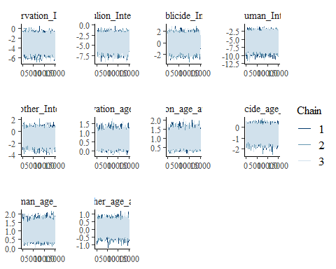

rhat(fit)

## b_mustarvation_Intercept b_mulion_Intercept   
## 0.9999592 1.0000572   
## b_musiblicide_Intercept b_muhuman_Intercept   
## 0.9999475 1.0000153   
## b_muother_Intercept b_mustarvation_age_at_death   
## 1.0001175 1.0000540   
## b_mulion_age_at_death b_musiblicide_age_at_death   
## 1.0001042 1.0000290   
## b_muhuman_age_at_death b_muother_age_at_death   
## 1.0000967 1.0003780   
## lp__   
## 1.0000808

## Model detail and diagnostic for prey density ~ mortality + (1|clan)

Here we built a mixed model of prey density in the month before death as a function of mortality source, including a random effect of clan. This model was initialized with weak, uninformative priors, and four chains were run for 2000 iterations each (1000 warmup).

#### Model summary and diagnostic

# Priors  
prior_summary(prey_mod)

## prior class coef group resp  
## (flat) b   
## (flat) b mortality.modeldeathofmother   
## (flat) b mortality.modelhuman   
## (flat) b mortality.modellion   
## (flat) b mortality.modelother   
## (flat) b mortality.modelsiblicide   
## (flat) b mortality.modelstarvation   
## student_t(3, 174.7, 147.4) Intercept   
## student_t(3, 0, 147.4) sd   
## student_t(3, 0, 147.4) sd clan   
## student_t(3, 0, 147.4) sd Intercept clan   
## student_t(3, 0, 147.4) sigma   
## dpar nlpar bound source  
## default  
## (vectorized)  
## (vectorized)  
## (vectorized)  
## (vectorized)  
## (vectorized)  
## (vectorized)  
## default  
## default  
## (vectorized)  
## (vectorized)  
## default

summary(prey_mod)

## Family: gaussian   
## Links: mu = identity; sigma = identity   
## Formula: prey_density ~ 1 + mortality.model + (1 | clan)   
## Data: hypothesis.test.dataset[!is.na(hypothesis.test.dat (Number of observations: 85)   
## Samples: 4 chains, each with iter = 2000; warmup = 1000; thin = 1;  
## total post-warmup samples = 4000  
##   
## Group-Level Effects:   
## ~clan (Number of levels: 4)   
## Estimate Est.Error l-95% CI u-95% CI Rhat Bulk_ESS Tail_ESS  
## sd(Intercept) 63.41 56.85 2.27 205.37 1.00 1297 1630  
##   
## Population-Level Effects:   
## Estimate Est.Error l-95% CI u-95% CI Rhat Bulk_ESS  
## Intercept 171.48 65.45 34.25 298.39 1.00 1718  
## mortality.modellion 65.63 93.79 -120.08 250.54 1.00 1893  
## mortality.modelother 155.97 94.55 -28.44 339.86 1.00 1954  
## mortality.modelsiblicide 43.91 102.28 -156.20 243.23 1.00 2104  
## mortality.modeldeathofmother 18.43 71.05 -117.15 156.03 1.00 1723  
## mortality.modelstarvation -35.60 96.24 -234.03 152.57 1.00 2162  
## mortality.modelhuman 39.37 111.29 -179.72 252.16 1.00 2344  
## Tail_ESS  
## Intercept 1569  
## mortality.modellion 2545  
## mortality.modelother 2557  
## mortality.modelsiblicide 2629  
## mortality.modeldeathofmother 2339  
## mortality.modelstarvation 2096  
## mortality.modelhuman 2476  
##   
## Family Specific Parameters:   
## Estimate Est.Error l-95% CI u-95% CI Rhat Bulk_ESS Tail_ESS  
## sigma 212.48 17.12 181.78 249.06 1.00 3416 2852  
##   
## Samples were drawn using sampling(NUTS). For each parameter, Bulk_ESS  
## and Tail_ESS are effective sample size measures, and Rhat is the potential  
## scale reduction factor on split chains (at convergence, Rhat = 1).

par(mfrow = c(3, 3))  
mcmc_plot(prey_mod, type = 'trace') ## Traceplots indicate convergence

## No divergences to plot.

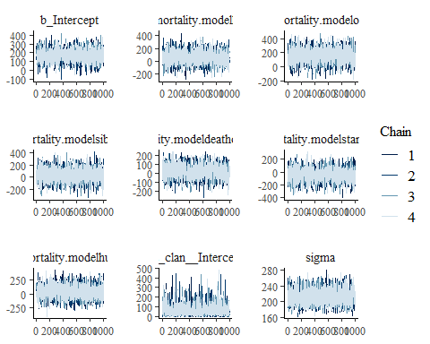

rhat(prey_mod)

## b_Intercept b_mortality.modellion   
## 1.0007226 1.0003561   
## b_mortality.modelother b_mortality.modelsiblicide   
## 0.9995397 1.0009362   
## b_mortality.modeldeathofmother b_mortality.modelstarvation   
## 1.0000562 0.9997458   
## b_mortality.modelhuman sd_clan__Intercept   
## 0.9999478 1.0017845   
## sigma Intercept   
## 0.9997444 1.0008370   
## r_clan[happy.zebra,Intercept] r_clan[serena.n,Intercept]   
## 0.9999492 0.9999367   
## r_clan[serena.s,Intercept] r_clan[talek,Intercept]   
## 1.0030681 1.0009977   
## lp__ z_1[1,1]   
## 1.0009693 0.9996342   
## z_1[1,2] z_1[1,3]   
## 1.0002753 1.0019428   
## z_1[1,4]   
## 1.0002476

## Model detail and diagnostic for cub density ~ mortality + (1|clan)

Here we built a mixed model of prey density in the month before death as a function of mortality source, including a random effect of clan. This model was initialized with weak, uninformative priors, and four chains were run for 2000 iterations each (1000 warmup).

#### Model summary and diagnostic

# Priors  
prior_summary(cub_density_mod)

## prior class coef group resp dpar  
## (flat) b   
## (flat) b mortality.modeldeathofmother   
## (flat) b mortality.modelhuman   
## (flat) b mortality.modellion   
## (flat) b mortality.modelother   
## (flat) b mortality.modelsiblicide   
## (flat) b mortality.modelstarvation   
## student_t(3, 5.3, 2.8) Intercept   
## student_t(3, 0, 2.8) sd   
## student_t(3, 0, 2.8) sd clan   
## student_t(3, 0, 2.8) sd Intercept clan   
## student_t(3, 0, 2.8) sigma   
## nlpar bound source  
## default  
## (vectorized)  
## (vectorized)  
## (vectorized)  
## (vectorized)  
## (vectorized)  
## (vectorized)  
## default  
## default  
## (vectorized)  
## (vectorized)  
## default

summary(cub_density_mod)

## Family: gaussian   
## Links: mu = identity; sigma = identity   
## Formula: cub_associates ~ 1 + mortality.model + (1 | clan)   
## Data: hypothesis.test.dataset[!is.na(hypothesis.test.dat (Number of observations: 80)   
## Samples: 4 chains, each with iter = 2000; warmup = 1000; thin = 1;  
## total post-warmup samples = 4000  
##   
## Group-Level Effects:   
## ~clan (Number of levels: 4)   
## Estimate Est.Error l-95% CI u-95% CI Rhat Bulk_ESS Tail_ESS  
## sd(Intercept) 0.90 0.80 0.03 2.98 1.00 1349 1935  
##   
## Population-Level Effects:   
## Estimate Est.Error l-95% CI u-95% CI Rhat Bulk_ESS  
## Intercept 4.49 0.96 2.54 6.47 1.00 1603  
## mortality.modellion 0.88 1.24 -1.59 3.33 1.00 1910  
## mortality.modelother 0.60 1.40 -2.20 3.39 1.00 1938  
## mortality.modelsiblicide 0.58 1.45 -2.27 3.46 1.00 2228  
## mortality.modeldeathofmother 2.38 0.99 0.46 4.34 1.00 1637  
## mortality.modelstarvation 1.34 1.32 -1.15 3.96 1.00 1990  
## mortality.modelhuman 1.05 1.60 -2.05 4.25 1.00 2267  
## Tail_ESS  
## Intercept 1988  
## mortality.modellion 2270  
## mortality.modelother 2594  
## mortality.modelsiblicide 2562  
## mortality.modeldeathofmother 2273  
## mortality.modelstarvation 2691  
## mortality.modelhuman 2565  
##   
## Family Specific Parameters:   
## Estimate Est.Error l-95% CI u-95% CI Rhat Bulk_ESS Tail_ESS  
## sigma 2.86 0.24 2.43 3.36 1.00 3083 2692  
##   
## Samples were drawn using sampling(NUTS). For each parameter, Bulk_ESS  
## and Tail_ESS are effective sample size measures, and Rhat is the potential  
## scale reduction factor on split chains (at convergence, Rhat = 1).

par(mfrow = c(3, 3))  
mcmc_plot(cub_density_mod, type = 'trace') ## Traceplots indicate convergence

## No divergences to plot.

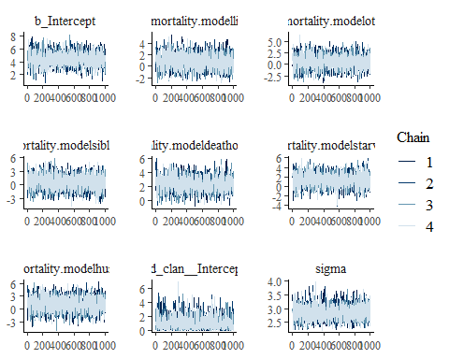

rhat(cub_density_mod)

## b_Intercept b_mortality.modellion   
## 1.003904 1.001073   
## b_mortality.modelother b_mortality.modelsiblicide   
## 1.001814 1.001838   
## b_mortality.modeldeathofmother b_mortality.modelstarvation   
## 1.001989 1.002282   
## b_mortality.modelhuman sd_clan__Intercept   
## 1.000776 1.002827   
## sigma r_clan[happy.zebra,Intercept]   
## 1.000621 1.001415   
## r_clan[serena.n,Intercept] r_clan[serena.s,Intercept]   
## 1.002030 1.001213   
## r_clan[talek,Intercept] lp__   
## 1.001291 1.002071