**Estimating longitudinal hierarchies: A framework for studying the dynamics of dominance**

Eli D Strauss1,2,3

Kay E Holekamp1,2,3

1Department of Integrative Biology, Michigan State University, East Lansing, MI, USA

2Program in Ecology, Evolutionary Biology, and Behavior, Michigan State University, East Lansing, MI, USA

3BEACON Center for the Study of Evolution in Action, Michigan State University, East Lansing, Michigan, USA

Eli Strauss (Corresponding author): [straussed@gmail.com](mailto:straussed@gmail.com)

Kay Holekamp: holekamp@msu.edu

**Abstract**

1. Social inequality is a consistent feature of animal societies, often manifesting in dominance hierarchies, in which each individual is characterized by a dominance rank denoting its place in the network of competitive relationships among group-members. Most studies treat dominance hierarchies as static entities despite their true longitudinal, and sometimes highly dynamic, nature.
2. To guide study of the dynamics of dominance, we propose the concept of a longitudinal hierarchy: the characterization of a single, latent hierarchy and it’s dynamics over time. Longitudinal hierarchies thus comprise both periodic rank-order estimates and assessment of rank dynamics between these estimates. Methods that estimate longitudinal hierarchies should optimize accuracy of rank dynamics as well as the rank orders themselves. Although ranking algorithms have often been assessed for their accuracy at estimating rank orders, their ability to estimate rank dynamics has never been evaluated.
3. Estimation of longitudinal hierarchies requires both incorporation of new individuals and optimal identification of rank dynamics. We propose that prior knowledge of dominance correlates can be used to inform placement of new individuals in the hierarchy, and that an inertial tendency for individuals to maintain their ranks over time in the absence of evidence to the contrary can be used to prevent overestimation of rank dynamics. We suggest a novel matrix-based method (‘CRAM’) for determining longitudinal hierarchies that incorporates these strategies.
4. Using both a simulated dataset and a long-term empirical dataset from a species with two distinct sex-based dominance structures, we compare the performance of CRAM with four existing methods. We show that incorporation of inertial tendency is vital to avoid overestimation of rank dynamics, and that prior knowledge of dominance correlates improves the accuracy of estimated longitudinal hierarchies. We find that CRAM is the most accurate method for estimating more stable longitudinal hierarchies, like those found in most long-lived vertebrates, and that a modified Elo rating method performs best when estimating highly dynamic hierarchies.
5. This work provides the first explicit framework for studying the dynamics of dominance.

**INTRODUCTION**

Social inequality is a surprisingly consistent feature of group living. This inequality often manifests as a dominance hierarchy, in which repeated agonistic interactions between group members lead to the emergence of a linear order of individuals from high to low rank (H. de Vries, 1998), with rank position often determining priority of access to resources. Found in a diverse set of organisms including protists (Fortunato, Queller, & Strassmann, 2003), insects (Shimoji, Abe, Tsuji, & Masuda, 2014), fish (Sneddon, Schmidt, Fang, & Cossins, 2011), mammals (Bro Jørgensen & Beeston, 2015), and birds (Schjelderup-Ebbe, 1922), dominance hierarchies promote group stability and reduce the costs of living in an uncertain social environment (Beaulieu, Mboumba, Willaume, Kappeler, & Charpentier, 2014; Mendonça-Furtado et al., 2014). Since the first description of a ‘peck order’ among chickens (Schjelderup-Ebbe, 1922), dominance hierarchies have proven to be an important force structuring myriad aspects of an organism’s biology, including its space use (Boydston, Kapheim, Szykman, & Holekamp, 2003; Murray, Mane, & Pusey, 2007), health (Sapolsky 2005; Flies et al. 2016; Snyder-Mackler et al. 2016), longevity (Swanson, Dworkin, & Holekamp, 2011; Tung, Archie, Altmann, & Alberts, 2016), and reproductive success (D. de Vries, Koenig, & Borries, 2016; Pusey, Williams, & Goodall, 1997).

Dominance hierarchies are dynamic systems: the positions of individuals within a hierarchy can change over time due to temporal variation in demography, ecological conditions, ontogenetic development, or the relative body condition of group members (Hasegawa & Kutsukake, 2014; Lea, Learn, Theus, Altmann, & Alberts, 2014; Samuels, Silk, & Altmann, 1987; Sapolsky, 2005). Nevertheless, most studies treat dominance as a constant individual attribute rather than a transient state. This static approach to dominance is appropriate for many studies conducted over short periods of time; consistency, at least over short times scales, is a defining feature of dominance relationships (Drews, 1993). While useful for understanding the consequences of dominance hierarchies, this approach does not allow for the study of system dynamics. Understanding these dynamics will facilitate study of the structure of inequality in animal societies, the relationships between dominance networks and other social networks, and the stability of dominance hierarchies. The rapid recent advances in social network analysis techniques (Farine, 2017; Hobson, Avery, & Wright, 2013; Pinter-Wollman et al., 2014) offer promising methods for assessing the dynamics of dominance hierarchies, but reliable estimation of hierarchies and their dynamics is a requisite first step.

Until now, an explicit framework for investigating the dynamics of dominance hierarchies has been lacking. Most studies have estimated the dynamics of dominance systems by dividing the study into periods, determining ranks independently within each period, and inferring changes in rank based on the differences observed between one period and the next (Chapais, Girard, & Primi, 1991; Combes & Altmann, 2001; Hasegawa & Kutsukake, 2014; Higham & Maestripieri, 2010; K E Holekamp, Ogutu, Dublin, Frank, & Smale, 1993; Koenig, Borries, Caselli, & Lu, 2013; Samuels et al., 1987). Others simply report directly observing changes (Dettmer, Woodward, & Suomi, 2015; Ehardt & Bernstein, 1986; Perry, 1998). Most studies focus on rank reversals, in which two individuals reverse their dominance relationship. For some, rank reversals are only identified if they are observed to be persistent (Chikazawa, Gordon, Bean, & Bernstein, 1979; Samuels et al., 1987), but it is often unclear whether or not transient cases are included as rank reversals. The Elo-rating method has been used to calculate changes in numerical dominance scores for individuals by progressively updating scores after each new interaction or after each discreet period (Albers & de Vries, 2001; McDonald & Dillon, 2015; Neumann et al., 2011). In light of these varied approaches, it would be useful to have an overarching framework for assessing the dynamics of dominance hierarchies.

To guide research on the dynamics of dominance, we propose the concept of a ‘longitudinal hierarchy’, which is the characterization of a single, latent hierarchy and it’s dynamics over time (Fig. 1). In this framework, the total length of the study is divided into time periods. These time periods could be long enough to encompass many interactions, shortened to contain only one interaction (i.e., progressively updating ranks after each interaction; Neumann et al., 2011), or nested such that each period includes the previous periods plus some new interactions (e.g., McDonald & Dillon, 2015). Although any period delineation approach is consistent with the longitudinal hierarchy framework, some approaches are likely to work better than others depending on the ranking method used, data availability, and the biology of the study organism. Whereas static hierarchies describe the rank (r) of each individual (i) during a single period (t), longitudinal hierarchies estimate both the rank of each individual in multiple time periods (rit, rit+1, etc.) and the rank dynamics of all individuals between time periods (∆it, ∆it+1). Rank dynamics for any single individual comprise both the sum of its changes in rank due to rank reversals and those that occur in the absence of rank reversals, such as those due to demographic events. The amount of rank change an individual undergoes due to demographic events is thus calculated as the total change by one individual from one period to the next minus the number of group-mates with which that individual reversed its dominance relationship from one period to the next. Hence the key to estimating the dynamics of a latent hierarchy is to estimate the number of rank-reversals taking place.

Following from this framework, the best approach to studying the dynamics of dominance is to construct longitudinal hierarchies that most accurately estimate both rank orders of individuals (henceforth, *r*) and rank dynamics (henceforth, ∆). Although rank dynamics are likely to be extremely important to the biology of social animals, a lack of guidelines on how to reliably estimate ∆ currently inhibits our ability to study them. Furthermore, whereas much work has investigated the performance of different ranking algorithms at optimally estimating r, no work to date has explicitly investigated the performance of these algorithms at estimating ∆.

The primary challenge in estimating longitudinal hierarchies is to ensure the accuracy of estimates of the dynamics of the hierarchy (∆). An obvious approach to estimating ∆ is to estimate ranks for all individuals at time *t* and time *t+*1 and then infer ∆ from the difference between the two. However, this approach is likely to overestimate the amount of rank change in the hierarchy if the estimates of the rank order at time *t* and *t+1* are calculated independently, because slight inaccuracies in the rank orders at each time point can be amplified to suggest rank reversals that never took place (Fig 2). In light of limited sample size, sampling error, and natural variation in the outcome of dominance interactions, the problem is how best to discriminate between constant and shifting dominance ranks. We propose that an optimal procedure for estimating ∆in a longitudinal hierarchy should incorporate an inertial tendency for individuals to maintain their ranks from one time period to the next unless the data suggest otherwise. This inertial tendency is justified by the very definition of dominance, which includes temporal stability as an essential component (Drews, 1993). In fact, the notion that dominance hierarchies reduce uncertainty about the outcomes of contests between group members (Beaulieu et al., 2014; Mendonça-Furtado et al., 2014) assumes that the state of the hierarchy at a given time is predictive of future interactions. Points-based methods that continuously update scores after new interactions, such as the Elo-rating method, already incorporate this inertial tendency, because the scores of individuals at any time point reflect the outcomes of recent interactions as well as historical interactions. The simplest approach to incorporating inertial tendency into a dynamic ranking method is to use the rank-order from one study period as an initial order for subsequent periods. The rank order during any given study period is thus determined to be the order from the previous study period amended by new data from the current study period.

The incorporation of demographic changes poses another critical challenge to the construction of longitudinal dominance hierarchies. Although individuals leaving the group (due to emigration or death) don’t pose a major problem, individuals who join the group (due to immigration or birth) need to be included in the hierarchy in appropriate places. One approach is to have individual-specific ‘burn-in’ periods, where some early data for each new individual are used to assign its starting rank, and that individual is then added to the hierarchy at the end of the burn-in period. This burn-in paradigm is used on the whole hierarchy in the Elo-rating method (Albers & de Vries, 2001; Neumann et al., 2011), and can result in significant amounts of discarded data, which are particularly troubling when interaction data are sparse (Newton-Fisher, 2017). A better approach uses prior knowledge of dominance correlates to inform the placement of new individuals in an existing hierarchy. The success of this approach will vary among species, and it will only be viable for species for which prior research has identified reliable correlates of dominance rank. For example, in species with age- or size-based hierarchies (e.g. Archie et al. 2006), new individuals can be added to the hierarchy based on their body size relative to the sizes of other same-sex group members. Newton-Fisher (2017) used prior information about individual dominance ranks to improve the effectiveness of the Elo-rating in resolving a hierarchy of male chimpanzees. Not only does this approach eliminate data lost from a burn-in period, but it also allows for systematic study of the causes of deviation from expected rank based on rank correlates.

Here we use the longitudinal hierarchy framework to provide the first methodological investigation of the dynamics of dominance hierarchies. We first describe the Conservative Rank Assignment Method (CRAM), a novel method for estimating longitudinal hierarchies that uses a matrix-reordering approach that incorporates prior knowledge of dominance correlates, as well as an updating algorithm to reliably estimate both *r* and ∆. We then use both simulated data and empirical data from a long-term study of spotted hyenas (*Crocuta crocuta*) to assess the accuracy of *r* and ∆ estimated by our new method in relation to the Elo method, a modified Elo method informed by prior knowledge of dominance correlates, the percolation and conductance method, and the David’s score method. To demonstrate the general applicability of using prior knowledge of dominance correlates to inform the creation of longitudinal hierarchies, we conducted tests using dominance hierarchies of both philopatric female and immigrant male hyenas, as these hierarchies are structured by two different dominance correlates. We hope that this longitudinal hierarchy framework and the methodological investigation we present here will encourage future research on the structure and dynamics of non-egalitarian societies.

**METHODS**

**Conservative Rank Assignment Method (CRAM)**

*Overview*

CRAM is a matrix-reordering approach that overcomes the challenges to estimation of longitudinal hierarchies by incorporating an inertial tendency for ranks to remain stable over time, and by using prior knowledge of dominance correlates to inform the placement of new individuals as they enter the hierarchy. The method’s general approach is to divide the data into periods that together span the entire duration of the study (Fig 1). In each period, an initial order is determined that is identical to the order from the previous period, with any new individuals added to the hierarchy according to some criteria determined *a priori,* and based on prior knowledge of the biology of the organism. The outcome of agonistic interactions from the current study period are then converted to a binary outcome matrix (McDonald & Dillon, 2015) and used to identify dyads for which the observations from the current period are inconsistent with the initial order. Akin to the I&SI method (H. de Vries, 1998; Schmid & de Vries, 2013), individuals in inconsistent dyads are then moved iteratively to minimize the number of inconsistencies in the matrix and all minimal-inconsistency orders are saved. Finally, the optimal order for the current study period is selected as the minimal-inconsistency order that is most similar to the initial order.

*Assumptions*

CRAM makes two key assumptions that guide the rank assignment process. First, the hierarchy in question is assumed to be transitive and linear. Although this assumption may not hold for all animal groups, we argue that it is reasonable for the majority of species. In a survey of 172 groups of mammals, insects, fish, and birds, Shizuka and McDonald (2015) found that transitive triadic motifs were common and that non-transitive (i.e., cyclical) triadic motifs were rare, suggesting that transitive hierarchies are normative across phyla. Furthermore, although some have argued for the pervasiveness of non-linear dominance hierarchies (Douglas et al., 2017), the linearity metrics that support this claim are biased towards underestimating linearity (Shizuka & McDonald, 2012), and are highly sensitive to the amount of missing information in the dataset (Klass & Cords, 2011). Finally, the assumption of linearity is made implicitly or explicitly in all ordinal ranking methods, including all those we investigate here. However, to confirm this assumption, we recommend that researchers use the triangle transitivity measure (ttri; Shizuka & McDonald, 2012) to assess the linearity of their aggression networks before proceeding with any linear rank ordering approach, including CRAM.

The second assumption made by CRAM is that the true ranks of individuals at consecutive time points are non-independent. This assumption manifests itself in CRAM’s procedure for assigning ranks for all study periods after the first. That is, ranks are assumed to have remained the same from one period to the next unless there are observations suggesting that a rank change has taken place. Not only is this assumption justified by the definition of dominance, but it is also made by the Elo method.

*Pre-processing*

Before beginning the main phase of CRAM, a few pre-processing steps must be taken by the investigator. The first step is to divide the total duration of the study into periods. Individuals are assigned a rank within each period, and an individual’s rank may change from period to period. The length of each period should depend on the research aim, the biology of the organism, and the frequency of observation of the study organism. Furthermore, the duration of the periods need not be identical; for example, some researchers have found dividing a longitudinal study into periods based on demographic events to be a useful strategy (Neumann, Assahad, Hammerschmidt, Perwitasari-Farajallah, & Engelhardt, 2010; Schülke, Bhagavatula, Vigilant, & Ostner, 2010). Alternatively, to emulate the progressive evaluation implemented in the Elo method, one could divide the study into periods such that each period contained only a single interaction.

Next, the researcher must choose an *a priori* ordering rule based on previous research on the study organism. This rule guides the formation of the starting order in the first period, and determines where new individuals are initially added into the order in subsequent periods. An ordering rule might be based on body size, weapon size, tenure in the study group, age/sex class, individual variation in aggressiveness, maternal social position, or any other reliable correlate of social rank in the study species. In the absence of an unambiguous ordering rule, another ranking method could potentially be used to set an initial order.

*Main phase*

CRAM selects an optimal order for each period by modifying the order from the previous period to minimize the proportion of dyadic relationships inconsistent with the data while retaining as much of the structure from the previous period as possible. The algorithm starts by creating an initial order for the current period based on the order from the previous period. Dead or emigrated individuals are removed from the order and new individuals are added to the hierarchy according to the *a priori* ordering rule.

Next, the algorithm adjusts this initial order by tabulating all outcomes of observed agonistic interactions in a sociomatrix, and binarizing the matrix such that a 1 appears in cells where the row individual beat the column individual more than vice versa, and a 0 appears in cells where the row individual lost to the column individual more than vice versa. Cells for dyads that don’t interact or where both individuals win the same number of interactions also receive 0s. Inconsistencies are identified as dyads with an observed winner that is not consistent with the proposed order. In order to minimize overfitting of the data from a particular study period, inconsistencies are ignored if there are no subsequent observations of the dyad that corroborate the inconsistency. A transient inconsistent outcome in a dyadic fight might occur, for example, when a low-ranking female defends her offspring against a higher-ranking female; the apparent reversal in the rank relationship between the two adult females indicated by their agonistic behavior does not necessarily persist after the specific fight in question. This approach is similar to that taken by other researchers (Koenig et al., 2013; Samuels et al., 1987). Because future observations are required to corroborate any observed inconsistency, studies investigating the dynamics of dominance should exclude the final period from their analysis, as no subsequent observations are available for that period.

Once persistent inconsistencies have been identified, the order is optimized in a multi-step reordering process similar to that implemented in the I&SI method (H. de Vries, 1998; Schmid & de Vries, 2013). In the first step the order is iteratively modified by randomly selecting a single individual involved in an inconsistent dyad and moving it to a new location in the hierarchy. All potential new placements are checked, and each new placement that improves the order is saved as a minimally inconsistent order (MIO). This reordering process then repeats 1000 times, each time selecting a new individual involved in an inconsistency from the list of MIOs. Next, step 1 is repeated 100 times, producing a list of orders that each have the minimal number of inconsistencies identified during the reordering processes. Finally, the optimal order is selected from the list of MIOs by comparing the similarity between each MIO and the initial order from the current study period. Ties between equally optimal orders are broken by selecting a MIO that best fits, first, the observations from the study period, then observations from subsequent study periods. If ties remain after these selection criteria are applied, a final order is selected randomly from among the tied orders.

**Comparison of different rank-ordering methods**

*Rank-ordering methods*

We tested five rank-ordering methods using both empirical and simulated datasets. We used two versions of the Elo-rating method, a method in which individuals gain or lose points after each interaction according to the outcome of the interaction and the relative ranks of the contestants (Albers & de Vries, 2001; Elo, 1978; Neumann et al., 2011). Here the “Informed Elo” method used prior information about rank correlates to initialize starting scores for new individuals, whereas the “Uninformed Elo” method did not. For both Elo implementations, the k parameter, which determines the magnitude of point gain/loss after each interaction, was set to 200 (following Sánchez-Tójar, Schroeder, & Farine, 2017). The order produced by the Elo method was determined by the final scores from each study period. All individuals began each study period after the first with their final scores from the previous period. Thus, the Informed Elo method, like CRAM, incorporated both inertial tendency and prior knowledge of dominance correlates to optimally estimate *r* and *∆*, whereas the Uninformed Elo method only incorporated the inertial tendency. Here both Informed and Uninformed Elo methods were implemented with a modified version of the *elo_scores* function in the aniDom package in R (Farine & Sanchez-Tojar, 2017; R scripts in Supplemental Materials). We also tested the David’s scores method (implemented in the EloRating package, Neumann & Kulik, 2014), which assigns each individual a score based on the proportion of group-members it dominates, corrected for the number of observations per dyad (David, 1987; Gammell, de Vries, Jennings, Carlin, & Hayden, 2003). Both Elo and David’s scores methods produce numerical rank scores, which are more useful for addressing some research questions than a simple rank-order (Albers & de Vries, 2001; Neumann et al., 2011). Our current longitudinal hierarchy framework doesn’t support the use of non-ordinal ranks, however, so we converted scores used with both methods to ordinal ranks. The fourth method we tested was the percolation and conductance (PERC; Fujii et al., 2016) method, a promising new rank-ordering approach that uses transitive network motifs to inform rank assignment. The PERC method was run with a maximum path length of four; if there were no paths of length four, this value was decreased to match the data. Neither PERC nor the David’s score method incorporate an inertial tendency for ranks to remain constant from one period to the next, so we expected both to overestimate ∆. Finally, we tested CRAM, which was parameterized to perform 100 attempts at finding a best order for each study period with up to 1000 reordering steps per attempt. We elected not to test the I&SI method in our main study, despite its similarity to CRAM, because it has prohibitively slow runtimes, especially with sparse data, and because our method is a direct extension of I&SI. All methods and statistics were implemented in the statistical software R, version 3.4.0 (R Development Core Team, 2017).

*Simulated data*

To compare performance among these methods in a situation with a known true hierarchy, we simulated 10 longitudinal hierarchies, each comprised of 20 individuals and spanning 20 study periods. We simulated minor shifts in the hierarchy through randomly determined rank reversals. We simulated hierarchies both with moderate amounts of changes of small magnitude and with many changes of large magnitude to assess the performance of each method under varying conditions. In each study period, the number of individuals undergoing rank changes was randomly selected from a Poisson distribution (lambda = {1, 5}). The number of rank positions each individual moved up or down the hierarchy during a rank change was drawn from an exponential distribution (rate = {1, 0.5}), and a random sample from a binomial distribution (prob = {0.5, 0.5}) determined whether they moved up or down**.** Additionally, we simulated the demographic changes of birth or immigration by including a 20% probability that a new individual would enter the hierarchy at a random location in each study period. We did not simulate emigration or death because individuals who leave the group are no longer assigned ranks.

Simulated interactions were generated using the *generate_interactions* function from the *aniDom* package, with parameters *a* = 15 and *b* = 0, both ID- and rank-based biases, and generating 20 interactions per individual (Farine & Sanchez-Tojar, 2017). This produced hierarchies similar to those found in gregarious vertebrates, in which (1) higher-ranked individuals were very likely to win interactions, (2) this likelihood increased with the rank difference between the two individuals, and (3) individuals varied in the number of interactions in which they engaged (see Farine & Sanchez-Tojar, 2017; Sánchez-Tójar, Schroeder, & Farine, 2017 for details). Because ranking methods are highly sensitive to the proportion of ‘unknown’ dyads, or dyads for which there are no observed behavioral interactions during the study period (H. de Vries, 1998; Gammell et al., 2003; Klass & Cords, 2011; Neumann et al., 2011), we tested each method with three different proportions of missing data. Henceforth we will refer to this proportion as “*% unknowns*”, following Klass & Cords (2011). To do this, we removed observations from randomly selected dyads until the *% unknowns* matched a predetermined value, which we set to low (20%), medium (50%) or high (80%). The simulation occasionally produced more than 20 *% unknowns* before any data were removed, in which case we simply left all data intact in the ‘low’ condition. For the methods incorporating prior knowledge of dominance correlates, we simulated an arbitrary rank-associated trait (e.g., body size) value between 0 and 100 for each individual such that the Spearman’s rank correlation between the trait value and the true ranks matched a specified value, which we tested at r= 0.9, 0.7, 0.5, and 0.2. This rank-associated trait was used as the initial order for both CRAM and the Informed Elo method, and was also used in placing new individuals in the hierarchy with these two methods. For the Informed Elo method, the initial scores for individuals were arranged from -1900 to 1900 by steps of 200, and ordered by the rank-associated trait. To ensure our results were not biased by the starting scores, we also ran a test with initial scores ranging from -475 to 475 by steps of 50 (Supplemental MaterialsFigs. S7, S8). For the Uninformed Elo method, each individual was assigned an initial score of 0 and new individuals entering the hierarchy were assigned the overall mean score at that time step. For the Informed Elo method, new individuals entered the hierarchy according to their simulated trait value and with an Elo score set to the mean of the two individuals adjacent in the hierarchy.

To assess the performance of each method, we tabulated the number of dyadic relationships identified correctly and incorrectly by each method across study periods, and used a binomial GLMM to test the effect of method on the proportion of dyads correctly identified. We also tabulated the numbers of dyads each method identified as changing with respect to their dominance order and those identified as remaining static, and we used a binomial GLMM to test the effect of method on ∆. Because CRAM uses future observations to corroborate changes observed in any given study period, we excluded the last period from our analyses. The first period was excluded from the analysis of ∆ because no rank reversals could take place in the first period. We included random effects for simulation run and study period nested within simulation run for all analyses.

*Empirical data*

We tested the performance of the five ranking methods on 25-year hierarchies of immigrant male and philopatric female spotted hyenas. Male and female hierarchies were analyzed separately because they follow different but predictable patterns, which allowed for testing CRAM and the Informed Elo method with two different dominance correlates. Like the pattern observed in many cercopithecine primates, rank acquisition in female spotted hyenas typically follows a pattern of maternal rank inheritance with youngest ascendancy (Kay E Holekamp & Smale, 1991; Kawamura, 1958), wherein each new female acquires the rank immediately below that of her mother and above her older sisters. In contrast, immigrant male spotted hyenas queue for dominance, such that males with the longest tenure in the group occupy the highest ranks (East & Hofer, 1993; Smale, Nunes, & Holekamp, 1997). We used these two principles to add new females and males to their respective hierarchies with both methods. New females in the Informed Elo method were added to the female hierarchy with a score of one less than their mothers (to mimic maternal rank inheritance with youngest ascendancy), and new males were added to the bottom of the male hierarchy with a score of 200 less than the next newest male (to mimic queueing).

The empirical data were collected by personnel of the Mara Hyena Project in the Masai Mara National Reserve in southern Kenya (Frank, 1986) from 1989 to 2015. Contest outcomes were recorded using all-occurrence sampling (Altmann, 1974) of agonistic interactions observed during daily morning and evening observation sessions, and genealogical relationships between mothers and daughters were inferred based on genotyping and observations of nursing behavior. Individuals were identified based on their unique spot patterns, and new immigrant males were considered to have immigrated once they had been observed interacting with members of the clan on at least three different occasions. We divided the longitudinal datasets into calendar year-long periods stretching from 1989 to 2013; given that hyenas breed and disperse throughout the year, calendar year represents a fair but arbitrary break point. Average group size was 24.23 (16-52) adult females, and there were on average 4.6 (1-14) females recruited per year and 3.56 (0-13) females lost per year. We calculated ranks for all females at least 1.5 years old at the start of each year and all immigrant males. The 1.5 year age threshold was selected based on previous work indicating that the process of rank acquisition among maturing females is complete at around 1.5 years of age (Smale, Frank, & Holekamp, 1993). For both Elo and CRAM methods, ranks for the first study year were set according to observations made by Laurence Frank, KEH and Laura Smale prior to 1989 using a strategy similar to that described by Martin & Bateson 1993 (Frank, 1986). We observed an average of 10.13 interactions per female per year (1.25-26.43), leading to a mean *% unknowns* per year of 65.2(range 44.2-85). There were on average 18.81 (11-26) adult males, and there were on average 3.84 (1-9) individuals recruited and 3.84 (0-13) individuals lost per year. Data from males were significantly more sparse, with an average of 3.64 interactions per male per year and a mean *% unknowns* per year of 83.05 (65.6-96.67). Although these values are lower than were depicted in a previous study from the same population (Kay E Holekamp & Smale, 1993), the adjacency matrix depicted earlier was created from three years of interactions, whereas the current study separated interactions by year.

We assessed performance of each method based on three criteria: (1) the number of rank-reversals from year to year, (2) the proportion of outcomes observed during a particular year that were consistent with the order produced by the method, and (3) the proportion of outcomes observed during the following year that were consistent with the order produced by the method. Based on reports in the literature about the societies of spotted hyenas and other species with maternal rank inheritance, we expect the hierarchy to be highly stable (East & Hofer, 1993; Frank, 1986; K E Holekamp & Smale, 1991). Methods that produce orders that change frequently from year to year and that are inconsistent with future data are likely to suffer from overfitting. To test the amount of change from year to year estimated by each method, we coded each dyad as a Bernoulli trial according to whether the dyadic relationship had changed from the previous year. We used a binomial GLM to test the effect of method on the yearly proportion of dyadic changes in the longitudinal hierarchy. Similarly, we recorded the proportion of aggressive interactions from the current year and from the subsequent year according to whether their outcomes were consistent with the order generated by the current year. Here again, we used a binomial GLM to test the relationship between ranking method and the proportion of data consistent with the rank orders produced. In all analyses we used Tukey post-hoc tests (R package *multicomp,* Bretz et al. 2016) to investigate pairwise differences between specific methods.

**RESULTS**

*Simulated data*

Both *% unknowns* and ranking method had strong effects on the accuracy of orders produced (Fig. 3-4) and on the estimated dynamics in the simulated dataset (Fig. 5-6). As the *% unknowns* increased, the methods estimated longitudinal hierarchies with more rank reversals (ß = 1.723, p < 0.0001) and less accurate rank orders (ß = -2.134, p < 0.0001). The differences in accuracy of *r* were relatively small among most methods, but CRAM and the Elo methods estimated *r* with the highest accuracy (Fig. 3c, 4c).

Although differences in the accuracy of *r* estimates were small, the methods differed importantly in the accuracy of their estimates of ∆. When tested on more stable simulated hierarchies, all methods overestimated the number of rank reversals from one period to the next, and CRAM produced the most accurate estimate of ∆ (Fig. 5). Furthermore, this difference was not small; the Informed Elo method did second best, and it was 3.49 times as likely to identify a rank reversal as was actually observed, whereas CRAM was only 1.20 times as likely. When tested on highly unstable simulated hierarchies, the Informed Elo method had the most accurate estimate of ∆, and CRAM underestimated ∆ (Fig. 6). In both cases, methods that incorporated inertial tendency estimated ∆ most accurately, whereas methods without an inertial tendency consistently overestimated the dynamics of the latent hierarchy. Finally, reducing the informative value of the dominance correlate (by reducing its correlation with the true order from 0.9 to 0.7, 0.5 and 0.2) somewhat reduced the performance of the methods using this information, but did not qualitatively change the pattern of results (Figs. S1-S6), suggesting that the Informed Elo method and CRAM were robust to variation in the accuracy of the dominance correlate.

*Empirical data*

In tests with the empirical dataset on philopatric females, method had strong effects on both the amount of change in the orders identified (Fig. 7) and on the fit between the identified orders and the observed data (Fig. 8). Pairwise comparisons (Table S12) revealed that CRAM produced hierarchies with the fewest rank-reversals from year to year (Fig. 7f; p < 0.0001). Furthermore, although the PERC method produced orders that were most consistent with the observations for the current year (Fig. 8a; p < 0.001; Table S10), these orders were poorly predictive of the outcome of observations from the following year (Fig. 8b; Table S11), and changed frequently from year to year (Fig. 7d). CRAM produced orders that were consistent with the current data and most consistent with future data (Fig. 8; p < 0.0001). As in the simulated study, methods that incorporated inertial tendency estimated significantly fewer rank-reversals than methods without inertial tendency. Although we don’t know the true number of rank-reversals taking place in the latent hyena hierarchies, the methods that incorporated inertial tendency produced more biologically realistic estimates of hierarchy dynamics (Fig 7).

Despite the fact that male and female hierarchies in spotted hyena clans are organized based on entirely different rules (tenure and maternal rank inheritance, respectively), results from the immigrant male data corroborated our findings from females. Here again, CRAM produced the hierarchy with fewest rank-reversals (Fig. 9; p < 0.001; Table S15). The patterns of consistency between current and future interactions were similar to those observed in females; however, not all difference that were significant in females were significant in males (Fig. S9), and CRAM and the Informed Elo method were tied as the methods that produced orders that were most consistent with future interactions (p = 0.979; Table S14). Furthermore, the sparseness of the data used to derive the male hierarchies limits the conclusions that can be drawn from this analysis.

**DISCUSSION**

Data from empirical and simulated datasets suggest that CRAM and the Informed Elo method produce the most accurate longitudinal hierarchies. We found that CRAM was the most accurate at estimating longitudinal hierarchies from less dynamic latent hierarchies (Figs. 3,5), whereas the Informed Elo method did better when estimating longitudinal hierarchies from highly dynamic latent hierarchies (Figs. 4,6). Results from our empirical study confirm that CRAM produces a more conservative estimate of hierarchy dynamics than the Informed Elo rating. Because we expect the latent hierarchy of spotted hyenas to have few rank reversals (Hofer & East, 2003; Kay E Holekamp, Smith, Strelioff, Van Horn, & Watts, 2012), CRAM’s estimate of the hierarchy dynamics in this case may be more accurate. However, our lack of knowledge of the true state of the latent hierarchy prevents us from being certain.

Most generally, we found that the incorporation of inertial tendency is vital to the accurate estimation of longitudinal hierarchies because methods that calculate orders *de novo* each period tend to overestimate the dynamics of the latent hierarchy (Figs 2, 4, 6, 7). We conclude that the use of methods without an inertial tendency to characterize longitudinal hierarchies is inappropriate. Furthermore, the fact that the two best methods incorporated prior information on dominance correlates suggests that this information also significantly improves the ability to estimate accurate longitudinal hierarchies. Obviously, this strategy is dependent upon a previously identified dominance correlate or acquisition rule (e.g., maternal rank inheritance with youngest ascendancy), and some organisms may not yet be sufficiently well-studied to identify such a pattern, or no such pattern may exist at all. In these cases, use of CRAM or the Informed Elo method is not feasible, so we expect the standard Elo method to be most appropriate. However, we foresee the incorporation of prior knowledge of dominance correlates to be useful for a wide variety of organisms; hierarchies based on status badges (e.g., Tibbetts & Dale 2004), tenure- or inheritance-based rank acquisition (Lea, Learn, Theus, Altmann, & Alberts, 2014), or hierarchies based on size, age or weapon size (Archie et al., 2006; Côté, 2000) may all provide the basis for such an approach. Finally, as found elsewhere (Klass & Cords, 2011), the *% unknowns* negatively influenced the performance of each method. Because of the sensitivity of ranking methods to missing information, it is important to report the *% unknowns* from datasets used to derive dominance measures, and caution should be taken when interpreting output from methods supplied with very sparse data.

What explains the different estimates of hierarchy dynamics between CRAM and the Informed Elo method, given that both incorporate inertial tendency and prior information of dominance correlates? One possible explanation is that points-based methods like Elo-rating suffer from conflation of dominance and aggression, which could lead to overestimation of rank-reversals. Although these two behavioral traits are highly related, they are not identical, and aggressive tendencies can vary independent of dominance status (Buwalda, Koolhaas, & de Boer, 2017; Kay E Holekamp & Strauss, 2016; Searcy & Wingfield, 1980). Consider two individuals who have adjacent dominance ranks but vary in their aggressiveness. The more aggressive individual may engage in more contests with lower-ranked group members, and consequently gain more points than the less aggressive individual, even though the less aggressive individual may have a higher dominance rank. This is especially likely in species where group members are spatiotemporally dispersed, as in fission-fusion societies or in groups that aggregate loosely. Consequences of individual differences in aggressive tendencies may be magnified when individuals have more choice regarding which group mates become their contest opponents.

The fact that the structure of the latent hierarchy influenced whether CRAM or the Informed Elo method was the most accurate highlights a major issue facing the study of dominance hierarchies: the optimal methods for estimating the structure of hierarchies depend upon that structure. For example, Sánchez-Tójar, Schroeder, & Farine, (2017) found that the optimal method for estimating rank orders of a static hierarchy depends on hierarchy steepness (i.e., the strength of the effect of rank difference on the probability of dominants winning contests), and we have yet to evaluate the effect of hierarchy steepness on the efficacy of methods for estimating longitudinal hierarchies. Given that properties of latent hierarchies can only be measured by ranking algorithms whose performance depends upon these properties, how does one know which method to use for a given dataset? One approach to solving this problem may be to identify hierarchical measurements that could provide a preliminary assessment of the latent hierarchy and thus guide selection of an optimal ranking algorithm. For example, Neumann et al., (2011) introduced a measurement of the overall stability of a hierarchy, *S*, that could be used to determine whether a hierarchy of interest was more appropriately estimated using the Informed Elo method or CRAM. However, further research is needed to explore which measurements are reliable estimates of latent hierarchical properties and how optimal ranking algorithms map to values of these measurements. For now, previous reports specific to the study organism could be used to provide a best guess about these properties. For example, most vertebrate hierarchies are stable most of the time, although periods of extreme instability can arise as a result of new individuals entering the group (Broom, Koenig, & Borries, 2009). It may be that periods of upheaval and periods of stability are best measured by different methods.

Assigning dominance ranks is a data-hungry and complex optimization problem, one exacerbated when using long-term data. In this paper, we advance the concept of a longitudinal hierarchy as a framework for investigating the dynamics of dominance hierarchies (Fig 1). A longitudinal hierarchy characterizes a latent hierarchy through estimation of both rank orders during distinct time periods and rank dynamics between time periods. Consequently, effective methods for estimating longitudinal hierarchies should be evaluated in terms of their accuracy at estimating both rank orders and rank dynamics. Despite its challenges, the estimation of longitudinal dominance hierarchies allows for greater understanding of the forces that have led to the evolution of unequal societies across taxa, and is thus worthy of further study. Long-term data provide the opportunity to detect patterns that operate on a scale larger than would to be detectable by short-term studies (Smith, Lehmann, Montgomery, Strauss, & Holekamp, 2017), and thus a reliable system for extracting dominance information from longitudinal data will enable new perspectives on dominance. Our future work will use this framework to investigate the dynamic structure of inequality and the role of individual traits, socioecological factors, and social bonds in shaping animal societies.

**AUTHOR CONTRIBUTIONS**

EDS led the study design, the analyses, and the writing of the manuscript. KEH collected the data and contributed significantly to study design and manuscript preparation. Both authors give final approval for publication.

**DATA ACCESSIBILITY**

All data for this paper were either generating using the accompanying R scripts (online at https://github.com/straussed/longitudinal_hierarchies) or will be made available on dryad upon publication.

**ACKNOWLEDGEMENTS**

We thank the Kenyan National Commission for Science, Technology and Innovation, the Narok County Government and the Kenya Wildlife Service for permission to conduct our long-term study. We also thank all those who assisted with data collection in the field, and with data entry and manipulation in the lab. Project infrastructure was supported by NSF Grants OISE 1556407, DEB 1353110 and IOS1755089 to KEH. EDS was supported by a NSF Graduate Research Fellowship and a University Distinguished Fellowship from Michigan State University. The authors declare that they have no conflicts of interest.

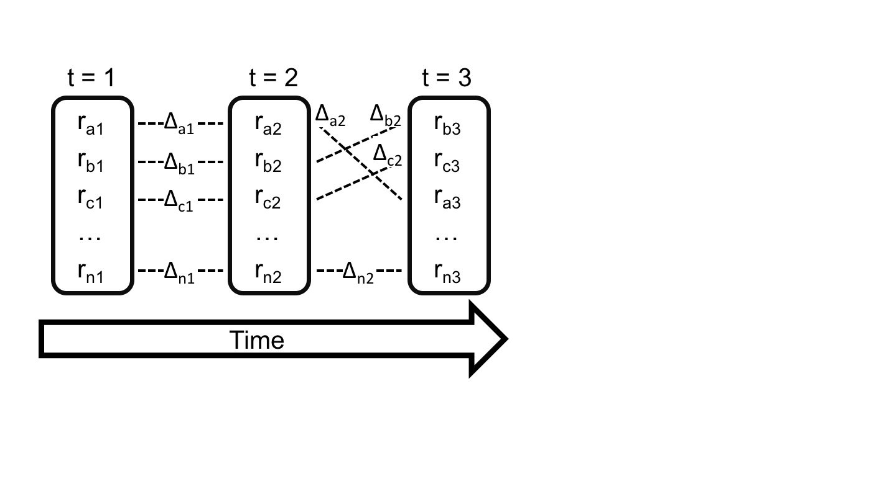

Figure 1. A longitudinal hierarchy characterizes the rank orders and dynamics of a single latent hierarchy over time, and is comprised of rank orders at various time points and the dynamics between time points. Rank changes between time points can be caused by rank reversals, demographic events or both.

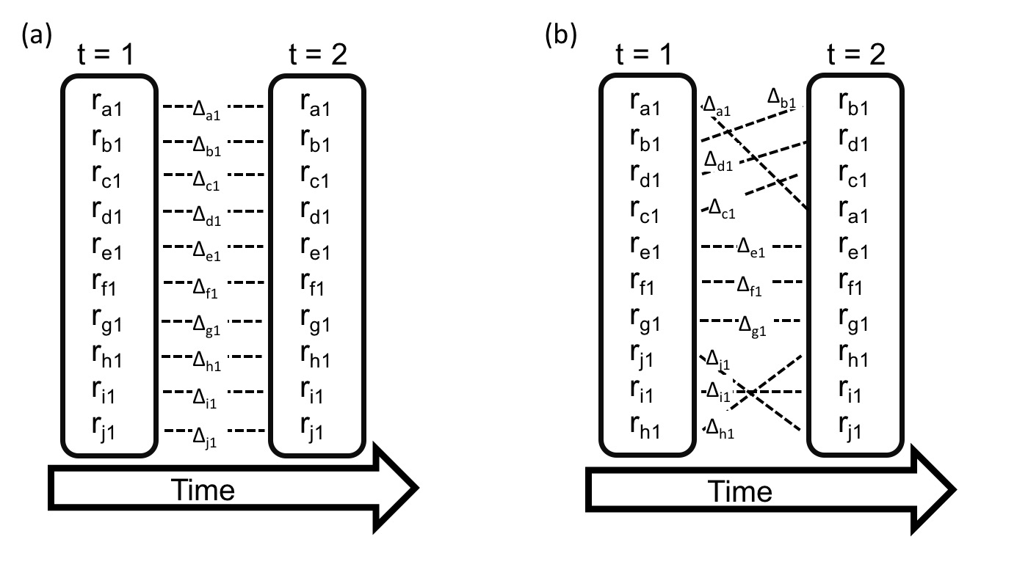

Figure 2. The true state of the hierarchy (a) and an imperfect longitudinal hierarchy estimating it (b). Rank orders in (b) have a Pearson’s rank correlation with the true orders of 0.9. The longitudinal hierarchy in (b) overestimates the dynamics in the hierarchy as a result of small inaccuracies in rank orders at both t1 and t2.

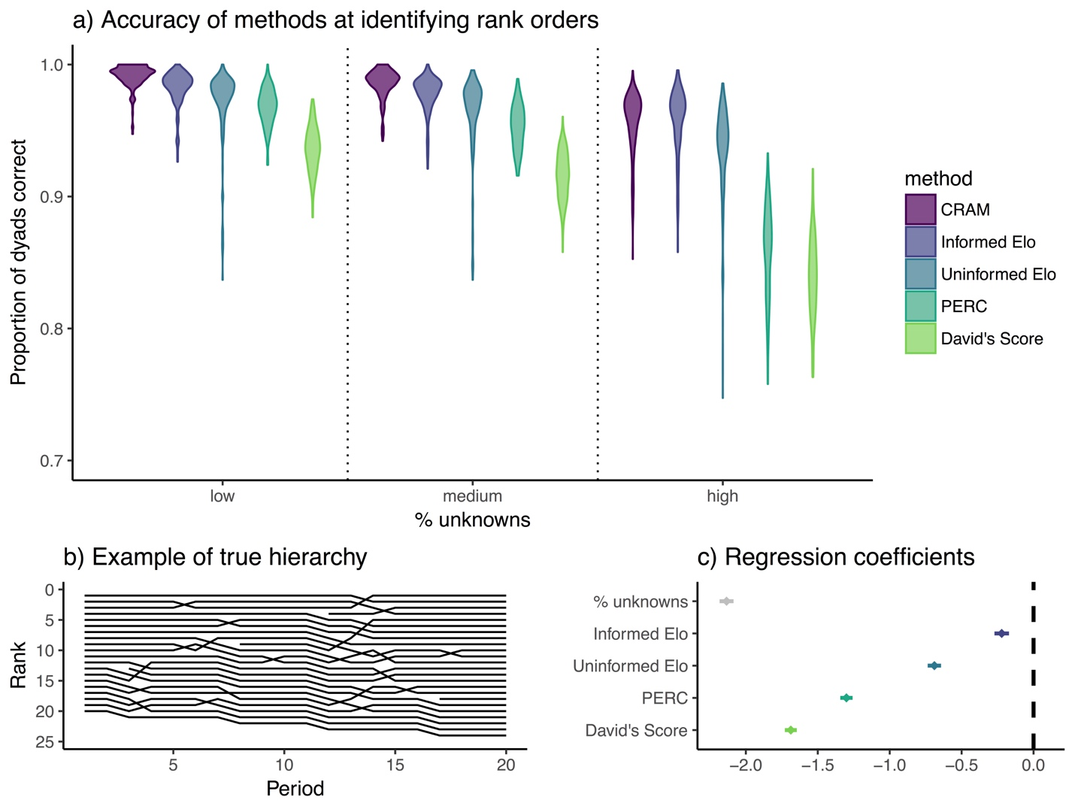

**Figure 3.** a) The similarity between the true order from the simulated data and the orders identified by each method. Five rank-ordering methods were tested under conditions of low (20%), medium (50%), and high (80%) proportions of dyads with missing data. b) An example of one of the 10 true latent hierarchies, which were simulated to have few rank reversals of small magnitude. c) Regression coefficients and 95% confidence intervals from a binomial GLMM modeling the proportion of dyadic relationships identified correctly by the different methods for each study period, with data under three conditions of *% unknowns* (n = 2850 periods). CRAM is the reference level in this analysis, so estimates above or below 0 indicate methods that performed better or worse than CRAM.

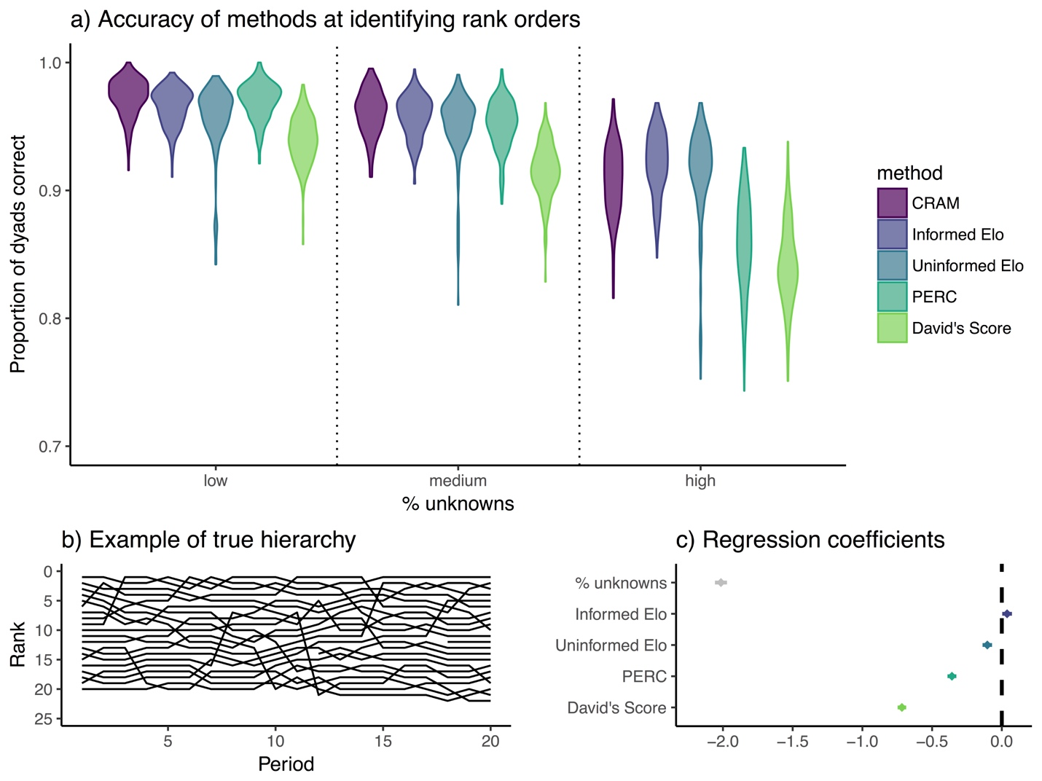

**Figure 4.** a) The similarity between the true order from the simulated data and the orders identified by each method. Five rank-ordering methods were tested under conditions of low (20%), medium (50%), and high (80%) proportions of dyads with missing data. b) An example of one of the 10 true latent hierarchies, which were simulated to have many rank reversals of large magnitude. c) Regression coefficients and 95% confidence intervals from a binomial GLMM modeling the proportion of dyadic relationships identified correctly by the different methods for each study period, with data under three conditions of *% unknowns* (n = 2850 periods). CRAM is the reference level in this analysis, so estimates above or below 0 indicate methods that performed better or worse than CRAM.

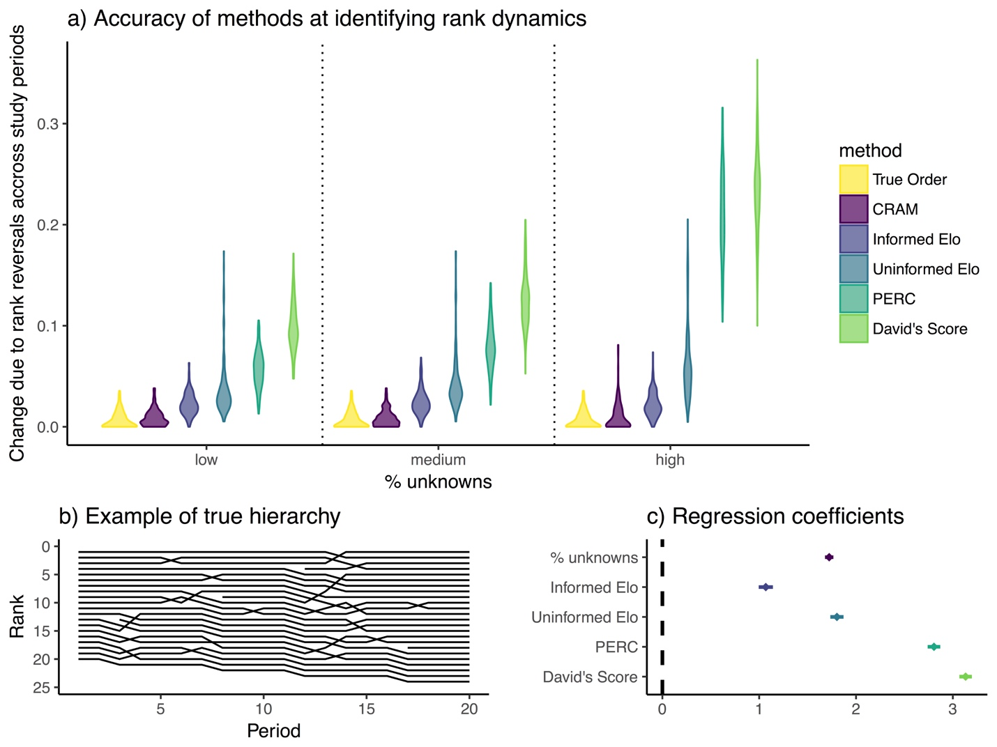

**Figure 5.** a) The similarity between the proportion of dyadic relationships that changed in the simulated data for each period and the proportions dyads that changed identified by each method. Five rank-ordering methods were tested under conditions of low (20%), medium (50%), and high (80%) proportions of dyads with missing data. b) An example of one of the 10 true latent hierarchies, which were simulated to have few rank reversals of small magnitude. c) Regression coefficients and 95% confidence intervals from a binomial GLMM modeling the proportion of dyads that changed identified by the different methods, with data under three conditions of *% unknowns* (n = 3240 periods). The True Order is the reference level in this analysis, so estimates above or below 0 indicate that methods over- or underestimated the dynamics of the hierarchy.

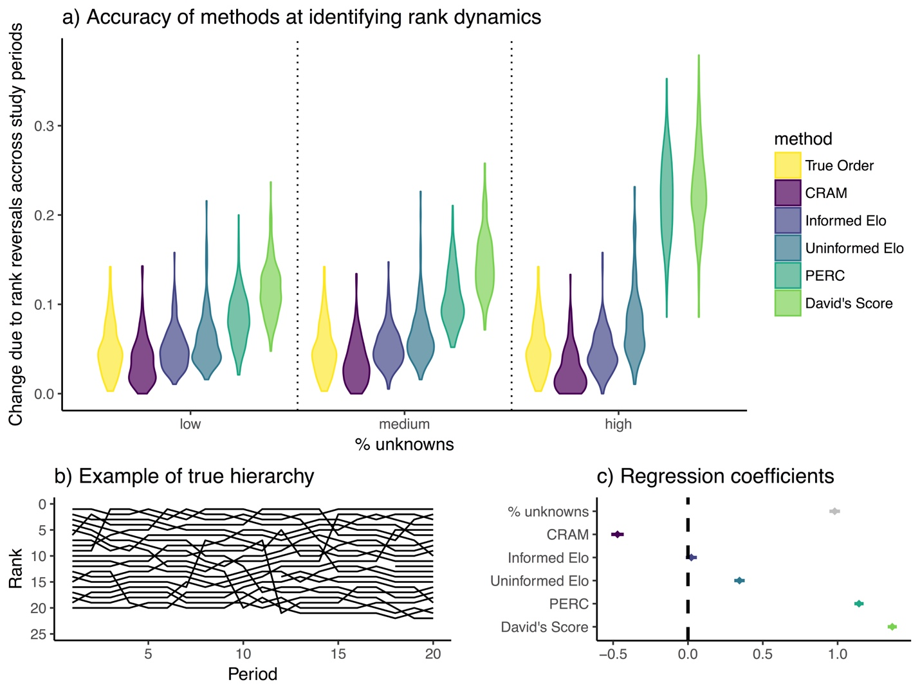

**Figure 6.** a) The similarity between the proportion of dyadic relationships that changed in the simulated data for each period and the proportions dyads that changed identified by each method. Five rank-ordering methods were tested under conditions of low (20%), medium (50%), and high (80%) proportions of dyads with missing data. b) An example of one of the 10 true latent hierarchies, which were simulated to have many rank reversals of large magnitude. c) Regression coefficients and 95% confidence intervals from a binomial GLMM modeling the proportion of dyads that changed identified by the different methods, with data under three conditions of *% unknowns* (n = 3240 periods). The True Order is the reference level in this analysis, so estimates above or below 0 indicate that methods over- or underestimated the dynamics of the hierarchy.

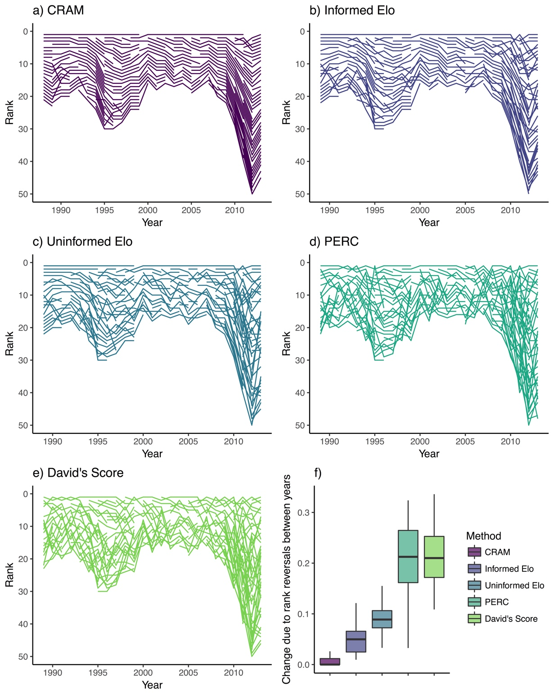

**Figure 7.** (a-e) Visual depiction of the dominance hierarchies identified by each method from the 25-year empirical dataset from a wild population of philopatric female spotted hyenas. Each line represents the rank assigned to a single adult female over the course of its lifetime. Crossing lines indicate an identified rank reversal, whereas non-crossing lines indicate stability in the identified longitudinal hierarchy. Numbers of rank positions varied with size of the group over time. (f) The number of rank reversals across years in the hierarchies identified by each method shown in a-e, as measured by Kendall’s rank correlation between orders in consecutive years.

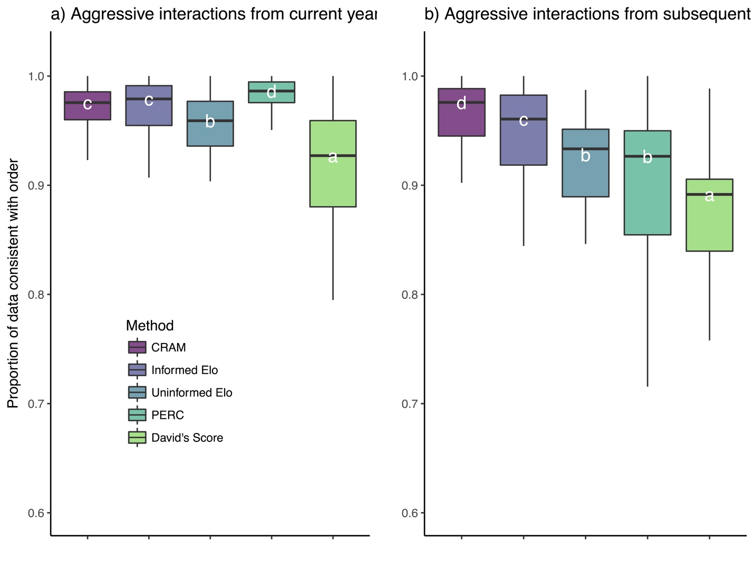

Figure 8. The proportion of observed outcomes of agonistic interactions between philopatric adult female spotted hyenas and the rank orders identified by each method. Data from (a) were from a current year in the study and were used to produce the order. Data in (b) were from the following study year. Disparities between the fit in (a) and (b) indicate overfitting. Letters indicate significantly different groups.

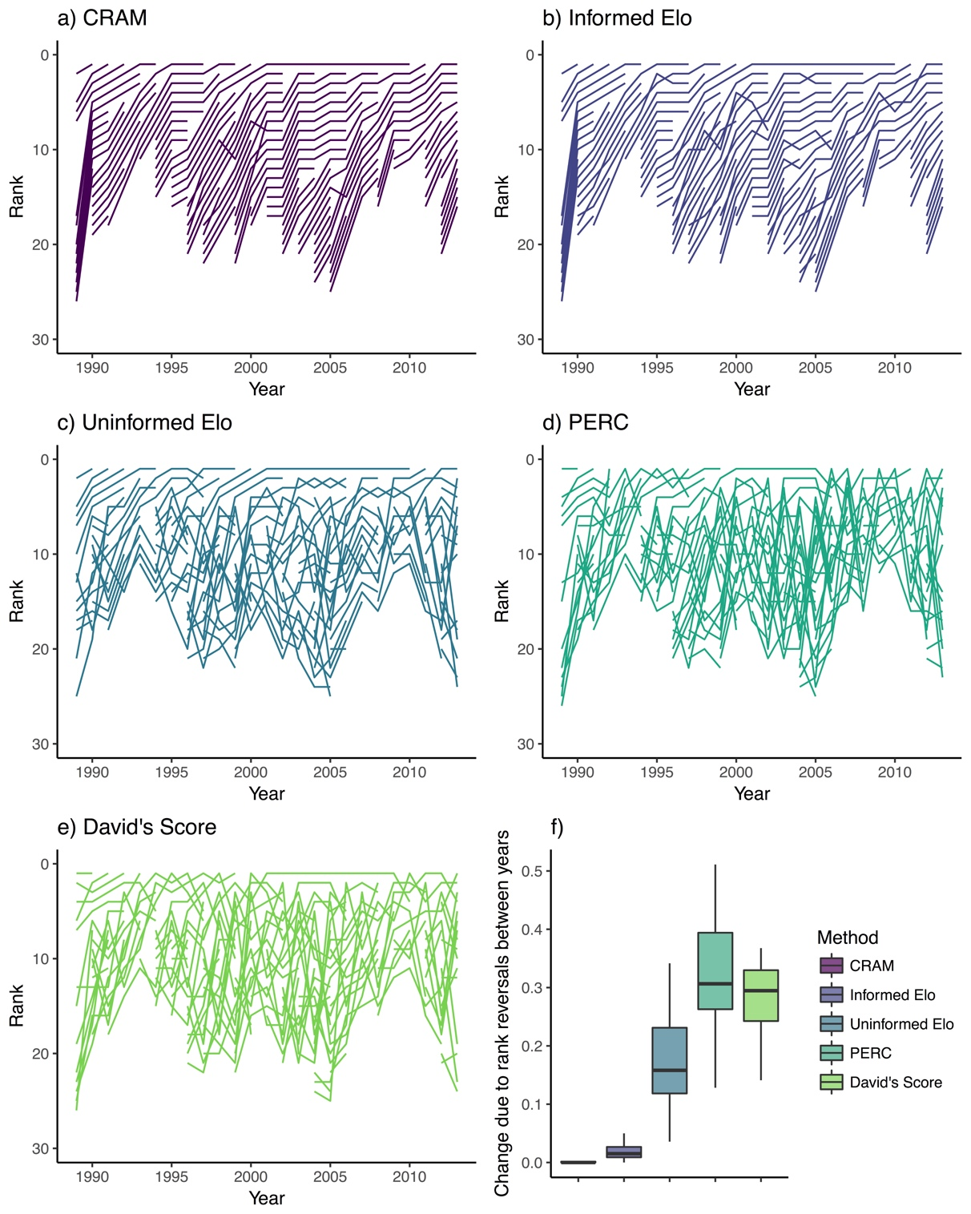

Figure 9. (a-e) Visual depiction of the dominance hierarchies identified by each method from the 25-year empirical dataset from a wild population of immigrant male spotted hyenas. Each line represents the rank assigned to a single adult male over the course of its lifetime. Crossing lines indicate an identified rank reversal, whereas non-crossing lines indicate stability in the identified longitudinal hierarchy. Numbers of rank positions varied with size of the group over time. (f) The amount of change across years in the hierarchies identified by each method shown in a-e, as measured by Kendall’s rank correlation between orders in consecutive years.

**REFERENCES**

Albers, P. C. H., & de Vries, H. (2001). Elo-rating as a tool in the sequential estimation of dominance strengths. *Animal*, *61*, 489–495. doi:10.1006/anbe.2000.1571

Altmann, J. (1974). Observational study of behavior: sampling methods. *Behaviour*, *49*(3), 227–266.

Archie, E. A., Morrison, T. A., Foley, C. A. H., Moss, C. J., & Alberts, S. C. (2006). Dominance rank relationships among wild female African elephants,< i> Loxodonta africana</i>. *Animal Behaviour*, *71*(1), 117–127.

Beaulieu, M., Mboumba, S., Willaume, E., Kappeler, P. M., & Charpentier, M. J. E. (2014). The oxidative cost of unstable social dominance. *Journal of Experimental Biology*, *217*(Pt 15), 2629–2632.

Boydston, E. E., Kapheim, K. M., Szykman, M., & Holekamp, K. E. (2003). Individual variation in space use by female spotted hyenas. *Journal of Mammalogy*, *84*(3), 1006–1018.

Bretz, F., Westfall, P., Heiberger, R. M., Schuetzenmeister, A., & Scheibe, S. (2016). Package “ multcomp .”

Bro Jørgensen, J., & Beeston, J. (2015). Multimodal signalling in an antelope: fluctuating facemasks and knee-clicks reveal the social status of eland bulls. *Animal Behaviour*, *102*, 231–239.

Broom, M., Koenig, A., & Borries, C. (2009). Variation in dominance hierarchies among group-living animals: modeling stability and the likelihood of coalitions. *Behavioral Ecology*, *20*(4), 844–855.

Buwalda, B., Koolhaas, J. M., & de Boer, S. F. (2017). Physiology & Behavior Trait aggressiveness does not predict social dominance of rats in the Visible Burrow System. *Physiology & Behavior*, *178*, 134–143. doi:10.1016/j.physbeh.2017.01.008

Chapais, B., Girard, M., & Primi, G. (1991). Non-kin alliances, and the stability of matrilineal dominance relations in Japanese macaques. *Animal Behaviour*.

Chikazawa, D., Gordon, T. P., Bean, C. A., & Bernstein, I. S. (1979). Mother-daughter dominance reversals in rhesus monkeys (Macaca mulatta). *Primates*, *20*(2), 301–305.

Combes, S. L., & Altmann, J. (2001). Status change during adulthood: life-history by-product or kin selection based on reproductive value? *Proceedings of the Royal Society B: Biological Sciences*, *268*(1474), 1367–1373.

Côté, S. D. (2000). Dominance hierarchies in female mountain goats: stability, aggressiveness and determinants of rank. *Behaviour*, *137*, 1541–1566.

David, H. A. (1987). Ranking from unbalanced paired-comparison data. *Biometrika*, *74*(2), 432–436.

de Vries, D., Koenig, A., & Borries, C. (2016). Female reproductive success in a species with an age-inversed hierarchy. *Integrative Zoology*.

de Vries, H. (1998). Finding a dominance order most consistent with a linear hierarchy: a new procedure and review. *Animal Behaviour*, 1–17.

Dettmer, A. M., Woodward, R. A., & Suomi, S. J. (2015). Reproductive Consequences of a Matrilineal Overthrow in Rhesus Monkeys, *352*(July 2014), 346–352. doi:10.1002/ajp.22350

Douglas, P. H., Ngonga Ngomo, A. C., & Hohmann, G. (2017). A novel approach for dominance assessment in gregarious species: ADAGIO. *Animal Behaviour*, *123*, 21–32. doi:10.1016/j.anbehav.2016.10.014

Drews, C. (1993). The concept and definition of dominance in animal behaviour. *Behaviour*, 283–313.

East, M. L., & Hofer, H. (1993). Male spotted hyenas (*Crocuta crocuta*) queue for status in social groups dominated by females. *Behavioral Ecology*, *12*(5), 558–68. doi:10.1093/beheco/12.5.558

Ehardt, C. L., & Bernstein, I. S. (1986). Matrilineal overthrows in rhesus monkey groups. *International Journal of Primatology*, *7*(2), 157–181. doi:10.1007/BF02692316

Elo, A. E. (1978). *The rating of chessplayers, past and present*. New York: Arco Pub.

Farine, D. R. (2017). When to choose dynamic versus static social network analysis. *Journal of Animal Ecology*, (June), 1–11. doi:10.1111/1365-2656.12764

Farine, D. R., & Sanchez-Tojar, A. (2017). aniDom: Inferring Dominance Hierarchies and Estimating Uncertainty. R package version 0.1.2.

Flies, A. S., Mansfield, L. S., Flies, E. J., Grant, C. K., & Holekamp, K. E. (2016). Socioecological predictors of immune defences in wild spotted hyenas. *Functional Ecology*, *30*(9), 1549–1557.

Fortunato, A., Queller, D. C., & Strassmann, J. E. (2003). A linear dominance hierarchy among clones in chimeras of the social amoeba Dictyostelium discoideum. *Journal of Evolutionary Biology*, *16*(3), 438–445.

Frank, L. G. (1986). Social organization of the spotted hyaena< i> Crocuta crocuta</i>. II. Dominance and reproduction. *Animal Behaviour*, *34*(5), 1510–1527.

Fujii, K., Jin, J., Shev, A., Beisner, B., Mccowan, B., & Fushing, H. (2016). Using Percolation and Conductance to Find Information Flow Cerntainty in a Directed Network.

Gammell, M. P., de Vries, H., Jennings, D. J., Carlin, C. M., & Hayden, T. J. (2003). David’s score: a more appropriate dominance ranking method than Clutton-Brock et al.’s index. *Animal Behaviour*, *66*(3), 601–605.

Hasegawa, M., & Kutsukake, N. (2014). Bayesian competitiveness estimation predicts dominance turnover among wild male chimpanzees. *Behavioral Ecology and Sociobiology*, *69*(1), 89–99.

Higham, J., & Maestripieri, D. (2010). Revolutionary coalitions in male rhesus macaques. *Behaviour*, *147*(13), 1889–1908.

Hobson, E. A., Avery, M. L., & Wright, T. F. (2013). An analytical framework for quantifying and testing patterns of temporal dynamics in social networks. *Animal Behaviour*, *85*(1), 83–96. doi:10.1016/j.anbehav.2012.10.010

Hofer, H., & East, M. L. (2003). Behavioral processes and costs of co-existence in female spotted hyenas: a life history perspective. *Evolutionary Ecology*.

Holekamp, K. E., Ogutu, J. O., Dublin, H. T., Frank, L. G., & Smale, L. (1993). Fission of a spotted hyena clan: consequences of prolonged female absenteeism and causes of female emigration. *Ethology*, *93*(4), 285–299.

Holekamp, K. E., & Smale, L. (1991). Dominance acquisition during mammalian social development: the “inheritance” of maternal rank. *American Zoologist*, *31*(2), 306–317.

Holekamp, K. E., & Smale, L. (1991). Dominance acquisition during mammalian social development: the “inheritance” of maternal rank. *American Zoologist*.

Holekamp, K. E., & Smale, L. (1993). Ontogeny of dominance in free-living spotted hyaenas: juvenile rank relations with other immature individuals. *Animal Behaviour*, *46*(3), 451–466.

Holekamp, K. E., Smith, J. E., Strelioff, C. C., Van Horn, R. C., & Watts, H. E. (2012). Society, demography and genetic structure in the spotted hyena. *Molecular Ecology*, *21*(3), 613–632.

Holekamp, K. E., & Strauss, E. D. (2016). Aggression and dominance: an interdisciplinary overview. *Current Opinion in Behavioral Sciences*.

Kawamura, S. (1958). The matriarchal social order in the Minoo-B group. *Primates*, *1*(2), 149–156.

Klass, K., & Cords, M. (2011). Effect of unknown relationships on linearity, steepness and rank ordering of dominance hierarchies: simulation studies based on data from wild monkeys. *Behavioural Processes*, *88*(3), 168–176.

Koenig, A., Borries, C., Caselli, A., & Lu, A. (2013). Effects of age, reproductive state, and the number of competitors on the dominance dynamics of wild female Hanuman langurs. *Behaviour*, *150*(5), 485–523.

Lea, A. J., Learn, N. H., Theus, M. J., Altmann, J., & Alberts, S. C. (2014). Complex sources of variance in female dominance rank in a nepotistic society. *Animal Behaviour*, *94*, 87–99.

Martin, P., & Bateson, P. (1993). *Measuring behaviour: an introductory guide*. Cambridge, UK: Cambridge University Press.

McDonald, D. B., & Dillon, M. E. (2015). Temporal changes in dominance networks and other behaviour sequences. In J. Krause, R. James, D. W. Franks, & D. P. Croft (Eds.), *Animal Social Networks* (pp. 61–72). Oxford, UK: Oxford University Press, USA.

Mendonça-Furtado, O., Edaes, M., Palme, R., Rodrigues, A., Siqueira, J., & Izar, P. (2014). Does hierarchy stability influence testosterone and cortisol levels of bearded capuchin monkeys (Sapajus libidinosus) adult males? A comparison between two wild groups. *Behavioural Processes*, *109*, 79–88.

Murray, C. M., Mane, S. V, & Pusey, A. E. (2007). Dominance rank influences female space use in wild chimpanzees , Pan troglodytes : towards an ideal despotic distribution. *Animal Behaviour*, *74*, 1795–1804. doi:10.1016/j.anbehav.2007.03.024

Neumann, C., Assahad, G., Hammerschmidt, K., Perwitasari-Farajallah, D., & Engelhardt, A. (2010). Loud calls in male crested macaques, Macaca nigra: a signal of dominance in a tolerant species. *Animal Behaviour*, *79*(1), 187–193. doi:10.1016/j.anbehav.2009.10.026

Neumann, C., Duboscq, J., Dubuc, C., Ginting, A., Irwan, A. M., Agil, M., … Engelhardt, A. (2011). Assessing dominance hierarchies: validation and advantages of progressive evaluation with Elo-rating. *Animal Behaviour*, *82*(4), 911–921.

Neumann, C., & Kulik, L. (2014). EloRating: Animal Dominance Hierarchies by Elo Rating. *R Package Version 0.43.*

Newton-Fisher, N. E. (2017). Modeling Social Dominance : Elo-Ratings , Prior History , and the Intensity of Aggression. *International Journal of Primatology*, *38*, 427–447. doi:10.1007/s10764-017-9952-2

Perry, S. (1998). A Case Report of a Male Rank Reversal in a Group of Wild White-faced Capuchins, *39*(January), 51–70. doi:https://doi-org.proxy2.cl.msu.edu/10.1007/BF02557743

Pinter-Wollman, N., Hobson, E. A., Smith, J. E., Edelman, A. J., Shizuka, D., de Silva, S., … McDonald, D. B. (2014). The dynamics of animal social networks: analytical, conceptual, and theoretical advances. *Behavioral Ecology*, *25*(2), 242–255. doi:10.1093/beheco/art047

Pusey, A., Williams, J., & Goodall, J. (1997). The influence of dominance rank on the reproductive success of female chimpanzees. *Science*, *277*(5327), 828–831.

R Development Core Team. (2017). R: A language and environment for statistical computing. Vienna, Austria: R Foundation for Statistical Computing.

Samuels, A., Silk, J. B., & Altmann, J. (1987). Continuity and change in dominance relations among female baboons. *Animal Behaviour*, *35*(3), 785–793. doi:10.1016/S0003-3472(87)80115-X

Sánchez-Tójar, A., Schroeder, J., & Farine, D. R. (2017). A practical guide for inferring reliable dominance hierarchies and estimating their uncertainty. *Journal of Animal Ecology*, 1–15. doi:10.1111/1365-2656.12776

Sapolsky, R. M. (2005). The influence of social hierarchy on primate health. *Science*, *308*(5722), 648–652.

Schjelderup-Ebbe, T. (1922). Contributions to the social psychology of the domestic chicken. *Reprinted from Zeitschrift Fuer Psychologie*, *88*, 225–252.

Schmid, V. S., & de Vries, H. (2013). Finding a dominance order most consistent with a linear hierarchy: an improved algorithm for the I&SI method. *Animal Behaviour*, *83*, 1097–1105.

Schülke, O., Bhagavatula, J., Vigilant, L., & Ostner, J. (2010). Social bonds enhance reproductive success in male macaques. *Current Biology*, *20*(24), 2207–2210. doi:10.1016/j.cub.2010.10.058

Searcy, A., & Wingfield, J. C. (1980). The Effects of Androgen and Antiandrogen on Dominance and Aggressiveness in Male Red-Winged Blackbirds. *Hormones and Behavior*, *14*, 126–135.

Shimoji, H., Abe, M. S., Tsuji, K., & Masuda, N. (2014). Global network structure of dominance hierarchy of ant workers. *Journal of the Royal Society, Interface / the Royal Society*, *11*(99), 20140599.

Shizuka, D., & McDonald, D. B. (2012). A social network perspective on measurements of dominance hierarchies. *Animal Behaviour*, *83*(4), 925–934.

Shizuka, D., & McDonald, D. B. (2015). The network motif architecture of dominance hierarchies. *Journal of the Royal Society, Interface / the Royal Society*, *12*(105), 20150080.

Smale, L., Frank, L. G., & Holekamp, K. E. (1993). Ontogeny of dominance in free-living spotted hyaenas: juvenile rank relations with adult females and immigrant males. *Animal Behaviour*, *46*(3), 467–477.

Smale, L., Nunes, S., & Holekamp, K. E. (1997). Sexually Dimorphic Dispersal in Mammals: Patterns, Causes, and Consequences. In P. J. B. Slater, J. S. Rosenblatt, C. T. Snowdon, & M. Milinski (Eds.), *Advances in the Study of Behavior, Vol. 26* (pp. 181–250). Academic Press.

Smith, J. E., Lehmann, K. D. S., Montgomery, T. M., Strauss, E. D., & Holekamp, K. E. (2017). Insights from long ‐ term field studies of mammalian carnivores. *Journal of Mammalogy*, *98*(3), 631–641. doi:10.1093/jmammal/gyw194

Sneddon, L. U., Schmidt, R., Fang, Y., & Cossins, A. R. (2011). Molecular Correlates of Social Dominance: A Novel Role for Ependymin in Aggression. *PloS One*, *6*(4), e18181.

Snyder-Mackler, N., Sanz, J., Kohn, J. N., Brinkworth, J. F., Morrow, S., Shaver, A. O., … Tung, J. (2016). Social status alters immune regulation and response to infection in macaques. *Science*, *354*(6315), 1041–1046.

Swanson, E. M., Dworkin, I., & Holekamp, K. E. (2011). Lifetime selection on a hypoallometric size trait in the spotted hyena. *Proceedings of the Royal Society B: Biological Sciences*, *278*(1722), 3277–3285.

Tibbetts, E. A., & Dale, J. (2004). A socially enforced signal of quality in a paper wasp. *Nature*, *432*(7014), 218–222.

Tung, J., Archie, E. A., Altmann, J., & Alberts, S. C. (2016). Cumulative early life adversity predicts longevity in wild baboons. *Nature Communications*, *7*, 1–7. doi:10.1038/ncomms11181