Documentation

Mlops-Project

Submitted By:

i190520, i190522, i190444

# Data Acquisition

# Data Pre-processing

# Model Training

# Deployments

## Added Dockerfile

## 

## Made image

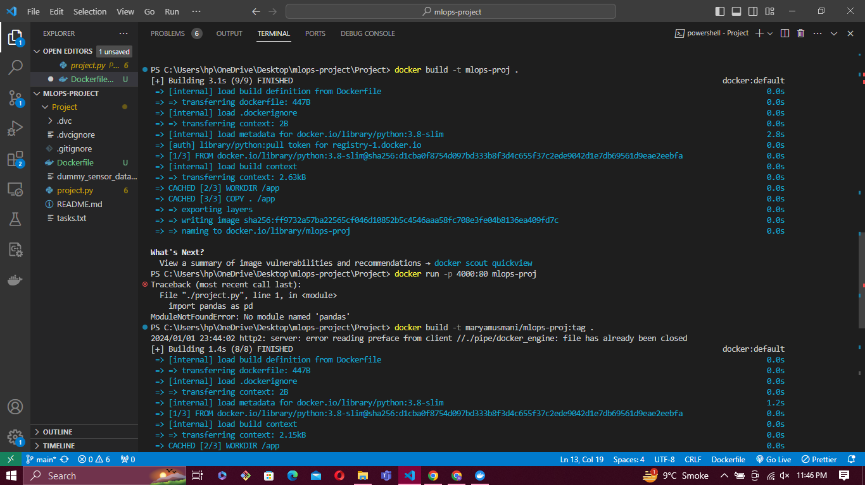

## Made container



## Pushed to DockerHub

<https://hub.docker.com/repository/docker/maryamusmani/mlops-proj/general>

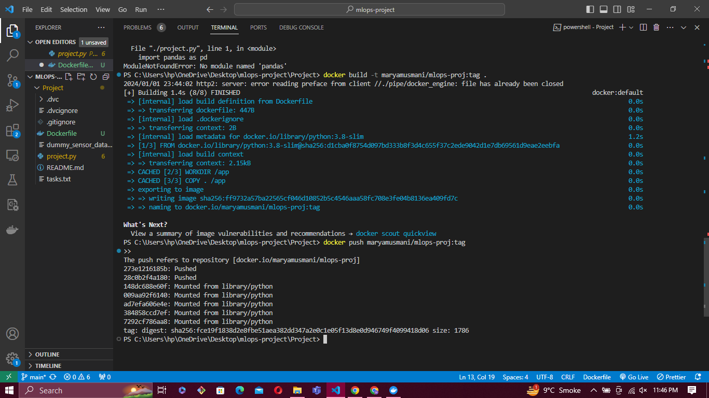

## Added docker-compose file

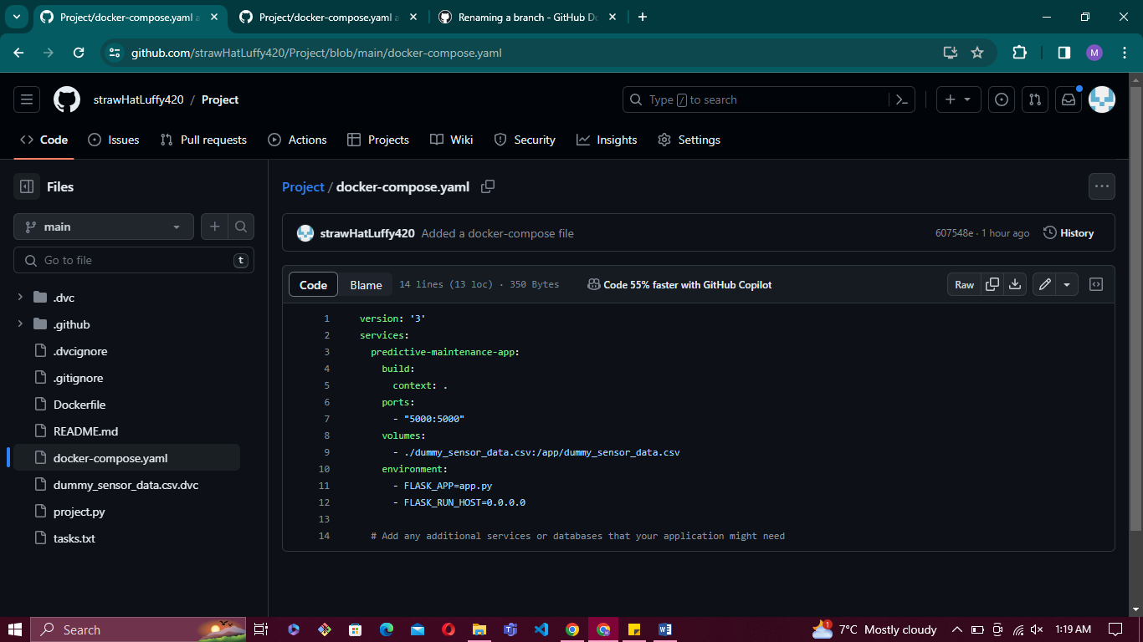

## Made CI/CD workflow using Github Actions

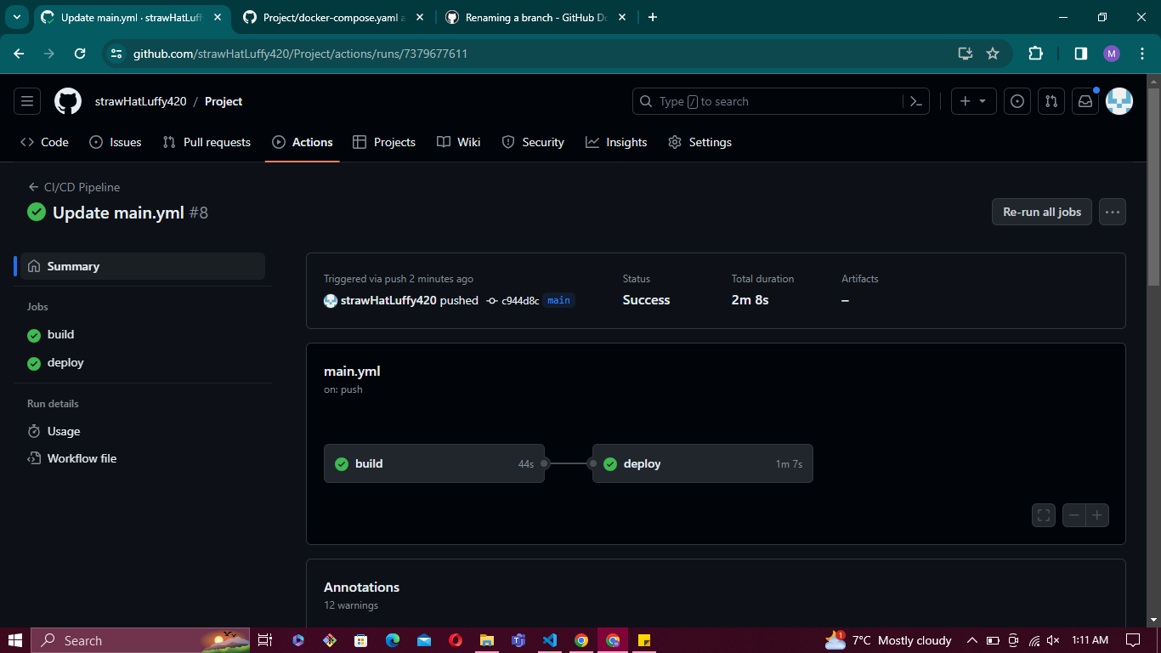

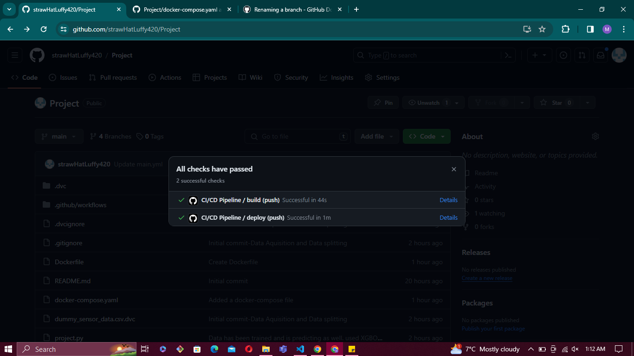

# Concept Drift Monitoring