* (Czumn, 2018)*

CLIMATE CHANGE

& the rise of misinformation

Beatrice Valentine | May 2024

Table of Contents

Pollution Around the World 2

Canada’s Impact 3

A Generational Divide 4

Bibliography 5

# Pollution Around the World

Worldwide, China emits the highest amount of CO2 per capita, followed by USA, then India. Greenland emits the lowest. *(Worldometer, 2016)*

*Table 1: CO2 Emissions in 2016 (Worldometer, 2016)*

|  |  |  |  |  |
| --- | --- | --- | --- | --- |
| Country | China | USA | India | Greenland |
| CO2 Emissions | 10,432,751,400 | 5,011,686,600 | 2,533,638,100 | 1,530 |
| Population | 1,401,889,681 | 327,210,198 | 1,338,636,340 | 55,916 |
| Share of World | 29.18% | 14.02% | 7.09% | 0.00% |

Developing countries, such as Zimbabwe, use coal and other pollutants for a large amount of their energy production. This represents contributions of 7-20% to the global budget of greenhouse gases. *(Ludwig, 2003)*

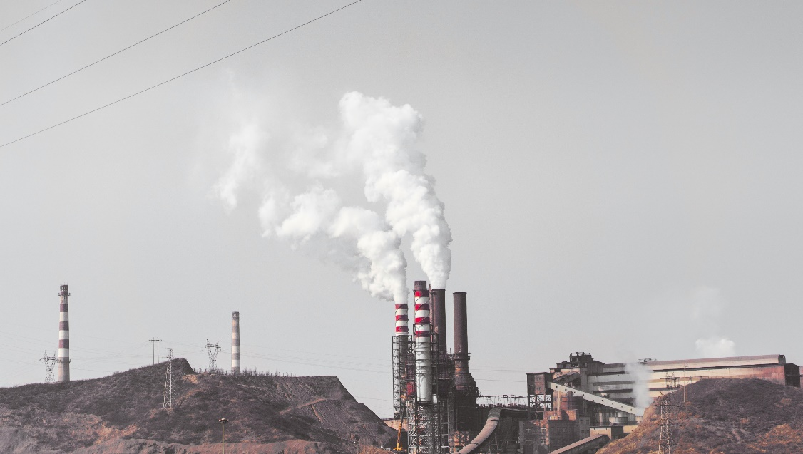

Image 1: JuniperPhoton @ Unsplash (2018)

# Canada’s Impact

The average Canadian household saw its predicted CO2 emissions decline from 11.49 tons per year in 1997 to 9.7 tons in 2009; a decline of approximately 16% over 12 years. Edmonton had the highest emissions in 2016, followed by Calgary. Montreal had the lowest, followed by Vancouver*. (Fercovic, 2016)*

Figure 1: Greenhouse gas emissions in Canada from 1990-2019 (Government of Canada, 2021)

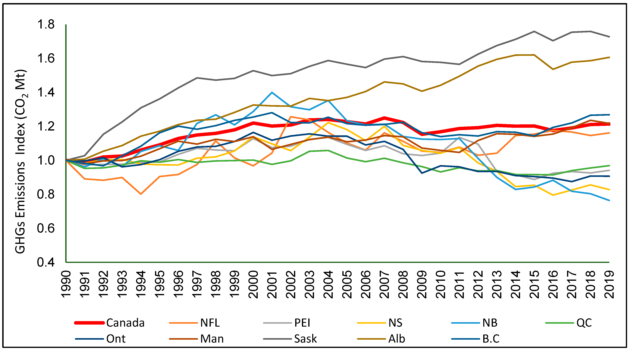

*Figure 1* shows how greenhouse gas emissions are increasing over time. *(Haider, 2024)*

Emissions are typically from the consumption of gasoline, natural gas, and electricity. Higher density is associated with lower gasoline consumption in personal vehicles, cold weather is associated with higher energy consumption for heating, and higher income and family size are associated with overall greater energy use*.* *(Fercovic, 2016)*

# A Generational Divide

Fake news about climate change refers to fabricated information that mimics the appearance of legitimate reporting but is intended to mislead consumers. In light of concerns about fake news regarding climate change and other topics, researchers and media providers have been searching for ways to limit its spread and influence*. (Lauren Lutzke, 2019)*

47% of Americans report that they use social media to check the news “sometimes” or “often”, with Facebook being the most popular platform for this purpose. *(Lauren Lutzke, 2019)* Older adults in particular are a vulnerable population for online risks. *(Vargas-Bianchi, 2023)*



Image 2: Christin Hume @ Unsplash (2018)

# Bibliography

Czumn, J. (2018). *House on an Iceberg*. Retrieved from Pexels: https://www.pexels.com/photo/house-on-an-iceberg-5792506/

Fercovic, J. a. (2016). *Comparing household greenhouse gas emissions across Canadian cities*. Retrieved from ScienceDirect: https://www.sciencedirect.com/science/article/abs/pii/S0166046216300783

Government of Canada. (2021). *National Inventory Report 1990–2019: Greenhouse Gas Sources and Sinks in Canada.* Gatineau, QC, Canada: Environment and Climate Change Canada.

Haider, A. (2024). *The Determinants of Greenhouse Gas Emissions: Empirical Evidence from Canadian Provinces.* Halifax, NB: Department of Economics, Dalhousie University.

Hume, C. (2018). *Person using laptop computer photo*. Retrieved from Unsplash: https://unsplash.com/photos/person-using-laptop-computer-Hcfwew744z4

JuniperPhoton. (2018). *Smoke comes out from industrial factory chimney photo*. Retrieved from Unsplash: https://unsplash.com/photos/smoke-comes-out-from-industrial-factory-chimney-KKFKrOu3BVc

Lauren Lutzke, C. D. (2019). *Priming critical thinking: Simple interventions limit the influence of fake news about climate change on Facebook*. Retrieved from ScienceDirect: https://www.sciencedirect.com/science/article/abs/pii/S0959378019307009

Ludwig, J. M. (2003). *Domestic Combustion of Biomass Fuels in Developing Countries: A Major Source of Atmospheric Pollutants.* Retrieved from https://link.springer.com/article/10.1023/A:1022159910667

Vargas-Bianchi, L. M.-C.-N.-Z. (2023). *'No, auntie, that's false': Challenges and resources of female baby boomers dealing with fake news on Facebook*. Retrieved from First Monday: https://firstmonday.org/ojs/index.php/fm/article/view/12678/10818

Worldometer. (2016). *Carbon Dioxide (CO2) Emissions by Country*. Retrieved from Worldometer: https://www.worldometers.info/co2-emissions/co2-emissions-by-country/