解题报告_spoj1674

石家庄二中 贾志豪
Jia Zhihao
From No.2 Middle School,
In Shijizhuang,
Of Hebei Province

- 题目大意

设图G有N个点，每个点恰好向外连一条有向边，现在让你找出最小的点集S，使得对于任何不属于S的点，有向边一定连向属于S的点。

- 解题方法

首先，我们可以发现，有向图的连通分支之间是相互没有影响的，所以我们可以单独考虑每一个连通分支。

对于每一个连通分支，它的结构都大致如下图。

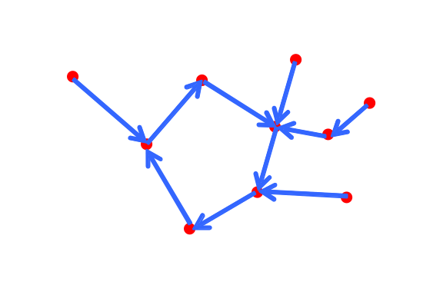

我们可以只要将图中的环上删去一个点，那么原图就变成了一棵树，且每个点的有向边恰好连向他的父节点。

于是我们不难想到：可以将图转化成树形DP来做。

方法如下：

对于每一个连通分支，我们任意找环上的一条边，则他两端的点至少有一个在S中，我们枚哪个点在S中，之后可以去掉我们枚举的点向外连的有向边，该连通分支转化成了树。下面两幅图为两种情况。

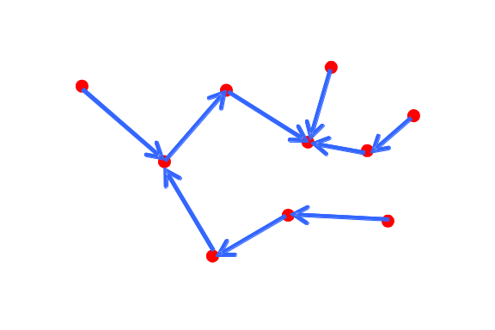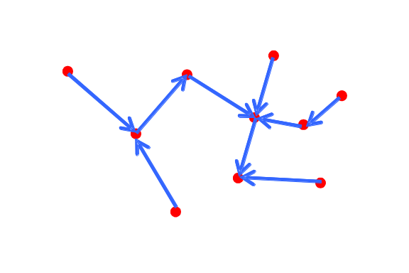

对于每一种情况，我们用树形DP计算|S|的最小值。

我们先将多叉树用左儿子-右兄弟的二叉表示法表示，用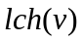表示的左儿子，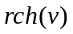表示的右儿子。

定义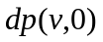表示的父亲节点属于S时，在二叉表示的子树中，最少有几个节点属于S；定义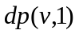表示的父亲节点不属于S时，在二叉表示的子树中，最少有几个节点属于S；

则
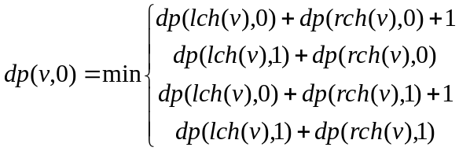

特别的，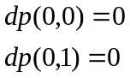

于是，我们可以通过这个方法求出每一个连通分支的min{|S|}，相加起来就是最终答案。

- 总结

要善于发现题目的特点：图G有N个点，每个点恰好向外连一条有向边，则图G的每一个连通分支有且仅有一个环。

多叉树的左儿子-右兄弟的二叉表示法。

用DP思想解决树的问题。

- 附代码
PROGRAM spoj;
CONST
maxnum=60000000;
VAR
last,pre,next,fa,lch,rch:array[1..100000]of longint;
d:array[0..100000,0..1]of longint;
c:array[0..100000]of record x,y:longint;end;
k1,k2,ans,i,numtest,test,n,m:longint;

Function find(v:longint):longint;
Begin
while fa[v]<>fa[fa[v]] do fa[v]:=fa[fa[v]];
exit(fa[v]);
End;

Procedure build(root:longint);
Var
i:longint;
Begin
i:=last[find(root)];
while i>0 do begin
lch[i]:=0;rch[i]:=0;
d[i,0]:=-1;d[i,1]:=-1;
i:=pre[i];
end;{while}

i:=last[find(root)];
while i>0 do begin
if i<>root then begin
if lch[next[i]]=0 then lch[next[i]]:=i
else begin
rch[i]:=lch[next[i]];
lch[next[i]]:=i;
end;{else}
end;
i:=pre[i];

end;{while}
End;

Function dp(v,c:longint):longint;
Var
i,k1,k2:longint;
Begin
if d[v,c]<>-1 then dp:=d[v,c]
else if v=0 then dp:=0
else begin
d[v,c]:=maxnum;
if(c=0)then d[v,c]:=dp(lch[v],1)+dp(rch[v],0)+1
else begin
if dp(rch[v],0)<dp(rch[v],1) then k1:=dp(rch[v],0) else k1:=dp(rch[v],1);
if dp(lch[v],0)<dp(lch[v],1)+1 then k2:=dp(lch[v],0) else k2:=dp(lch[v],1)+1;
d[v,c]:=k1+k2;
end;{else}
dp:=d[v,c];
end;{else}
End;

BEGIN
read(numtest);
for test:=1 to numtest do begin
read(n);m:=0;
for i:=1 to n do fa[i]:=i;
fillchar(last,sizeof(last),0);
for i:=1 to n do begin
read(next[i]);
if find(i)<>find(next[i]) then fa[find(i)]:=find(next[i])
else begin
inc(m);c[m].x:=i;c[m].y:=next[i];
end;{else}
end;{for i}

for i:=1 to n do begin
pre[i]:=last[find(i)];last[find(i)]:=i;
end;{for i}

ans:=0;
for i:=1 to m do begin
build(c[i].x);

k1:=dp(lch[c[i].x],1)+1;
build(c[i].y);

k2:=dp(lch[c[i].y],1)+1;
if k1<k2 then ans:=ans+k1 else ans:=ans+k2;
end;{for i}

writeln(ans);
end;{for test}

END.

- 附英文原题

SPOJ Problem Set (classical)
1674. The Explosion
Problem code: EXPLOSN
The day of 6.XII.2003 in Megabyteland began calm and quietly as any other day. Some people went to work, some - to school, some - to store to buy food. Drivers were traditionally stucked in traffic jams, drinking coffee and reading morning newspaper. Suddenly the regularity of this day was disturbed by huge explosion."They blew up the embassy of Bajtocja!!!" - somebody cried. Everybody began to run away in panic.
Police works pretty good in Megabyteland and first radiocars appeared near the embassy only few seconds after the explosion. All the people near the embassy were detained. Some of these people are the organizers of the explosion, but the others could by just occasional witnesses. During the testification each person named exactly one perpetrator. It is known, that if a man is not a perpetrator, than he always says the truth (he haven't a reason to lie, have he?). However, perpetrators want to make the work of the police more difficult, so a perpetrator can name any person during the testification (even himself).
The policemen are in the very hard situation. They should arrest some group of potential perpetrators, but it is difficult to determine who is guilty and who is not from the data they have. There exists many groups of potential perpetrators, that don't contradict to any of the testimonies. The policemen want to arrest as small innocent people as possible. So they would like to choose the group with minimal number of people.
Write a program that, given the number of detained people and their testimonies, will determine the number of people in the smallest group of potential perpetrators, that don't contradict to the testimonies.
Input
The first line of the input contains a single integer T, the number of testcases (1<=T<=10).
First line of each testcase contains integer number N (2 <= N <= 100000), equal to the number of detained people (the people are numbered from 1 to N). The i-th of the following N lines contain one integer number Pi (1 <= Pi <= N). Here Pi is the man whom i-th man testified to be guilty.
Output
The output should consist of T lines, containing one integer number for each testcase - the number of people in the smallest group of potential perpetrators, that don't contradict to the testimonies.
Example
Input:
1
3
2
3
1

Output:
2

Added by: | Jin Bin
Date: | 2007-07-04
Time limit: | 1s-2s
Source limit: | 50000B
Languages: | All except: C99 strict
Resource: | First Minsk Training Camp for NEERC teams, day 2 – MWPZ' 2003

