Milestone 3: Reflection
CS-499
Estera Jablonska
3/29/2026

For my algorithms and data structures enhancement, I chose my Lipstick Matcher project. This is a personal project I originally built to experiment with face-api.js and facial landmark detection, mainly because I was interested in how much analysis I could do locally in the browser. The original project was successful enough in proving that concept, but a lot of the surrounding logic was not built in a very scalable or maintainable way. Because of that, this artifact continued to be a strong choice for enhancement. I had already worked through much of the larger file restructuring and modularization in the previous milestone, so for this milestone I was able to focus more directly on improving the actual algorithms, data handling, and overall quality of the recommendation logic.
The main reason I included this artifact in my ePortfolio is because it shows real progress in applying algorithmic thinking to a practical problem. The application depends on color analysis, classification, and recommendation logic, so it was a good fit for the algorithms and data structures category. In the earlier version of the project, much of the matching logic relied on more rigid thresholds and hardcoded mappings. For this enhancement, I improved the recommendation process by making the matching more deliberate and stable. Instead of relying on a single sampled result, the updated version can aggregate multiple selfie samples, filter for more stable RGB values, and then use weighted matching logic based on depth, undertone, and color harmony. I also improved the way color data is processed by combining RGB, HSL, and Lab-style lightness calculations to produce more realistic tone detection and shade ranking.
Since a large part of the modular refactoring had already been completed in the previous milestone, this phase of the project was more about strengthening the logic that now lives inside those separate modules. That included improving the recommendation utilities, expanding the analysis flow to support multi-image sampling, and adding tests to verify that changes to the matching logic still produce stable and reasonable results. These passing test and validation results are shown in the screenshot below. These changes fit the expectations of the assignment because they go beyond cosmetic cleanup and instead improve the actual computing solution. The enhancement demonstrates a stronger use of algorithmic principles by improving how input data is sampled, how noisy values are reduced, and how final recommendations are ranked. 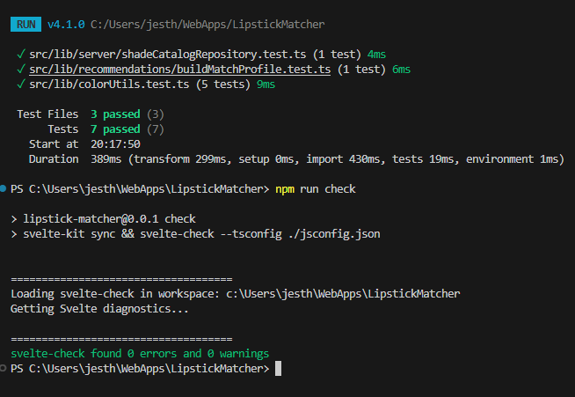
Figure 1. Passing test and validation results for Lipstick Matcher enhancements
I also used this milestone to continue improving the project’s overall design by beginning the transition from a hardcoded catalog structure to a database ready model. While that work also supports software engineering and database goals, it connects to this category because it required organizing recommendation data in a more structured way and separating core matching logic from the lipstick catalog itself. The enhancement reflects both stronger algorithm design and more thoughtful use of data structures.
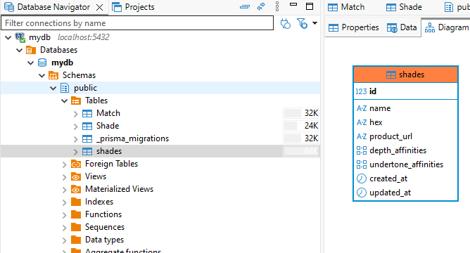
Figure 2. PostgreSQAL table for normalized lipstick shade cataglog
This enhancement helped me make progress toward the course outcomes I identified earlier, especially designing and evaluating computing solutions using algorithmic principles, and using appropriate tools and practices to build a better software solution. One challenge I faced was balancing improvement with realism. It would have been easy to keep adding more complexity, but I had to focus on changes that were meaningful, testable, and still aligned with the project’s privacy focused goal of keeping image analysis local to the browser.
Overall, this enhancement helped me better understand that improving software is not just about adding features, but about making the existing logic more reliable, modular, and defensible. This process gave me a clearer understanding of how algorithms, data structures, and system design work together in a real application, and it helped push Lipstick Matcher further from a personal experiment into a stronger portfolio artifact.

