**Rakib Ahmed**

[**LinkedIn**](https://www.linkedin.com/in/rakib-ahmed19/) **|** [**Piratechs**](https://piratechs.com/) **|** [**Github**](https://github.com/strawhat19) **|** [**Instagram**](https://www.instagram.com/piratechsatl/)

[**678-790-3980**](tel:6787903980) **| 2804 Plennie Lane, Lawrenceville, Georgia 30044 |** [**rakib987@gmail.com**](mailto:rakib987@gmail.com)

**Seeking A Relevant Position as One of The Following**

**Front End Developer / Designer | Full Stack Developer | UI/UX Designer / Developer**

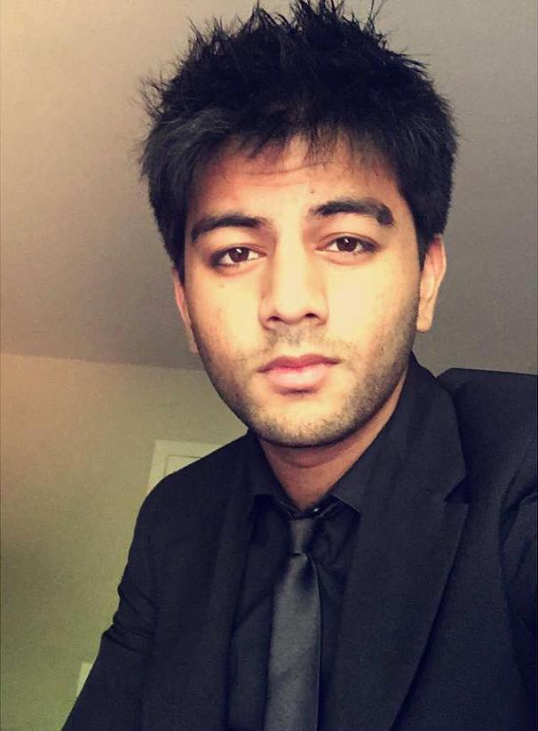

**SKILLS**

**(Work Experience & Education on 2nd Page)**

| **HTML** | **CSS** | **JavaScript** | **WordPress** | **CMS (All)** | **jQuery** | **React** |
| --- | --- | --- | --- | --- | --- | --- |
| **Windows** | **Android** | **Apple** | **iOS** | **VS Code** | **Brackets** | **SASS** |
| **Figma** | **Axure** | **HubSpot** | **UX/UI** | **PHP** | **C#** | **TypeScript** |
| **Java** | **Ionic** | **Python** | **C++** | **Async/Await** | **Node** | **SQL** |
| **Express** | **Handlebars** | **React Native** | **MongoDB** | **Unity** | **GIT** | **CLI** |
| **Vue.js** | **Angular** | **Next.js** | **Solid.js** | **Swift** | **Kotlin** | **Flutter** |
| **Redux** | **Context API** | **Gatsby.js** | **Mentoring** | **GraphQL** | **PWA** | **SPA** |
| **Graphic Design** | **Apollo Client** | **React Hooks** | **MVC Architecture** | **Game Development** | **Adobe Photoshop** | **Adobe Illustrator** |
| **Source Control** | **MS Office Suite** | **Google Firebase** | **Data Driven Design** | **Project Management** | **State Management** | **API Dynamic Data** |
| **CSS Frameworks (All)** | **Object**  **Oriented Development** | **Apache**  **Web**  **Server** | **Adobe Creative Cloud** | **Amazon**  **Web**  **Services** | **Scrum & Agile Workflows** | **Data Structures & Schemas** |

**WORK EXPERIENCE**

**1)** [**Project Escape**](https://www.projectescapeatl.com/)**, Marietta, GA** **August 2016 - January 2020 - Manager & Web Developer (4 Years)**

**•** **Managed** **Multiple Escape Rooms** and **Groups of people.**

**•** **Dealt** with **Customers, Bookings, and Payments.**

**•** **Fully Designed and Developed** their **Website from scratch and deployed it, with E2E Testing for QA**.

**2)** [**Precision Creative**](https://precisioncreative.com/)**, Marietta, GA** **April 2019 - January 2021 - Web Developer (2 Years)**

**•** **Managed** **Multiple Websites** for **50+ Clients** & Completed a Course on **Data Driven Design by Hubspot CRM.**

**•** **Designed** **& Developed** many of the **User Interfaces & Experiences.**

**•** **Responsible** for talking to clients,and **Teaching New** developers& designersour company practices & processes.

**•** **Some Websites** became **Web Apps** once we transitioned them to **Modern JS Frameworks**, such as **React, Angular, and Vue.js.**.

[**Kore Payments**](https://korepayments.com/) **|** [**Curiosity Lab**](https://www.curiositylabptc.com/) **|** [**Lights Over Atlanta**](https://www.lightsoveratlanta.com/) **|** [**Quality Craftsmen**](https://quality-craftsmen.com/) | [**Perfectly Portioned Nutrition**](https://perfectlyportionednutrition.com/)

[**The Unsealed**](https://theunsealed.com/) | [**Hotel Logistics**](https://hotellogistics.com/) | [**Pinnacle Painting**](http://paint.precision-dev.com/) | [**Galileo**](https://galileoaz.com/) | [**Moore Tutoring**](https://mooretutoring.com/) | [**Cagle Senior Living Resource**](https://cagleseniorlivingresource.com/)

**3)** [**Piratechs**](https://piratechs.com)**, January 2019, and** [**Github Projects**](https://github.com/strawhat19)**, January 2020 - Present - Full Stack Web Developer (2.5 Years)**

**•** **Maintain Client Sites** (3) from my small **Freelance Business & Made a Video Game in Unity in 48 Hours.**

**•** **Complete Responsibility** for **Design, Development,** & **Deployment** of **Full Stack Applications.**

[**Dyer & Posta**](https://dyerandposta.com/) **|** [**Reborn Aesthetics**](https://www.reborn-aesthetics.com/) **|** [**Portfolio**](https://strawhat19.github.io/Portfolio/) **|** [**Weather App**](https://strawhat19.github.io/Weather-App/) **|** [**Code Quiz**](https://strawhat19.github.io/Coding-Quiz/) | [**Sanctuary Game**](https://www.youtube.com/watch?v=mAiFUNvG0Pk&ab_channel=RickyAhmed)[**React TypeScript Netflix Clone**](https://react-netflix-clone-ra.herokuapp.com/) **|** [**MyDex Pokedex Clone**](https://mydex-pokedex-clone.herokuapp.com/) **|** [**What’s Your Deal**](https://whats-your-deal.herokuapp.com/) **|** [**React Portfolio**](https://rahmedportfolio.herokuapp.com/)

**4)** [**Global Game Jam**](https://globalgamejam.org/)**, January 2020 - February 2020 - Unity Game Developer (1 Month)**

**•** **Participated** in an event known as **Global Game Jam,** where you and a **team of friends** get **48 hours** to **make a video game from scratch.**

**•** **Worked on a team** an **artist/animator, a musician, and 2 other C# developers, using Unity’s built in source control, Unity Collab,** to **deliver a finished product, a Game called** [**Sanctuary**](https://www.youtube.com/watch?v=mAiFUNvG0Pk)on the final day of the **competition… We got 2nd Place!**

**5)** [**Varsity Tutoring**](https://www.varsitytutors.com/)**, January 2021 - Present - Programming Tutor (1 Year)**

**•** **Tutoring 5 Students ages 16 - 35 in Programming, Game Development, Graphic Design, Web Development, React, Angular, Vue.js, WordPress, Figma, Axure, After Effect, Photoshop, and Illustrator.**

**EDUCATION**

[**Kennesaw State University**](https://www.kennesaw.edu/) - Pursuing **Bachelor's Degree** in **Computer Software Engineering** **(Graduating 2023)**

[**Georgia Tech University**](https://www.gatech.edu/)- [**Full Stack Flex Web Development Bootcamp**](https://github.com/strawhat19/Portfolio/blob/main/resume/Rakib-Ahmed-Georgia-Tech-Fullstack-Certificate-of-Completion.pdf) **(6 month bootcamp) Graduate** **(2021)**