Branches, merging and rebasing: more git
Andrew Straw
13 July 2012

Background refresher

Recall how git stores its history as a series of commits.

Image from http://git-scm.com/book/en/Getting-Started-Git-Basics

Local operations

Image from http://git-scm.com/book/en/Getting-Started-Git-Basics

File status lifecycle

Image from http://git-scm.com/book/en/Git-Basics-Recording-Changes-to-the-Repository

Branches, merging, pushing

“gitk –all” shows all branches in repository
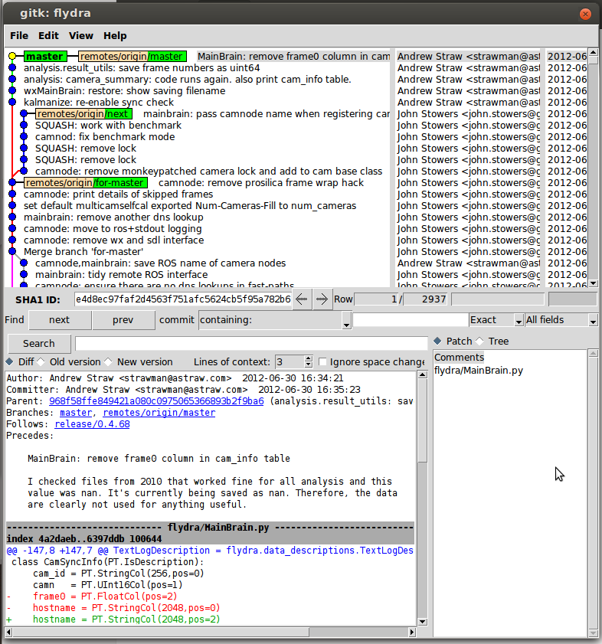

Tasklist for today:
- Fork a repository into your github account.
- Clone this repository from your github account onto your local machine.
- Make a new branch called “development” (or whatever descriptive title you want)
- Add some commits to this branch
- Push these commits (in the new “development” branch) back to your github repository
- Issue a pull request against the original repository.
(Members of my lab: repeat as necessary when updating our software.)

Fork a repository into your github account.
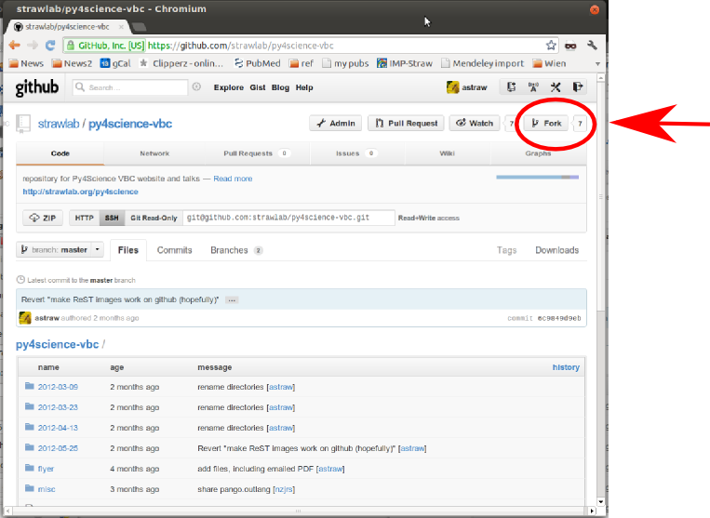

Clone from your github account to your local machine
Change into a comfortable directory and then:
git clone https://github.com/astraw/py4science-vbc.git

Make a new branch
Now, do this:
cd py4science-vbc/
git branch development
git checkout development

Add some commits to this branch
# edit your files
git add filename1
git commit -m "commit message"

Push these commits back to your github account
git push origin development

Now issue a pull request
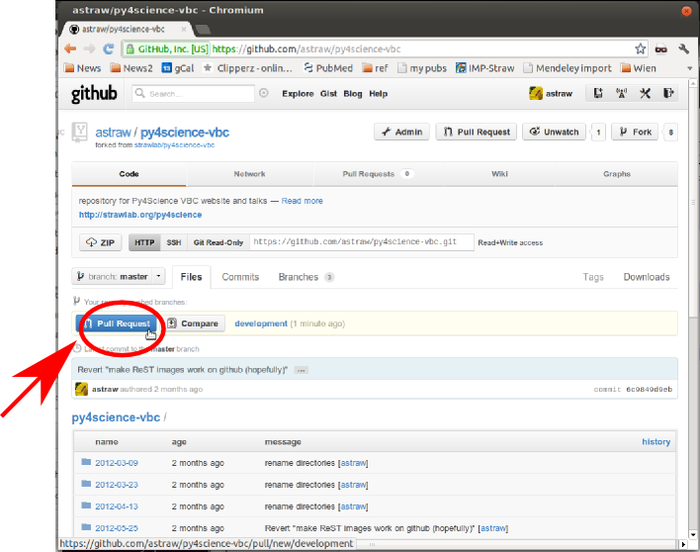
Now, people with permissions on the original github repository can accept/reject your pull request, ask for changes or make other comments all through the github website.

