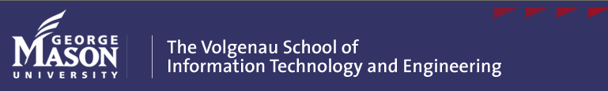

Paul Strassmann 2008-2009 Public Lecture: Monday, February 23, 2009
George Mason University Campus, 7:30PM; Public Reception in at 6:30PM

Operation of a Network Control Center



Organizations now manage hundreds of servers in order to support a timely and reliable delivery of their transactions. Their private networks depend on internal as well as on external “clouds” of computing capacity to obtain standard services as well as backups that provide the necessary redundancy for the delivery of high network availability. The management of these network complexes calls for large investments in the automation of controls as well as for improved network security.
Labor-intensive oversight used to be committed to the management of single applications running on dedicated servers. Such a distributed arrangement was not only inefficient, but also exposed the network to increased security risks. Centrally located managers of virtual applications will displace local staffs. Specialists in information warfare countermeasures will replace on site security staff.
Network Control Centers (NOC) are becoming the hubs where organizations can invest in the capitalization of network management by supporting operators with sophisticated software, which includes the management of virtualized servers as well as forensic tools that are needed for security. The objective of NOCs is to achieve automation of complete oversight over all network transactions, which includes the monitoring of all access points to the network. The lecture will include an outline of the requirements for a highly secure network environment.

The objective of this lecture is to describe the requirements for a Network Control Center and to show the economic advantages of centralization of the management of network computing. Since centralization of management is more vulnerable than presently fractured solutions, safeguards against security compromises will be also discussed.

Professor Strassmann, former Acting Chief Information Officer (CIO) of the National Aeronautics and Space Administration (NASA); former Director of Defense Information, Office of the Secretary of Defense; and retired Vice President of the Xerox Corporation will present his third lecture of the 2008-2009 series. The Strassmann lectures are free and open to the public. Professor Strassmann’s previous lectures from 2005 through 2008 series can be viewed and downloaded from http://www.strassmann.com/.

Distinguished Professor of Information Sciences Paul Strassmann has written numerous books and articles on information management including The Business Value of Computers (1990), The Squandered Computer (1997) and Corporate Information Economics (2007). Professor Strassmann is delivering four annual lectures on current issues in information management. His research and writing focuses on the growing scope and complexity of information-intensive organizations and the establishment of empowered CIOs. Professor Strassmann created the Information Value-Added and Information Productivity formulas behind the 2005, 2006 and 2007 Baseline Magazine 500 rankings of the companies that manage information best.

Visitor parking information and campus maps can be found on the Mason Web Site (www.gmu.edu).

