| **STREAMANALYTIX 3.1.0** | Learn about-**AWS-SQS-Channel** |

# Custom AWS SQS Channel

AWS SQS Channel is a Spark Streaming application written in Java, the purpose of which is to poll and fetch messages from a given queue in SQS.

## Configure AWS SQS Channel

**Step 1:** Drag the AWS SQS Chanel on the pipeline canvas and right click on it to configure. On the Select Message tab, select a Message Type and provide a Message Name

|  |  |
| --- | --- |
| **Field** | **Description** |
| **Message Type** | **Single:** If only one message needs to be parsed in the pipeline.  **Multi:** If multiple messages needs to be parsed in the pipeline. |
| **Message Name** | Click on the Message Name input field to get a list of all the messages and select message(s). |
| **Schema Identifier** | In case, you have written your own code for schema identification, check the box to provide fully qualified name of your class. |

**Step 2:** Configure AWS SQS channel properties on the **Configuration** tab.

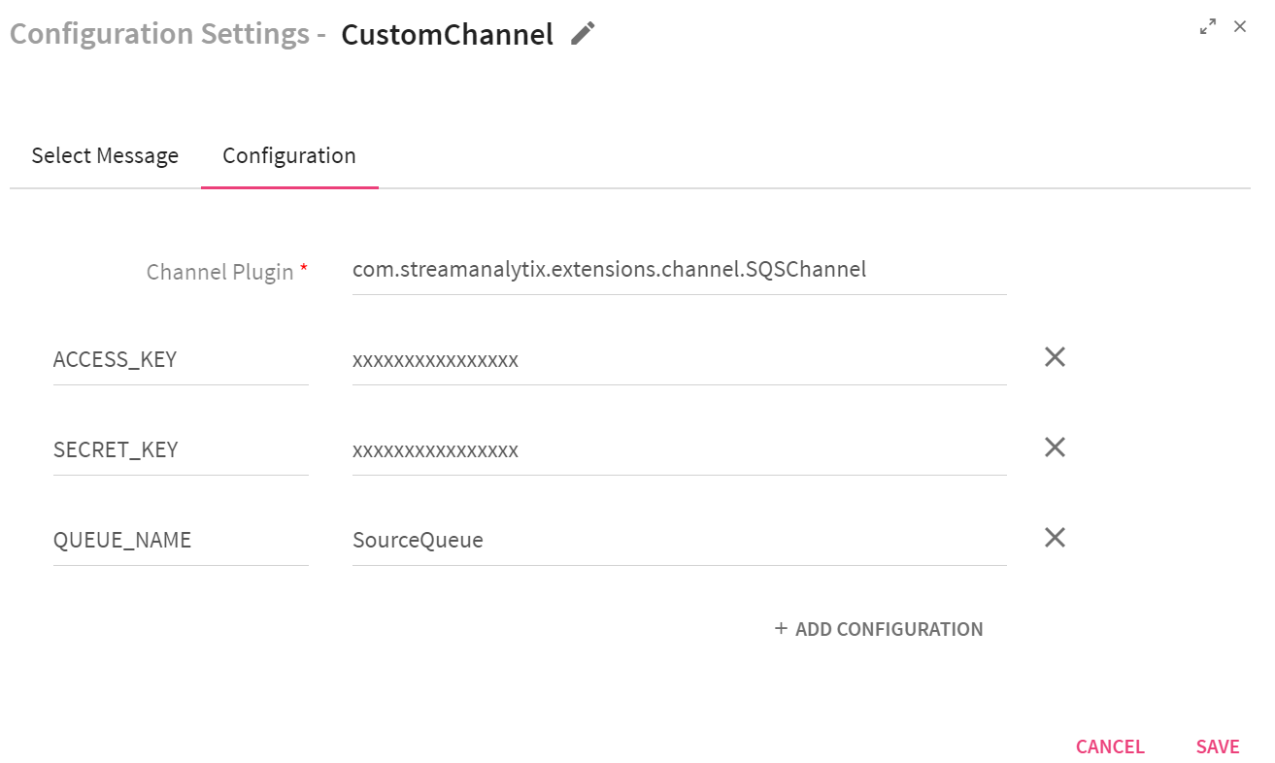

|  |  |
| --- | --- |
| **Field** | **Description** |
| **Channel Plugin** | Fully qualified name of the channel class. com.streamanalytix.extensions.channel.SQSChannel) |
| **Custom field: ACCESS_KEY** | Access key for AWS .AWS account is identified by Access Key ID, which AWS uses to look up for your Secret Access Key. |
| **Custom field:**  **SECRET_KEY** | Secret access keys are—as the name implies—secrets, like your password. For your own security, AWS doesn’t reveal your password to you if you forgot it (you’d have to set a new password). Similarly, AWS does not allow retrieval of a secret access key after its initial creation. This applies to both root secret access keys and AWS Identity and Access Management (IAM) user secret access keys. |
| **REGION** | The AWS region name (Default is us-west-2). This is an optional field. |
| **QUEUE_NAME** | Name of the queue. This is a mandatory field. |
| **MAX_NUMBER_MESSAGES** | The maximum number of messages to return. Valid values are 1 to 10. This is an optional field. |
| **VISIBILITY_TIMEOUT** | The duration (in seconds) that the received messages are hidden from subsequent retrieve requests after being retrieved by a ReceiveMessagerequest. This is an optional field. |
| **WAIT_TIME_SECONDS** | The duration (in seconds) for which the call waits for a message to arrive in the queue before returning. If a message is available, the call returns sooner than WaitTimeSeconds. This is an optional field. |

To give us your feedback on your experience with the application and report bugs or problems, mail us at [support@streamanalytix.com](mailto:support@streamanalytix.com) [support@streamanalytix.com](mailto:support@streamanalytix.com)