|  |  |
| --- | --- |
|  | Learn about-**Field Masking-Processor** |

# Custom Field Masking Processor

Field Masking Processor reads incoming JSON messages and if processor finds information related to credit card number, TIN, SSN or EMAIL ID then it masks all the defined fields.

**Field** **Masking Configuration**

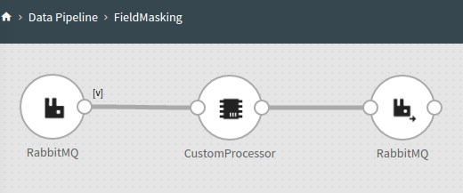

**Sample Input JSON Messages:**

{

"CC":"4567898765432678 ",

"TIN":"345678945 ",

"Email":"sandy.dsouza@impetus.co.in ",

"SSN":"123456789 "

}

**Input JSON:**

{

"CC":"4567898765432123 ",

"TIN":"345678123 "

}

**Input JSON:**

{

"CC":"4567564765432123 "

}

## Configure Field Masking Processor for Streaming Pipelines

To add a Field Masking Processor into your pipeline, drag the processor to the canvas and right click on it to configure as explained below.

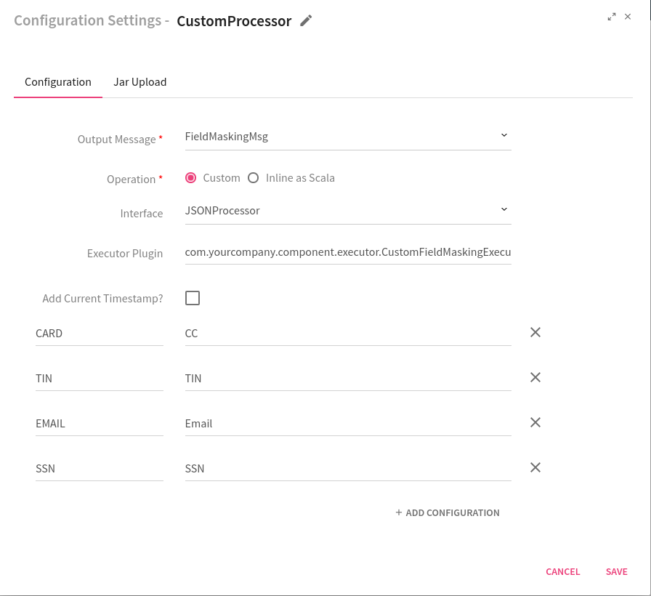

|  |  |
| --- | --- |
| **Field** | **Description** |
| **Output Message** | Message which is being processed |
| **Operation** | Select **Custom** as Operation. |
| **Interface** | **JSONProcessor:** Interface which provides flexibility for implementing the business logic over the streaming JSON object. |
| **Executor Plugin** | Specify the executor class. |
| **Custom field: MaskingField** | Message Key value pair fields used for masking. **Key** definesvariable and **Value** indicatesfield name on which Masking will be applied.  For example, **CARD** is a key and **CC** indicates value of that field which needs to be masked. |
| **Add Current Timestamp** | If selected, displays timestamp for the generated result. |

# To give us your feedback on your experience with the application and report bugs or problems, mail us at [support@streamanalytix.com](mailto:support@streamanalytix.com) [support@streamanalytix.com](mailto:support@streamanalytix.com)