| **STREAMANALYTIX 3.1.0** | Learn about-**SalesForce-Channel** |

# Custom SalesForce Channel

StreamAnalytix Salesforce channel reads data from different salesforce tables. The data is further analyzed and processed using different processors and emitters.

## Configure SalesForce Channel

**Step 1:** Drag the SalesForce Chanel on the pipeline canvas and right click on it to configure. On the Select Message tab, select a Message Type and provide a Message Name

|  |  |
| --- | --- |
| **Field** | **Description** |
| **Message Type** | **Single:** If only one message needs to be parsed in the pipeline.  **Multi:** If multiple messages needs to be parsed in the pipeline. |
| **Message Name** | Click on the Message Name input field to get a list of all the messages and select message(s). |
| **Schema Identifier** | In case, you have written your own code for schema identification, check the box to provide fully qualified name of your class. |

**Step 2:** Configure SalesForce channel properties on the Configuration tab.

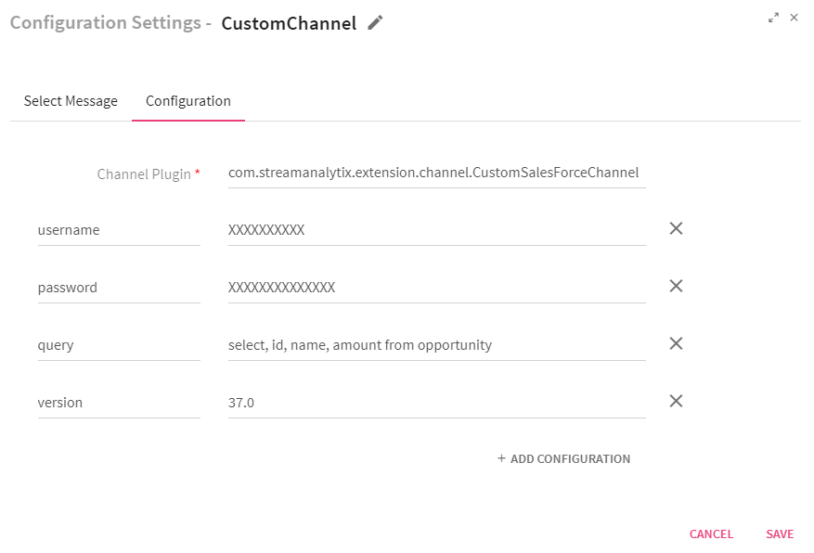

|  |  |
| --- | --- |
| **Field** | **Description** |
| **Channel Plugin** | Fully qualified name of the channel class. com.streamanalytix.extension.channel.CustomSalesForceChannel |
| **username** | Enter the salesforce account username |
| **password** | Enter the salesforce account password appended with security token |
| **query** | Salesforce **soql** query. |
| **version** | Enter the version of the salesforce API |

To give us your feedback on your experience with the application and report bugs or problems, mail us at [support@streamanalytix.com](mailto:support@streamanalytix.com) [support@streamanalytix.com](mailto:support@streamanalytix.com)