|  |  |
| --- | --- |
| **StreamAnalytix**  **Salesforce channel** | StreamAnalytix – SalesForce Integration |

# Introduction

Welcome to StreamAnalytix!

StreamAnalytix platform enables enterprises to analyze and respond to events in real-time at Big Data scale. With its unique multi-engine architecture, StreamAnalytix provides an abstraction that offers a flexibility to execute data pipelines using a stream processing engine of choice depending upon the application use-case, taking into account the advantages of Storm or Spark Streaming based upon processing methodology (CEP, ESP) and latency.

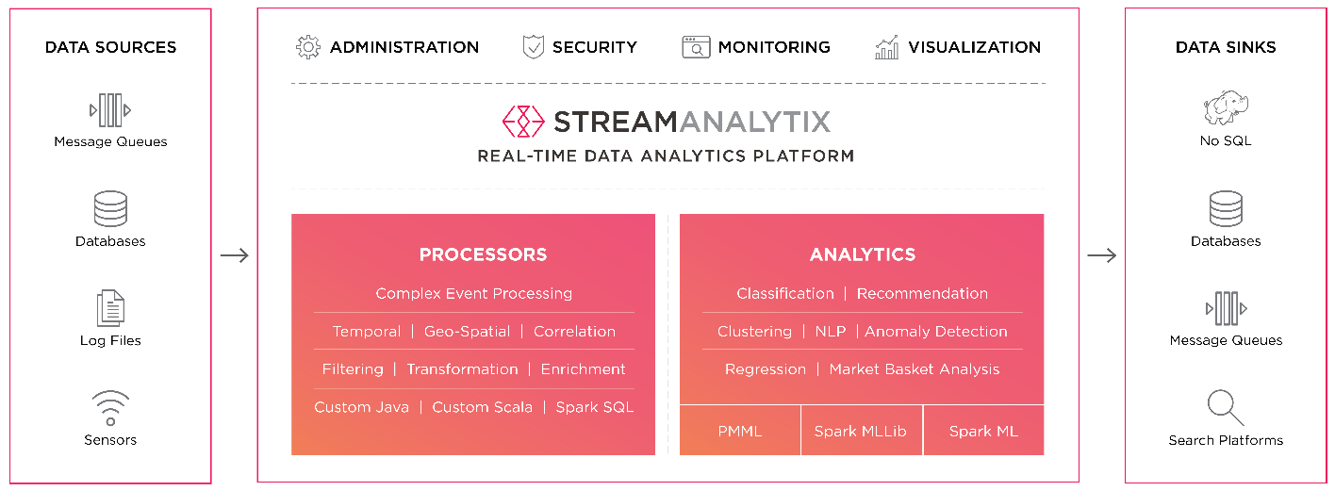

## About This Guide

This guide describes the integration of Salesforce with StreamAnalytix application as a channel to read data from salesforce tables.

**More Information**

Please visit [www.streamanalytix.com](http://www.streamanalytix.com/)

To give us your feedback on your experience with the application and report bugs or problems, mail us at [support@streamanalytix.com](mailto:support@streamanalytix.com)

To receive updated documentation in the future please register yourself at [www.streamanalytix.com](http://www.streamanalytix.com/)

We welcome your feedback.

# Terms & Conditions

This manual, the accompanying software and other documentation, is protected by U.S. and international copyright laws, and may be used only in accordance with the accompanying license agreement. Features of the software, and of other products and services of Impetus Technologies, may be covered by one or more patents. All rights reserved.

All other company, brand and product names are registered trademarks or trademarks of their respective holders. Impetus Technologies disclaims any responsibility for specifying which companies own which marks or which organizations.

USA

Los Gatos

Impetus Technologies, Inc.

720 University Avenue, Suite 130

Los Gatos,

CA 95032, USA

Ph.: 408.252.7111, 408.213.3310

Fax: 408.252.7114

© 2017 Impetus Technologies, Inc., All rights reserved.

If you have any comments or suggestions regarding this document, please send them via e-mail to [support@streamanalytix.com](mailto:support@streamanalytix.com)

Table of Contents

Introduction 1

About This Guide 1

Terms & Conditions 2

Table of Contents 3

1. Salesforce Pipeline: 4

2. Configuring the sample channel: 4

# Salesforce Pipeline:

StreamAnalytix custom channel can be customized to read data from different salesforce tables and use different S-Ax processors for enrich, analyze & persist data.

This document will illustrate a sample pipeline which will read data(Id, name & Amount) from **Opportunity** table in salesforce, apply a simple filter(Amount > 60000.0) and publishes the result set in a rabbitMq channel.

# Configuring the sample channel:

1. Refer document <Register Component> and follow the steps for registering the Salesforce component as channel in StreamAnalytix.
2. Create pipeline.
   1. Creating message
      1. Message Configuration, create S-Ax message as illustrated in the below image.

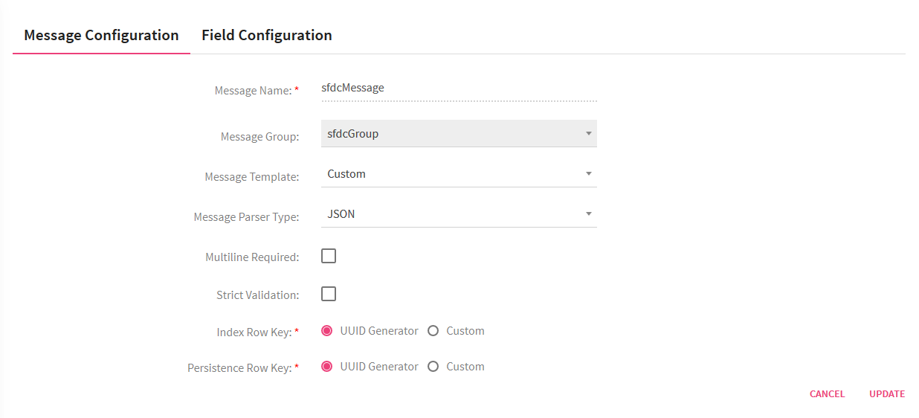

* + 1. Field Configuration, we will be fetching fields like Id, Name & Amount from the opportunity table. Hence we will need three fields to be created Id(text), Name (text) & Amount(Decimal).

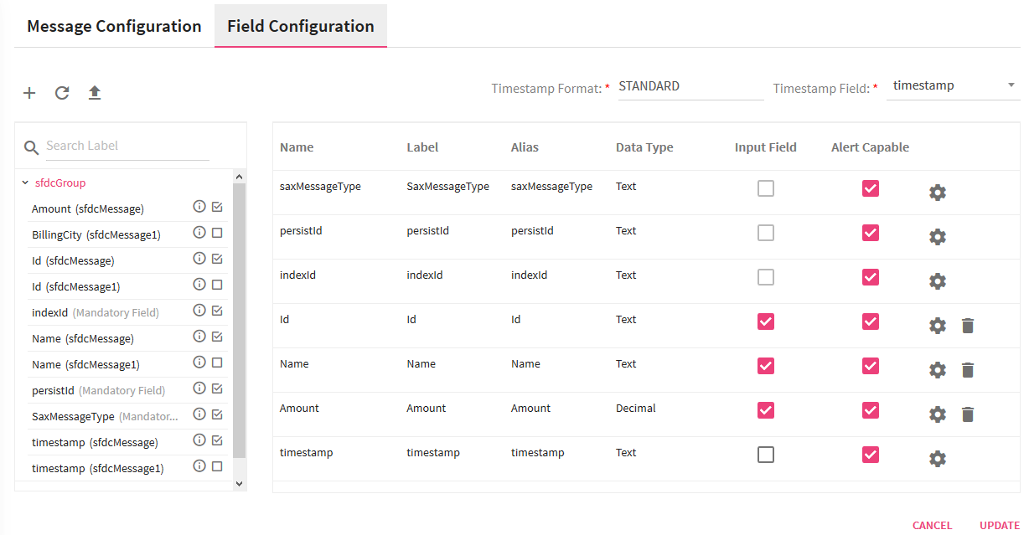

* + 1. Save and continue with pipeline creation.
  1. On the right hand side menu select application type as “Batch”.
  2. Select Channel -> Advanced data sources, and drag and drop Salesforce channel on the pipeline canvas. Also drag drop filter processor and RabbitMq Emitter.

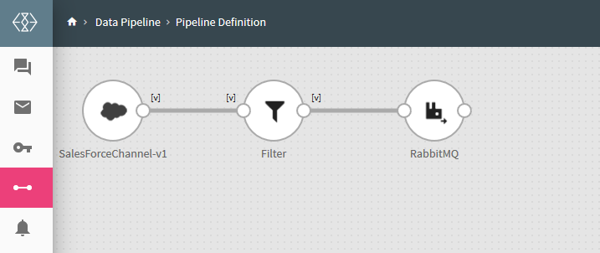

Fig 1. Creating the pipeline structure

* 1. Configuring the components.
     1. Custom SalesForceChannel, select message created in the point 2.a.

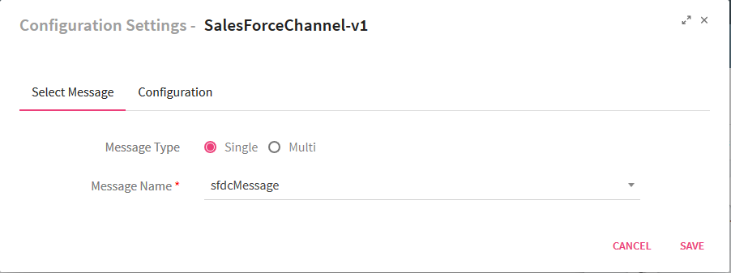

* + 1. Select tab configuration, and configure as illustrated below

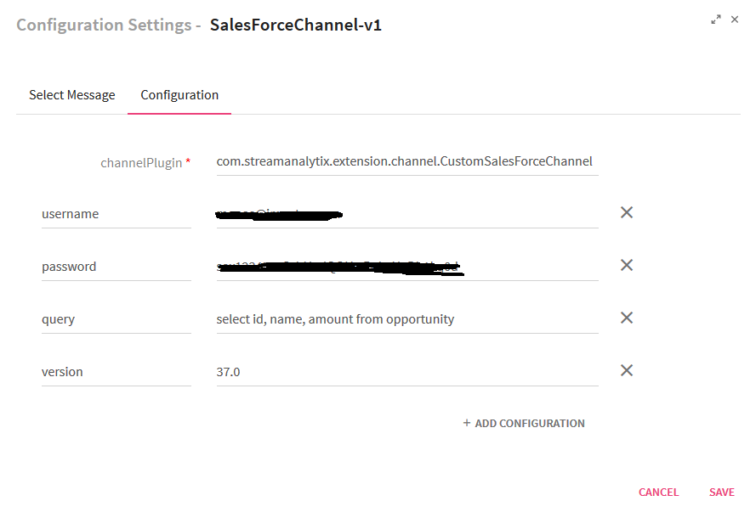

|  |  |
| --- | --- |
| **Field** | **Description** |
| **Channel Plugin** | Enter the fully qualified name of the channel class |
| **username** | Enter the salesforce account username |
| **password** | Enter the salesforce account password appended with security token |
| **query** | Salesforce “soql” query. |
| **version** | Enter the version of the salesforce API |

* 1. Follow StreamAnalytix user guide to configure filter & RabbitMq components as illustrated below.

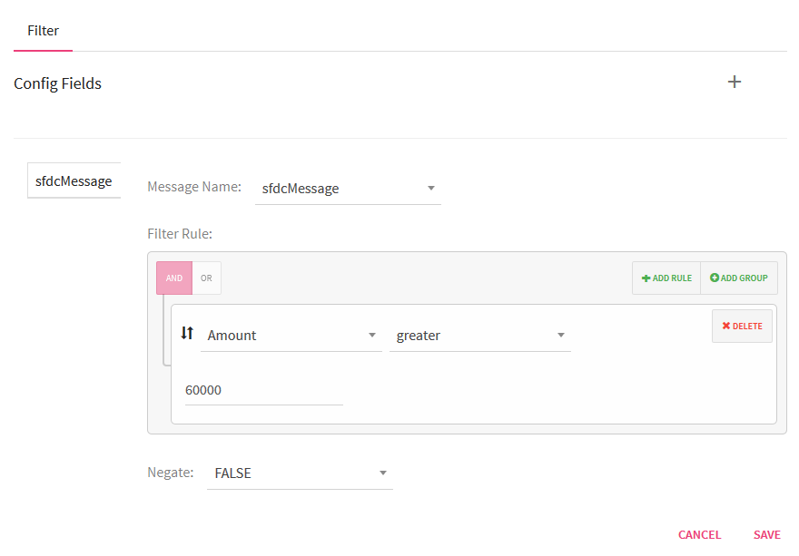

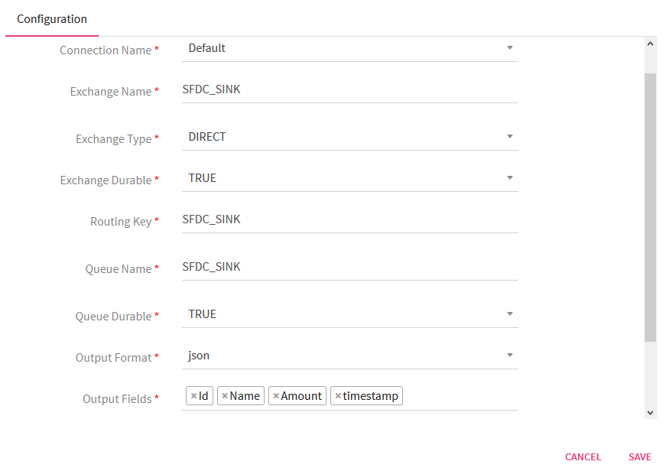

1. Save and play the pipeline, check for results of the filter on RabbitMq. Check the illustration below.

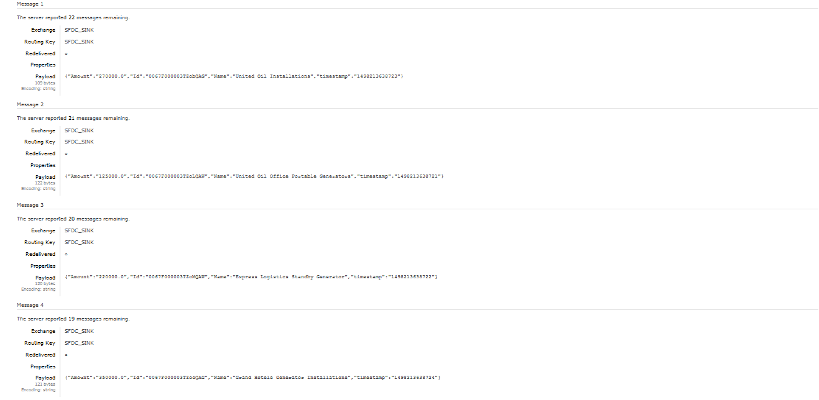

To give us your feedback on your experience with the application and report bugs or problems, mail us at [support@streamanalytix.com](mailto:support@streamanalytix.com)

