Hello !
First of all i want to thank you for buying my product! if u find any issues or have any sugestion Please contact me at Wao3dStudio@gmail.com

v1
To get the same effect please download the unity Legacy image effects package from the asset store it’s free , and add the bloom effect and color correction to your camara in your scene,also make sure to play with the colors of the particles for diferent effects.
All materials are using Mobile particle shader .
Follow these simple steps for the image effects.
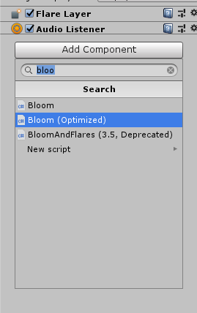
1 2
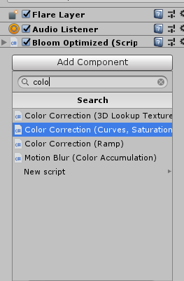

Before
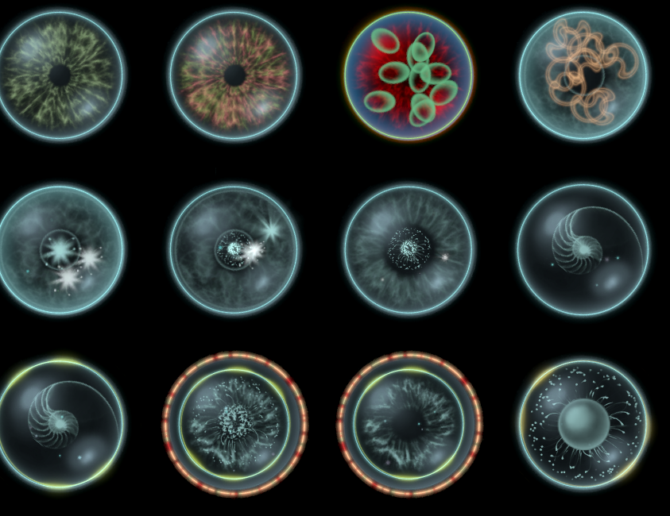

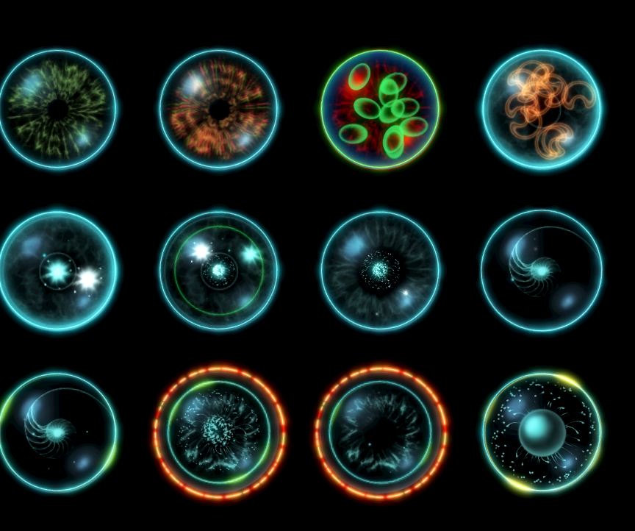
After

