Name: **Rayyan Saeed**

Assignment: **Task 1: NUMBERS AND VARIABLES**

Date: **09/19/2019**

1. Create three variables in a single line and assign different values to them and make sure their data types are different. Like one is int, another one is float and last one is string.

**Solution:** *a, b, c = 2, 2.2, “2.2”*

2. Create a variable of value type complex and swap it with another variable whose value is an integer.

**Solution:** *b, a = 2r, 2*

*a, b = b, a*

3. Swap two numbers using third variable as result name and do the same task without using any third variable.

**Solution:** *a, b = 2, 4*

*temp= a*

*a= b*

*b=temp*

Not using third variable

*a,b= 2,4*

*b,a= a,b*

4. Write a program to print the value given by the user by using both Python 2.x and Python 3.x Version.

**Solution:**  Python 2.x

*print a*

Python 3.x

*Print (a)*

5. Write a program to complete the task given below:

* Ask user to enter any 2 numbers in between 1-10 and add both of them to another variable call z.

**Solution:** *a= input(“Enter first number”)*

*b= input(“Enter second number”)*

*z= a+b*

* Use z for adding 30 into it and print the final result by using variable result.

**Solution:**  *print(z + 30)*

6. Write a program to check the data type of the entered values. HINT: Printed output should say - The input value data type is : int/float/string/etc

**Solution:** *print ( "The input value data type is : ", type(a))*

7. Create Variable using CamelCase, LadderCase and UPPERCASE.

**Solution:** CamelCase: *localVariable = 2*

LadderCase:

Uppercase:  *GLOBALVARIABLE = 2*

8. If one data type value is assigned to ‘a’ variable and then a different data type value is assigned to ‘a’ again. Will it change the value. If Yes then Why?

**Solution:** Yes, it will change the value and the datatype. In python, it deduce the datatype automatically and changes according to given data unlike other programming languages.

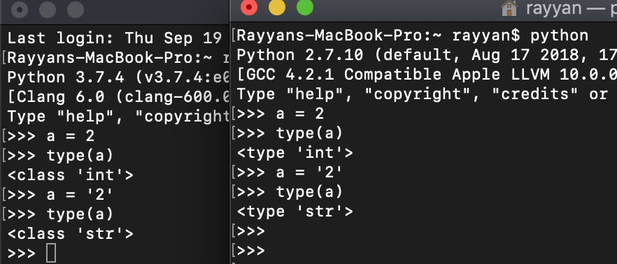

**FEEDBACK:**

In question no 4: You have to take input from user and then print it in both Python2 and Python3.

Rest all questions are correct.

Name: **Rayyan Saeed**

Assignment: **Task 2: OPERATORS AND DECISION MAKING STATEMENT**

Date: **09/21/2019**

**Solution 1)**

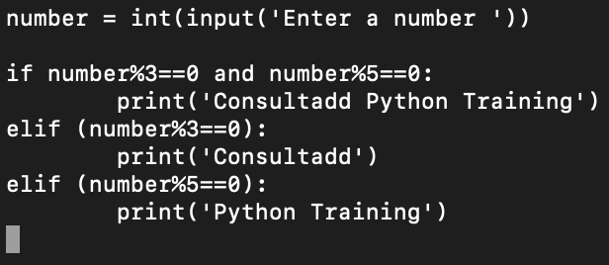

Output:

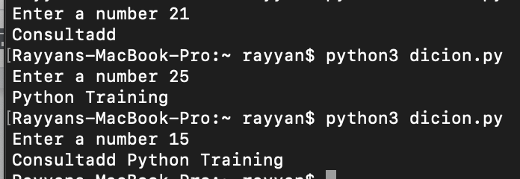

**Solution 2:**

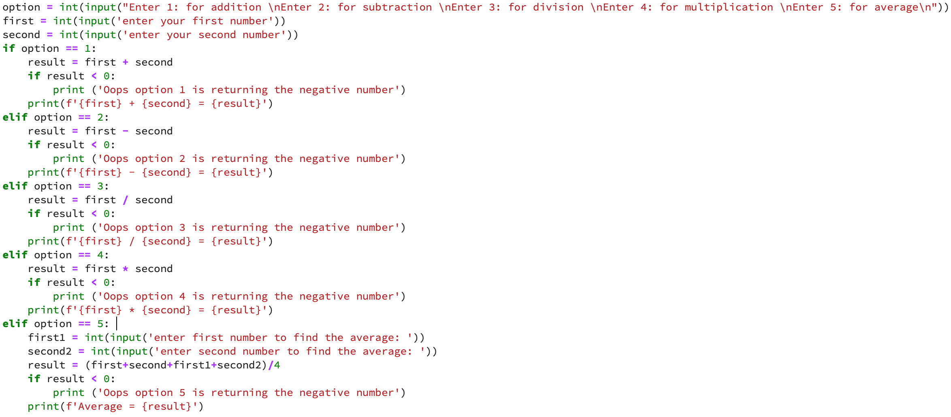

Output:

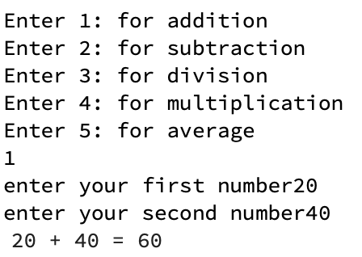

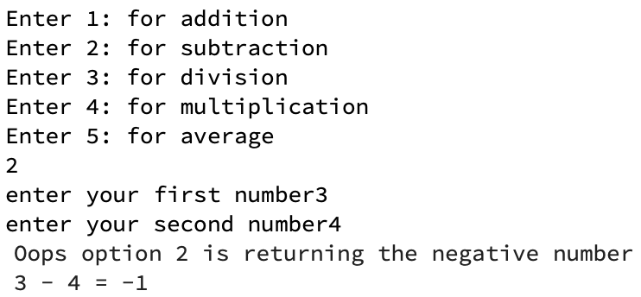

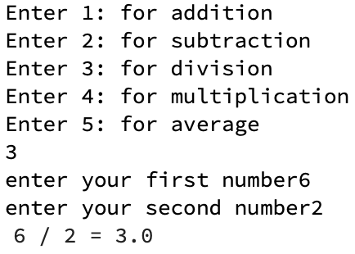

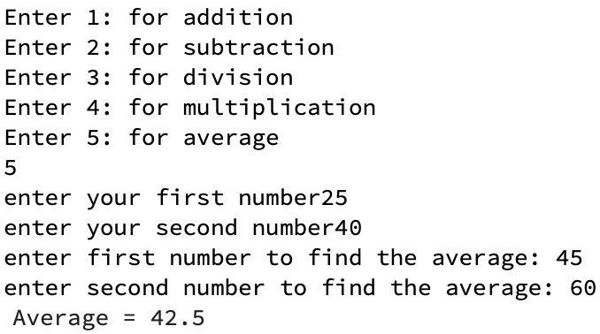

**Solution 3:** OUTPUT:

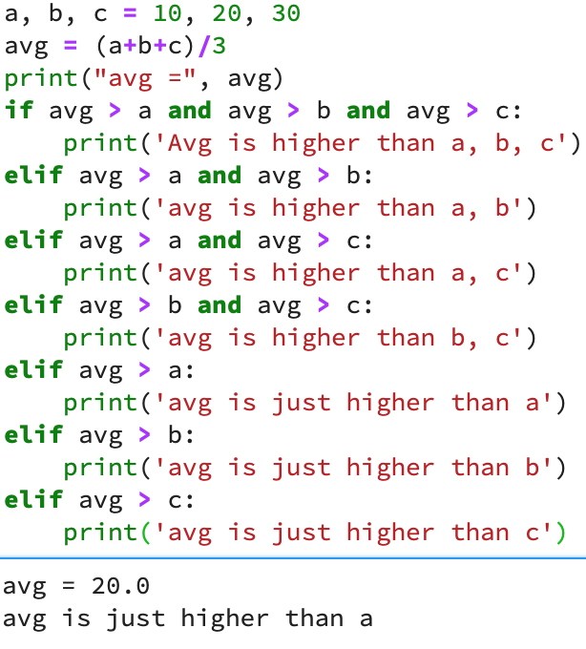

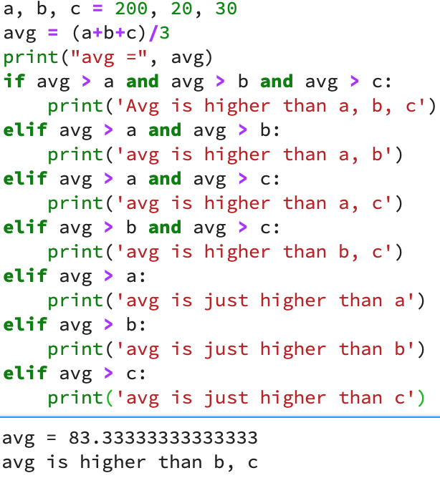

**Solution 4:**

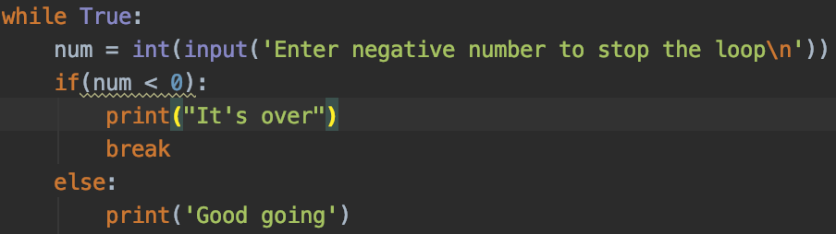

OUTPUT:

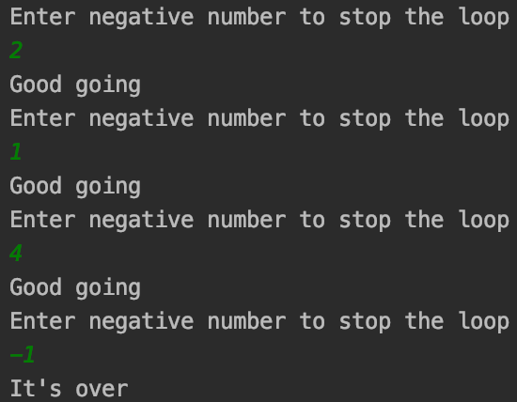

**Solution 5:**

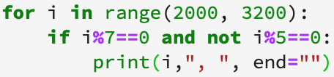

OUTPUT:



**Solution 6:**

* x=123

for i in x:

print(i)

**Ans:** Error because x is an integer value. It cannot work with for loop.

* i = 0

while i < 5:

print(i)

i += 1

if i == 3:

break

else:

print(“error”)

**Ans:** 0

1

2

* count = 0

while True:

print(count)

count += 1

if count >= 5:

Break

**Ans:** 0 1 2 3 4

*’Break’ should have been ‘break’.

**Solution 7:**

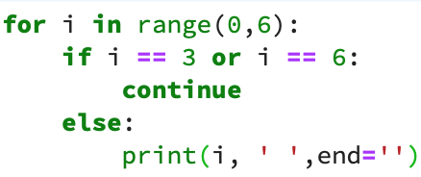

Output:



**Solution 8:**

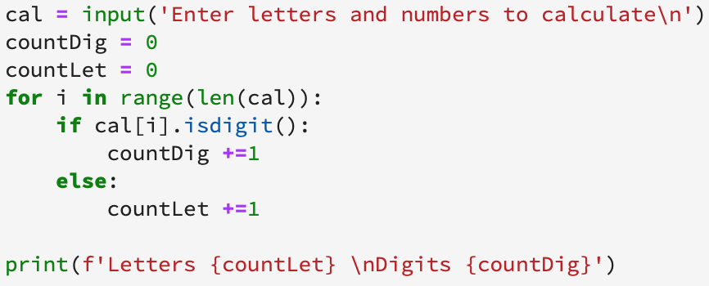

Output:

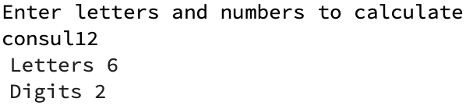

**Solution 9)a):**

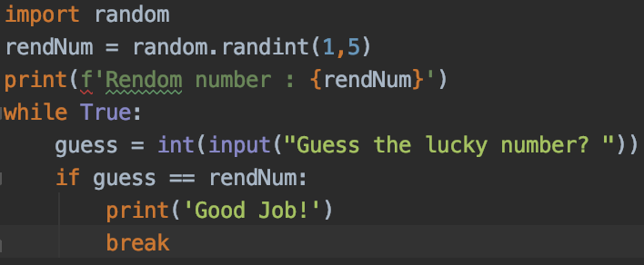

Output:

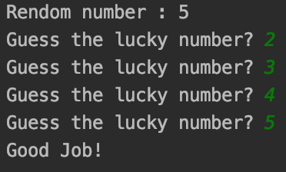

**9)b):**

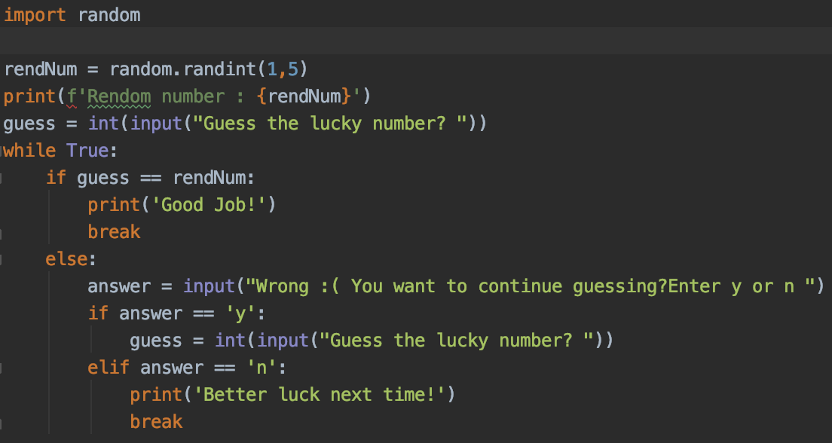

Output:

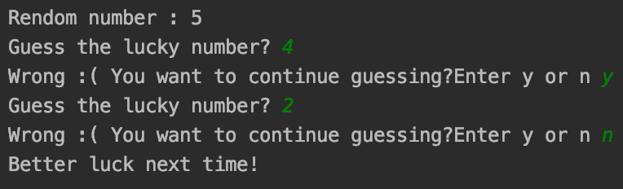

**Solution 10:**

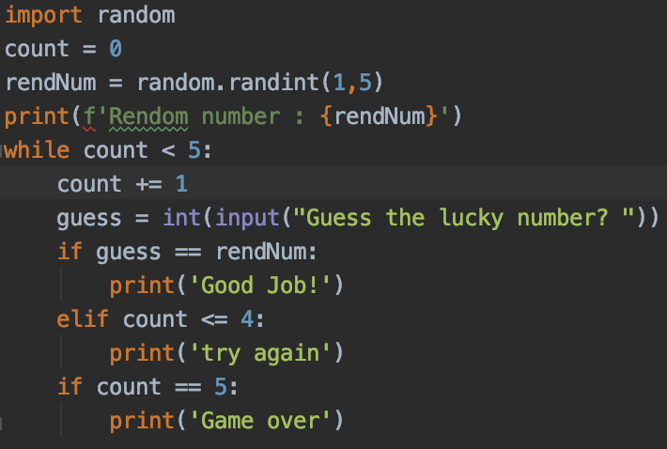

Output:

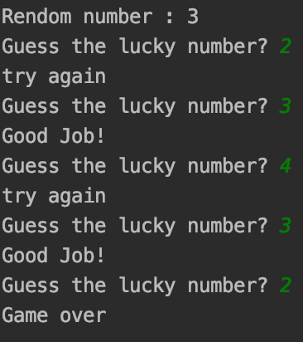

**Solution 11:**

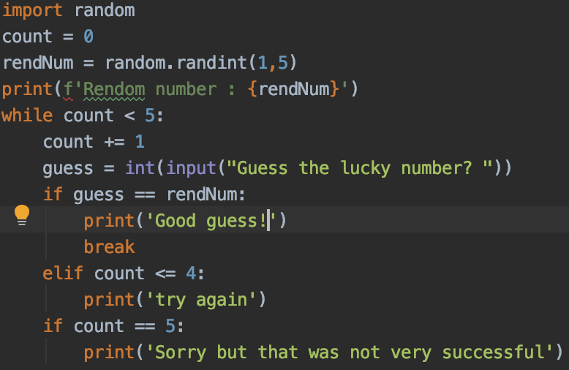

Output:

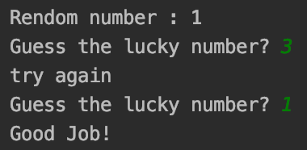

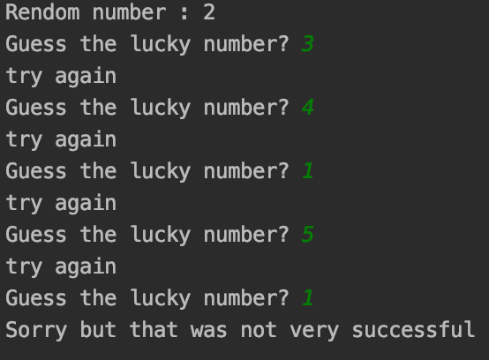

**FEEDBACK:**I am not sure how you got the output of question 4.  
As it is giving the Good going thrice a time. Can you please check

I replaced the output. I used anaconda before which was giving me weird output. But now, I corrected it.

Name: **Rayyan Saeed**

Assignment: **Task 3: Data Structure**

Date: **09/23/2019**

**Solution 1:**

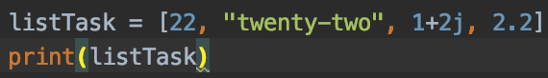

**Solution 2:**

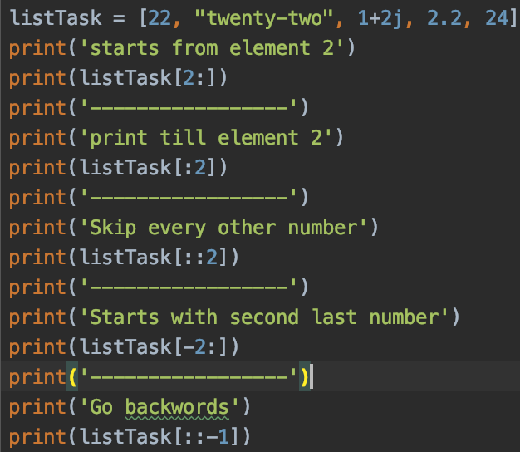

Output:

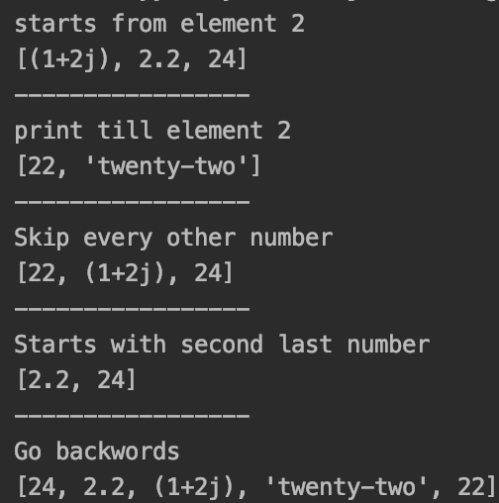

**Solution 3:**

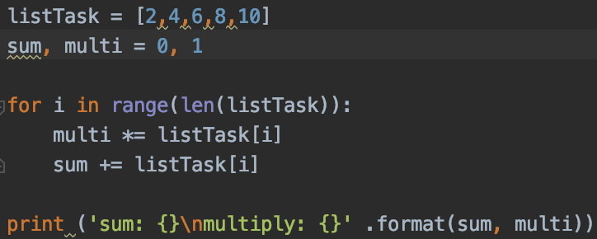

Output:

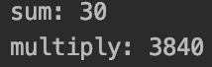

**Solution 4:**



Output:

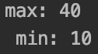

**Solution 5:**

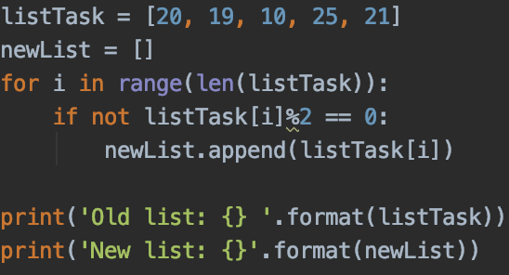

Output:

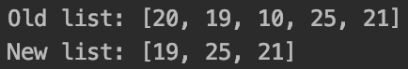

**Solution 6:**

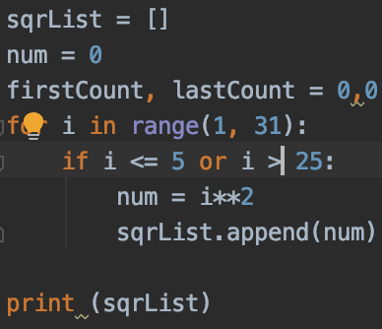

Output:



**Solution 7:**

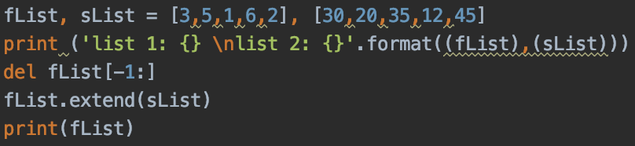

Output:

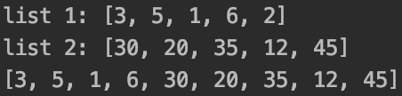

**Solution 8:**

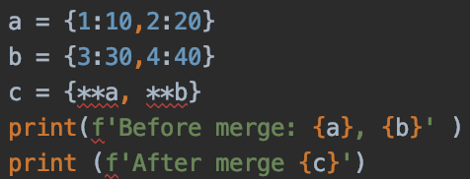

Output:

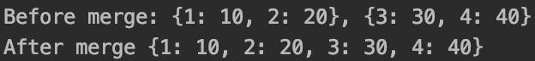

**Solution 9:**

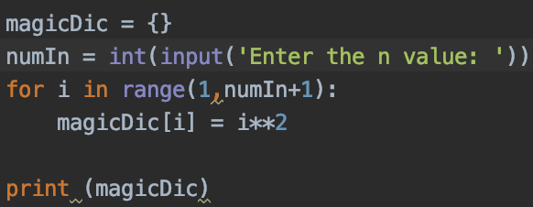

Output:

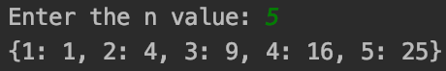

**Solution 10:**

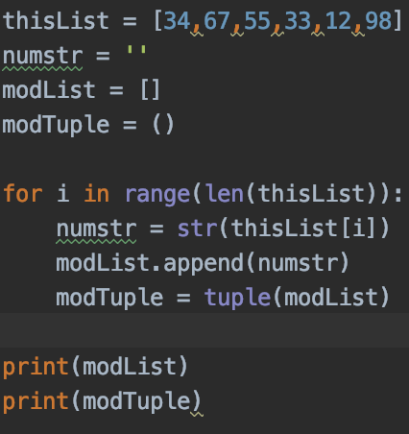

Output:

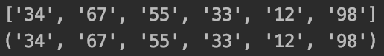

**FEEDBACK:**

**What other approach can be applied in question no 6 and 8. Try solving those questions with some another approach.**

**Great work!**

Name: **Rayyan Saeed**

Assignment: **WEEKEND ACTIVITY ON DATA STRUCTURES**

Date: **09/29/2019**

**Solution 1:**



Output:



**Solution 2:**



Output:



**Solution 3:**

**x=[100,200,300,400,500,[1,2,3,4,5,[10,20,30,40,50],6,7,8,9],600,700,800]**

* Access list [1, 2, 3, 4]
  + print(x[5][0:4])
* Access list [600, 700]
  + print(x[6:8])
* Access list [100, 300, 500, 600, 800]
  + print(x[::2])
* Access list [[800, 700, 600, [1, 2, 3, 4, 5, [10, 20, 30, 40, 50], 6, 7, 8, 9], 500, 400, 300, 200, 100]]
  + print(x[::-1])
* Access list [10]
  + print(x[5][5][0])
* Access list [ ]

**Solution 4:** There is no difference between the two in terms of functionality. Xrange does not work in python3.   
**Solution 5:** Tuple is immutable which means that it cannot be replaced by any other assignment.

**Solution 6:**

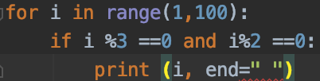

Output:



**Solution 7:**

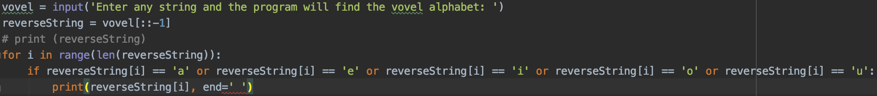

Output:



**Solution 8:**

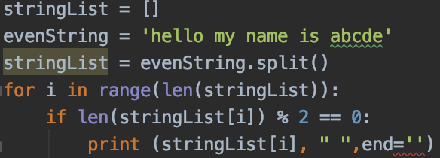

Output:



**Solution 9:**

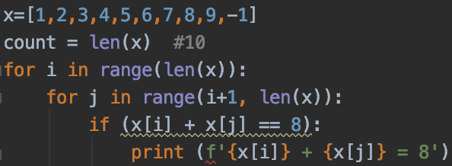

Output:

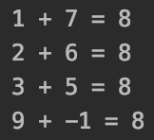

**Solution 10:**

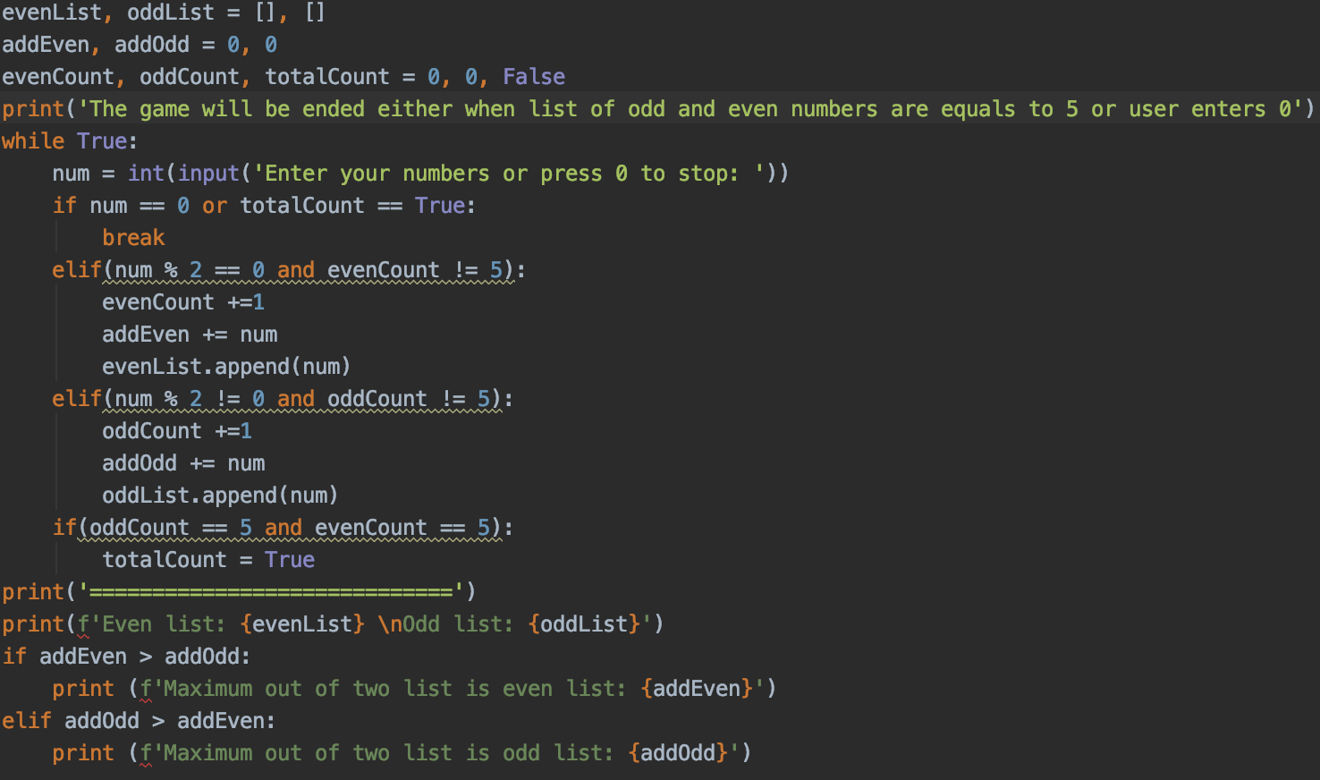

Output:

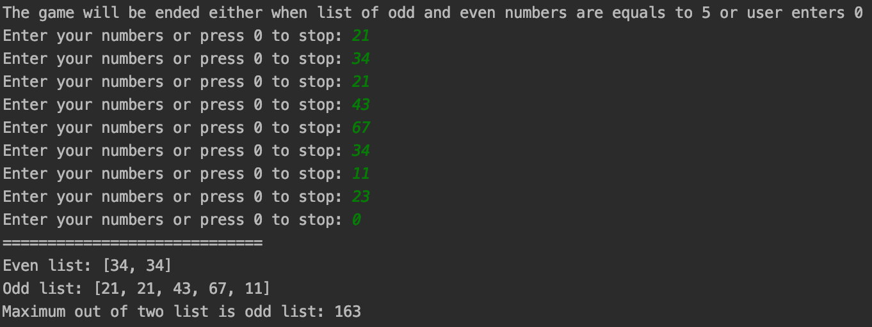

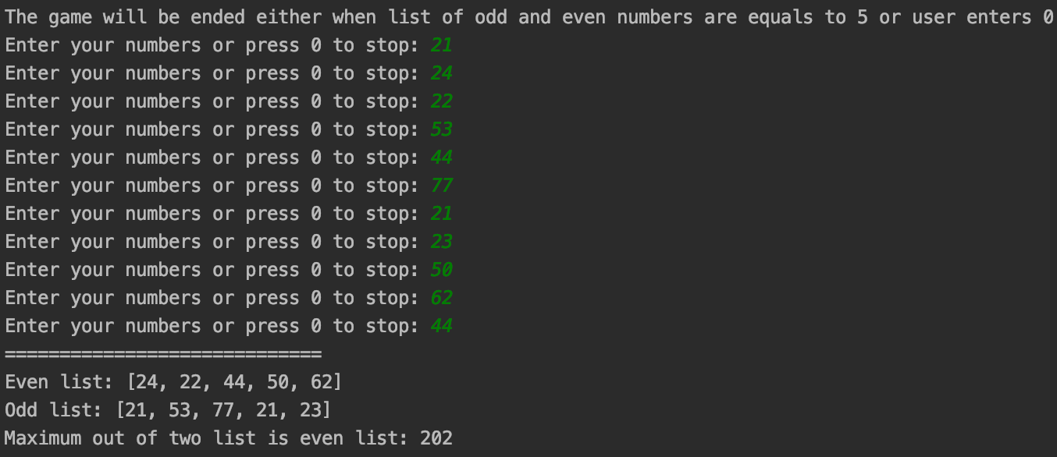

**Solution 11:**

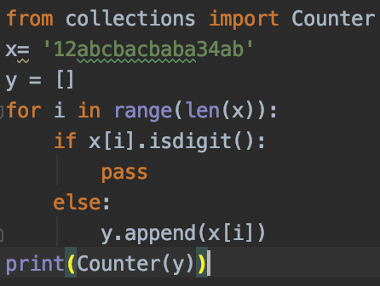

Output:



Name: **Rayyan Saeed**

Assignment: **WEEKEND ACTIVITY ON FUNCTION**

Date: **09/29/2019**

**Solution 1:**

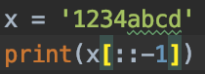

**Solution 2:**

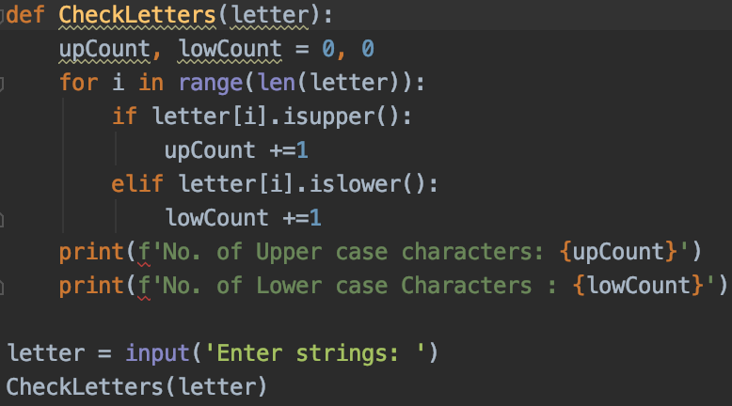

Output:



**Solution 4:**

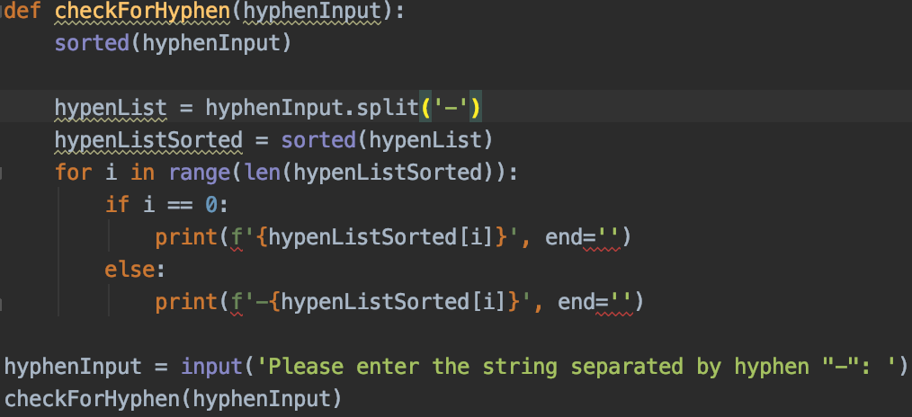

Output:



**Solution 5:**

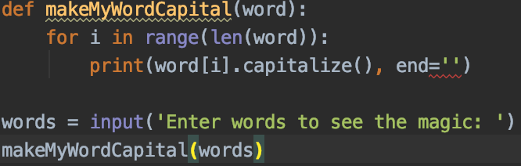

Output:



**Solution 6:**

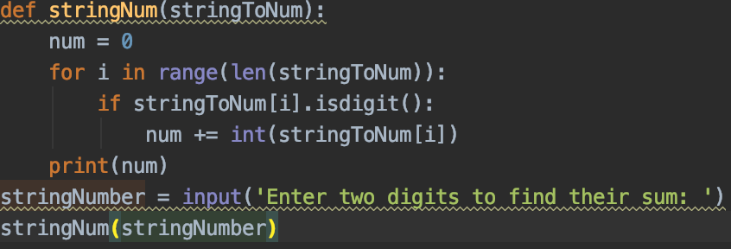

Output:

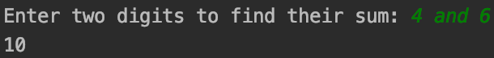

**Solution 7:**

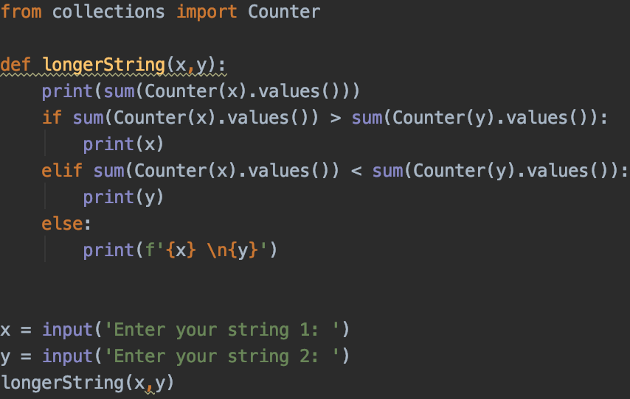

Output:

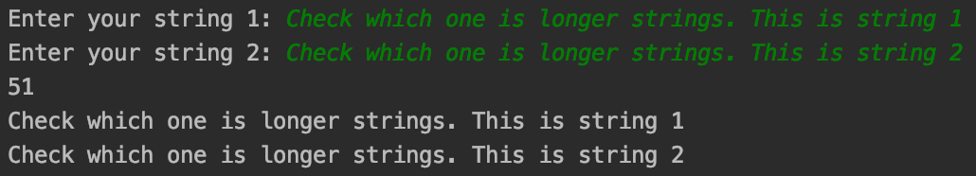

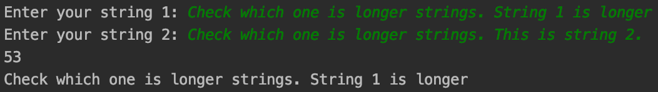

**Solution 8:**

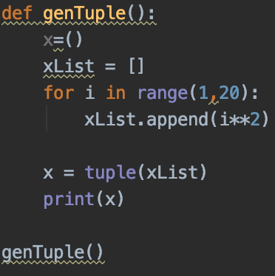

Output:



**Solution 9:**

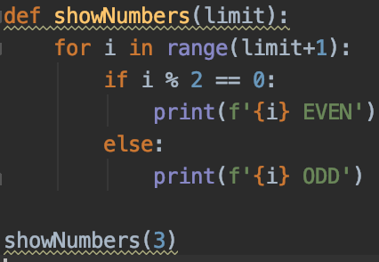

Output:

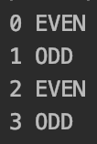

**Solution 10:**



Output:



**Solution 11:**



Output:



**Solution 12:**

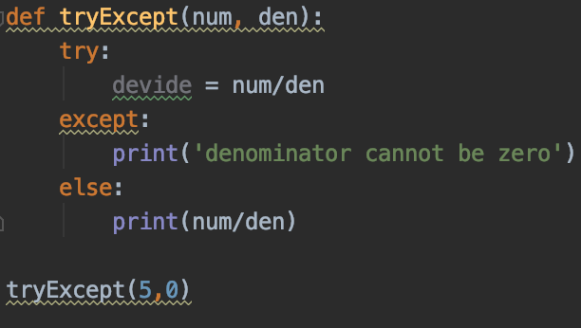

Output:



**Solution 13:**

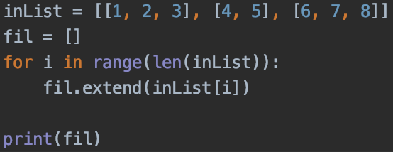

Output:



**Solution:**

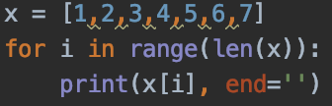

Output:



**Solution 14 1):**

Output: 2

**Solution 14 2):**

Output: error as f function is not defined

Name: **Rayyan Saeed**

Assignment: **HIGHER ORDER FUNCTIONS, GENERATORS, LIST COMPREHENSION AND DECORATOR**

Date: **09/29/2019**

**Solution 1:**



Output:



**Solution 3:**

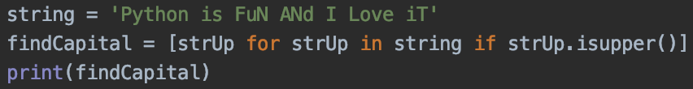

Output:



**Solution 4:**

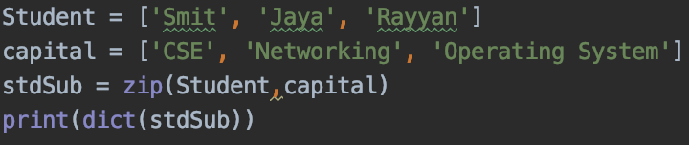

Output:



**Solution 6:**

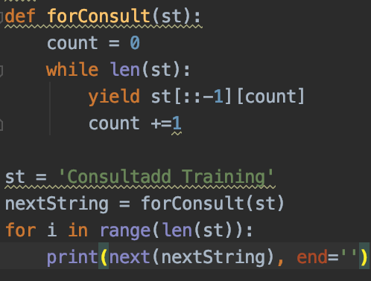

Output:



**Solution 7:**

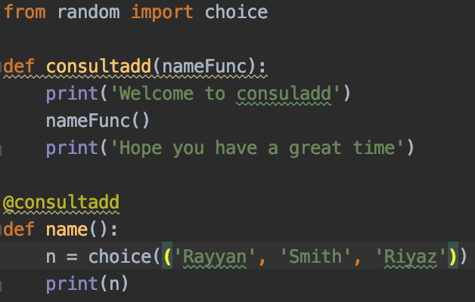

Output:

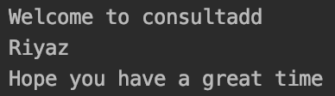

**Solution 8:**

Top 5 technologies

1. Vue.JS
2. Angular
3. Blockchian Testnet
4. Ionic 2
5. NPM

Source: <https://www.valuecoders.com/blog/technology-and-apps/top-15-front-end-development-tools-2019/>

Companies that use those technologies

Vue.JS: Netflix, Adobe, Alibaba (Source: <https://www.netguru.com/blog/13-top-companies-that-have-trusted-vue.js-examples-of-applications> )

Angular: Google(designer), Weather, Lego, Paypal

Blockchian Testnet: Testing tool to experiment bitcoin.

Ionic 2: Channel Impact, [Shootsac, Inc.](https://enlyft.com/tech/company/shootsac.com) (source: <https://enlyft.com/tech/products/ionic-framework>)

NPM: Linkedin, Uber, Walmart (source: <http://www.tothenew.com/blog/how-are-10-global-companies-using-node-js-in-production/>)

Name: **Rayyan Saeed**

Assignment: **Task 5: FILE HANDLING AND EXCEPTION HANDLING**

Date: **10/02/2019**

**Solution 1:**

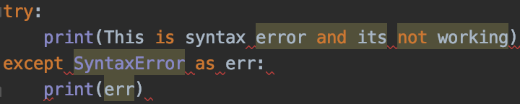

Output:

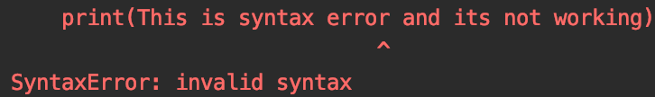

**Solution 2:**

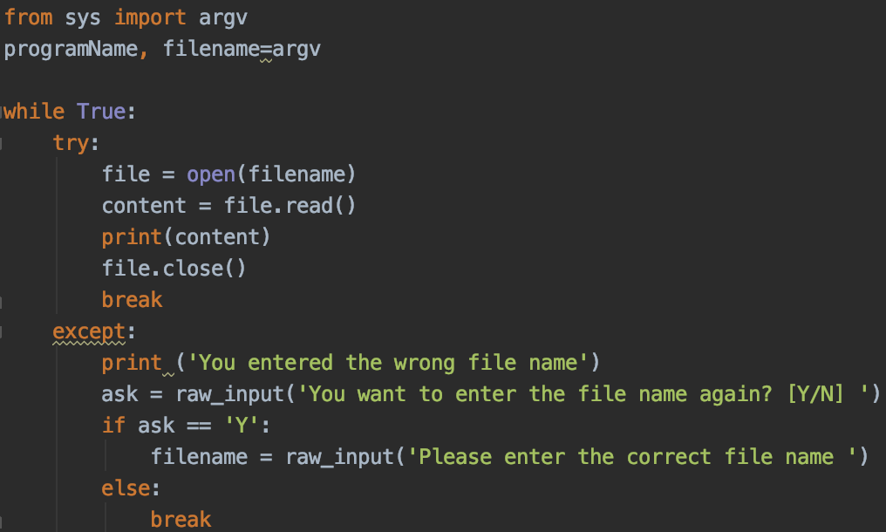

Output:

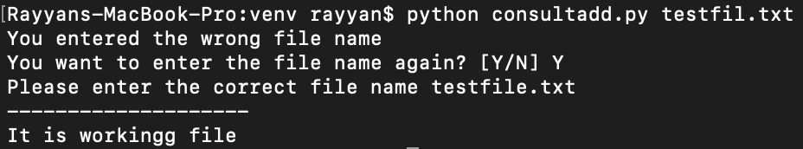

**Solution 3:**

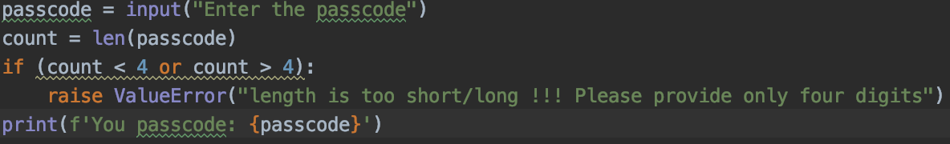

**Solution 4:**

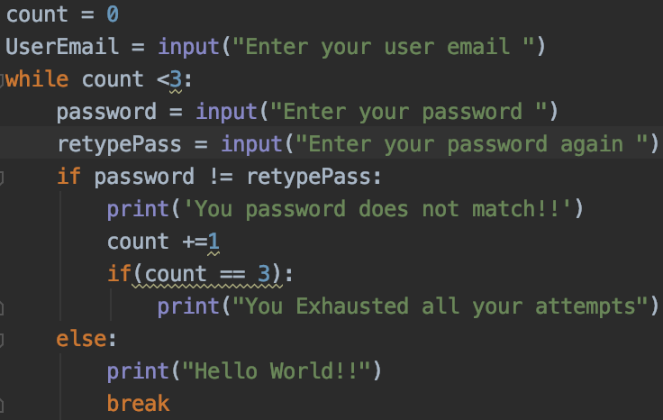

Output:

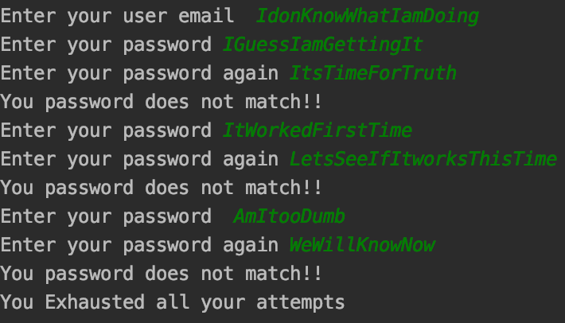

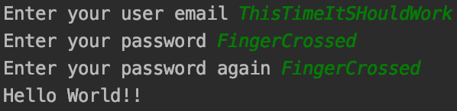

**Solution 6:**

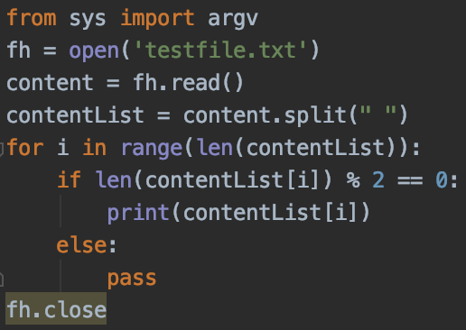

Output:

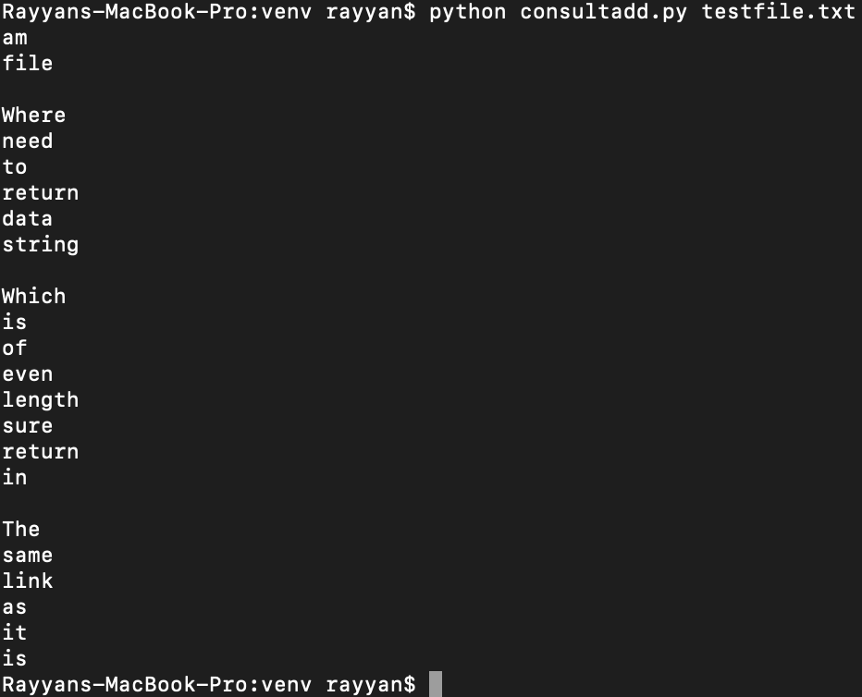

Name: **Rayyan Saeed**

Assignment: **Task 6: Classes and objects**

Date: **10/03/2019**

**Solution 1:**

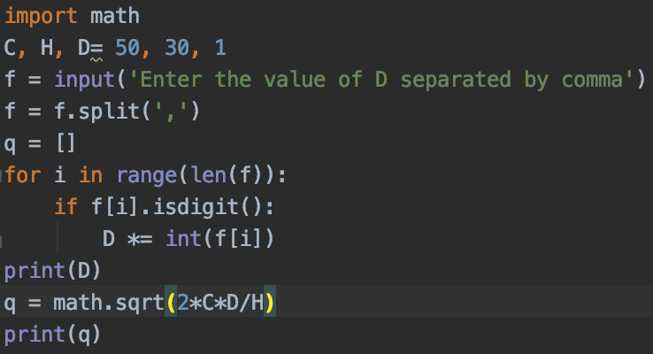

Output:

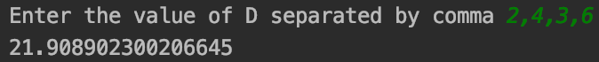

**Solution 2:**

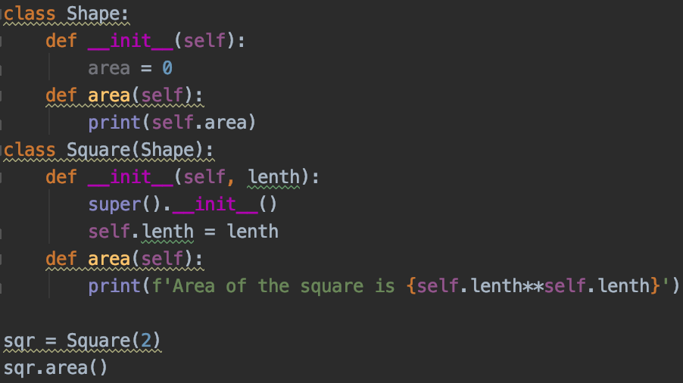

Output:



**Solution 3:**

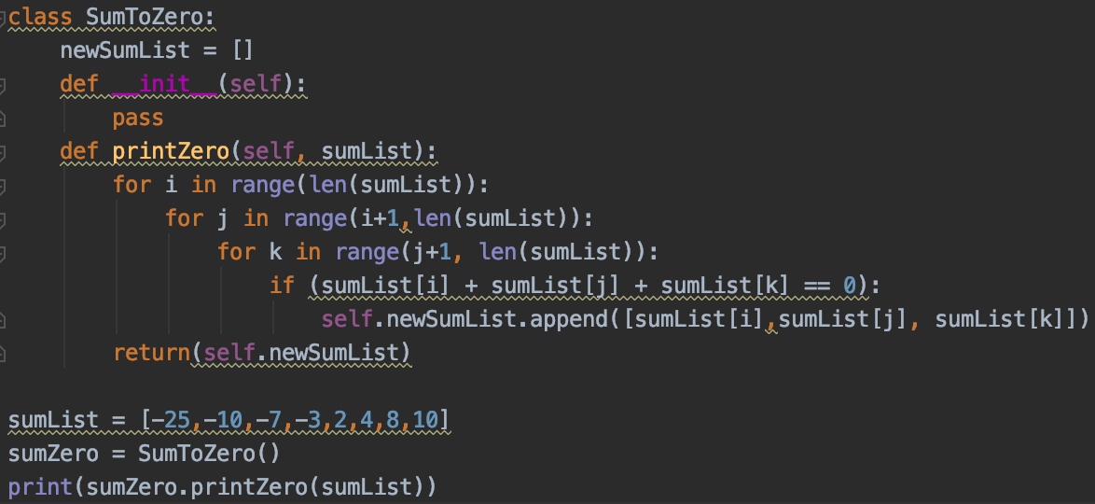

Output:



**Solution 4)1):**

Its an error as it does not recognize ‘x’ variable. It can be solved by adding ***super().__init__()***in a constructor of Derived_Test class

**Solution 4)2):**

Output: 1 2

**Solution 4)3):**

*Output: 3 1*

When it calls count method, it will only call class B count method because the instantiation was for object B. Therefore, the output was 1 for value Y while for X was 3(default value given by object B).

**Solution 4)4):**

*Output: 30*

At first glance, I predicted output 60 but upon realization that obj instantiates object B. Therefore, class B constructor calls class A constructor(because of *super())* that calls multiply method. Since, class B contains multiply method, it will be called. Otherwise, class A multiply method would have been called and output would have been 60.

**Solution 5)**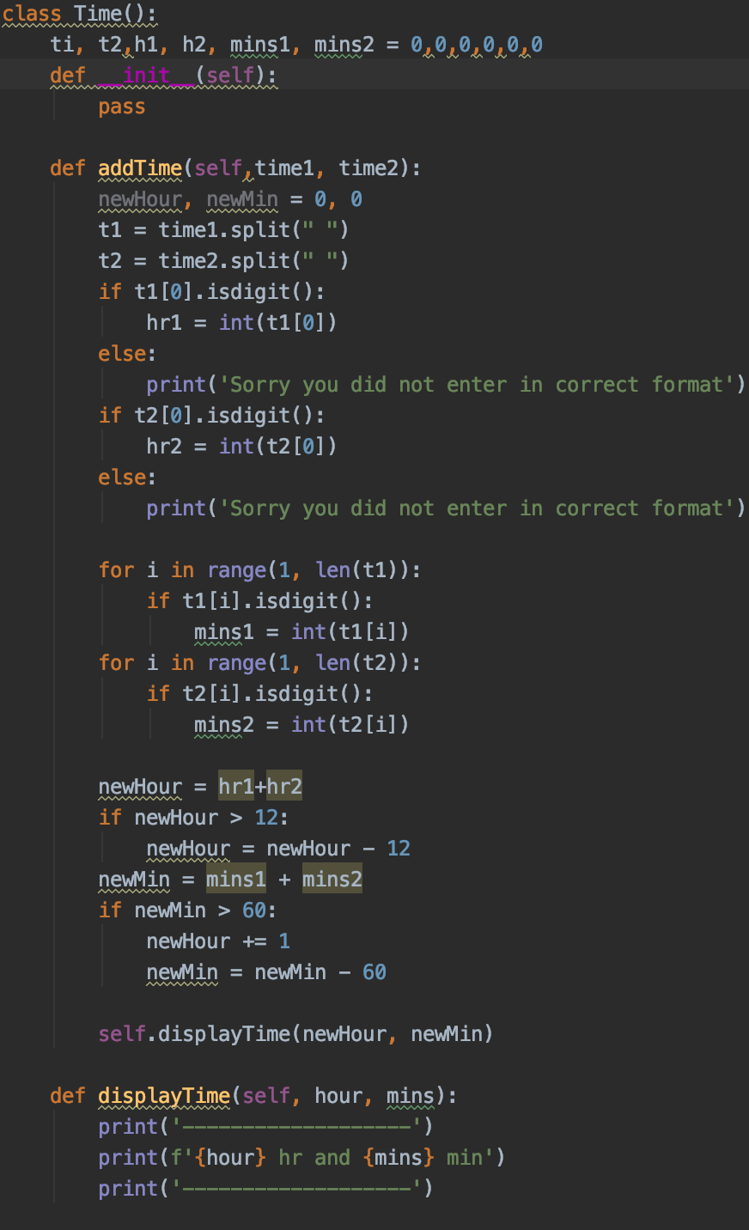

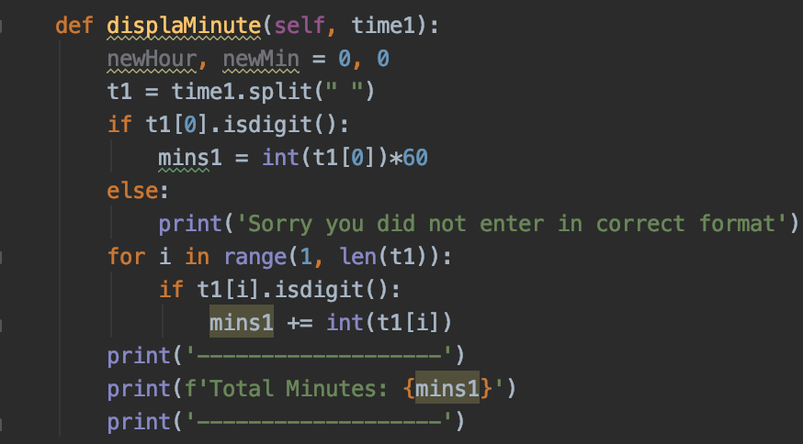

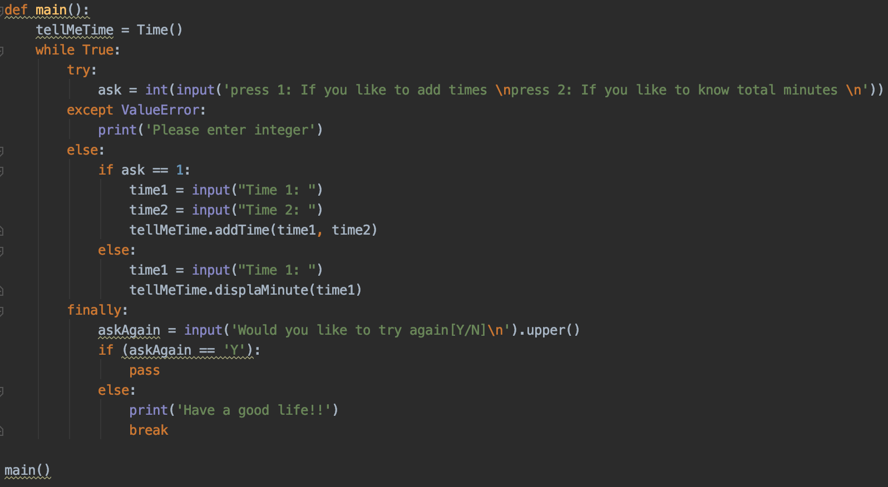

Output:

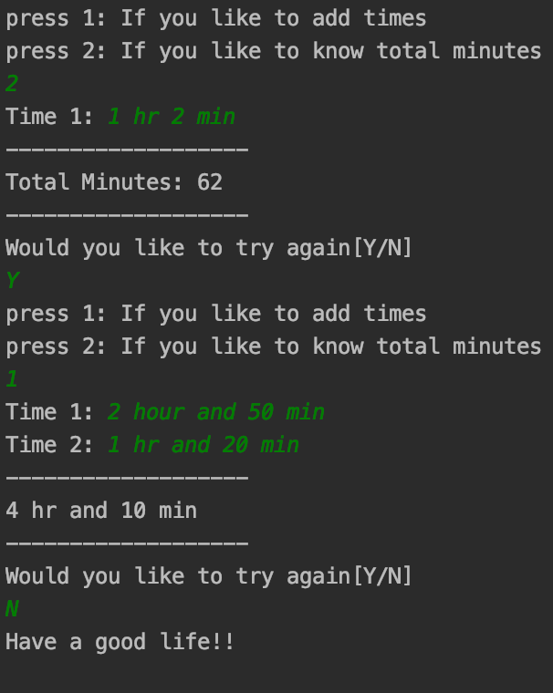

**Solution 6)**

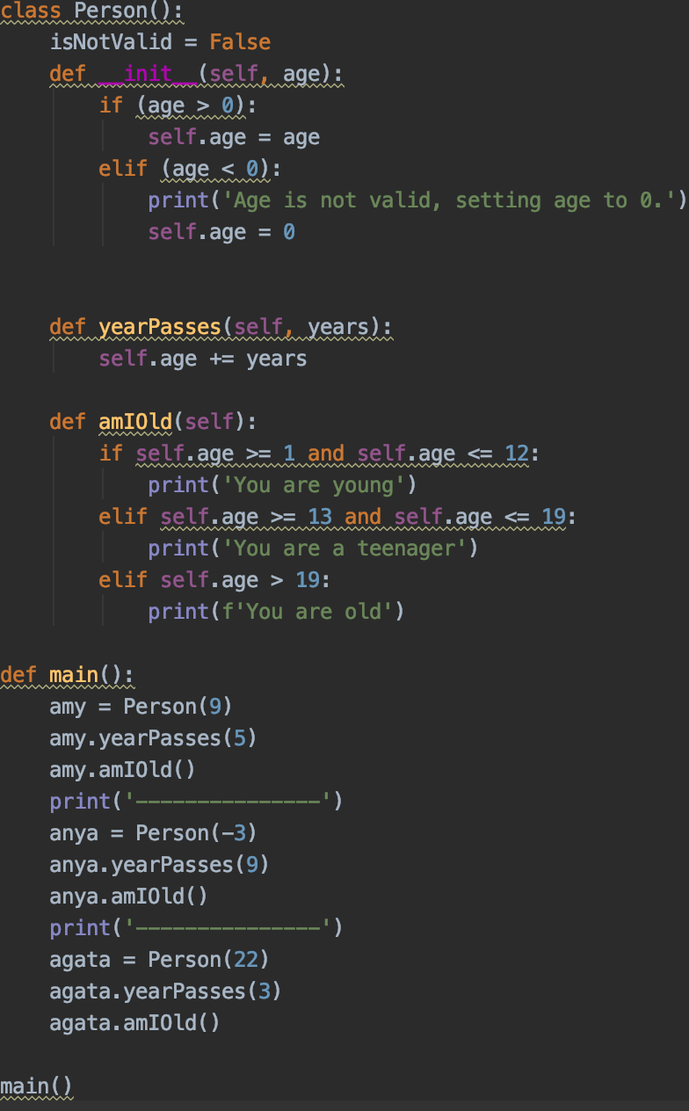

Output:

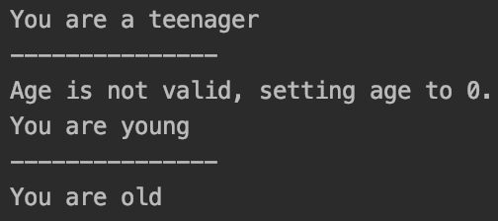

Name: **Rayyan Saeed**

Assignment: **Weekend Task: THEORETICAL JOURNEY**

Date: **10/05/2019**

**Solution 1)** As philosophy goes ‘Not everything can be divided as 0’s and 1’s’. At least in Python, the process called pickling proved it wrong that philosophy. By importing pickle library, the whole data structure can be converted into the 0's and 1’s using dump module of pickle . Also, it can be reverted back by the process called unpickling using load module of pickle.

Source:pythoncentral.io/how-to-pickle-unpickle-tutorial/

**Solution 2)** In Python, coder does not have to worry about freeing the memory. Garbage collector will automatically delete/free the memory if an object is no longer reference to the program. For instance:

*process ([‘Consultadd’, ‘training’, ‘inprocess’])*

*process = ([‘skills’, ‘goodjob’, ‘money!’])*

Second ‘process’ will make garbage collector to delete first ‘process’ without being explicitly called delete.

**Solution 3)**

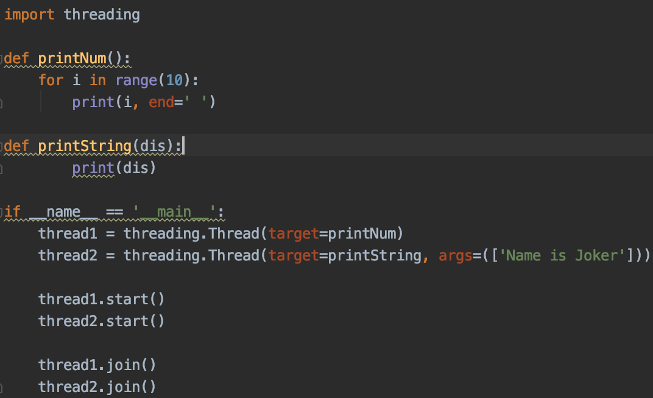

Output:

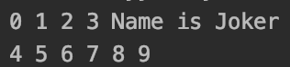

**Solution 4)**

**namedtuple():** It’s a method of collection library which gives tuple an index value to retrieve data easily. Also we can say that it creates a class instantly. For instance:

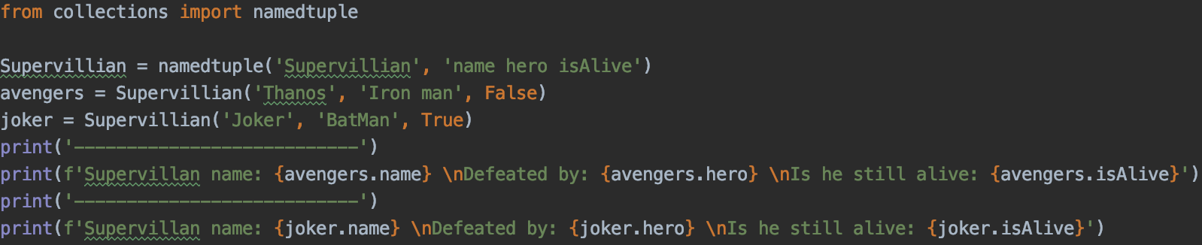

Output:

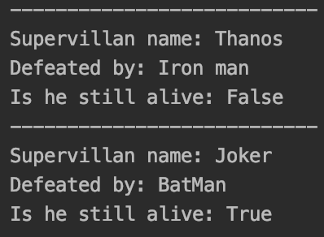

**Counter: Counter is a dict subclass that helps count hashtable objects. For instance:**

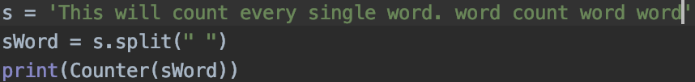

Output:



**OrderDict:** Order dictionary keeps the dictionary in order. By default, the order is random.

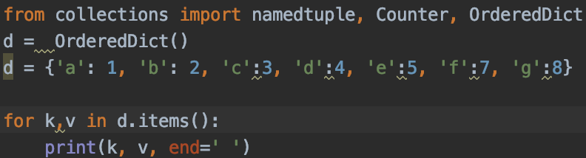

Output:



**ChainMap:** It combines dictionaries into one.

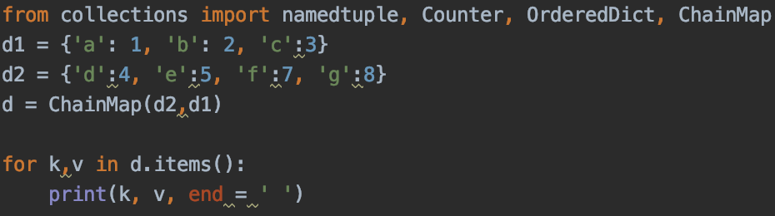

Output:



**deque:** It is an efficient way to append or pop the data from either side of the list.

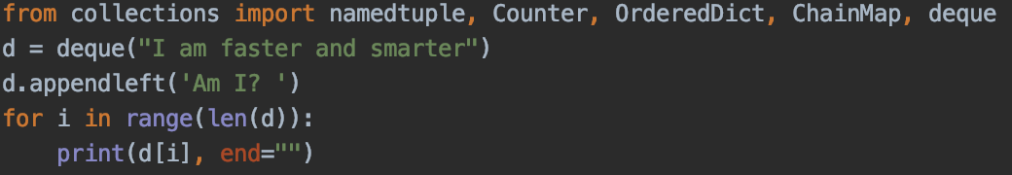

Output:



**Solution 6)**  virtualenv and conda are both environments where user can install packages according to the project. It helps preventing the package conflict if there are multiple projects are running in a system. While pip is a package manager that need to be installed in order to install packages in a system.

Name: **Rayyan Saeed**

Assignment: **Weekend Task: Github**

Date: **10/06/2019**

**Solution 1)** Version system controls are software tools that help teams to collaborate their work and modify it without compromising the original file.

**Top 5 software:**

Git, Apache subversion, Mercurial, Concurrent version system, perforce

**Solution 2)** Git is a version control system while github is a platform to host git repositories.

**Solution 3)**

**PR is Version Control Systems:** PR is a pull request feature in github that helps users to inform the changes were made in the program.

**Fork vs Commit:** Fork that makes a copy of repository of a file that can be changed or experimented without sacrificing the original file. While commit which users make on stagged changes. We can also say that its a snapshot of the updated stage of a program. User can go back to particular commit and make changes from that stage.

**Init vs clone:** Init initiates the repository using git while clone dependent on init to create a copy of the project.

**Branching and merging:** Branching is a process in git to switch to different branches to prevent editing wrong file while merging merge branches into one.