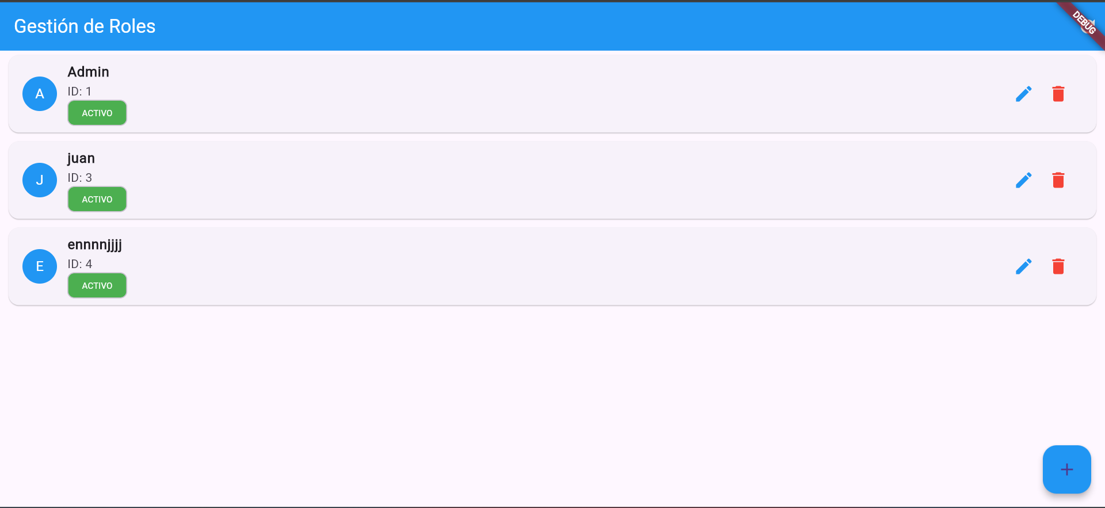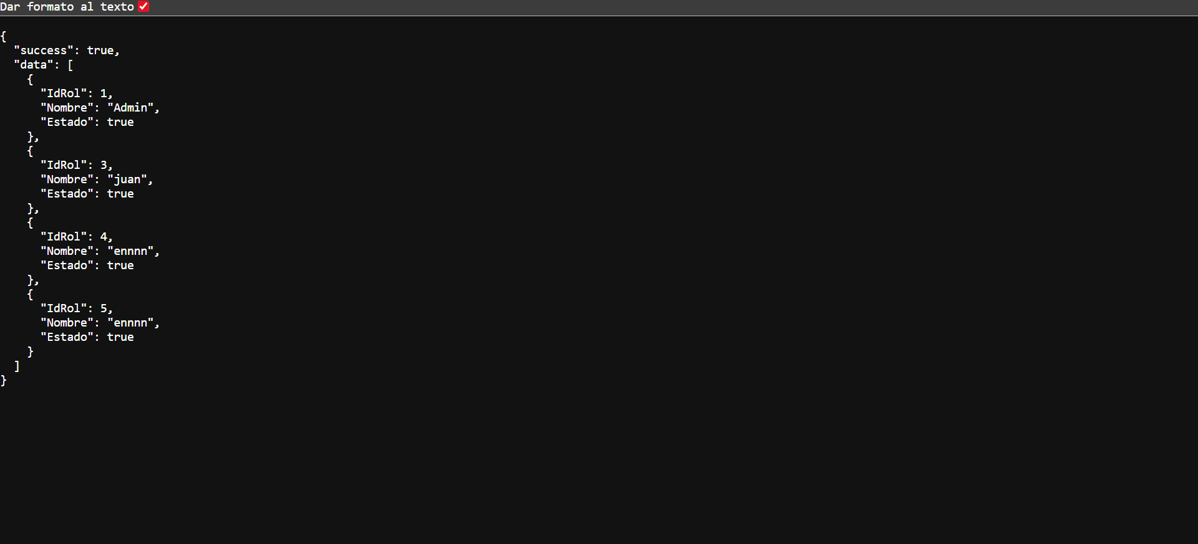
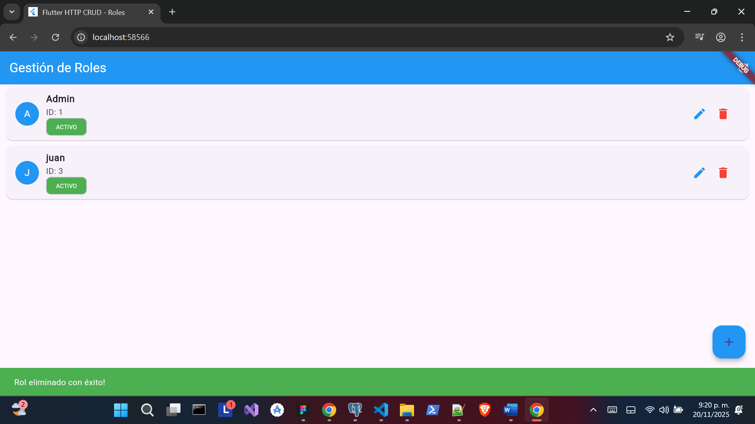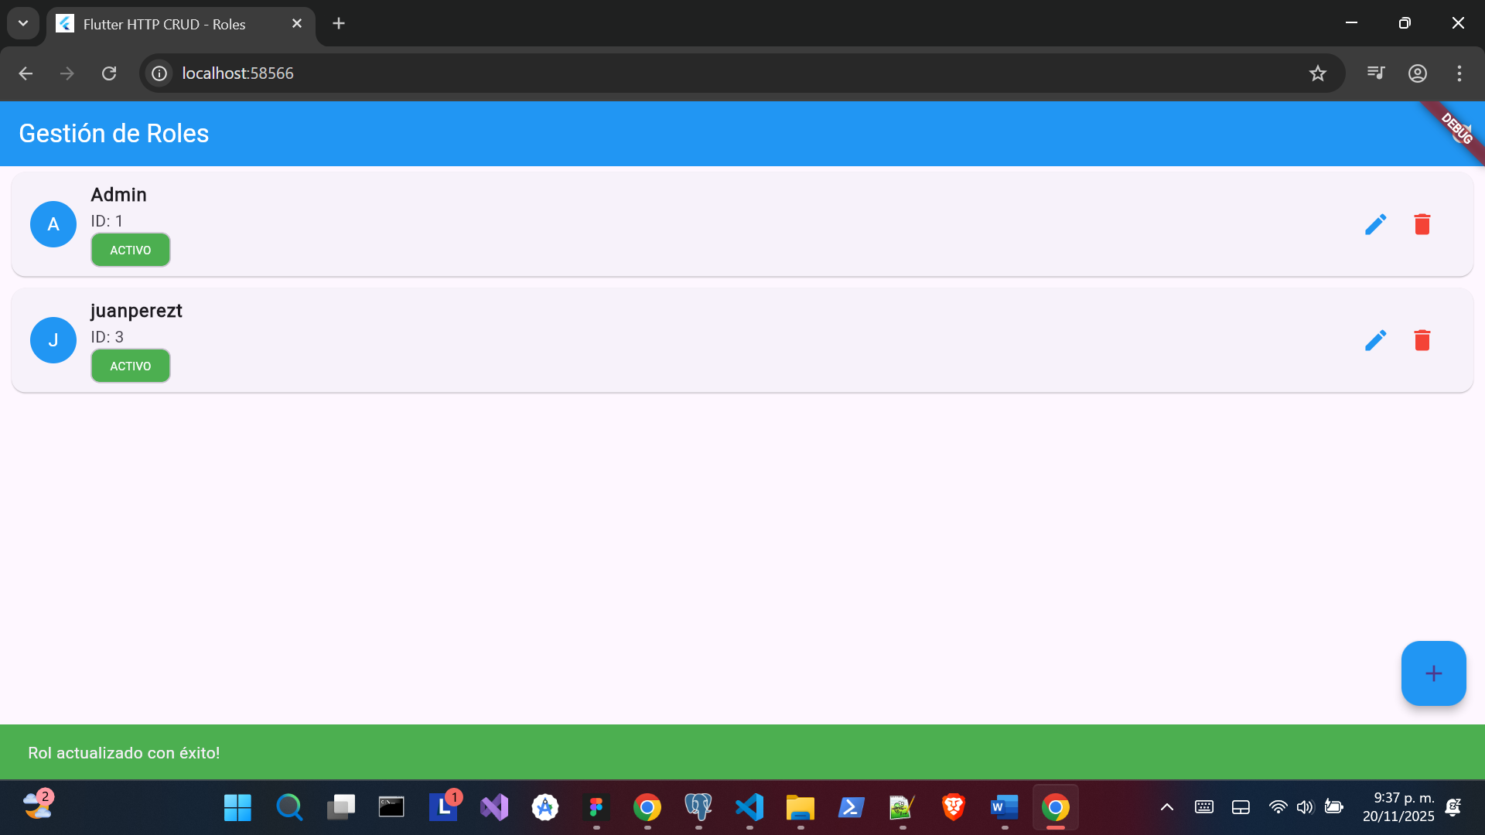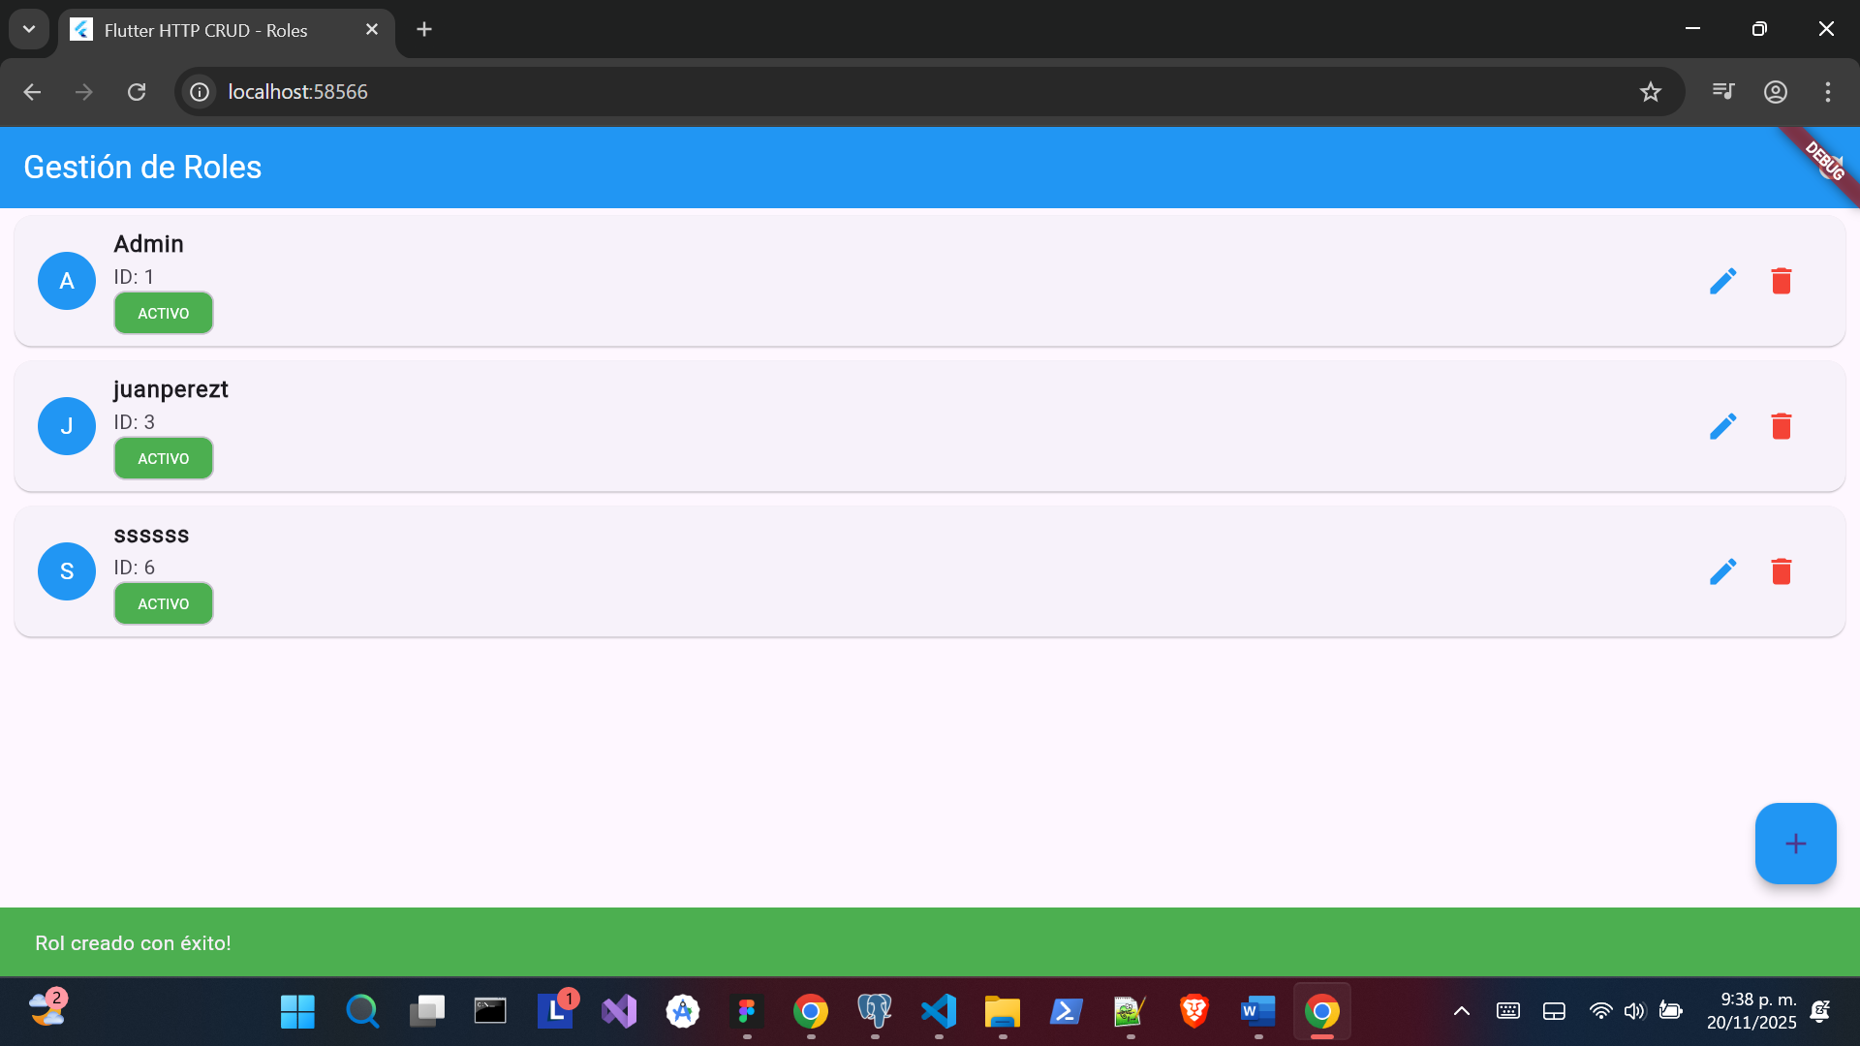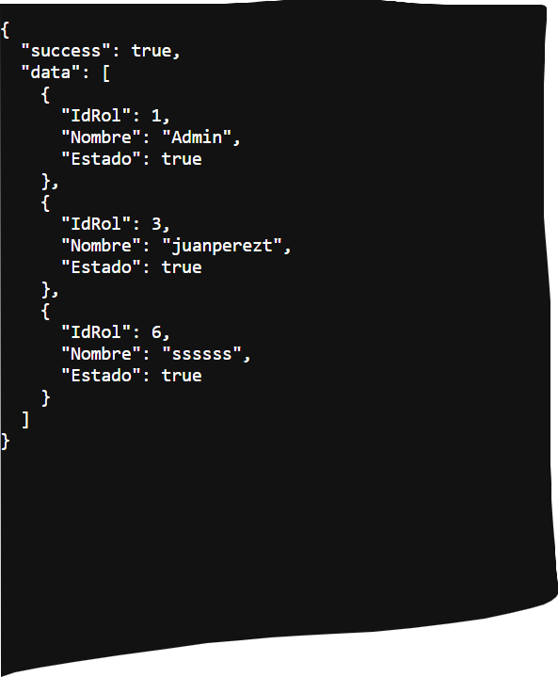

import 'dart:convert';
import 'package:flutter/material.dart';
import 'package:http/http.dart' as http;

void main() {
runApp(MyApp());
}

class MyApp extends StatelessWidget {
@override
Widget build(BuildContext context) {
return MaterialApp(
title: 'Flutter HTTP CRUD - Roles',
theme: ThemeData(
primarySwatch: Colors.blue,
),
home: MyHomePage(title: 'Gestión de Roles'),
);
}
}

class MyHomePage extends StatefulWidget {
MyHomePage({Key? key, required this.title}) : super(key: key);

final String title;

@override
_MyHomePageState createState() => _MyHomePageState();
}

class _MyHomePageState extends State<MyHomePage> {
List<dynamic> _roles = [];
bool _isLoading = true;
String _errorMessage = '';

@override
void initState() {
super.initState();
_fetchRoles();
}

final TextEditingController _nombreController = TextEditingController();
final TextEditingController _estadoController = TextEditingController();

void _showForm(String? id) async {
if (id != null) {
try {
final existingRole = _roles.firstWhere((element) =>
element['IdRol']?.toString() == id ||
element['IdRoll']?.toString() == id
);
_nombreController.text = existingRole['Nombre'] ?? '';
_estadoController.text = (existingRole['Estado'] ?? true).toString();
} catch (e) {
print('Error loading role for edit: $e');
}
} else {
_nombreController.text = '';
_estadoController.text = 'true';
}

showModalBottomSheet(
context: context,
elevation: 5,
isScrollControlled: true,
builder: (_) => Container(
padding: EdgeInsets.only(
top: 15,
left: 15,
right: 15,
bottom: MediaQuery.of(context).viewInsets.bottom + 120,
),
child: Column(
mainAxisSize: MainAxisSize.min,
crossAxisAlignment: CrossAxisAlignment.end,
children: [
TextField(
controller: _nombreController,
decoration: InputDecoration(
hintText: 'Nombre del rol',
labelText: 'Nombre',
),
),
SizedBox(height: 10),
DropdownButtonFormField<String>(
value: _estadoController.text,
decoration: InputDecoration(
labelText: 'Estado',
),
items: [
DropdownMenuItem(value: 'true', child: Text('Activo')),
DropdownMenuItem(value: 'false', child: Text('Inactivo')),
],
onChanged: (value) {
setState(() {
_estadoController.text = value!;
});
},
),
SizedBox(height: 20),
Row(
mainAxisAlignment: MainAxisAlignment.spaceBetween,
children: [
ElevatedButton(
onPressed: () {
Navigator.of(context).pop();
},
style: ElevatedButton.styleFrom(
backgroundColor: Colors.grey,
),
child: Text('Cancelar'),
),
ElevatedButton(
onPressed: () async {
if (id == null) {
await _createRole();
} else {
await _updateRole(id);
}

_nombreController.text = '';
_estadoController.text = 'true';

if (!mounted) return;
Navigator.of(context).pop();
},
child: Text(id == null ? 'Crear Rol' : 'Actualizar'),
),
],
)
],
),
));
}

// Método para obtener roles - CORREGIDO
Future<void> _fetchRoles() async {
try {
setState(() {
_isLoading = true;
_errorMessage = '';
});

final response = await http.get(Uri.parse('https://cristian-new-4.onrender.com/api/roles'));

if (response.statusCode == 200) {
final responseData = jsonDecode(response.body);

print('Respuesta completa de la API:');
print(responseData);

// Manejar la estructura correcta de tu API
if (responseData is Map<String, dynamic> && responseData['success'] == true) {
if (responseData.containsKey('data') && responseData['data'] is List) {
_roles = responseData['data'];
} else {
_roles = [];
}
} else {
_roles = [];
}

print('Roles cargados: ${_roles.length}');
if (_roles.isNotEmpty) {
print('Estructura del primer rol:');
print(_roles.first);
print('Campos disponibles:');
_roles.first.keys.forEach((key) {
print(' - $key: ${_roles.first[key]} (${_roles.first[key].runtimeType})');
});
}

} else {
_errorMessage = 'Error del servidor: ${response.statusCode}';
print(_errorMessage);
print('Respuesta del servidor: ${response.body}');
}
} catch (error) {
_errorMessage = 'Error de conexión: $error';
print(_errorMessage);
} finally {
setState(() {
_isLoading = false;
});
}
}

// Método para crear rol - CORREGIDO
Future<void> _createRole() async {
try {
final Map<String, dynamic> requestBody = {
'Nombre': _nombreController.text,
'Estado': _estadoController.text.toLowerCase() == 'true',
};

final response = await http.post(
Uri.parse('https://cristian-new-4.onrender.com/api/roles'),
headers: <String, String>{
'Content-Type': 'application/json; charset=UTF-8',
},
body: jsonEncode(requestBody),
);

print('Enviando datos: ${jsonEncode(requestBody)}');

if (response.statusCode == 200 || response.statusCode == 201) {
ScaffoldMessenger.of(context).showSnackBar(
SnackBar(
content: Text('Rol creado con éxito!'),
backgroundColor: Colors.green,
),
);
await _fetchRoles();
} else {
final errorResponse = jsonDecode(response.body);
throw Exception('Error al crear: ${response.statusCode} - ${errorResponse['message']}');
}
} catch (error) {
ScaffoldMessenger.of(context).showSnackBar(
SnackBar(
content: Text('Error al crear rol: $error'),
backgroundColor: Colors.red,
),
);
print(error);
}
}

// Método para actualizar rol - CORREGIDO
Future<void> _updateRole(String id) async {
try {
final Map<String, dynamic> requestBody = {
'Nombre': _nombreController.text,
'Estado': _estadoController.text.toLowerCase() == 'true',
};

final response = await http.put(
Uri.parse('https://cristian-new-4.onrender.com/api/roles/$id'),
headers: <String, String>{
'Content-Type': 'application/json; charset=UTF-8',
},
body: jsonEncode(requestBody),
);

print('Actualizando datos: ${jsonEncode(requestBody)}');

if (response.statusCode == 200) {
ScaffoldMessenger.of(context).showSnackBar(
SnackBar(
content: Text('Rol actualizado con éxito!'),
backgroundColor: Colors.green,
),
);
await _fetchRoles();
} else {
final errorResponse = jsonDecode(response.body);
throw Exception('Error al actualizar: ${response.statusCode} - ${errorResponse['message']}');
}
} catch (error) {
ScaffoldMessenger.of(context).showSnackBar(
SnackBar(
content: Text('Error al actualizar: $error'),
backgroundColor: Colors.red,
),
);
print(error);
}
}

// Método para eliminar rol - CORREGIDO
Future<void> _deleteRole(String id) async {
bool confirmDelete = await showDialog(
context: context,
builder: (BuildContext context) {
return AlertDialog(
title: Text('Confirmar eliminación'),
content: Text('¿Estás seguro de que quieres eliminar este rol?'),
actions: [
TextButton(
onPressed: () => Navigator.of(context).pop(false),
child: Text('Cancelar'),
),
TextButton(
onPressed: () => Navigator.of(context).pop(true),
child: Text('Eliminar', style: TextStyle(color: Colors.red)),
),
],
);
},
);

if (confirmDelete != true) return;

try {
final response = await http.delete(
Uri.parse('https://cristian-new-4.onrender.com/api/roles/$id'),
);

if (response.statusCode == 200) {
ScaffoldMessenger.of(context).showSnackBar(
SnackBar(
content: Text('Rol eliminado con éxito!'),
backgroundColor: Colors.green,
),
);
await _fetchRoles();
} else {
final errorResponse = jsonDecode(response.body);
throw Exception('Error al eliminar: ${response.statusCode} - ${errorResponse['message']}');
}
} catch (error) {
ScaffoldMessenger.of(context).showSnackBar(
SnackBar(
content: Text('Error al eliminar: $error'),
backgroundColor: Colors.red,
),
);
print(error);
}
}

// Función para obtener el ID correcto del rol
String _getRoleId(dynamic role) {
return role['IdRol']?.toString() ??
role['IdRoll']?.toString() ??
role['id']?.toString() ??
role['_id']?.toString() ??
'';
}

// Función para obtener el nombre correcto del rol
String _getRoleName(dynamic role) {
return role['Nombre']?.toString() ??
role['nombre']?.toString() ??
role['name']?.toString() ??
'Sin nombre';
}

// Función para obtener el estado correcto del rol
bool _getRoleStatus(dynamic role) {
return role['Estado'] ??
role['estado'] ??
role['status'] ??
role['active'] ??
true;
}

@override
Widget build(BuildContext context) {
return Scaffold(
appBar: AppBar(
title: Text(widget.title),
backgroundColor: Colors.blue,
foregroundColor: Colors.white,
actions: [
IconButton(
icon: Icon(Icons.refresh),
onPressed: _fetchRoles,
tooltip: 'Actualizar',
),
],
),
body: _isLoading
? Center(
child: Column(
mainAxisAlignment: MainAxisAlignment.center,
children: [
CircularProgressIndicator(),
SizedBox(height: 20),
Text('Cargando roles...'),
],
),
)
: _errorMessage.isNotEmpty
? Center(
child: Column(
mainAxisAlignment: MainAxisAlignment.center,
children: [
Icon(Icons.error_outline, size: 64, color: Colors.red),
SizedBox(height: 20),
Text(
'Error',
style: TextStyle(fontSize: 24, fontWeight: FontWeight.bold),
),
SizedBox(height: 10),
Padding(
padding: EdgeInsets.symmetric(horizontal: 20),
child: Text(
_errorMessage,
textAlign: TextAlign.center,
style: TextStyle(fontSize: 16),
),
),
SizedBox(height: 20),
ElevatedButton(
onPressed: _fetchRoles,
child: Text('Reintentar'),
),
],
),
)
: _roles.isEmpty
? Center(
child: Column(
mainAxisAlignment: MainAxisAlignment.center,
children: [
Icon(Icons.people_outline, size: 64, color: Colors.grey),
SizedBox(height: 20),
Text(
'No hay roles',
style: TextStyle(fontSize: 20, color: Colors.grey),
),
SizedBox(height: 10),
Text(
'Presiona el botón + para agregar uno',
style: TextStyle(fontSize: 14, color: Colors.grey),
),
],
),
)
: ListView.builder(
itemCount: _roles.length,
itemBuilder: (BuildContext context, int index) {
final role = _roles[index];
final roleId = _getRoleId(role);
final roleName = _getRoleName(role);
final roleStatus = _getRoleStatus(role);

return Card(
margin: EdgeInsets.symmetric(horizontal: 10, vertical: 5),
child: ListTile(
leading: CircleAvatar(
backgroundColor: Colors.blue,
child: Text(
roleName.substring(0, 1).toUpperCase(),
style: TextStyle(color: Colors.white),
),
),
title: Text(
roleName,
style: TextStyle(fontWeight: FontWeight.bold),
),
subtitle: Column(
crossAxisAlignment: CrossAxisAlignment.start,
children: [
Text('ID: ${roleId}'),
Chip(
label: Text(
roleStatus ? 'ACTIVO' : 'INACTIVO',
style: TextStyle(
fontSize: 10,
color: Colors.white,
),
),
backgroundColor: roleStatus ? Colors.green : Colors.red,
materialTapTargetSize: MaterialTapTargetSize.shrinkWrap,
),
],
),
trailing: Row(
mainAxisSize: MainAxisSize.min,
children: [
IconButton(
icon: Icon(Icons.edit, color: Colors.blue),
onPressed: () => _showForm(roleId),
),
IconButton(
icon: Icon(Icons.delete, color: Colors.red),
onPressed: roleId.isNotEmpty
? () => _deleteRole(roleId)
: null,
),
],
),
),
);
},
),
floatingActionButton: FloatingActionButton(
onPressed: () => _showForm(null),
tooltip: 'Agregar Rol',
child: Icon(Icons.add),
backgroundColor: Colors.blue,
),
);
}
}

