REAL – TIME VIETNAM SIGN LANGUAGE GESTURE RECOGNITION BY COMPUTER CAMERA ( HA NOI’S DIALECT)

Dat Doan Tran
Faculty of Electrical and Electronics Engineering
Ho Chi Minh city University of Technology
Ho Chi Minh City, Viet Nam
1610676@hcmut.edu.vn
Kien Trung Ly
Faculty of Electrical and Electronics Engineering
Ho Chi Minh city University of Technology
Ho Chi Minh City, Viet Nam
1611682@hcmut.edu.vn
Tin T. Dang
Faculty of Electrical and Electronics Engineering
Ho Chi Minh city University of Technology
Ho Chi Minh City, Viet Nam
dttin@hcmut.edu.vn

Abstract—Nowaday, there are a lot of methods available for their communication for example: sign language, brain wave analysis, writing word, etc. The most popular and easiest to use is sign language. However, sign language is not popular for everyone especially ordinary people. So that developing sign language system is very important, we aim to create a system can help dumb, deaf and normal people who will be able to communicate easily with even those who don’t understand sign language. We focus on creating a vision based system to identify sign language gestures from the video sequences. The reason for choosing a system based on vision relates to the fact that it provides a simpler and more intuitive way of communication between a human and a computer. In this project, we use two different models to train both of the temporal as well as the spatial characteristics. CNN was trained on the frames obtained from the video sequences of train data. We have used RNN to train the model on the temporal features.
Keywords—Convolutional neural network (CNN), Recurrent neural network (RNN)

Introduction (Heading 1)
Human communicate with others by many ways but there are 2 basic ways: speech and gesture. Nowaday, about 15% of the world's population lives with some form of disability. Most of them are dumb or deaf so that they have a way of communication different from normal people. Disabled people can only use motions of any body language to express their idea. So that motion of any body parts are concentrated and builded a language system: sign language. Thanks to it, the communication of disabled people becomes easily but the problem of sign language is difficulty when normal people do not understand it. In our project, we are using image processing and computer vision to recognize and understand the human’s gestures. It acts as an interpreter between computer and human.This could provide solution to human to interact naturally with the computers without any physical contact of the mechanical devices.
In the deaf and dumb community, normally sign language is used by everyone but this is the only way of communication for deaf and dumb community. Moreover, sign language are considered as the second language of the disabled community. Depending on the geographical location and characteristics of the native language, the terminology is divided in many different ways such as: one hand or two hand. It is of two type isolated sign language and continuous sign language. Isolated sign language consists of single gesture having single word while continuous ISL or Continuous Sign language is a sequence of gestures that generate a meaningful sentence. In this report we performed isolated ASL gesture recognition technique.
Sign language is a visual language and consists of 3 major components:
Fingerspelling | Word level sign vocabulary | Nonmanual features
Used to spell words letter by letter . | Used for the majority of communication. | Facial expressions, tongue, mouth, and body position.

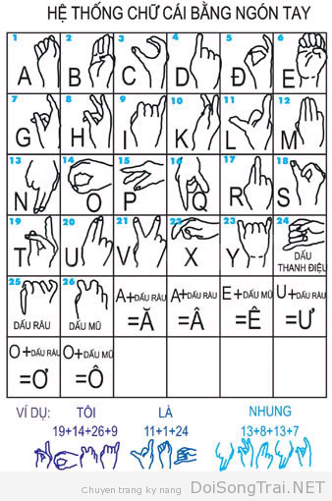
Fig. 1. The finger alphabet in Vietnam
Finger alphabet is one of the basic and first contents of learning Sign Language. It's like learning to spell in Vietnamese. In order for the project to be closer to reality, we designed it in the second component (Word level sign vocabulary). Our system can identify a series of actions from which to output specific words and match them to sentences.

MeThod:
In visionbased methods computer camera is the input device for observing the information of hands or fingers. The Vision Based methods require only a camera, thus realizing a natural interaction between humans and computers without the use of any extra devices. These systems tend to complement biological vision by describing artificial vision systems that are implemented in software and/or hardware. This poses a challenging problem as these systems need to be background invariant, lighting insensitive, person and camera independent to achieve real time performance. Moreover, such systems must be optimized to meet the requirements, including accuracy and robustness.
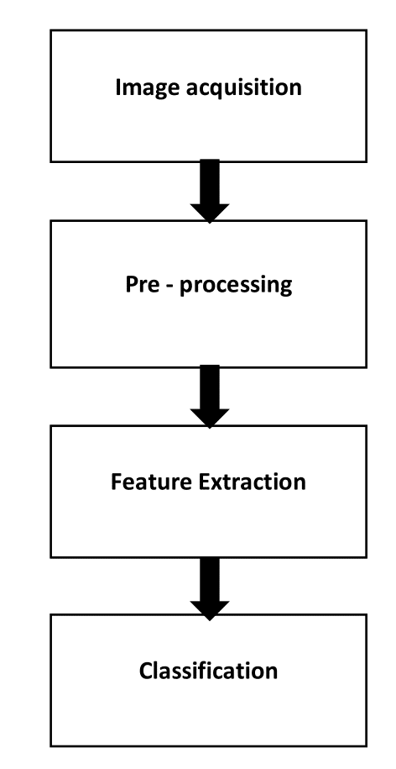
Fig. 2

Vision based analysis, is based on the way human beings perceive information about their surroundings, yet it is probably the most difficult to implement in a satisfactory way. Several different approaches have been tested so far. 1. One is to build a threedimensional model of the human hand. The model is matched to images of the hand by one or more cameras, and parameters corresponding to palm orientation and joint angles are estimated. These parameters are then used to perform gesture classification. 10 2. Second one to capture the image using a camera then extract some feature and those features are used as input in a classification algorithm for classification.
The proposed system comprises of four major modules: Data Acquisition, Preprocessing, Feature Extraction and Classification. Preprocessing stage involves Skin Filtering and histogram matching after which Eigenvector based Feature Extraction and Eigen value weighted Euclidean distance based Classification Technique was used. 24 different alphabets were considered in this paper.
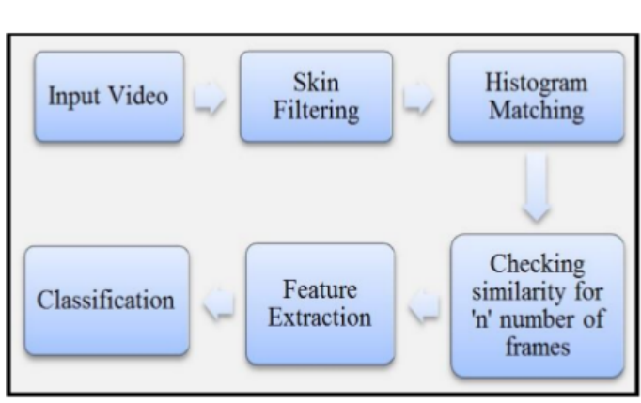
Fig 3:

III. ALGORITHMS
- Convolutional Neural Network (CNN) []
- In deep learning, a convolutional neural network (CNN, or ConvNet) is a class of deep neural networks, most commonly applied to analyzing visual imagery.
- CNNs have repetitive blocks of neurons that are applied across space (for images) or time (for audio signals etc). For images, these blocks of neurons can be interpreted as 2D convolutional kernels, repeatedly applied over each patch of the image. For speech, they can be seen as the 1D convolutional kernels applied across timewindows. At training time, the weights for these repeated blocks are 'shared', i.e. the weight gradients learned over various image patches are averaged.
- CNN Summarized in 4 Steps
- There are four main steps in CNN: convolution, subsampling, activation and full connectedness.
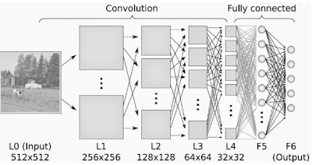

Fig 4: Convolutional neural network

- Convolution is a process where the network tries to label the input signal by referring to what it has learned in the past. If the input signal looks like previous cat images it has seen before, the “cat” reference signal will be mixed into, or convolved with, the input signal. The resulting output signal is then passed on to the next layer.
- Inputs from the convolution layer can be “smoothened” to reduce the sensitivity of the filters to noise and variations. This smoothing process is called subsampling, and can be achieved by taking averages or taking the maximum over a sample of the signal. Examples of subsampling methods (for image signals) include reducing the size of the image, or reducing the color contrast across red, green, blue (RGB) channels.
- The activation layer controls how the signal flows from one layer to the next, emulating how neurons are fired in our brain. Output signals which are strongly associated with past references would activate more neurons, enabling signals to be propagated more efficiently for identification. CNN is compatible with a wide variety of complex activation functions to model signal propagation, the most common function being the Rectified Linear Unit (ReLU), which is favored for its faster training speed.
- The last layers in the network are fully onnected, meaning that neurons of preceding layers are connected to every neuron in subsequent layers. This mimics high level reasoning where all possible athways from the input to output are considered.
- When training the neural network, there is additional layer called the loss layer. This layer provides feedback to the neural network on whether it identified inputs correctly, and if not, how far off its guesses were. This helps to guide the neural network to reinforce the right concepts as it trains. This is always the last layer during training.
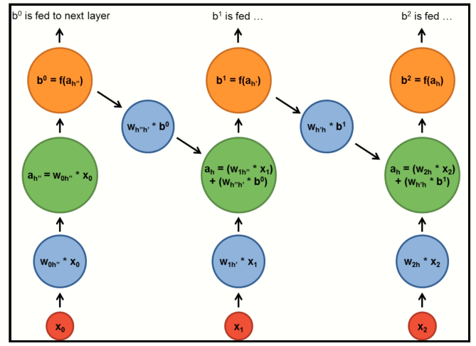
- Inception
- We’ve used the Inception v3 model of the Tensor Flow library. Inception is a huge image classification model with millions of parameters that can differentiate a large number of kinds of images. We only trained the final layer of that network, so training will end in a reasonable amount of time.

- Recurrent Neural Network (RNN)
- Recurrent Neural Networks have Loops
- RNN has loops in them that allow information to be carried across neurons while reading in input. In the following diagram, a chunk of Recurrent neural network, A, looks at some input and outputs a value ht. The loop allows information to be passed from one step of the network to the next. The decision a recurrent net reached at time step t1 affects the decision it will reach one moment later at time step t. So recurrent networks have two sources of input, the present and the recent past, which combine to determine how they respond to new data.
- A recurrent neural network can be thought of as multiple copies of the same network, each passing a message to a successor. Consider what happens if we unroll the loop:
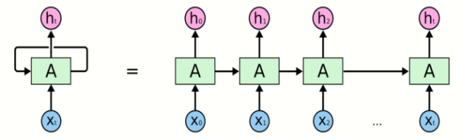
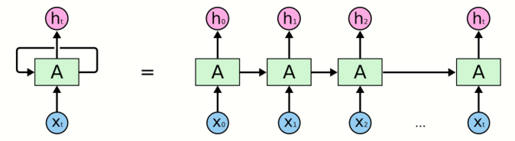
Fig 5: An Unrolled recurrent neural network

- Memory of previous inputs Carried forward:
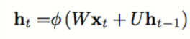

- The hidden state at time step t is ht. It is a function of the input at the same time step xt, modified by a weight matrix W_{hh}, added to the hidden state of the previous time step h_{t-1} multiplied by its own hiddenstatetohiddenstate matrix U called transition matrix. The weight matrices are filters that determine how much importance to accord to both the present input and the past hidden state. The error they generate can be used to adjust their weights using Backpropagation through Time (BPTT). The sum of the weight input and hidden state is squashed by the function φ – either a logistic sigmoid function or tanh. Because this feedback loop occurs at every time step in the series, each hidden state contains traces not only of the previous hidden state, but also of all those that preceded h_{t-1} for as long as memory can persist.

Fig 6: Memory of previous inputs being carried forward

- Exploding and Vanishing Gradient Problem
- In theory, RNNs are absolutely capable of handling longterm dependencies.Sadly, in practice, RNNs don’t seem to be able to learn them as explained in [5]. The gradient expresses the change in all weights with regard to the change in error. Since the layers and time steps of deep neural networks relate to each other through multiplication, gradient is susceptible to vanishing or exploding.
- Long ShortTerm Memory Units (LSTMs) [1]
- LSTM is a very special kind of recurrent neural network which works, for many tasks, much much better than the standardversion.
- In LSTMs remembering information for long periods of time is practically their default behavior. LSTMs also have this chain like structure, but the repeating module has a different structure. Instead of having a single neural network layer, there are four, interacting in a very special way:
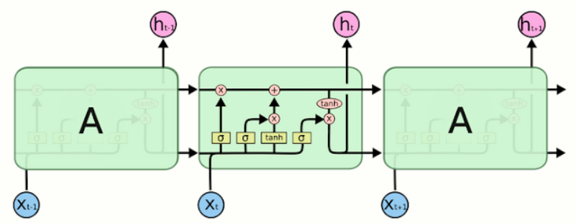
Fig 7: The repeating module in an LTSM contains four interacting layers

IV. WORKFLOW
  - Methodology:
- First, we will extract the frames from the multiple video sequences of each gesture.
- After the first step, noise from the frames i.e background, body parts other than hand are removed to extract more relevant features from the frame.
- Frames of the train data are given to the CNN model for training on the spatial features. We have used inception model for this purpose which is a deep neural net.
- Store the train and test frame predictions. We’ll use the model obtained in the above step for the prediction of frames.
- The predictions of the train data are now given to the RNN model for training on the temporal features. We have used LSTM model for this purpose.
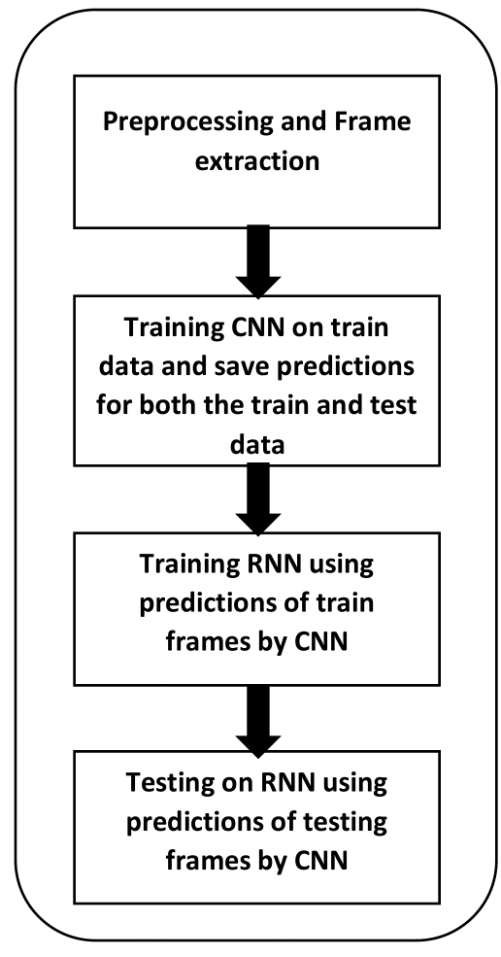
Fig 8:

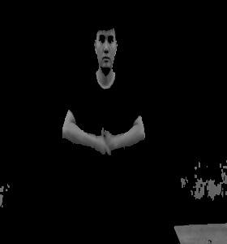
  - Preprocessing
Fig 10: after preprocessing
Fig 9: before preprocessing

  - Train CNN(SpatialFeatures) and Prediction
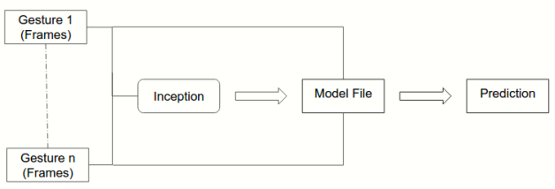
Fig 11:

- The first row in the below illustration is the video of a gesture Elephant. The second row shows the set of frames extracted from it. The third row shows the sequence of predictions for each frame by CNN after training it.
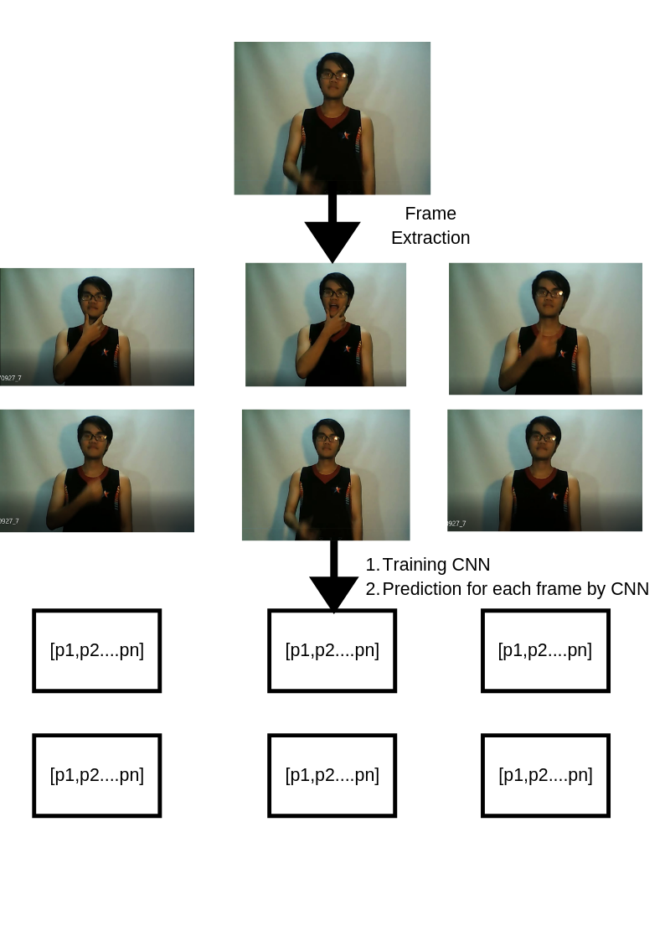
Fig 12:

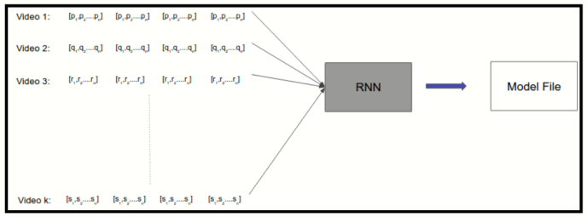
  - Training RNN (Temporal Features)
Fig 13:
  - Our RNN Model
- We have create a RNN model based on LSTMs. The first layer is an input layer used to feed input to the upcoming layers. Its size is determined by the size of the input being fed. Our Model is a wide network consisting of single layer of 256 LSTM units. This Layer is followed by a fully connected layer with softmax activation. In Fully Connected every neuron is connected to every neuron of previous layer. The fully connected layer consists of as many neurons as there are categories/classes. Finally a regression layer to apply a regression (linear or logistic) to the provided input. We used adam[8] (Adaptive Moment Estimation) which is a stochastic optimizer, as a gradient descent optimizer to minimize the provided loss function “categorical_crossentropy” (which calculate the errors)
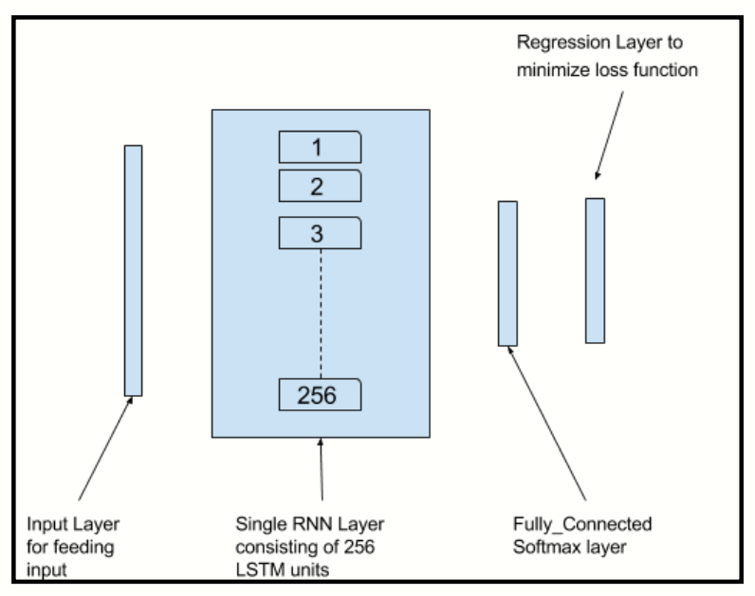
Fig 14:

We also tried a wider RNN network with 512 LSTM units and another deep RNN network with three layers of 64 LSTM units each. We tested these on a sample of the dataset and found that wide model with 256 LSTM units performed the best and therefore only the wide model was used for training and testing on complete dataset.

V. EXPERIMENTAL RESULTS
We used the result after test with a same project using kNNs method to compare with our method, with same gesture, same number of attemps, and same background (we used a monochrome background for best performance). On a small dataset, kNNs seem faster than CNNs and LSTM, and some time, the result is better. But with some complex gesture, CNNs+LSTM is more accurate. There are some gestures seem quite similar in our dataset: bố (father), ăn (eat) and bà (grandmother). With these gestures, both mothed often confuse between them, but our method have better performance. Comparison time response time, the kNNs methods result gives better than our method, the meaning of gestures appear as soon as the “finish signal” end (the “finish signal” is a gesture which used to separate gesture of two words). But this project run on a cloud platform, so the hardware limitations is trivial. Our CNNs and LSTM method is slower, we have to wait about 20-30 seconds to see the result. Because of the computer hardware limitations, we can’t increase batch number (we use batch=3), the final evaluation run slowly too.
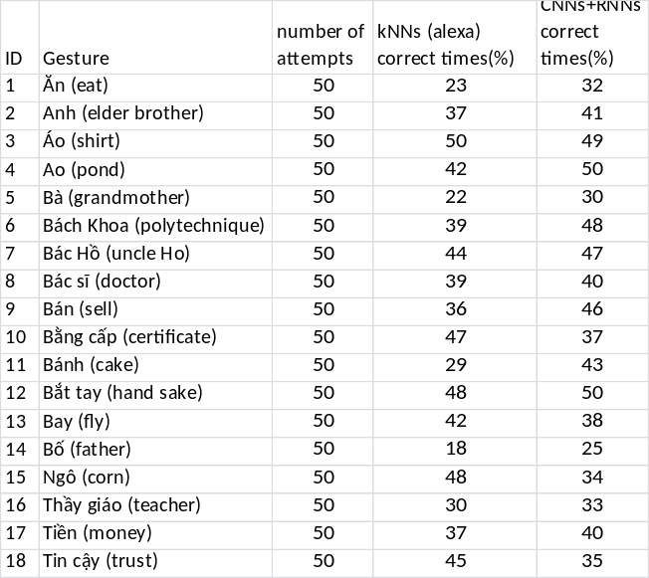
VI. CONCLUSION AND FUTURE WORK
Human almost communicate with others by body motion, gestures and speech. So that it has a lot of potential in the area of human computer interaction. Camera Vision based hand gesture recognition techniques have many proven advantages compared with traditional devices. It seems to have the current trend, thanks to usability, ease of production and installation, camera vision appears everywhere and it becomes the part of our life. Developing the gesture recognition bring so much applications not only sign language but also other area.
However, the gesture recognition is a difficult problem and the current work is only a small contribution towards achieving the results needed in the field of sign language gesture recognition. Videos are difficult to classify because they contain both the temporal as well as the spatial features. We have used two different models to classify on the spatial and temporal features. CNN was used to classify on the spatial features whereas RNN was used to classify on the temporal features. We obtained an accuracy of about 80%. This shows that CNN along with RNN can be successfully used to learn spatial and temporal features and classify Sign Language Gestures.
From the first step, we hope to extend our work further in recognising continuous sign language gestures with better accuracy. This model use for individual gestures can also be extended for sentence level sign language. Also the current process uses two different models, training inception (CNN) followed by training RNN. For future work one can focus on combining the two models into a single model.

References
- Ronchetti, Franco, Facundo Quiroga, César Armando Estrebou, and Laura Cristina Lanzarini. "Handshape recognition for argentinian sign language using probsom." Journal of Computer Science & Technology 16 (2016).
- Singha, Joyeeta, and Karen Das. "Automatic Indian Sign Language Recognition for Continuous Video Sequence." ADBU Journal of Engineering Technology 2, no. 1 (2015).
- https://medium.com/technologymadeeasy/thebestexplanationofco nvolutionalneuralnetworksontheinternetfbb8b1ad5df8
- M. Young, The Technical Writer’s Handbook. Mill Valley, CA: University Science, 1989.
- https://sciagaprogramisty.blogspot.com/2018/04/rnn-recurrent-neural-networks-and-lstm.html
- [5] Bengio, Yoshua, Patrice Simard, and Paolo Frasconi. "Learning longterm dependencies with gradient descent is difficult." IEEE transactions on neural networks 5, no. 2 (1994): 157166.
- https://www.quora.com/WhatisanintuitiveexplanationofConvol utionalNeuralNetworks
- https://www.edureka.co/blog/convolutional-neural-network/
- https://tudienngonngukyhieu.com/

