1. 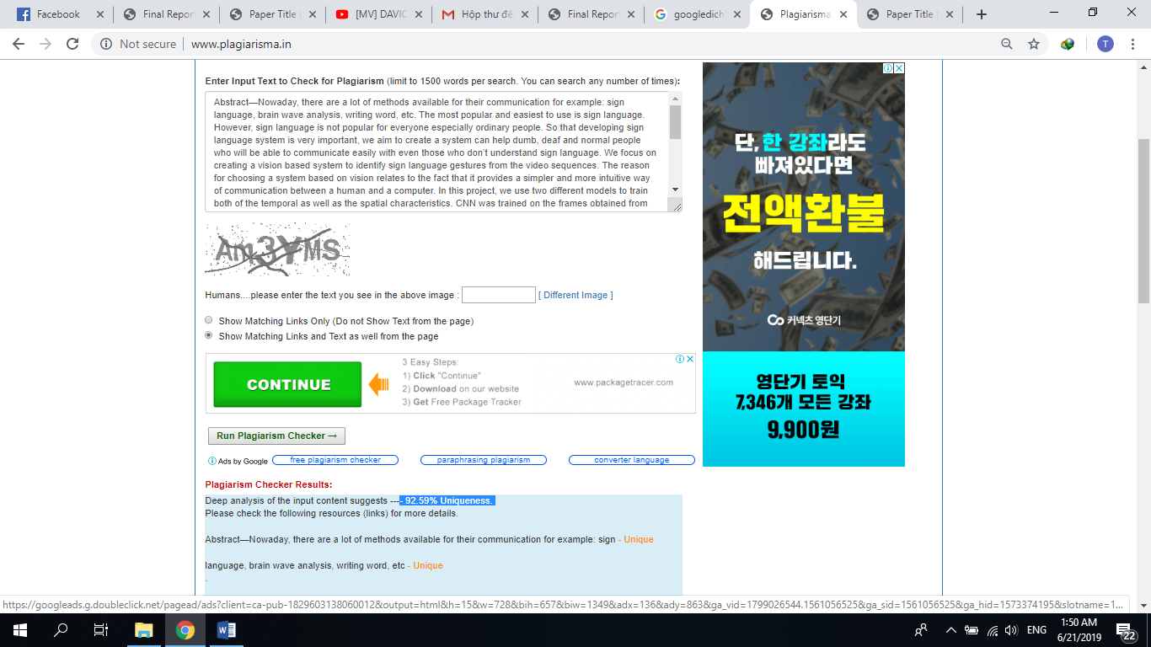[http://www.plagiarisma.in](http://www.plagiarisma.in/)
2. <https://www.duplichecker.com/>

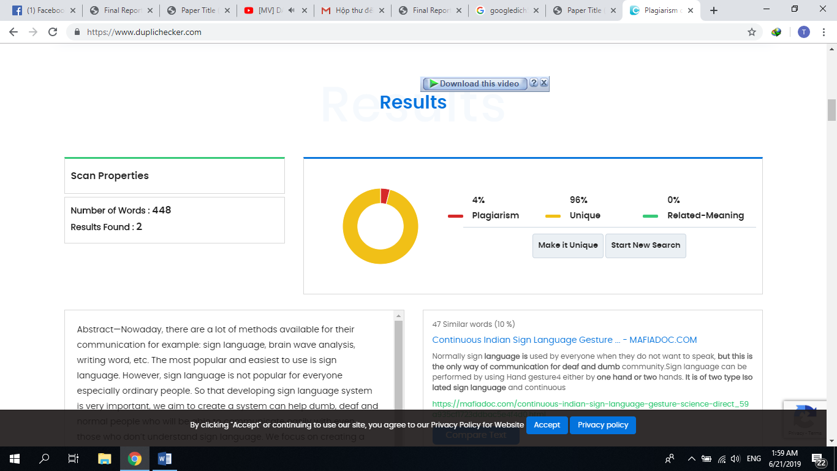

1. <https://smallseotools.com/plagiarism-checker/>

