Selection screen:
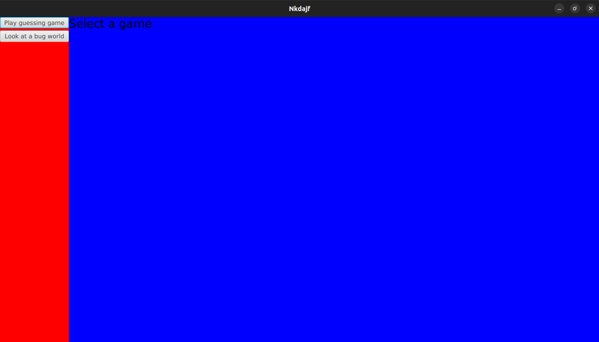
Selection screen allows the user to choose between the number game and bug world. Each time the user selects one of these it is a new game, so their data for the previous game (number of guesses, locations of bugs, etc.) will be lost.

Number Game:
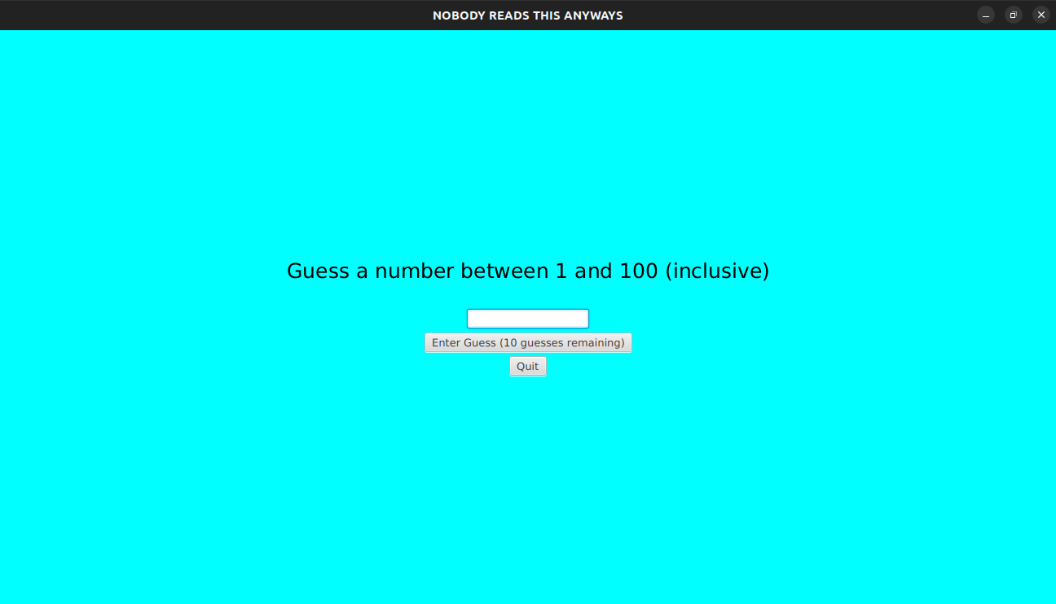
The quit button returns the user to the selection screen. The enter guess button allows the user to input their guess. The enter guess button also shows the user how many guesses they have left. When the user inputs a valid guess this number goes down by 1. When they reach 0 it goes to the loss screen.

Number Game Invalid Guess:
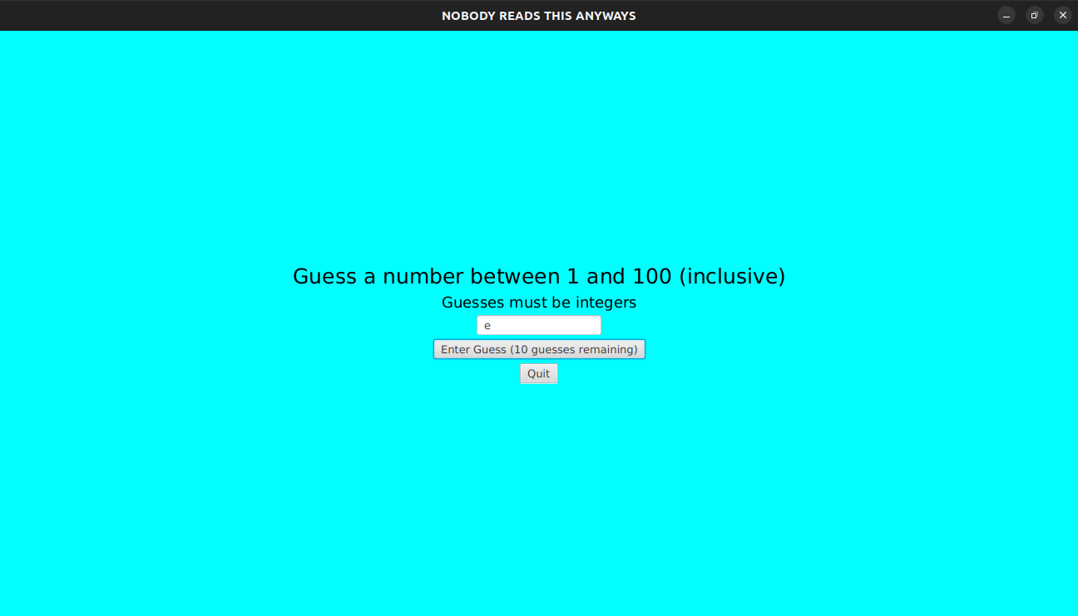
If the user enters a non-integer guess, an error message will come up. These invalid guesses do not reduce the number of guesses the user has left.

Number Game Guess was smaller than the answer:
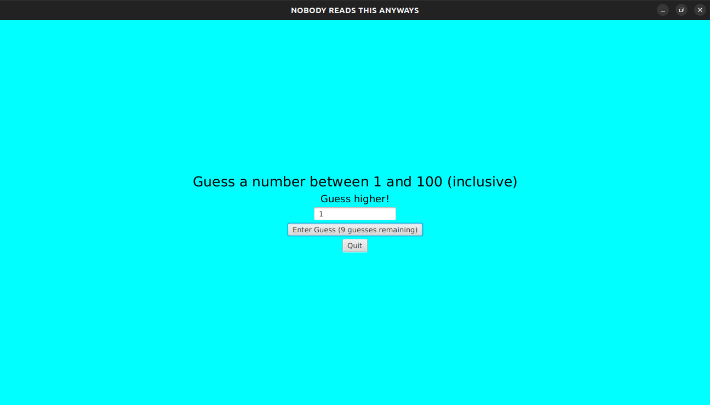
The program will tell the user to guess higher.

Number Game Guess was larger than the answer:
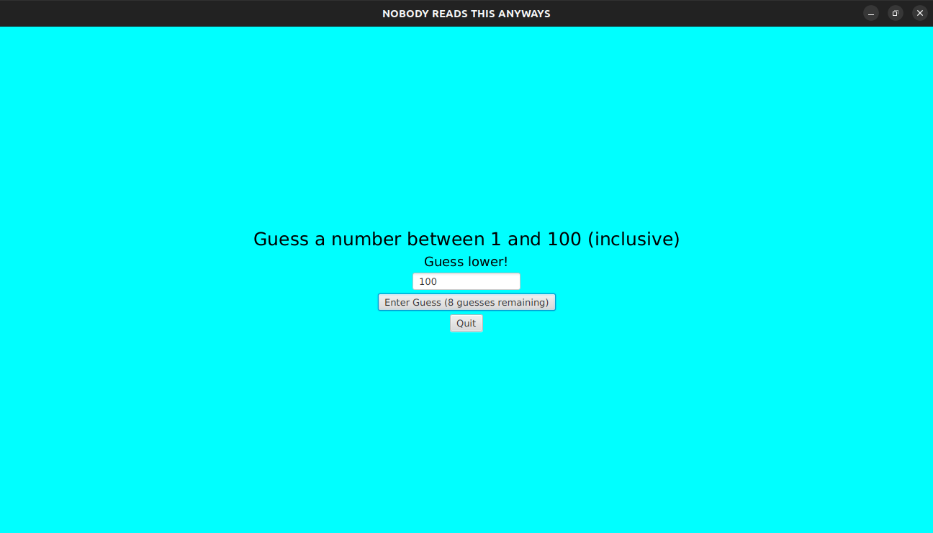
The program will tell the user to guess lower.

Number Game ran out of guesses:

The program will show the loss screen. The loss screen has a button that allows the user to play again.

Number Game user got it right:

The program will show the victory screen and tells the user how many guesses it took them to get it right. The victory screen has a button that allows the user to play again.

Bug World:
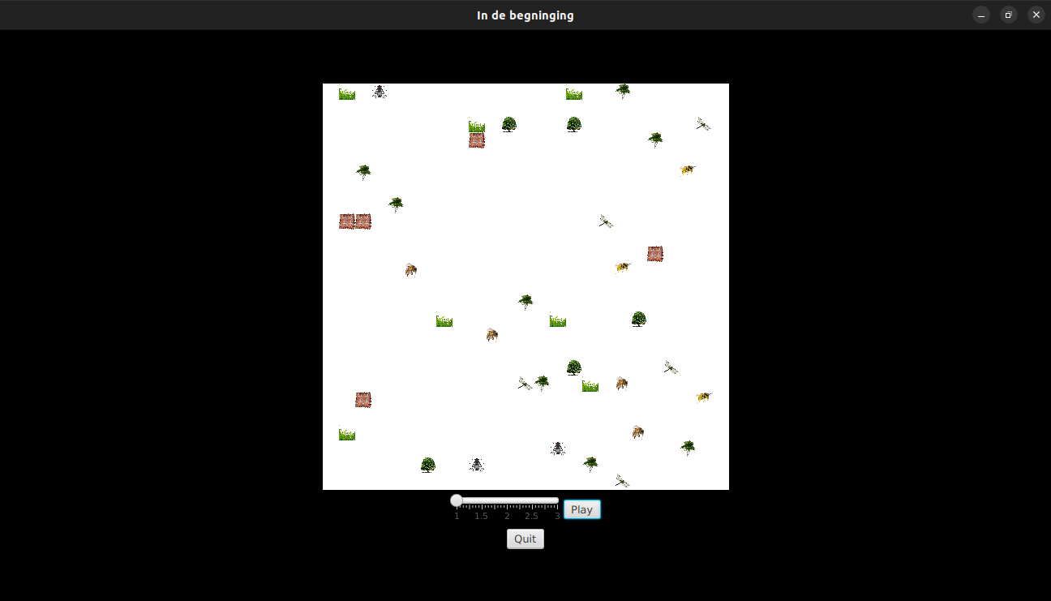
The quit button will end the simulation and animation, returning the user to the selection screen. The play button starts the animation. Upon clicking the play button, it will switch to the pause button. The pause button pauses the animation and switches back to the play button. The slider controls how fast the animation is played to the user.

Bug World plants:
The plants start with a random size which is stored internally. Plants are displayed as either grass, a sparse tree, or a dense tree. These images correspond to the size ranges 1-10, 11-20, and 21-30 respectively. These plants can then grow. When a plant goes to the next size range, its image gets updated accordingly. Plants cannot go above size 30.

Bug World bugs:
There are 4 different types of bugs, each with a different type of behaviour. Bees eat plants. Flies eat plants, but move faster than bees. Wasps eat plants, bees, and flies. Dragonflies eat bees, flies, and wasps. All bugs have an energy rating which decreases as they move. When their energy reaches 0, they die. Bugs regain energy by eating. Bugs cannot move onto another entity, unless they can eat that entity (in which case they do).
Internlly the bugs move one at a time (but this is all displayed simulataneously). The bugs with higher energy move before those with less energy. In the case of a tie, bugs of certain species will move before other ones (but I do not remember the ordering for this). If both of these are the same, it will be random (as dealt with by .sort).

