Semi-Autonomous Wildfire Monitoring and Control System Framework

Gene Foxwell
Woolf University / Udacity School of Artificial Intelligence
Industry Integrated AI-Synthesis Project

Overview and Industry Context
Driven by climate change, wildfires have been increasing in both number and intensity. As our planet continues to warm, this increase will put pressure on our ability to monitor and respond to wildfire incidents – leading to potential loss human life, animal life, and property damage. This project looks at how various techniques in Artificial Intelligence could be combined to create a Semi-Autonomous Wildfire Monitoring and Control Framework. We will look at a vertical slice of the problem – starting with Wildfire simulation, Risk Prediction (where will the fire spread next) Resource Allocation (how should we allocate a limited number of patrol / firefighting resources), and long-term wildfire fighting strategies (which activities should we focus on first?)

Integration Rationale
The main body of your paper goes here, starting on page 3. (Or starting on page 2, if you’re not required to include an abstract.)

System Design and Technical Decisions
We broke the problem down in three key components:
- Environmental Simulation: To test the idea, we needed to simulate Wildfire Behavior. Based (Ramadan 2024) and (Ghosh 2024) we used a Stochastic Cellular Automata to simulate Wildfire propagation with some simplifying assumptions to fit our use case. (We do not simulate tree regrowth for example and trees aren’t going to have time to regrow in our timeline. This was broken into the following steps:
  - Terrain Generation: Following ideas found in (Kamble 2025) we used Perlin Noise to generate plausible forest terrain maps. We expanded on the 2024 approach by adding additional features for Rural houses and urban areas. Rural housing is assumed to be “flammable” in this model, while urban is not. Other features we generated were small bodies of water, simple grassland, brush, and dense forest. Each flammable source was given a different amount of “fuel” it could burn as well as adjusted probability of ignition.
  - Wind Generation: To simplify the simulation, we assumed that Wind would remain static throughout the simulation. We used Perlin Noise to generate a vector field of wind directions.
  - Human Agents: A missing component in both Ramadan 2024 and Ghosh 2024 is the presence of humans in the path of the wildfire. We added a small number of humans to our simulation to provide a conflicting set of priorities to the system. Humans are simulated as stochastic agents who are either doing a random walk through the forest, or “camping” at inopportune spots.
- Risk Prediction: This system serves as an intermediary to the final Command Workflow system. Here we use a deep neural network to attempt to predict where the fire will be next. The purpose of this is to provide the planning system with a guideline on where to focus its firefighting efforts. For example, if the areas at risk include known human locations and known rural locations, which one should the planner prioritize? We attempt to perform Risk Prediction using semantic segmentation (see project 4). Here the base image is a snapshot of the simulation at random point, while the mask is a binary image where pixels are marked “safe” (they will not be in the fires path after 20 iterations) or Risky (they will be in the fires path after 20 iterations). 5000 example image/mask pairs were generated.
  - Loss Function: The challenge here was to devise a loss function that could handle the class imbalance between safe and risky cells. To solve this, we mixed a Binary Classification Entropy (BCE) loss function with the Dice Loss function. Our final loss function was the average of the sum of these functions. The idea here is that the BCE will help mitigate the effects of class imbalance on the standard Dice Loss used for semantic segmentation problems.
  - UNet Architecture: Figure 3 shows our modified UNet Architecture. We made two changes to this architecture: First, we made it smaller. Experiments in Project 4 suggested that for a binary classification problem we don’t need quite so many parameters on the two “walls” of the UNet. Second, we changed the bridge between the down sample and up sample stage to be a series of convolutions with 3x3 kernels instead of the standard 1x1kernel. This change was done to help the network “predict” where the fire would be next, instead of simply copying the fire’s starting location as was happening when experimentation was first started. Resulting outputs from the modified UNet can be seen in figure 4.
- UAV Dispatch Control: Given a set of priorities (protecting people, protecting property, protecting trees for example) we needed to be able to allocate and control a collection of UAVs in a simulated environment. To this end we developed an RL agent using a Generative AI approach (Chen 2021) that was demonstrated in Project 5 We have two primary components here:
  - UAV: We simulate UAV’s here as aerial drones that accept waypoints and perform a basic task. Control of the UAVs is based on (Julian 2018) as well as an abstracted version of the communications strategy outlined in (Merlin 2009). We assume a limited number of UAVs are available. We split the UAVs into two categories: Surveillance drones that provide real time fire tracking information, and Control Drones that provide fight extinguishing capabilities.
  - Decision Transformer: Our Decision Transformer takes the place of the Ground Crew in Merlin 2009.
- Command Workflow:

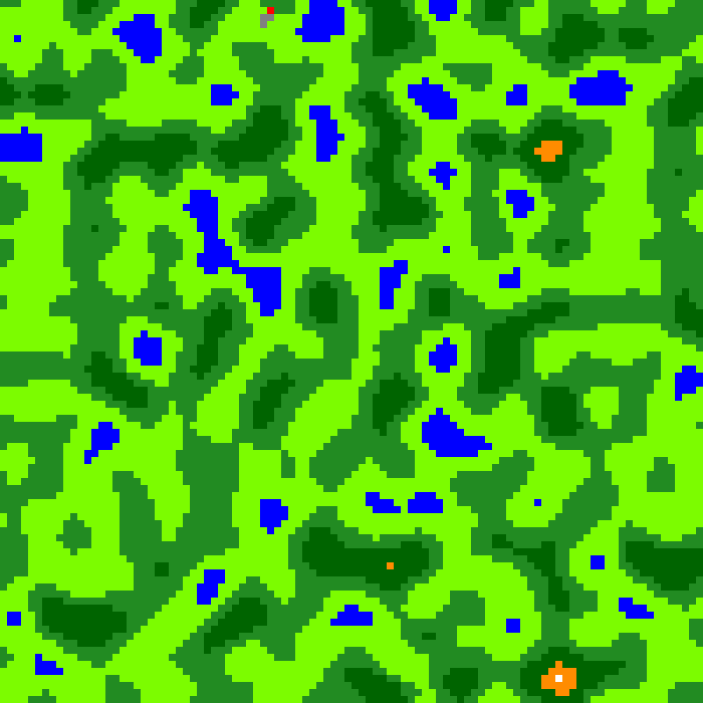
Figure 1 Perlin Noise Generated Terrain

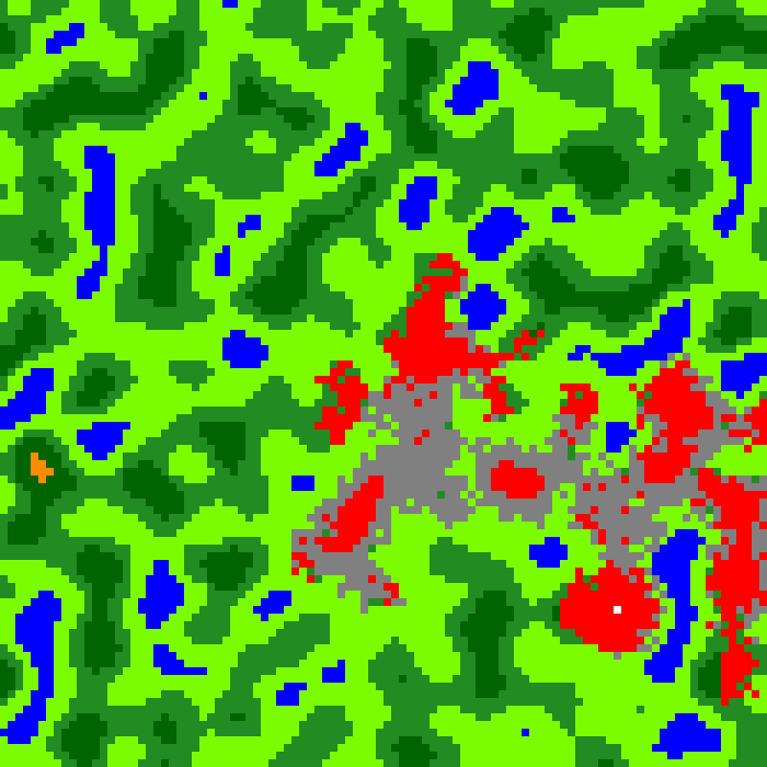
Figure 2 Wildfire CA in action

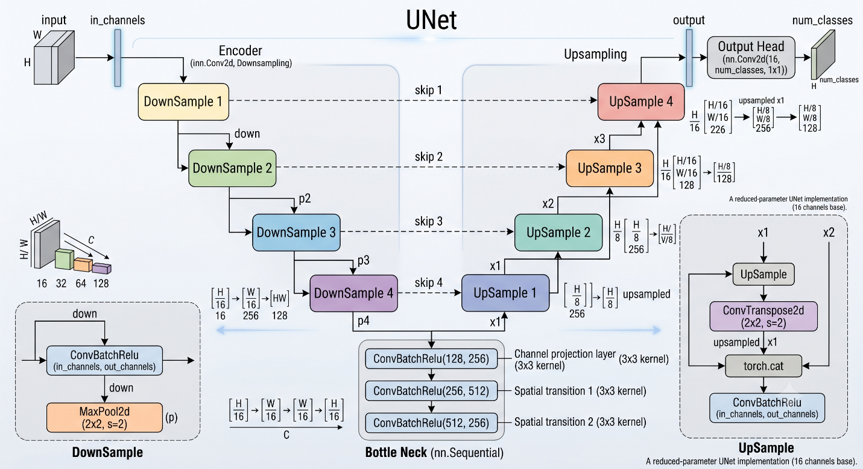
Figure 3 Modified UNet (image generated with assistance of Gemini AI Model based on authors UNet code)

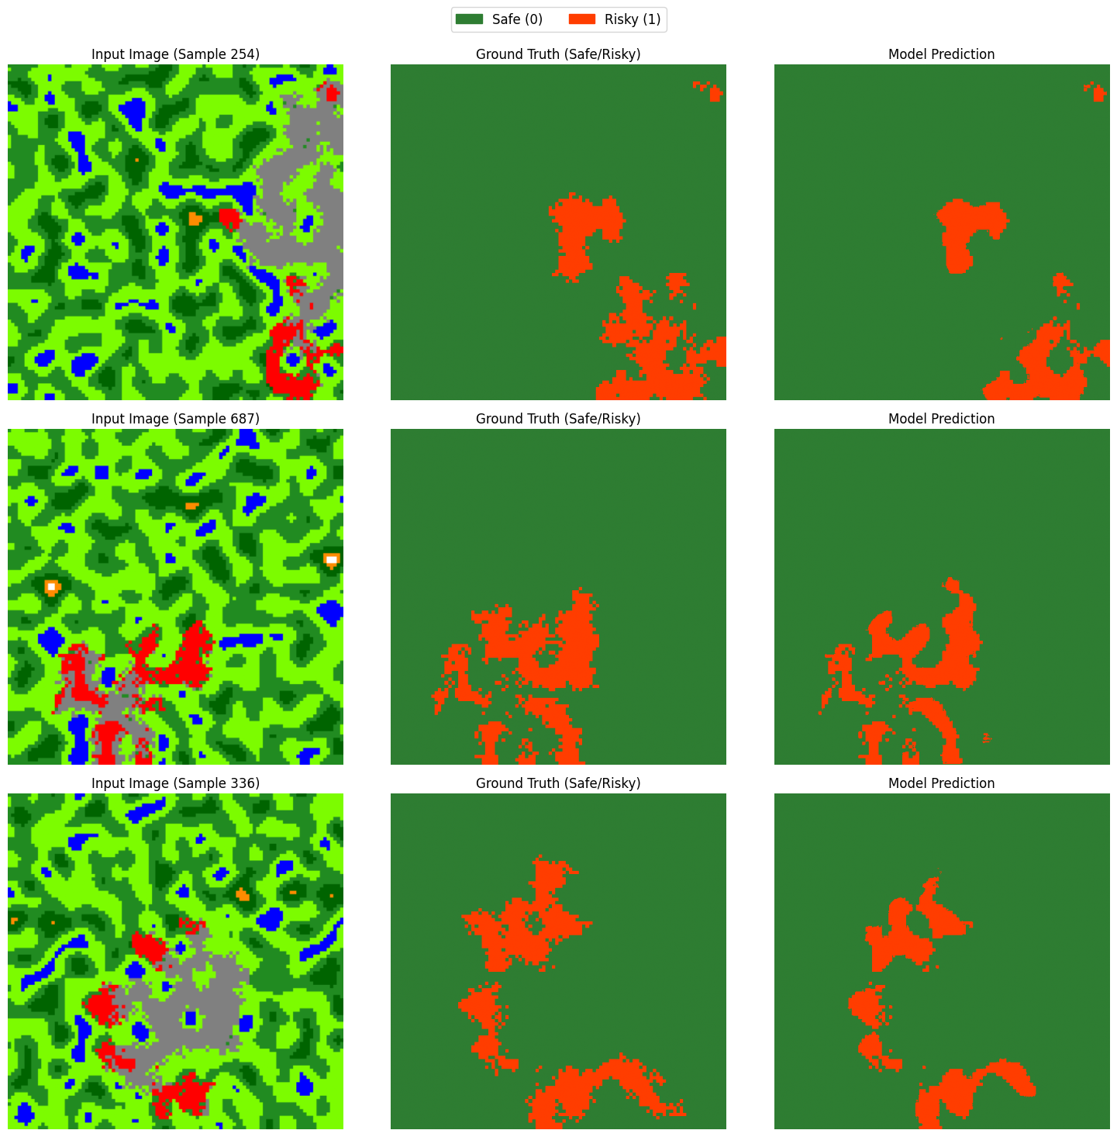
Figure 4 Fire Risk Prediction Outputs
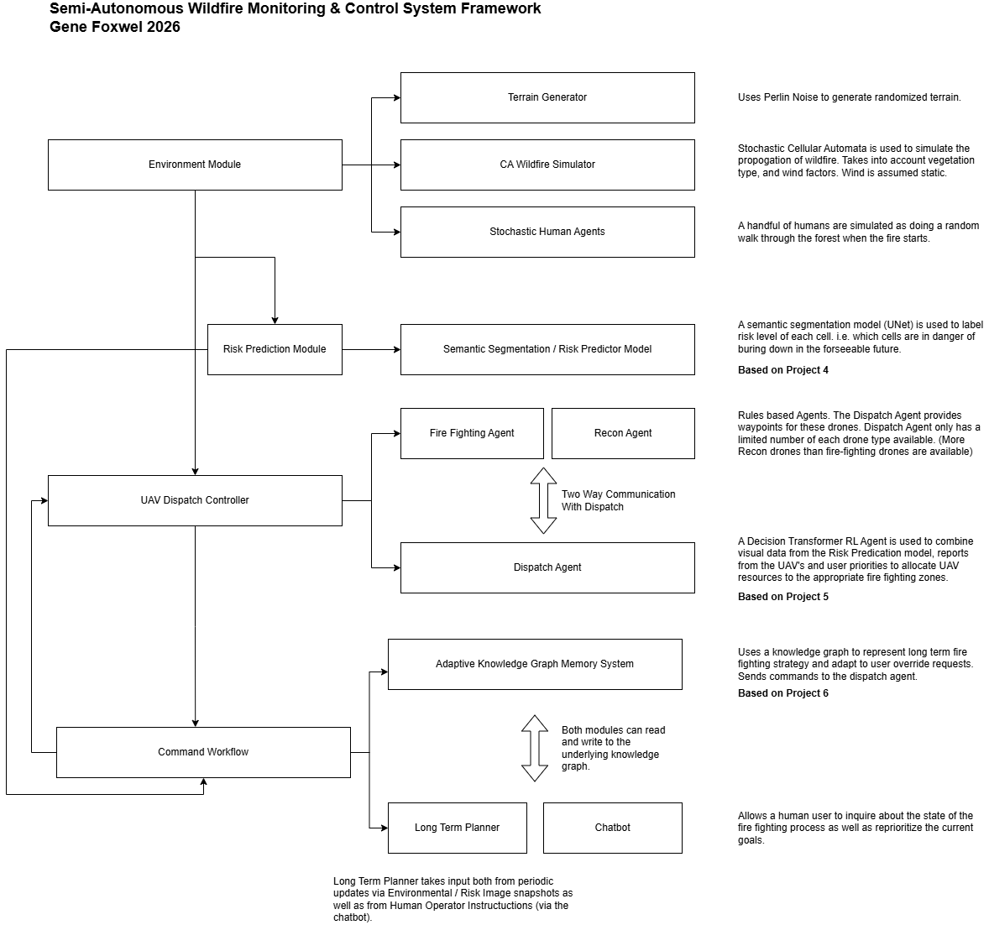
Figure 5 System Architecture

Ethical Considerations and Responsible AI
The main body of your paper goes here, starting on page 3. (Or starting on page 2, if you’re not required to include an abstract.)

Evaluation and Reflection
The main body of your paper goes here, starting on page 3. (Or starting on page 2, if you’re not required to include an abstract.)

Professional Relevance
The main body of your paper goes here, starting on page 3. (Or starting on page 2, if you’re not required to include an abstract.)

References
Chen, L., Lu, K., Rajeswaran, A., Lee, K., Grover, A., Laskin, M., Abbeel, P., Srinivas, A., & Mordatch, I. (2021). Decision transformer: Reinforcement learning via sequence modeling. arXiv. https://doi.org/10.48550/arXiv.2106.01345

Ghosh, R., Adhikary, J., & Chemlal, R. (2024). Fire spread modeling using probabilistic cellular automata. arXiv. https://doi.org/10.48550/arXiv.2403.08817

Julian, K. D., & Kochenderfer, M. J. (2018). Distributed wildfire surveillance with autonomous aircraft using deep reinforcement learning. arXiv. https://doi.org/10.48550/arXiv.1810.04244

Kamble, A. D., & Ghule, S. D. (2025). Procedural terrain generation using Perlin noise. International Journal of Innovative Research in Technology, 12(1), 256–259. https://ijirt.org/publishedpaper/IJIRT180167_PAPER.pdf

Merlin, P. W. (2009). Ikhana Unmanned Aircraft System: Western States fire missions (NASA SP-2009-4544; Monographs in Aerospace History, No. 44). National Aeronautics and Space Administration. https://www.nasa.gov/wp-content/uploads/2023/03/sp-4544.pdf

Ramadan, A. (2024). Wildfire autonomous response and prediction using cellular automata (WARP-CA). arXiv. https://doi.org/10.48550/arXiv.2407.02613

Ronneberger, O., Fischer, P., & Brox, T. (2015). U-Net: Convolutional networks for biomedical image segmentation. arXiv. https://arxiv.org/abs/1505.04597

FACT SHEET: Climate change and wildfires in Canada
BCEWithLogitsLoss — PyTorch 2.12 documentation
📉 Losses — Segmentation Models documentation

