**Bit (binary digit)**

Computers store information using bits. A **bit** (short for "binary digit") stores either the value 0 or 1.

**What fits in a bit?**

A single bit can only represent two different values. That's not very much, but that's still enough to represent any two-valued state.

**Is a lightbulb on or off?**

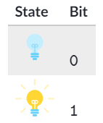

**Sequences of bits**

Computers use multiple bits to represent data that is more complex than a simple on/off value.

A sequence of two bits can represent four (22) distinct values:

00 01 10 11

A sequence of three bits can represent eight (23) different values:

000 001 010 011 100 101 110 111

A sequence can represent many things: a number, a character, a pixel. Plus, the same sequence can represent different types of data in different contexts. The sequence 1000011 could represent 67 in a calculator application while also representing the letter "C" in a text file.

**Physical storage**

Computers typically store bits using electromechanical transistors which can map electrical signals to either an on or off state.