**Patterns in binary numbers**

In those last two questions, you converted odd numbers. There's something interesting about odd numbers in binary. Here are a few more odd numbers to give you an idea:

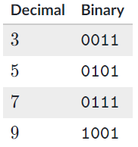

Do you see the pattern?

The last bit is always the ones' place, and if a number is odd, it must have a 1 in that ones' place. There's no way to create an odd number in the binary system without that ones' place, since every other place is a power of 2. Knowing this can give you a better intuitive understanding of binary numbers.

There's another interesting pattern in binary numbers. Take a look at these:

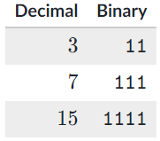

Each of the decimal numbers are a power of 2, minus 1: 4-1=3, 8-1=7, 16-1=15. When a binary number has a 1 in each of its places, then it will always equal the largest number that can be represented by that number of bits. If you want to add 1 to that number, you need to add another bit. It's like 999, 999999, and 999999999 in the decimal system.

As it turns out, the highest number that can be represented by n bits is the same as 2n - 1:

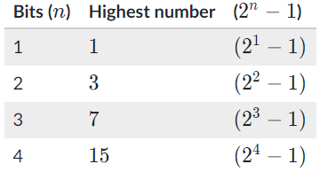

What do you think: what does  11111represent in decimal?

You could calculate that using our strategy from before fairly quickly. However, there's one more strategy, keeping in mind what we just learned: you could count the number of bits (5), calculate 25= 2×2×2×2×2=32, and then subtract 1.

All of this is to help you gain a more intuitive understanding of binary.