1. A website decides to use hexadecimal numbers as the unique identifiers for their users. Their first three users have identifiers of 000000, 000001, and 000002.

Which of these lists have the user IDs sorted correctly from earliest user first to most recent user last?

A

014756, 253C12, 7342AB, 98761F, FC0534, FC9821

B

98761F, FC9821, FC0534, 7342AB, 253C12, 014756

C

FC9821, FC0534, 98761F, 7342AB, 253C12, 014756

D

014756, 253C12, 7342AB, FC9821, FC0534, 98761F

2.When early computers ran into a fatal error, their error reports included information about the memory location of the error.

Many early computers included a "machine code monitor" which displayed the contents of the computer's memory. All the locations and data were displayed in hexadecimal, since that fit better on the screen and was easier for programmers to understand.

Here's an output from the Apple II machine code monitor:

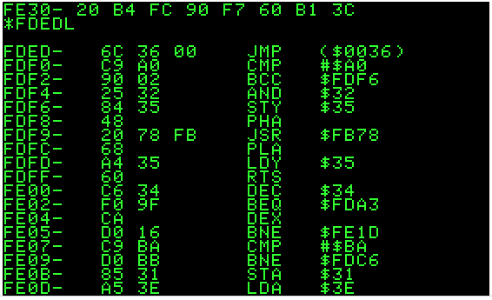

Even though those numbers are displayed as hexadecimal, they're stored in the computer as binary, since computers ultimately store all information as binary.

Location FDF8  contains the hexadecimal number 48.

**What is the binary equivalent of the hexadecimal number 48?**

A

0010 1111

B

01001000

C

0011 0100

D

0011 0000

3.At the Google campus in Mountain View, building 43 uses hexadecimal for the cubicle numbers. Brian lives in cubicle number 3D.

**What would his cubicle number be in decimal?**

4.Each device that can be connected to a network has an associated Media Access Control (MAC) address. Those addresses are typically printed on the actual device, using hexadecimal notation for each number in the address.

Every MAC address is made up of 6 sets of 2-digit hexadecimal numbers. Here's an example:

D5-BE-E9-8D-44-9C

**What's the maximum number of devices that can have unique MAC addresses?**

A

26

B

212

C

1612

D

166

5.Convert 1010 0111 1011 from binary to hexadecimal

6.Convert 7D0 from hexadecimal to binary

7.If you shift a hexadecimal number to the left by one digit, how many times larger is the resulting number?