# Assignment 1 println() exercises February 4, 2019

Write a program to print the following pictures using multiple System.out.println(). Take note that you need to use escape sequences to print special characters.



|\/\/\/|

| |

| |

| (o)(o)

C _)

| ,___|

| /

/____\

/ \

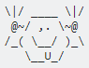

1. Add your name is ASCII graphics. For example:

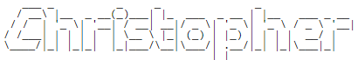

Or

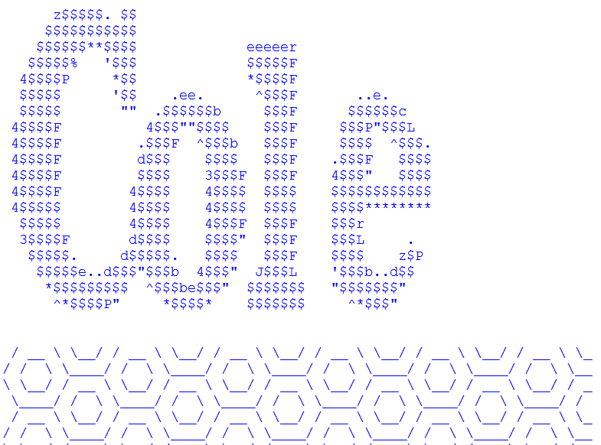

You don’t need to create the graphics on your own. There are a lot of websites that generate ASCII graphics.

Make sure you have a header – comments indicating your name, date, class, work description and teacher’s name

For example

// Chang Ed

// February 5, 2019

// Assignment 1 : face and name

// ICS3U Ms. Strelkovska

***After completing all the Exercises, create a folder named:  
YouLastnameFirstLetterOfYouFirstName_.... (for example ChangE_Assgn1 or SmithT_face_name). Folder should have .java file and .bat file. Be ready to drop assignment on February 5th into DropOff\Strelkovska_ICS3U_07\01_Assgn1_Face_Name***