# Assignment 1 Exercises 1-3(Println exercises) September 6, 2019

1. Write a simple program that prints the ASCII art below:

|\/\/\/|

| |

| |

| (o)(o)

C _)

| ,___|

| /

/____\

/ \

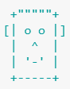

1. Add your name is ASCII graphics. For example:

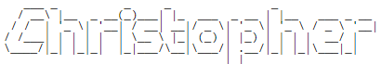

Or

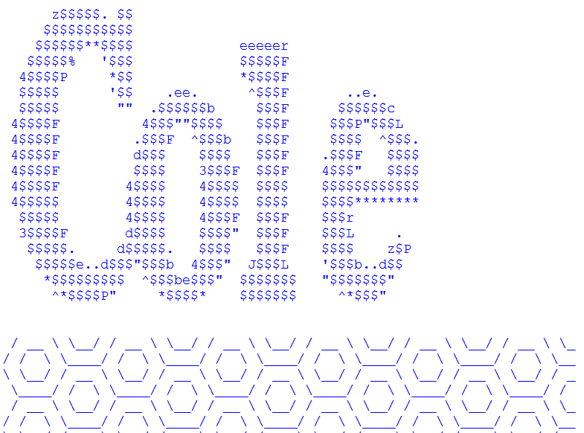

Make sure you have a header – comments indicating your name, date, class, work description and teacher’s name

For example

// Chang Ed

// September 6, 2019

// Assignment 1 : face and name

// ICS3U Ms. Strelkovska

***After completing all the Exercises, create a folder named:  
YouLastnameFirstLetterOfYouFirstName_....***

***(for example ChangE_Assgn1 or AnrikT_face_name)***

***and be ready to drop it off on September 6th***