Rock Paper Scissors Lizard Spock Exercise
For this exercise, you have to create a rock paper scissors lizard spock game. You may wish to do it either by using ifs, else ifs, and elses, or by using case switches, the choice is yours.
In this exercise the players is prompted for a throw, where r or R corresponds to Rock, p or P to Paper, and s or S to Scissors and so on(alternatively, you can use numbers to represent the throws, i.e. 1 for Rock, 2 for Paper, or 3 for Scissors …. You should display the player’s throw.
Example (the user entry is in red):
Enter your throw (r=Rock, p=Paper, s=Scissors, l=lizard, k=spock): s
Player throws SCISSORS.
OR
Enter your throw (1=Rock, 2=Paper, 3=Scissors, 5=lizard, 4=spock): 3
Player throws SCISSORS.
Now that we have the input from the player we have to complete the game. Generate a random number between 1 and 5 (or 0 and 4) for the computer throw. Determine the winner based on the rules shown in the diagram at the end of the assignment.
Example 1 (the player entry is in red):
Enter your throw (r=Rock, p=Paper, s=Scissors, l=lizard, k=spock): s
Player throws SCISSORS.
Computer throws PAPER.
You Win!

Example 2 (the player entry is in red):
Enter your throw (r=Rock, p=Paper, s=Scissors, l=lizard, k=spock): r
Player throws Rock.
Computer throws PAPER.
Computer Wins!
Example 3 (the player entry is in red):
Enter your throw (r=Rock, p=Paper, s=Scissors, l=lizard, k=spock): r
Player throws Rock.
Computer throws Rock.
You Tie!

The rules for the game are explained in the diagram below
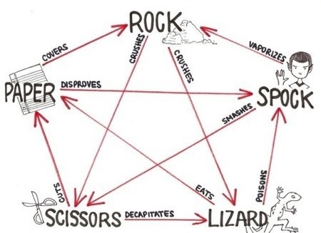

If we look at Lizard it will win in two cases (arrows going out), Lizard poison’s Spock, and Lizard eats paper, and it loses in two (arrows coming in), Scissors decapitates Lizard, and Rock crushes Lizard.

