Assignment 2 September 7, 2019

- Write a program that displays your first and last name and your timetable. You should use format and %. You should use right and left text alignment.

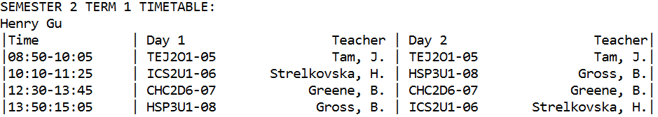

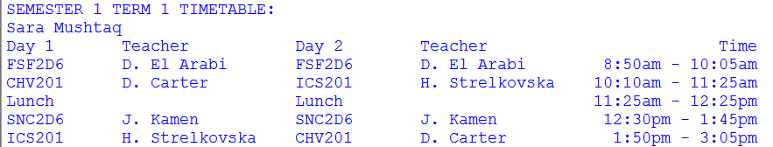

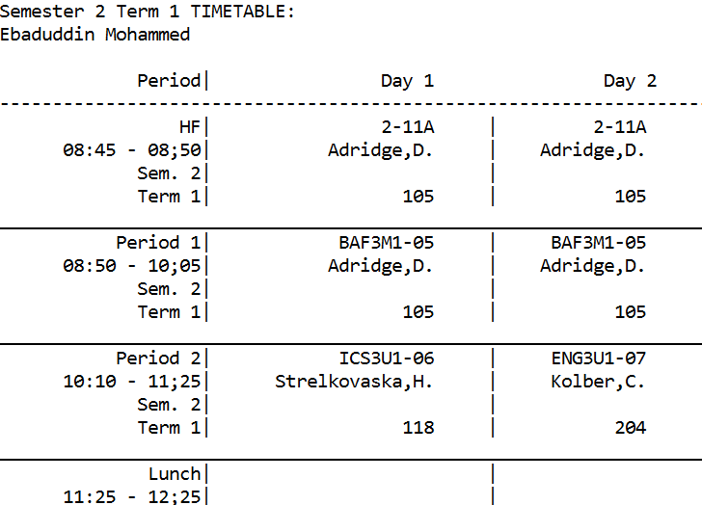

- a) Declare a variable of type double, assign some value( at least 6 deciaml places), and print this value rounded to 2, 3, and 5 decimal places.
For example:
x is 3.46723896
Rounded x: 3.47 3.467 3.46724

b) Declare a variable of type double, assign some value(less then 3 decimal places), and print this value with 3 decimal places.
For example:
y is 3.4
3.400

