Variable/Calculations Exercises

- Create a time conversion application. Declare the integer variable named seconds. Assign any value from 99 to 5999 to this variable. Then displays the time in hours, minutes, and seconds. Be sure to consider times where the number of minutes (or seconds) left over is less than 10. For example 3784 minutes in hour:minute:second format is 1:03:04 (Hint: use the modulus operator).

Example 1:
Number of seconds is 3734
The time is: 1:02:14

Example 2:
Number of seconds is 7322
The time is: 2:02:02

- Declare the variable of data-type double named money which represents the amount of money you have. Assign any value from 40 to 1200 to this variable. If the cost of a ticket for a hockey game is $64.97, what is the maximum number of tickets can be bought for the money you have? Calculate and display the change (separately dollars and cents).

For example,
With 640.57 dollars you can buy 9 tickets.
The change is 55 dollars and 84 cents.

3)
Write the code that calculates and round the result to 2 decimal places:
- 1/4 + 10 - 3/(5-0.00024)
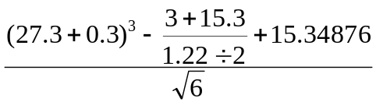
b)

- For each of the following sets of integers, write a single statement that will print a number at random from the set
  - 1, 2, 3,….,20

  - -6, -5, -4, -3, -2, -1, 0, 1, 2

  - 10, 20, 30, 40, 50, 60

