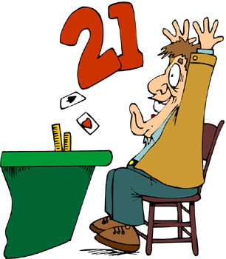
Black Jack assignment

Create a BlackJack application to simulate a simplified version of the game of “21”.

Game requirements:
- You should have at least 4 classes.
- One of the classes should have only static variables and static methods. This class should provide jokes for a player and a dealer. Every time a player wins – display a joke. This class should have a method nextJoke() which will check if the ArrayList of jokes is empty. If it is empty it should call another method loadJokes() that opens a file, loads jokes into an ArrayList and shuffles them. Every time nextJoke() is called a joke is returned and is removed from the ArrayList. You can use your own method names and own structure for this class, however your class should have a similar functionality.
- You should have at least one class that extends the other class.
- A card should be represented by an integer. This is a card ID. Only card ID should be passed from the deck to a player.
- You should use encapsulation, inheritance and polymorphism.
- When totals are calculated consider that Ace values 1 or 11. Make sure you consider the situation with more than one Ace.

Game playing:
- Print a deck of cards at the beginning of the game.
- Shuffle and print the deck again.
- Show player’s cards and card’s total all the time.
- Show dealer’s cards face down. ( or one card and other face down).
- Show dealer cards and card’s total when the game is over.
- Display the deck after every round.
- Ask if the user would like to play again.
- You should continue playing with the same deck. Introduce a new deck if less than 10 cards are left in a deck of card.
- Show dealer cards and card’s total when the game is over.
- Every time a player or dealer wins – display a joke from the Joke class.
(7, 9 and 12 are for Ms. Strelkovska – usually you don’t display it in a game)

Possible additions.
When you create a dealer randomly pick a dealer’s character or give the user a choice to pick For example, a dealer could be risky, conscious, with ability to count cards, or other.

The assignment will be mainly evaluated on the Object Oriented Structure.

Example running:
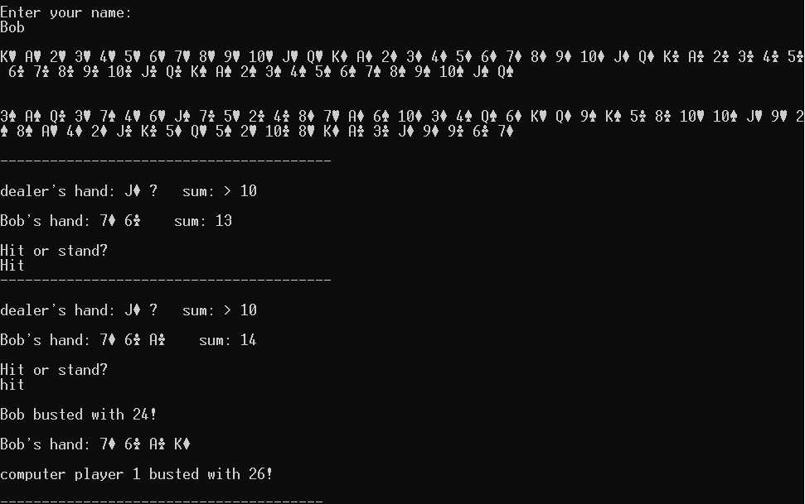
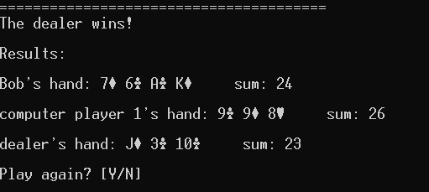
(Ms.S: In this case if both players busted, dealer wins even if the dealer busted as well.)

Second Example:
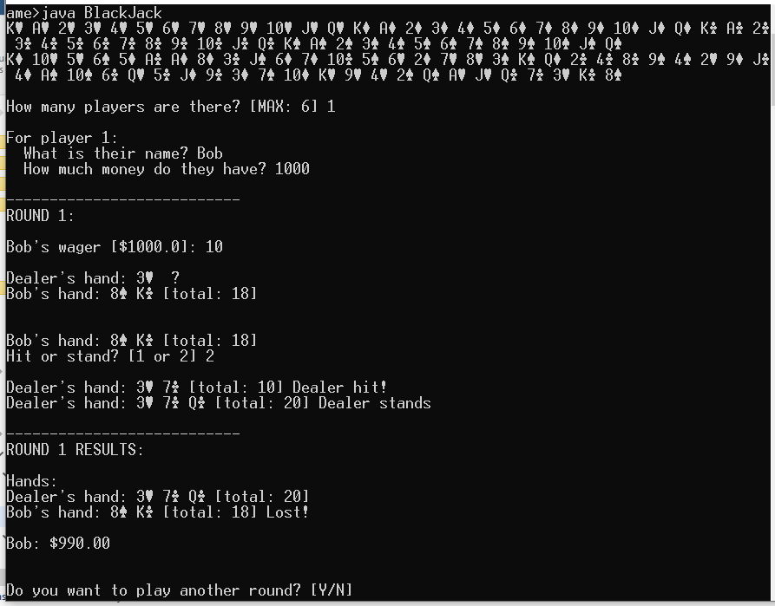
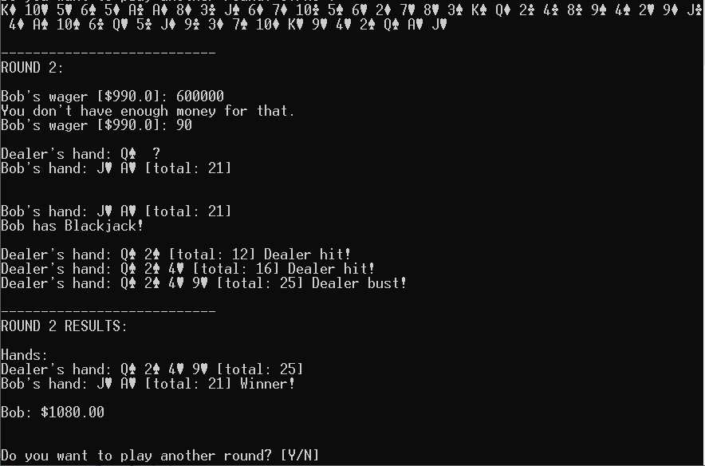
(Ms.S: In this example the student forgot to display jokes.)

