ICS3U

Calculation exercises

- Write the code that calculates and round the result to 2 decimal places:
    - 1/4 + 10
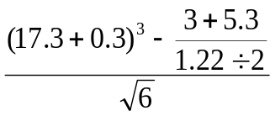

- For each of the following sets of integers, write a single statement that will print a number at random from the set
  - 1, 2, 3,….,30

  - -4, -3, -2, -1, 0

    - 10, 20, 30, 40, 50

