Scanner Exercises

- Ask the user for 3 marks and later for the name of the course. Display the course name with marks average.
For example,
Enter 3 marks: 90 95 87
Enter a course name: ICS3U
Your ICS3U average is 90.67
2.
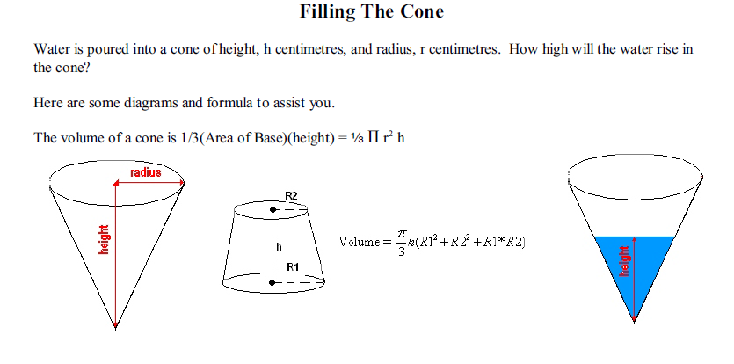
Ask the user for the value of h – the height of the cone in centimetres, the value of r - the radius of the cone in centimeters, the value of v - the volume of the water poured into the cone in cubic centimeters ( the value will be 0< v <= 1/3 Pi r²h ) . You should calculate and display the height of the water in the cone.
For example,
Enter h,r and v: 10 10 100
The height is 4.57
Enter h,r and v: 10 10 50
The height is 3.63
Enter h,r and v: 20 20 250
The height is 6.2

