Rock Paper Scissors Exercise
For this exercise you have to create a simple rock paper scissors game. You may wish to do it either by using ifs, else ifs, and elses, or by using case switches, the choice is yours.
In this exercise the players is prompted for a throw, where r or R corresponds to Rock, p or P to Paper, and s or S to Scissors (alternatively, you can use numbers to represent the throws, i.e. 1 for Rock, 2 for Paper, or 3 for Scissors. You should display the player’s throw.
Example (the user entry is in red):
Enter your throw (r=Rock, p=Paper, s=Scissors): s
Player throws SCISSORS.
OR
Enter your throw (1=Rock, 2=Paper, 3=Scissors): 3
Player throws SCISSORS.
Now that we have the input from the player we have to complete the game. Generate a random number between 1 and 3 (or 0 and 2) for the computer throw. Determine the winner based on the rules of Rock Paper Scissors: Rock dulls Scissors, Scissors cuts Paper, and Paper covers Rock.
Example 1 (the player entry is in red):
Enter your throw (r=Rock, p=Paper, s=Scissors): s
Player throws SCISSORS.
Computer throws PAPER.
You Win!

Example 2 (the player entry is in red):
Enter your throw (r=Rock, p=Paper, s=Scissors): r
Player throws Rock.
Computer throws PAPER.
Computer Wins!
Example 3 (the player entry is in red):
Enter your throw (r=Rock, p=Paper, s=Scissors): r
Player throws Rock.
Computer throws Rock.
You Tie!

For students that have done programming before (we know who you are!), you HAVE TO submit Rock, Paper, Scissors, Lizard, Spock version of this assignment. The rules for it are explained in the diagram below
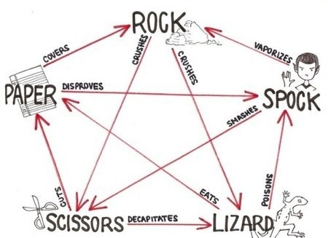

If we look at Lizard it will win in two cases (arrows going out), Lizard poison’s Spock, and Lizard eats paper, and it loses in two (arrows coming in), Scissors decapitates Lizard, and Rock crushes Lizard.

