Exercises a_01 println().

1. Exercise 2 pages 20 from the booklet.
Create a Smile application that displays a smiling face made of keyboard characters. The application output should look similar to:
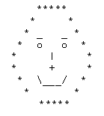

2. Write a program to print the following animal picture using multiple System.out.println(). Take note that you need to use escape sequences to print special characters.
'__'
(oo)
+========\/
/ || %%% ||
* ||-----||
"" ""

3. Write a program that displays your first and last name, the course code and name, and your school name in 3 separate lines.

