Calcution exercises

1. What do each of the following print?
a. System.out.println(2 + "ab");
b. System.out.println(2 + 3 + "ab");
c. System.out.println((2+3) + "ab");
d. System.out.println("ab" + 2 + 3);
d. System.out.println("ab" + 2 * 3);

2. Evaluate :
- 17%4
- 17%5
- 12%20
- -12%5
- 1/2*3
- 3/4+1.0
- 2/0
- 2/4
- 2.0/4
- 15%3+1/2+3/4
- 4+(1/2.0)*3
- (double)1/2*3
- (double)(3/4)+1.0
- (int)2/4.0
- (int)2.0/4
- (int)15%3+1/2+3/4.0

3. State the value each expression:
a) Math.abs(-3) – Math.abs(-8)
b) Math.abs(-1e-1) + Math.abs(-3e-1)
c) Math.sqrt(0.0049)
d) Math.sqrt(81)
e) Math.pow(Math.sqrt(16),2)
f) Math.max(2.5e-2, 0.095)
g) Math.min(13, 23.0)
h) Math.ceil(3.0083)
i) Math.ceil(-3.8)
j) Math.floor(9.99)
k) Math.floor(-7.7)
l) Math.pow(81, 1/4)
m) Math.pow(81, 0.25)
n) Math.pow(2, -2)
o) Math.floor(2.39 + 0.11)
p) Math.floor(2.39) + 0.11
q) Math.ceil(Math.Pi)
r)8%0
s)-10%2+1/2
t) 7.0/0

4) Write the following as Java expression:
a) 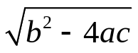
b) 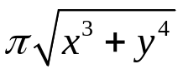
c) 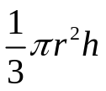
d)