- Ask the use for the double values x and y and calculate the following and display the result rounded to 2 decimal places :
  - 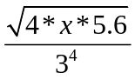

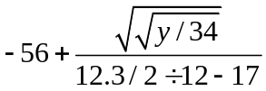

- Ask the user for 3 marks and later for the name of the course. Display the course name with marks average.
For example,

Enter 3 marks: 90 95 87
Enter a course name: ICS3U
Your ICS3U average is 90.67

