Scanner 2

- Ask the user for the values of integer x and double y. Use JOptionPane. Calculate the following and display the result rounded to 2 decimal places :
  - 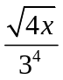

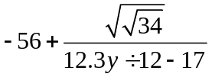

- Ask the user for a street number and after for a street name. Display the address.
For example:
What is your address?
Enter street number: 56
Enter street name: Bloor St. W
You address is 56 Bloor St. W

