Loop Exercises

1. Create an application that prompts the user to input their 4 digit pin number and checks to see whether it is correct or not (the correct pin number for this exercise is 1234). The user can only enter the pin number wrong 3 times before the system locks them out. (Use while loop)

Sample Output 1
Please enter your 4 digit pin number: 1234
Pin Accepted! Welcome to the system.

Sample Output 2
Please enter your 4 digit pin number: 1253
Wrong pin entered, you have 2 attempts remaining

Please enter your 4 digit pin number: 1313
Wrong pin entered, you have 1 attempt remaining

Please enter your 4 digit pin number: 1317
Wrong pin entered, you have been locked out of the system

Sample Output 3
Please enter your 4 digit pin number: 1253
Wrong pin entered, you have 2 attempts remaining

Please enter your 4 digit pin number: 1234
Pin Accepted! Welcome to the system.

2. Create a guessing game application where the computer generates a number (an integer) from 1 to 20 and the player has to guess what number the computer has generated. If the player’s guess is higher than chosen number, the computer should generate a message saying the number player guessed is higher, likewise if the player’s guess was lower. Also indicate how many tries it took for the player to guess the number

Sample Output 1
The computer has picked a number from 1 to 20, try and guess it
Enter your guess: 3
Your guess was low.
Enter your guess: 12
Your guess was high
Enter your guess: 10
Your guess was low
Enter your guess: 11
Congratulations, you guessed it in 4 tries!

Sample Output 2
The computer has picked a number from 1 to 20, try and guess it
Enter your guess: 16
Congratulations, you guessed it in 1 try!

3. Create an application to prints all the terms in the following series:-

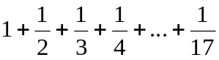
Sample output show for the series 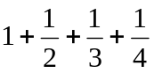

1 + 1 / 2 + 1 / 3 + 1 / 4

4. Find out what the sum of the following Series is and prints it to screen (round your answers to 4 decimal places):

Series : 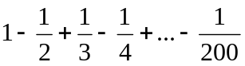

Sample output shown for following series: 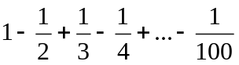

Sum of Series is 0.6882

- Write a program called ComputePI to compute the value of , using the following series expansion.
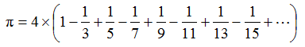
Find the estimation of pi (rounded to 3 decimal places) using 10,000 terms of the series

