Exercise 1. Counter.
Write a GUI application as shown below. The program has three components: Label "Counter", a non-editable TextField to display the counter value, and a Button "Count".

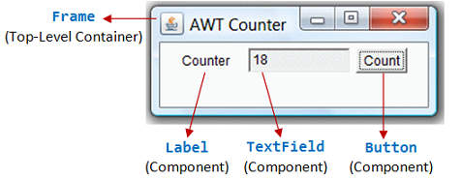
Exercise 1 b. Updated Counter.

Create an updated Counter application which has two additional buttons for counting down and reset the count value.
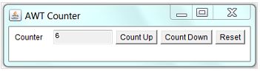
Exercise 2: Sudoku
Produce the display for a Sudoku game, as shown. It consists of 9x9 JTextFields arranged in a GridLayout. Use array of JTextFields.
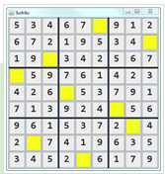
// Puzzle to solve - 0 are the empty cells
int[][] puzzle = {{5, 3, 4, 6, 7, 0, 9, 1, 2},
{6, 7, 2, 1, 9, 5, 3, 4, 0},
{1, 9, 0, 3, 4, 2, 5, 6, 7},
{0, 5, 9, 7, 6, 1, 4, 2, 3},
{4, 2, 6, 0, 5, 3, 7, 9, 1},
{7, 1, 3, 9, 2, 4, 0, 5, 6},
{9, 6, 1, 5, 3, 7, 2, 0, 4},
{2, 0, 7, 4, 1, 9, 6, 3, 5},
{3, 4, 5, 2, 0, 6, 1, 7, 9}};

Exercise3: SwingCalculator
Implement a simple calculator as shown.
Hints: Set the ContentPane to BorderLayout. Add a JTextField (tfDisplay) to the NORHT. Add a JPanel (panelButtons) to the CENTER. Set the JPanel to GridLayout of 4x4, and add the 16 buttons.

