Mouse Event exercise.

1. Create an application the will draw
- draw dots which are the same distances from each other

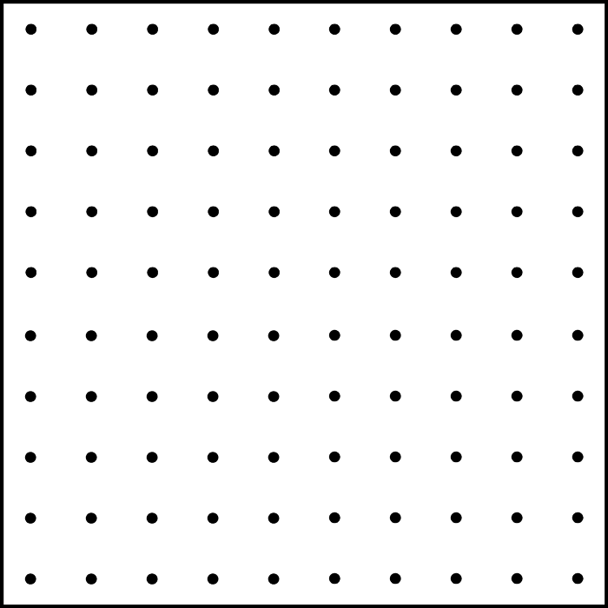

- update part a) by drawing lines that starts from these points and have the same length but random direction

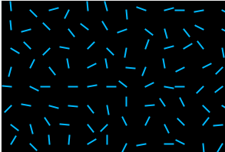

- update part b) by changing the colour of the lines every time the user click on the screen
- update part c) by changing the direction of the lines every time the mouse entered the frame.

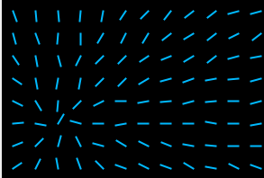

- Add a timer to the application so the lines will change their random directions constantly if the mouse is outside of the screen.

To add timer
  - import javax.swing.Timer.*;
if you have all swing packages imported (import javax.swing.*;) you don’t need to do anything
  - implement ActionListener
  - declare a variable Timer
For example, Timer myTimer;

  - create Timer object in JFrame constructor
For example, myTimer = new Timer(200, this); // where 200 is a delay in
//milliseconds and this indicates that action performer will be in the same class
  - start the timer
myTimer.start();
  - code for the timer should go to actionPerformed method

BONUS:
- Change a background every time the space bar is pressed.

Hint:
  - Use variable Color
Color col = new Color(Color.BLACK); // default colour at the beginning

  - Set background of the JFrame container in paint method.
myContainer.setBackground(col);

  - Change the value of the variable on keyPressed event and repaint the frame.
int randomRed=… //random number from 0 to 255
int randomGreen=… //random number from 0 to 255
int randomBlue=… //random number from 0 to 255
col=new Color(randomRed, randomGreen, randomBlue);
repaint();

