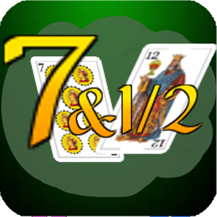
Seven and a half game.

Create an application to simulate a simplified version of the game of “seven and a half”.

The games is played with the 40 cards pack (pictures and cards from ace to seven). Any number of players may take part in the game, but it is not recommended to be more than 8.

The objective is to collect cards that total as near as possible to 7½ without exceeding that number.

Picture cards values are half a point and the values of the remaining cards are their indexes.

The dealer deals one card face down to each player.
If the players are satisfied with their total they may stay and the turn passes to the next player.
If they want to risk increasing their total, they ask the dealer for a card. If this new card takes their total over seven and a half they are bust.
A wild card (the King of Diamonds) at the owner's choice can take on either its normal value of one half or any whole number value from 1 to 7.

If you use your own rules, display them at the beginning of the game.

Programming game requirements:
- Print a deck of cards at the beginning of the game ( for Ms. Strelkovska)
- Shuffle and print the deck again ( for Ms. Strelkovska)
- Show players cards and card’s total all the time
- Show dealer cards and card’s total when the game is over
- Show dealer cards face down. ( or one card and other face down)
- Display the deck after every round ( for Ms. Strelkovska)
- Ask if the user would like to play again
- Use the same desk to continue playing. A new deck of card should be introduced if there is less than 15 ( or your game required number) cards in the current deck at the beginning of the new game
- Dealer should stay if he/she has total of 6 or higher and take a new card otherwise.
- When calculating totals consider the wild card
- You should use data encapsulation, inheritance, and polymorphism.
- You should have at least 3 classes
- You should have at least two static methods ( not counting methods in your testing class)
- You should have at least two static variable ( not counting variables in your testing class)
- You should have at least one class that extends the other class
- Create a class similar to Joke class discussed in class. You should run method similar to nextJoke() from different classes ( for example, Dealer and Player).

Possible additions.
When you create a dealer randomly pick a dealer’s character or give the user a choice to pick For example, a dealer could be risky, conscious, funny, with ability to count cards, or other.

The assignment will be mainly evaluated on the Object Oriented Structure.

