Moving Lines exercise.

1. Create an application the will draw
- draw circles which are the same distances from each other

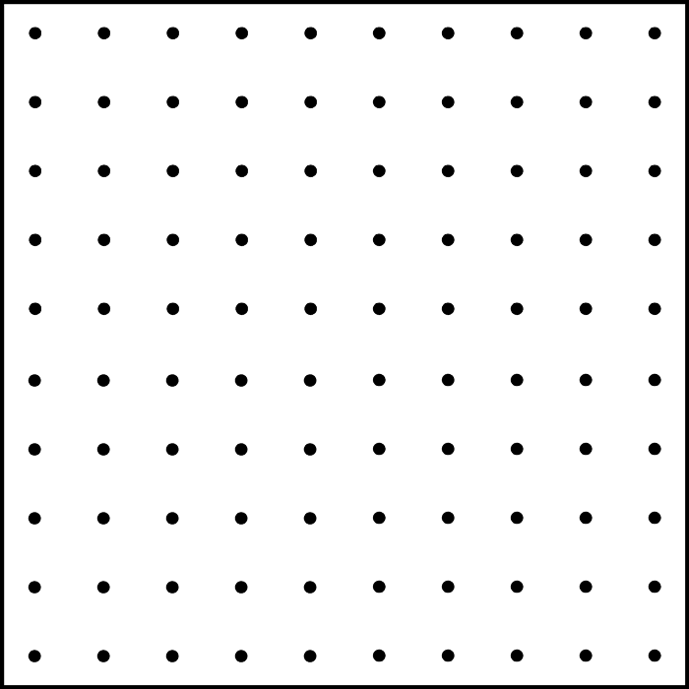

- update part a) by drawing lines that starts from these points and have the same length but random direction

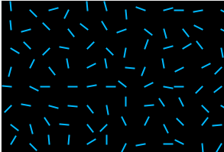

- Add a timer to the application so the lines will move clock wise or counter clock wise.

You should use a separate class to draw lines like we discuss in class.

