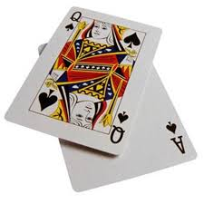
Baccarat game : Chemin de Fer version

Create Baccarat game application to simulate a simplified version of the game of Baccarat. Chemin de Fer version

Additional game requirements:
- Print a deck of cards at the beginning of the game
- Shuffle and print the deck again
- Show players cards and card’s total all the time
- Show dealer cards and card’s total when the game is over
- Show dealer cards face down. ( or one card and other face down)
- Display the deck after every round
- Ask if the user would like to play again
- A new deck of card should be introduced if there is less then 6 cards in the current deck at the beginning of the new game

Other application requirements:
- You should have at least 3 classes
- You should have at least one static methods ( not counting methods in your testing class)
- You should have at least two static variable ( not counting variables in your testing class)
- You should have at least one class that extends the other class
You should program considering 3 main principals of OO concept: data encapsulation, inheritance and polymorphism.

Possible additions.
When you create a player randomly pick a player’s character or give the user a choice to pick For example, a dealer could be risky, conscious, funny, with ability to count cards, or other.

The assignment will be mainly evaluated on the Object Oriented Structure.

