2.1 Snowflake
To draw a snowflake, lets draw a star: six lines radiating from a center.
Then, reduce the size of the pattern and draw the star at the end of each line of the original.
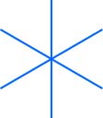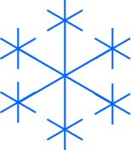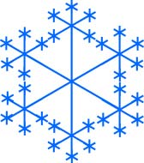
This is similar to what happens in nature. Water vapour forms into ice crystals where there is a particle of dust or a sharp point of a previous ice crystal.
Base Case: This snowflake drawing procedure stops when the sub-snowflakes reach the smallest size.

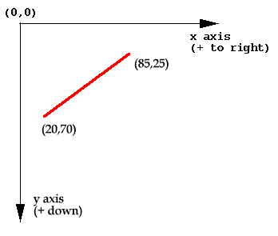
2.2 Graphics
The (0, 0) location is at the top left corner. Dimensions are measured in pixels. X and Y axis are as shown in the picture
We use method paint() to paint in Java. All drawing methods use Graphics object which is passed to the method.
For example:
public void paint(Graphics g) {
g.drawRect(20,30,40,50);
g.drawString(“Hello”,25,25);
}

What is the name of the method (of class Graphics) that draws a line from (x0, y0) to (x1, y1) ?
g.drawLine(x0, y0, x1, y1);
What is the code to draw the line in the picture?
g.setColor(Color.red); // or g.setColor(new Color(255,0,0));
g.drawLine(20,70,85,25);

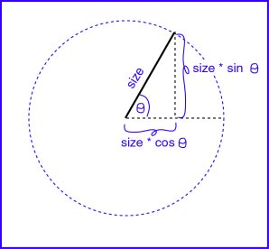

2.3 Geometry
Each line (of the six) starts at the center, (x, y), and ends at a point on the circle of radius size. The X distance from the center of a point on a circle is size*cos( theta ). The Y distance from the center of a point on a circle is size*sin( theta ).
All you need to do is find the six values for theta and the six endpoints are yours.

2.4 Dividing a Circle
The Java trigonometric functions are methods of the Math. They take radians for their arguments (as do such functions in most programming languages). Here is the complete method:
private void drawStar( int x, int y, int size ) {
int endX, endY ;
// Six lines radiating from (x,y)
for ( int i = 0; i<6; i++ ){
endX = x + (int)(size*Math.cos((Math.toRadians(360)/6)*i));
endY = y - (int)(size*Math.sin((Math.toRadians(360)/6)*i));
// Note"-"
graph.drawLine( x, y, endX, endY );
}
}
The circle is divided into six pieces. There are 360⁰ per circle. One sixth of a circle is (Math.toRadians(360)/6).
The minus sign is used in the calculation of endY because y increases in value going down. Using a "+" would also work because of symmetry.
What does (int) do in the statement ?
endY = y - (int)(size*Math.sin( (2*Math.PI/6)*i ));
This is a type cast. It notifies the compiler that it is OK to convert the double value to its right into an int.

2.5 Basic Star
Let us first write a code that draws the basic 6-pointed star.
import javax.swing.*;
import java.awt.* ;

public class SnowFlakeBasic extends JFrame{
Graphics graph; //can be used by any method
//constructor
public SnowFlakeBasic(){
Container c = getContentPane();
c.setBackground( new Color(154,183,228));
}
// draw six lines of length size
// from the point (x,y)
private void drawStar( int x, int y, int size ) {
. . . .
}

public void paint ( Graphics g) {
graph = g; //now global graph is g
int width = getSize().width;
int height = getSize().height;
drawStar( width/2, height/2, height/4 );
}
}

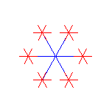
2.6 Second Stage Star. Recursion.
Next, to draw the snowflake, stars are drawn at the end of the six lines.
Do you already know where these locations are?
Of course. We already have a method to draw a star, so just use it.
The new stars need to be smaller than the central star. So the size of the new stars is size/3. (Other sizes will also work. You may wish to play with this.)

// Seriously Wrong Method
//
private void drawStar( int x, int y, int size ){
int endX, endY ;

// Six lines radiating from (x,y)
for ( int i = 0; i<6; i++ ){
endX = x + (int)(size*Math.cos( (2*Math.PI/6)*i ));
endY = y - (int)(size*Math.sin( (2*Math.PI/6)*i ));
graph.drawLine( x, y, endX, endY );

drawStar( endX, endY, size/3 ) ;
}
}
The basic star method is easily modified by inserting a statement that puts a star on the end of each line.

2.7 Base case: Small Stars
Our seriously wrong drawStar() method does not test for a base case.
When a star is too small, don't draw it.

private void drawStar( int x, int y, int size ) {
int endX, endY ;

if ( size <= 2 ) return; // base case

// Six lines radiating from (x,y)
for ( int i = 0; i<6; i++ ) {
endX = x + (int)(size*Math.cos( (2*Math.PI/6)*i ));

endY = y - (int)(size*Math.sin( (2*Math.PI/6)*i ));
graph.drawLine( x, y, endX, endY );
drawStar( endX, endY, size/3 );
}
}
We picked the value "2" for the base case. Smaller values result in almost 0 side length.
2.8 Complete Program
Here is the complete program.

// TestSnowFlake.java
//
import javax.swing.*;
import java.awt.* ;

/**********************************
/ Client code that has main method
/*************************************/

public class TestSnowFlake{
public static void main ( String[] args ){
SnowFlake sf = new SnowFlake() ;
sf.setSize( 300, 250 );
sf.setVisible( true );
sf.setDefaultCloseOperation( WindowConstants.EXIT_ON_CLOSE );
}
} //end TestSnowFlake

/**********************************
/ Class SnowFlake that has frame and does the drawing
/*************************************/

class SnowFlake extends JFrame{
Graphics graph; //variable of type Graphics

//*************constractor
public SnowFlake(){
super("Random Snow Flakes");
Container c = getContentPane();
c.setBackground( new Color(154,183,228));
}

//*************recursion => method drawStar
private void drawStar( int x, int y, int size ) {
int endX ;
int endY ;

if ( size <= 2 ) return;

// Six lines radiating from (x,y)
for ( int i = 0; i<6; i++ ) {
endX = x + (int)(size*Math.cos( (2*Math.PI/6)*i ));
endY = y - (int)(size*Math.sin( (2*Math.PI/6)*i ));
graph.drawLine( x, y, endX, endY );
drawStar( endX, endY, size/3 );
}
} // end drawStar

//*************paint which call drawStar

public void paint ( Graphics g ) {
super.paint(g);
graph = g; // set up global variable graph so any
// method of the class can use it and draw
int width = this.getSize().width;
int height = this.getSize().height;
int min;
if ( height < width )
min = height;
else
min = width;

g.setColor( new Color(38,38,170));

drawStar( width/2, height/2, min/4 );
}
} // end class SnowFlake

Recursion Exercises Set 2
Exercise 1
Modify the snowflake application to draw several snowflakes of random colors at random locations with random number of lines/arms similar to the following. The snowflakes should be felling down and rotate.
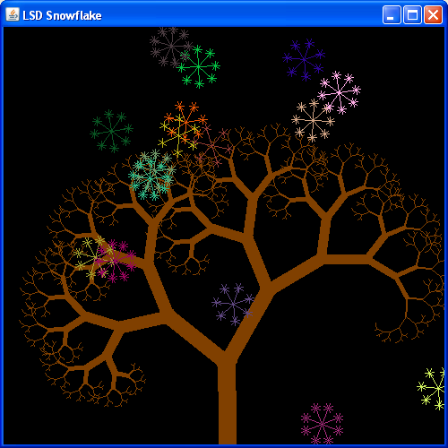
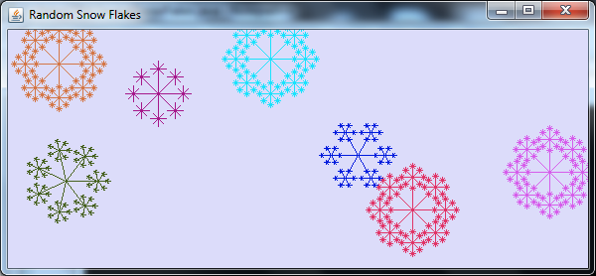
Exercise 2
Write DrawTree application to draw a tree similar to:
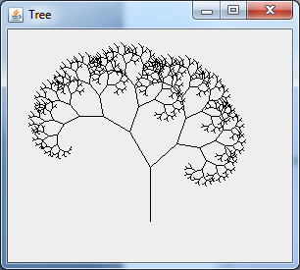
Looking at the picture, you'll notice that the tree consists of a trunk and two branches. Each branch appears exactly the same as the overall tree, but is smaller and rotated a bit.
You can use a recursive method which will take four parameters to indicate the trunk of the tree to be drawn (the trunk will in fact be the base of the branch being drawn). These four parameters indicate the x- and y-coordinates of the trunk's base, the length of the trunk, and the angle of the trunk.
The recursive method's base case will be when the length is at most 2 pixels. In this case, there is not an interesting tree to be drawn, so the method returns immediately. But if the length is more than 2 pixels, the method will compute the coordinates of the trunk's other end by applying basic trigonometry (cos and sin methods of the class Math). After computing the coordinates of the trunk's other end, the method draws a line corresponding to the trunk. And then it makes two recursive calls to draw each branch. Both branches are slightly smaller than the overall tree (75% in the case of the left branch and 66% in the case of the right), and at rotated at an angle from the trunk (30° counter-clockwise for the left branch, 50° clockwise for the right).
Playing with the proportions and rotation factors in the recursive calls leads to other interesting tree variants.

Possible improvements: You can make your tree look more natural using 3 branches and different stroke thickness.
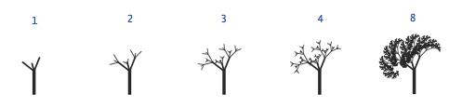
In order to use stroke you need to have Graphics2D object instead of Graphics.
Graphics2D g2D= (Graphics2D)g;
g2D.setStroke(new BasicStroke(1.3f));
g2D.drawLine(…);

