- Create a Smile application that displays a smiling face made of keyboard characters. The application output should look similar to:
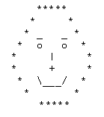

2. Write a program to print the following animal picture.
'__'
(oo)
+========\/
/ || %%% ||
* ||-----||
"" ""

